Add t
2018/2019

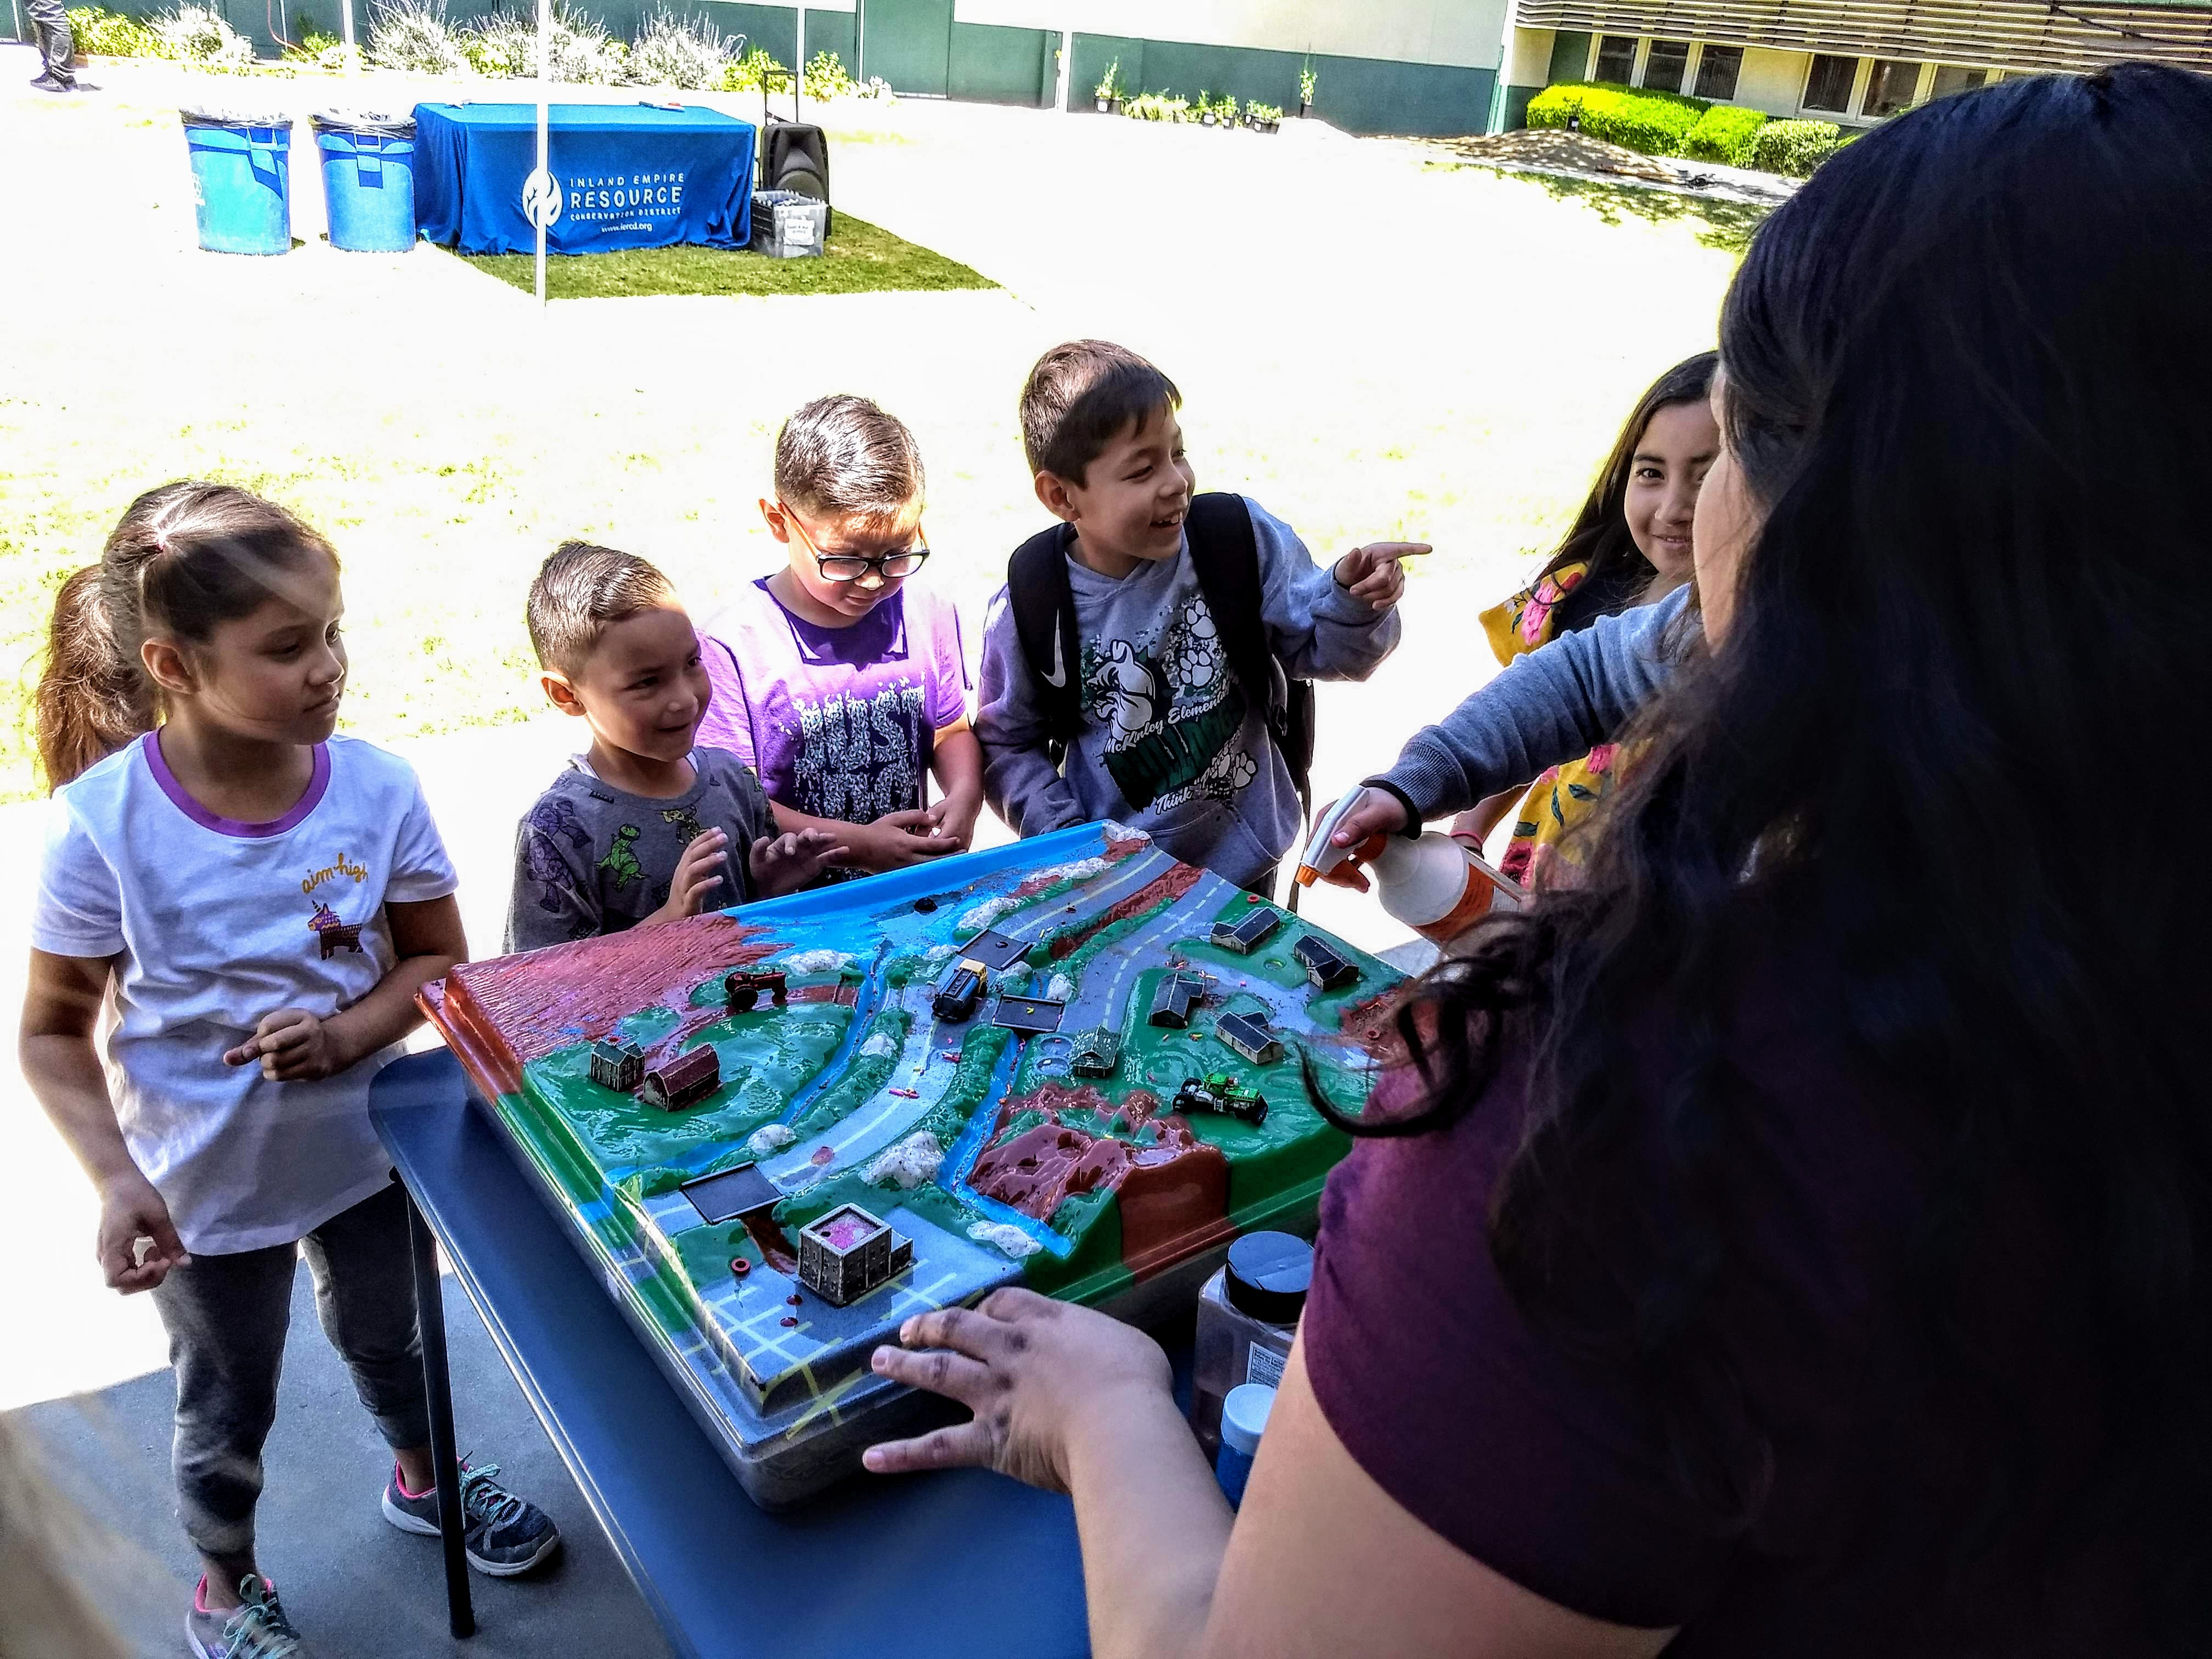
San Bernardino County Annual Report
University of California Cooperative Extension
San Bernardino County
http://cesanbernardino.ucanr.edu

Master Gardener Program
A note from the Directors

We are proud to share the many accomplishments and impacts of our University of California Cooperative Extension (UCCE) programs in San Bernardino County that occurred between July 1, 2018 and June 30, 2019. Over 35,000 county residents were reached through our Master Gardener, Master Food Preserver, 4-H/Youth, Horticulture, Natural Resources Management and Expanded Food and Nutrition (EFNEP) programs. Our 200+ volunteers alone contributed over $327,290 in services to county residents.

The report summarizes our UCCE applied research and extension activities extended to residents of San Bernardino County and illustrates the many ways that UCCE has enhanced the quality of life through the development and delivery of objective, research-based information.

Major accomplishments include:

- Providing free hands-on nutrition classes to low-income youth and adults (Expanded Food and Nutrition Education Program) to 640 adult participants and 2,352 youth.
- Providing free workshops, answering helpline inquiries from the public, staffing Farmers Markets and public service booths, and writing a weekly newspaper column (Master Gardener Program) that reached over 30,000 county residents.
- Providing free workshops on food safety and preservation (Master Food Preserver Program).
- Engaging 743 youth (aged 5 to 18) year-round with the support of 185 adult volunteers in ten 4-H Community Clubs and 462 youth at Ft. Irwin.
- Conducting applied research and education relevant to city foresters, arborists, landscapers, and pest control advisors and applicators on pest-resistant, drought-tolerant landscape plants (Horticulture Program) that reached over 1,500 end-users.
- Conducting applied research and education regarding important land management practices that reduce populations of the invasive yellow star thistle (Natural Resources Program).
Our UCCE programs in San Bernardino County would not be possible without the support of our many UC partners including the United States Department of Agriculture, County of San Bernardino (Public Health, Agriculture Weights and Measures, Libraries, Regional Parks, County Museums, Arrowhead Regional Medical Center and Preschool Services), Inland Empire Resource Conservation District, Chino Basin Water Conservation District (CBWCD) and many others. Thank you for helping us achieve our collective goals!

We hope the report illustrates the value and growing impacts of our UCCE programs in San Bernardino County. Do not hesitate to contact us regarding how our programs can further assist county residents or to discuss current or potential partnership opportunities.

Janet Hartin Christopher McDonald
Janet Hartin and Christopher McDonald
UCCE San Bernardino County Co-Directors

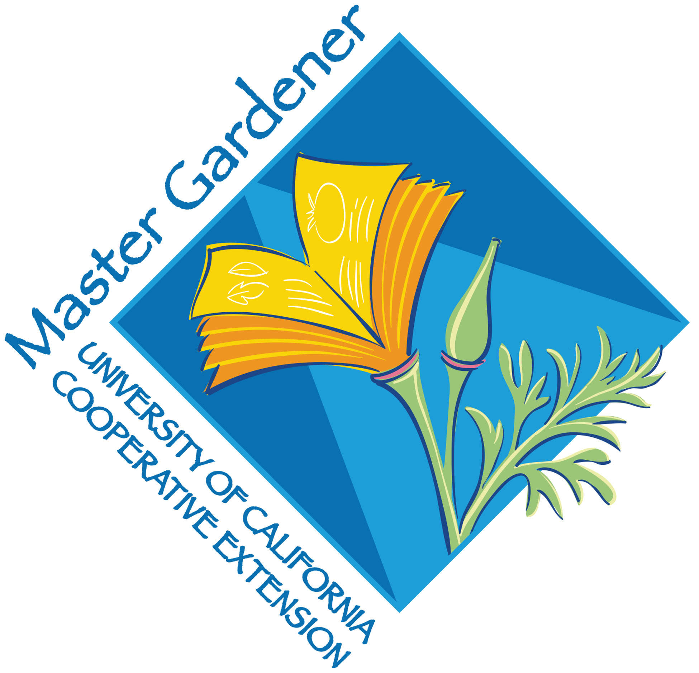
199 Volunteers
12,111 Volunteer Hours
$311,640 in Community Service

Over 150 volunteer Master Gardeners reached over 30,000 county residents through over 150 activities and events focused on sustainable, drought tolerant landscaping; growing food in home, community, and school gardens; and promoting healthy communities through outdoor activities. Activities included presenting talks to over 28 non-profit organizations; staffing information booths; answering helpline email and telephone inquiries; and, writing blogs and weekly Master Gardener newspaper column appearing in the San Bernardino County Sun, Redlands Daily Facts, and several other area newspapers. A new class of 45 volunteers from the valley, desert, and mountains completed training in May 2018. Each will complete a minimum of 50 volunteer hours in local communities throughout the county by June 30, 2020.

Master Gardeners partnered with the County of San Bernardino; the Chino Basin Water Conservation District (CBWCD); Farmers’ Markets in Redlands, Big Bear, and Wrightwood; San Bernardino County Museum (Redlands); 13 community and school gardens (including Huerta del Valle); the Edward Dean Museum; Big Bear Discovery Center (Fawnskin); University of Redlands; Cal State
University, San Bernardino; Lavender Festival; City of Loma Linda; Loma Linda University; Ontario Home and Garden Show, and many more. Events included water conservation workshops, landscape care seminars, pollination festivals, mulch demonstrations and giveaways, composting and vermicomposting workshops, school and community garden startup workshops, and growing food in containers and small spaces.
45 Master Gardener trainees completed their 18-week class in May, 2018 and each completed a minimum of 50 hours of volunteerism by June 30, 2019.
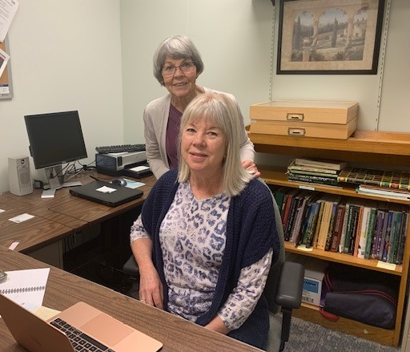
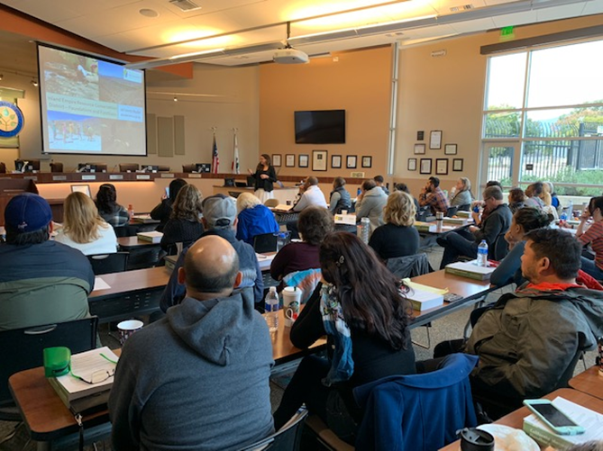
Master Gardeners staff telephone and email helplines in the UCCE San Bernardino County Master Gardener office
Master Gardeners Educated over 30,000 residents of San Bernardino County on Sustainable Landscaping Practices and How to Grow Food in Home, School, and Community Gardens
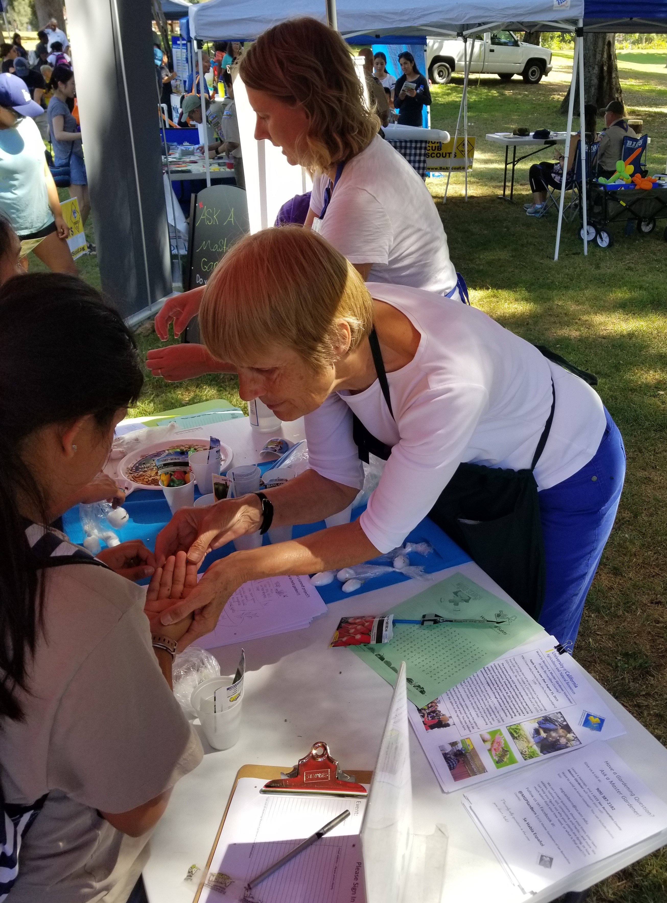
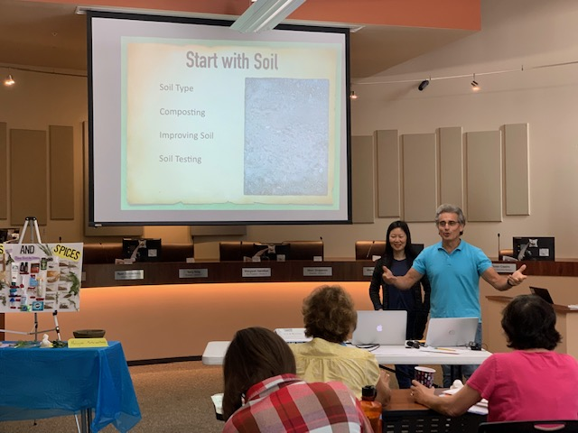

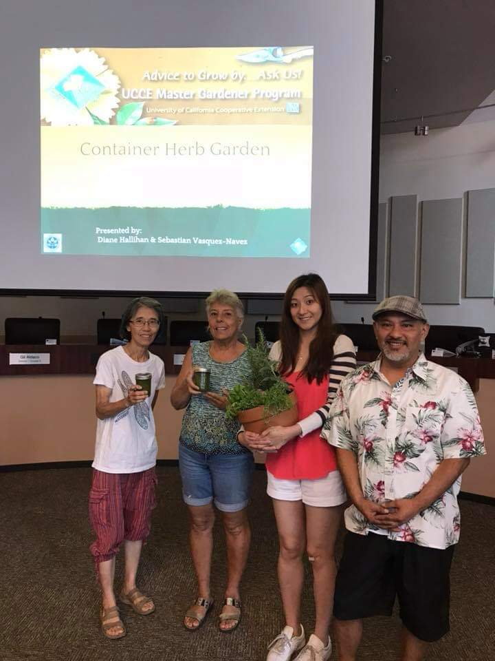
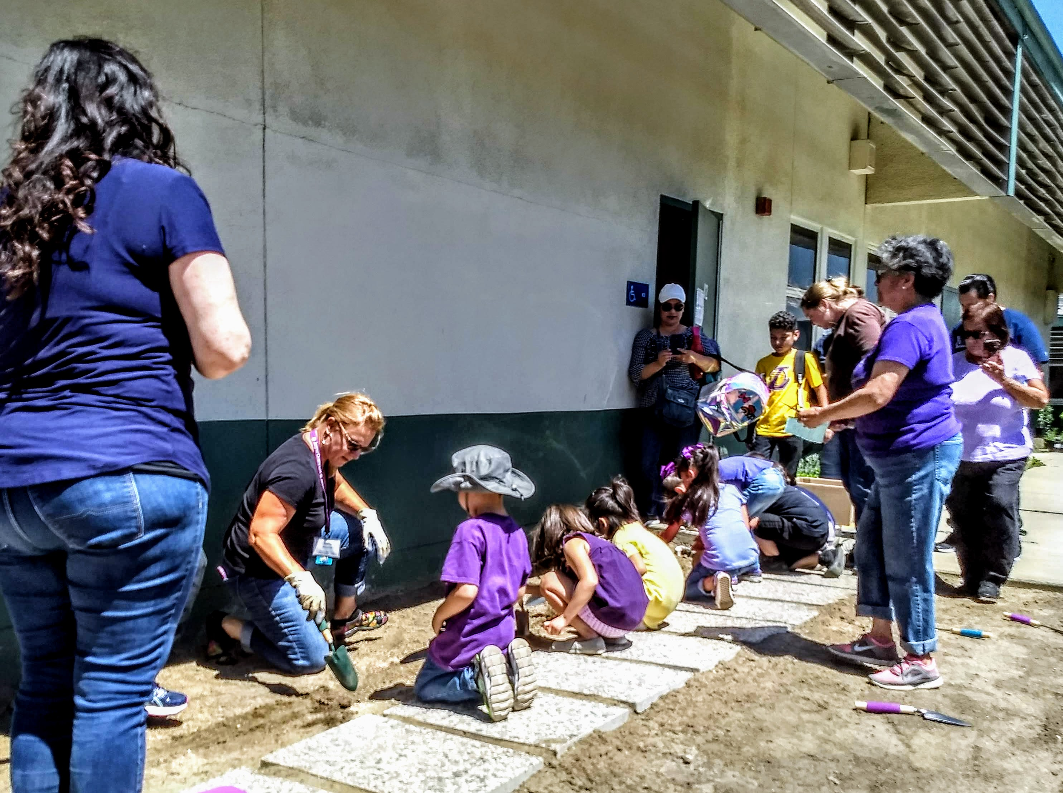
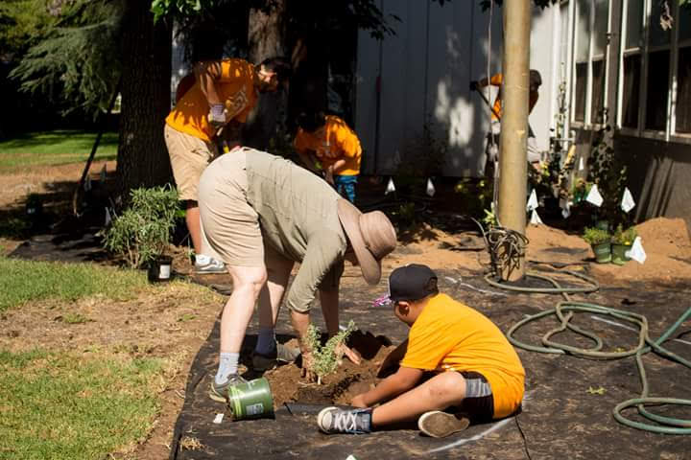
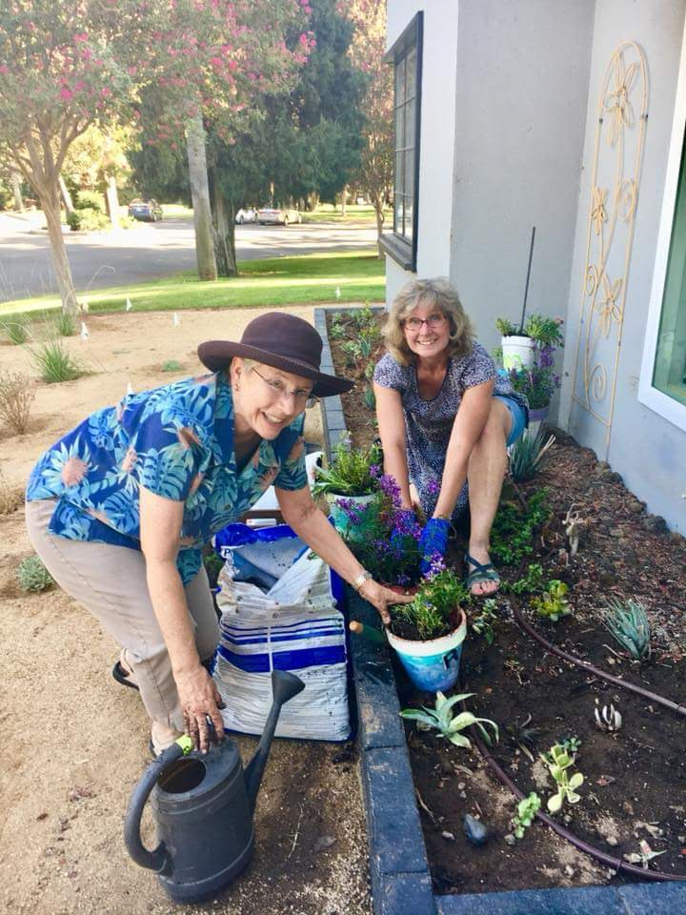

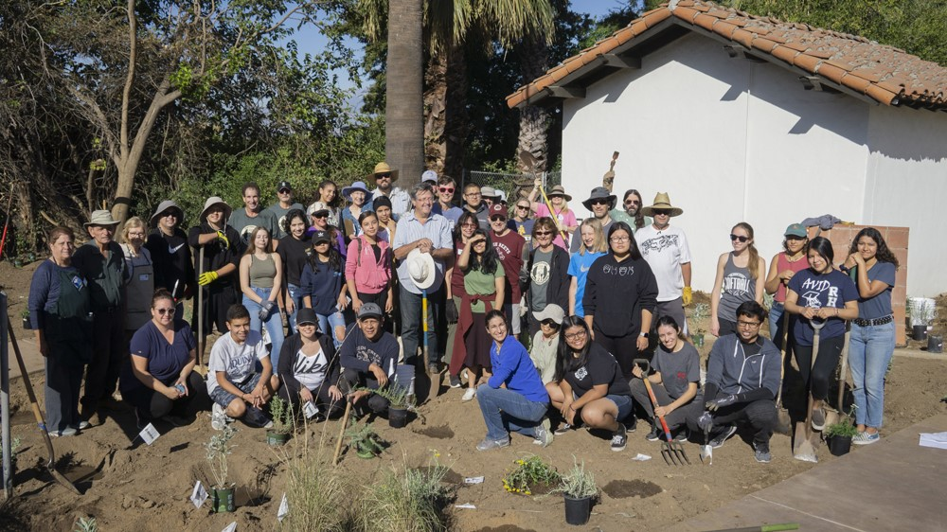

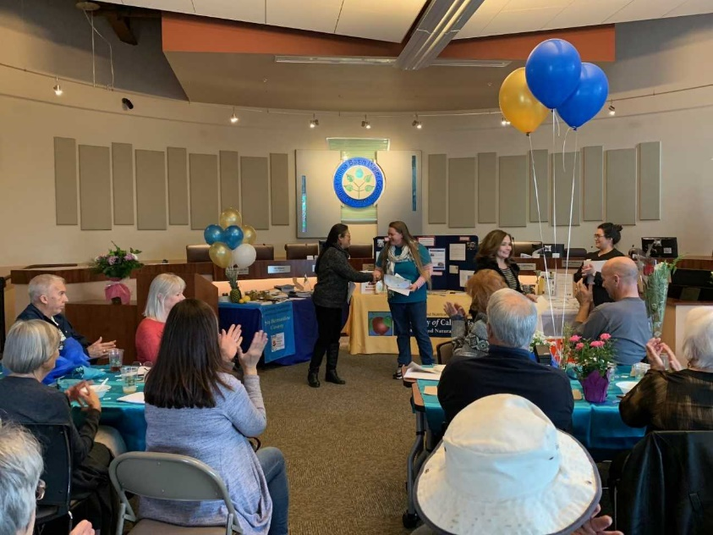
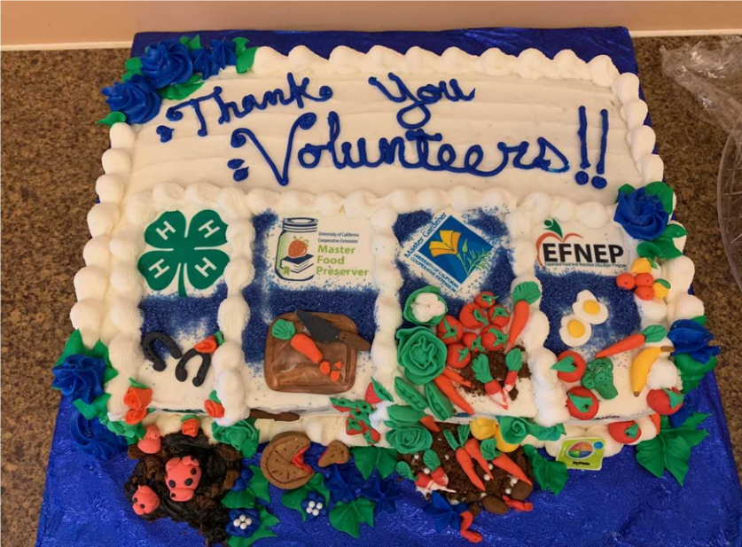
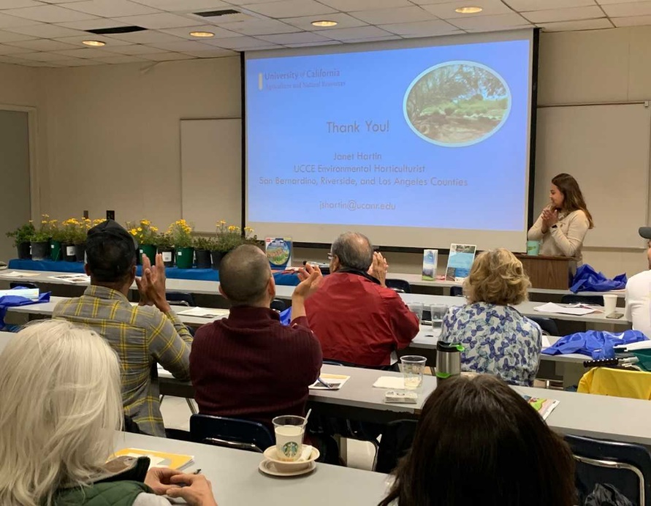
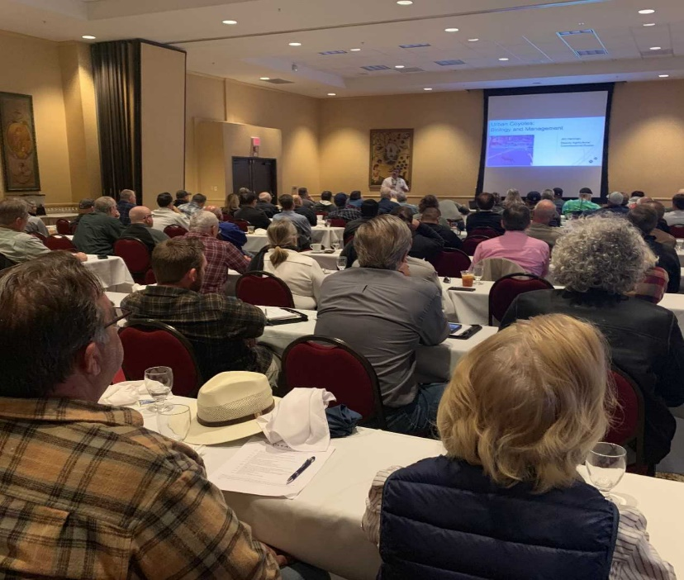
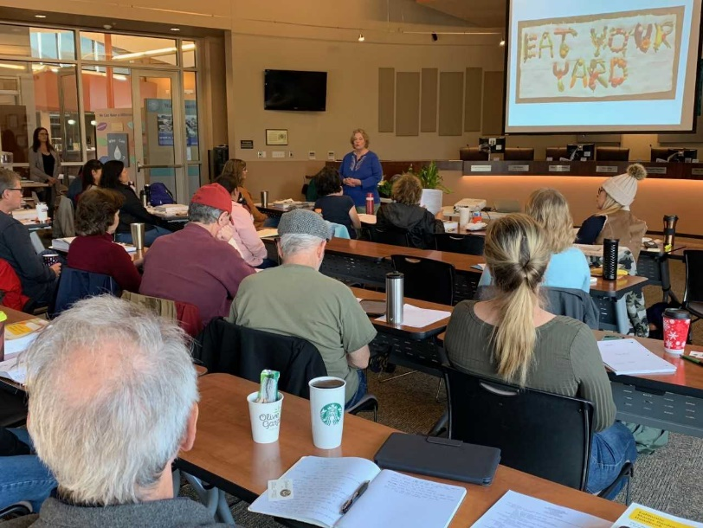
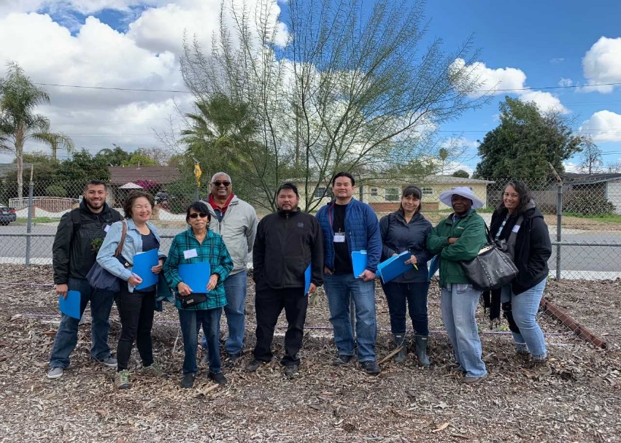
Top Left and Right: Recognition Ceremony Honors UCCE Volunteers.
Top left: Master Gardeners Help Take Data on Mulch/No Mulch Trial in Montclair; Top right: 56 new Master Gardener trainees learn about growing food.
Top Left: IERCD’s Jasmine Orozco Clark Giving Away Plants after Janet Hartin’s Presentation at Cal State San Bernardino on Sustainable Landscaping; Top Right: Janet Hartin hosted and spoke at a CAPCA seminar for urban foresters in Ontario.
Youth and Adult Expanded Food and Nutrition Education Programs (EFNEP)
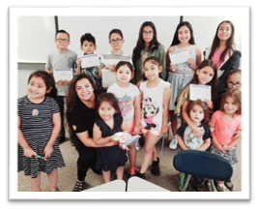
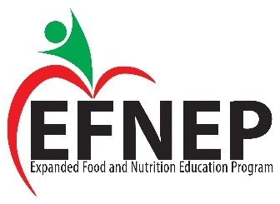
UCCE Youth and Adult EFNEP classes are offered gratis in English and Spanish to low income, limited-resource residents using a community-based, hands-on educational approach. The Youth EFNEP program provides no-cost curriculum, support, and resources to teachers from pre-kindergarten through high school. Lessons are delivered by EFNEP educators and teachers in the classrooms. Children actively engage in learning about the importance of healthy eating and physical fitness through hands-on experiential learning. EFNEP curricula correlate with common core content standards. Adult EFNEP’s ‘Eating Smart Being Active’ program promotes good nutrition and physical activity as a means of maintaining healthy lifestyles less prone to chronic disease. Participants learned to plan nutritious meals, stretch their food dollars and make healthy lifestyle choices including handling food safely and being physically active.
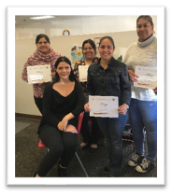
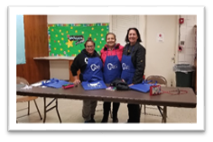
Overall, EFNEP reached 485 adult participants and 1767 youth during FY 2018/19. As a result of EFNEP participation, individuals and families experienced improvements in their overall health, level of physical activity, food resource management, food safety practices, and food security. The program is funded by the USDA and offered to county residents solely through UCCE. San Bernardino County’s EFNEP program is the third largest program in the state.

FFY19 EFNEP Impact
San Bernardino County
EFNEP Participant Profile:
- 67% of families had income levels at or below 125% of the poverty level.
- 83% of participants participated in one or more food assistance programs.
- 85% identified themselves as Hispanic or Latino.

EFNEP makes a difference
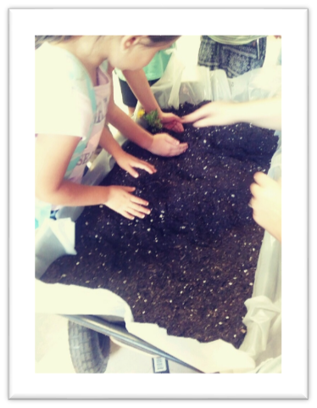
In FY 2018-2019, San Bernardino County EFNEP:
- Delivered nutrition education to 640 families.
- Taught an average of 8 lessons to each adult participant.
- Reached more than 2,879 family members indirectly.
- Provided nutrition education to 2,352 youth.
Of the 332 adult program graduates:
- 94% improved at least one nutrition practice.
- 81% improved at least one physical activity behavior.
- 78% improved at least one food resource management practice.
- 78% showed improvement in one or more food safety practices.
Youth evaluation data shows:
- 78% of children and youth improved their abilities to choose foods according to the Federal Dietary Recommendations or gain knowledge.

In FY 2009-2010, Riverside County EFNEP:
- Delivered nutrition education to 520 families.
- Taught an average of 9 lessons to each adult participant.
- Reached more than 2,600 family members indirectly.
- Provided nutrition education to 1,470 youth.
Of the 552 adult program graduates:
- 90% improved at least one nutrition practice.
- 87% improved at least one food resource management practice.
- 75% showed improvement in one or more food safety practices.

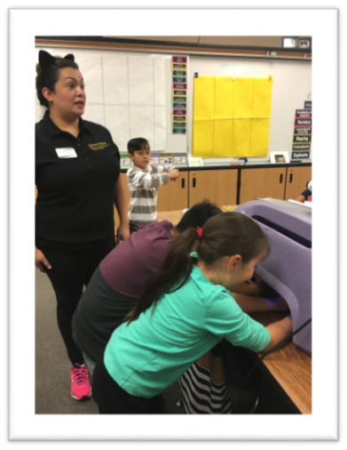

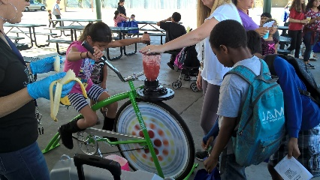
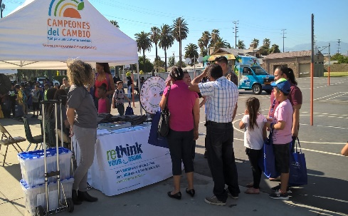
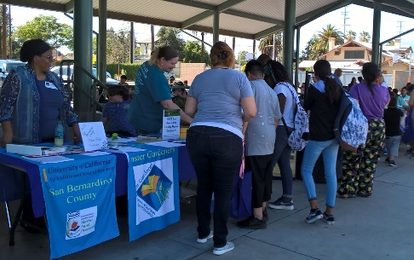
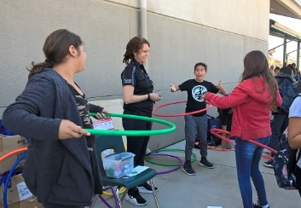
EFNEP helped Juanita Jones Elementary organize the first school health fair in April 2019, inviting other UCCE sister programs and county partners such as SB County Health Departments –Public Health and Oral Health & Superintendent of Schools to participate.
Students at Lincoln Elementary worked with UCCE Master Gardeners to plant radishes and lettuce in a garden cart, and learned about proper handwashing using Glo Germ during the food safety lesson with Youth EFNEP Educator.

4-H/Youth Development
During FY 2018/19, the San Bernardino 4-H program engaged 743 youth (aged 5 to 18) year-round with the support of 185 adult volunteers in ten 4-H Community Clubs. These clubs offered 68 educational projects in the cities of Barstow, Bloomington, Chino, Hesperia (3), Hinkley, Pinon Hills, Victorville and Yucca Valley. Each educational project provided at least 6 hours of instructions to youth in their communities by caring adults that are experts in one or more of the following areas:

- Animals
- Biological Sciences
- Civic Engagement
- Communication and Expressive Arts
- Community Service
- Consumer and Family Science
- Environmental Education
- Health
- Leadership
- Personal Development
- Personal Safety
- Physical Sciences
- Plant Science
- Technology and Engineering

Furthermore, 4-H members completed 34 community service projects. The depth and breadth of the 4-H program experiences allow youth in San Bernardino County to grow as capable, competent, caring and contributing citizens.

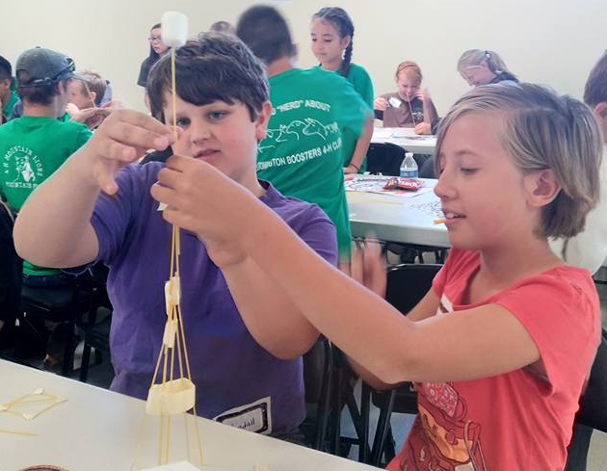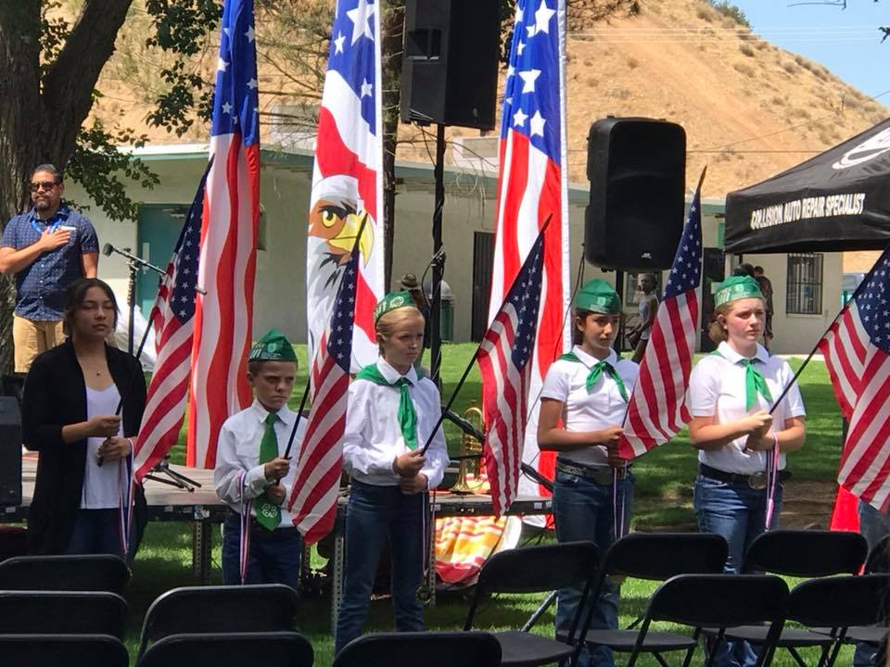
Additionally, 4-H served 462 youth through the 4-H Military Afterschool Clubs at Ft. Irwin and a summer day camp at Juanita Blakely Jones Elementary School and provided enrichment activities for the public in the San Bernardino County Museum ‘Sheep to Shawl’ and ‘Old West Days’ in partnership with San Bernardino County Museums.

The University of California 4‐H Youth Development Program presence in the county helps San Bernardino County youth reach their fullest potential by providing multiple meaningful engagement opportunities for youth to learn life skills such as leadership, teamwork and public speaking. Data corroborate that youth who participate in 4-H are 25 percent more likely to contribute to their families, themselves, and their communities; far more likely to attend college or trade school; and 41 percent less likely to engage in risk/problem behaviors than unexposed youth.

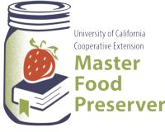
Master Food Preserver Program
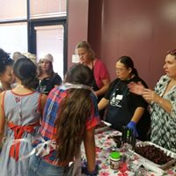
46 Volunteers
2,925 Volunteer Hours
$74,382 in Community Services

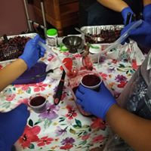
Master Food Preserver (MFP) volunteers provided research-based information on food safety and home preservation methods to hundreds of county residents after completing an 18-week class taught by experts. In addition to traditional safety and preservation topics, MFPs offered public classes on topics such as Gifts from the Kitchen, Grow and Preserve, Pickling and Jam Making. Education provided by the MFPs encouraged the public to engage in safe preservation practices and introduces ideas that may never have never considered regarding reducing food waste and improving food safety and preservation practices. Classes were held throughout the county including at several San Bernardino County Regional Libraries in partnership with the Master Gardeners. These classes allowed attendees opportunities to both observe and ask questions, with a favorite part being an opportunity to taste the delicious samples provided!

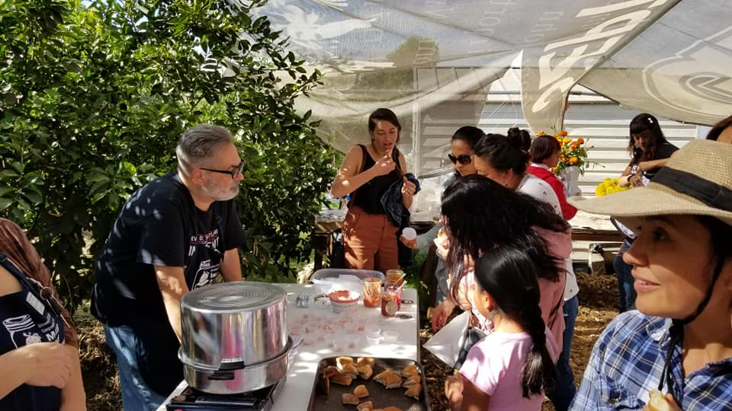

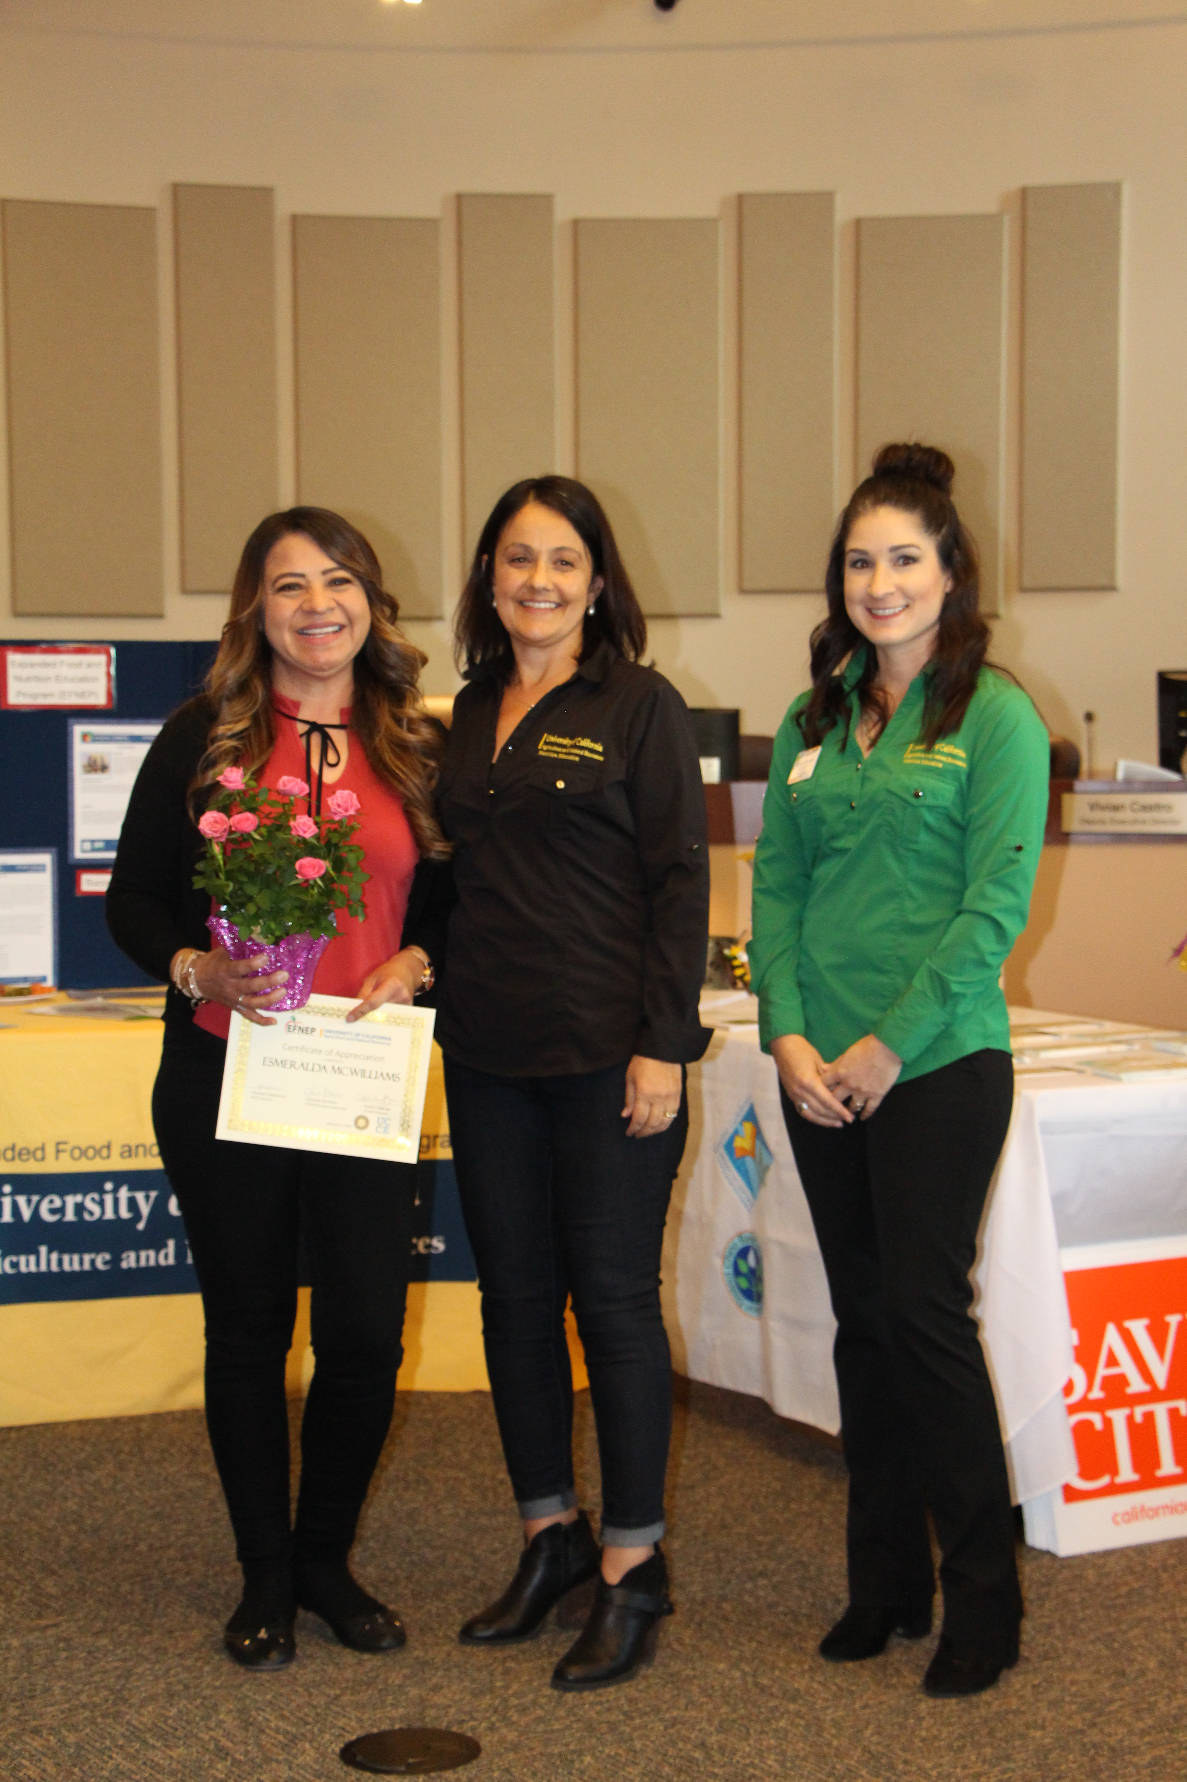
Recognizing our Master Gardener, Master Food Preserver, 4-H and EFNEP Volunteers
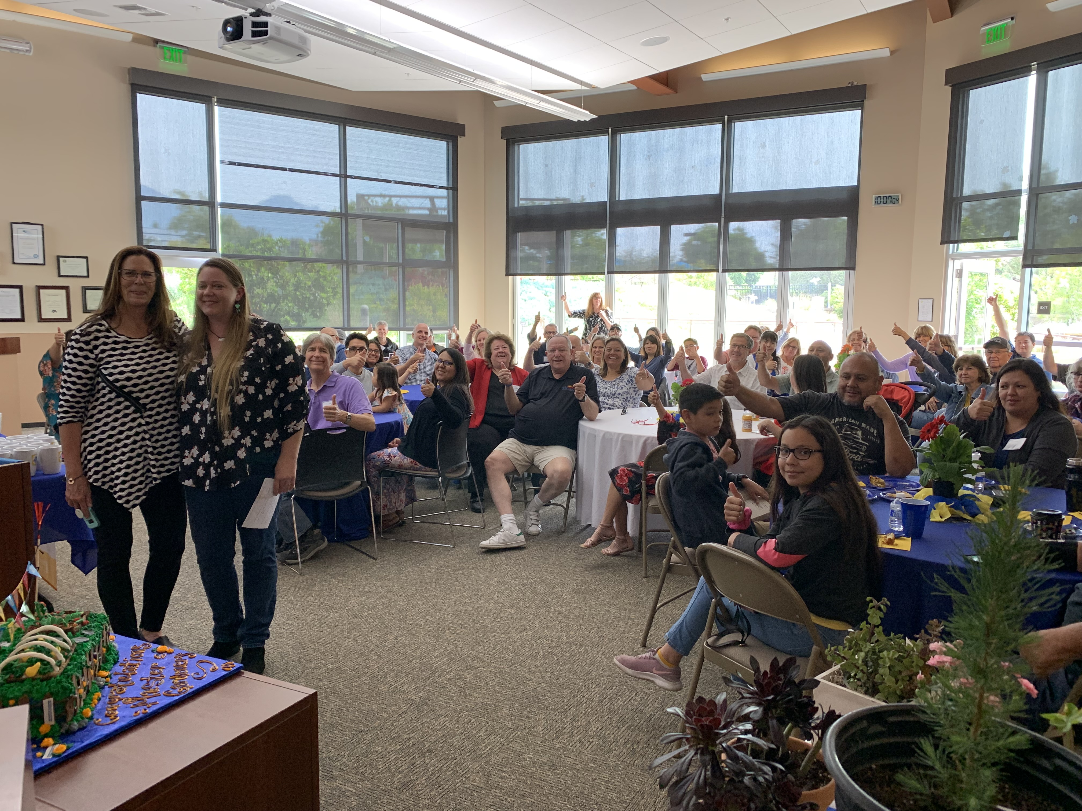

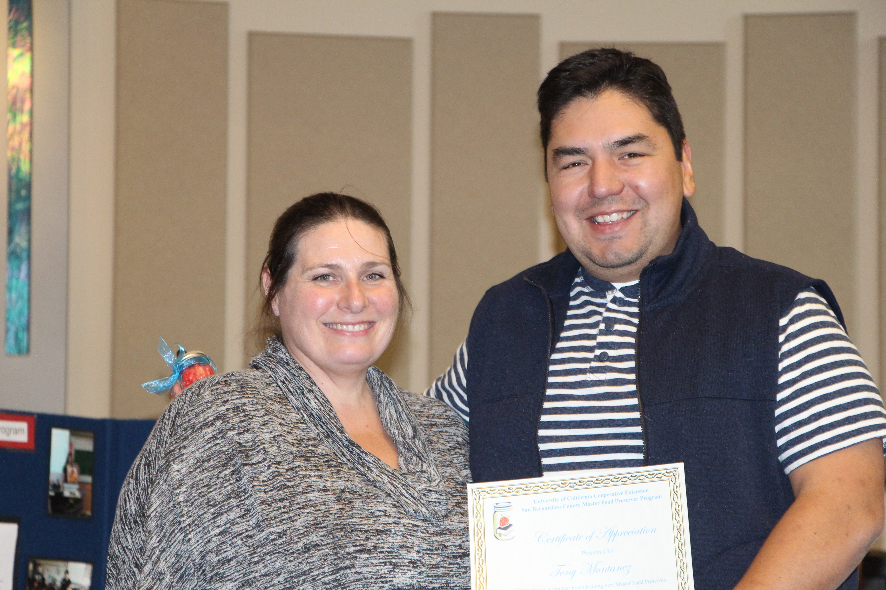

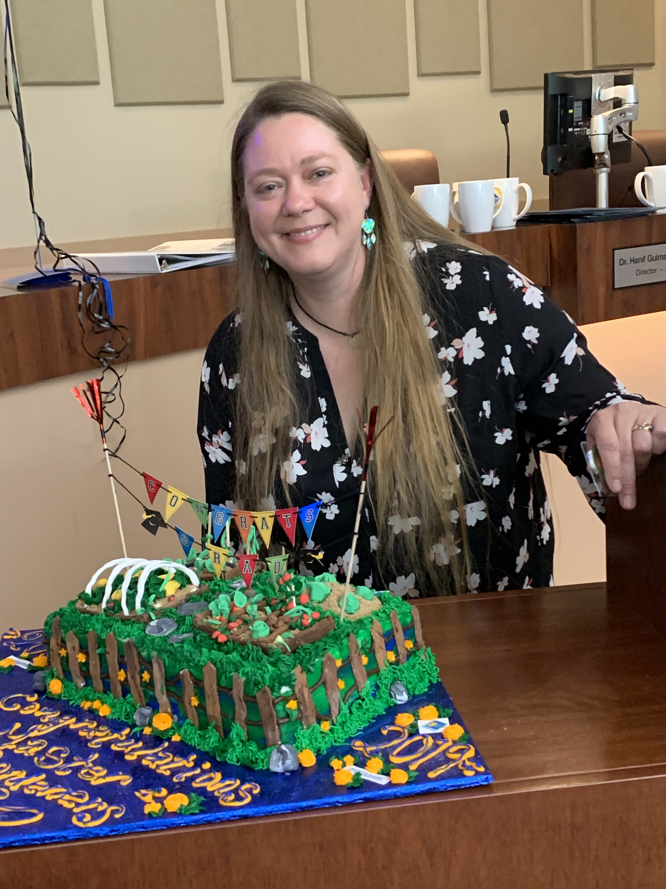
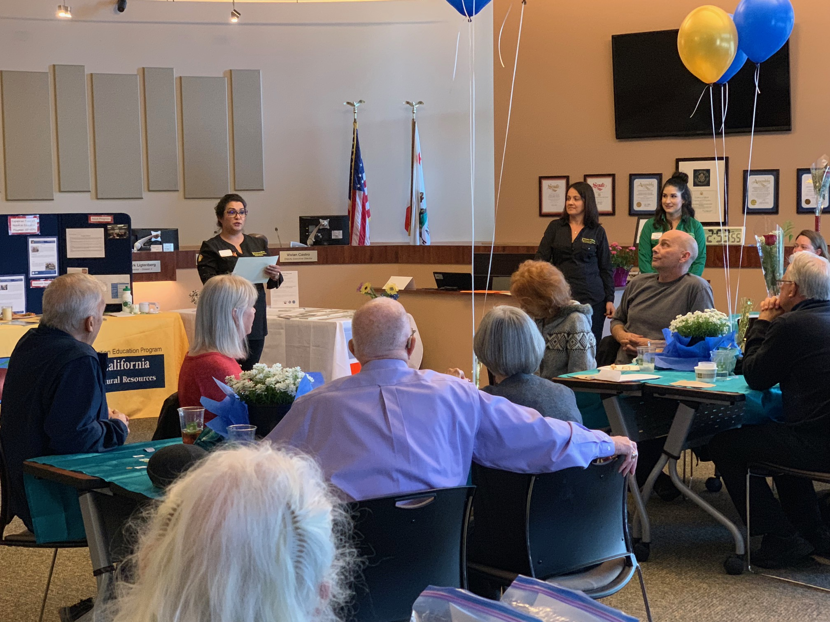

Environmental Horticulture Program

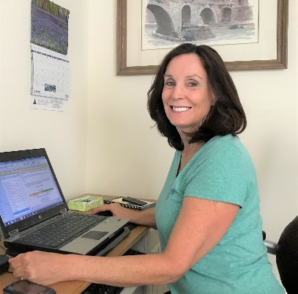
- Presented 28 workshops, seminars, and classes on sustainable, drought tolerant landscapes and integrated pest management to over 1,500 public and private landscape professionals, Master Gardeners, and residents of San Bernardino County.
Janet Hartin, Environmental Horticulture Program Advisor
- Organized, presided over, and spoke on climate-ready landscapes at the American Society for Horticultural Science annual conference.
- Serve as a project leader on timely research examining several new species of drought tolerant, climate resilient trees suitable for urban heat islands.
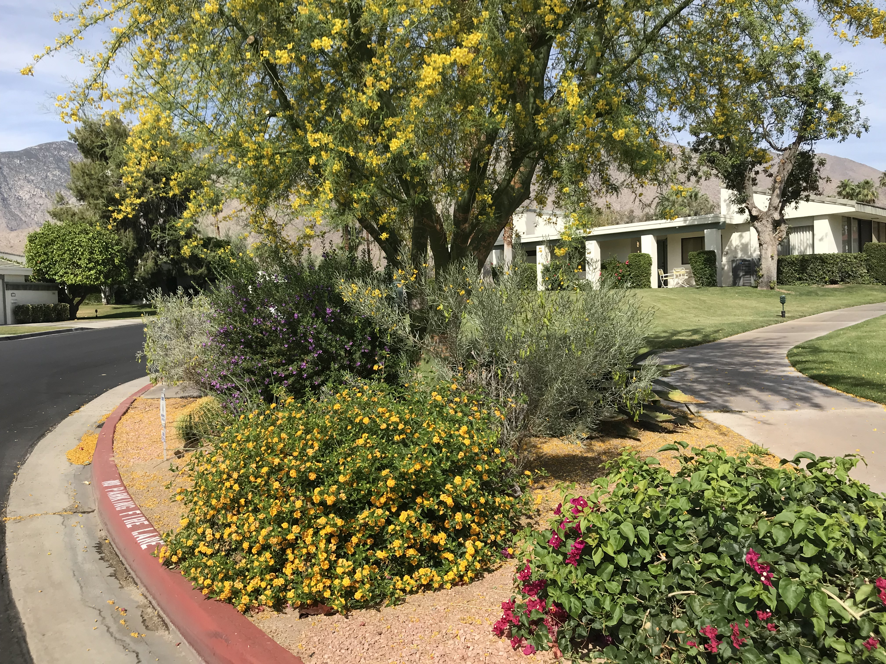
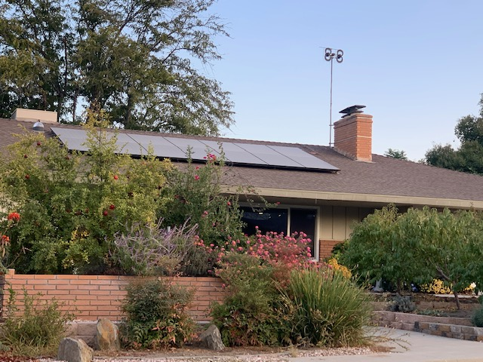
- Provide management and oversight of the Master Gardener program.
Water Conservation in Urban Landscapes
Conserving water in urban landscapes in San Bernardino County is important due to a limited water supply, recurring drought, and an increasing urban population. Prior to legislation that mandated water conservation, about one-half of the potable water used in urban setting and up to 60 percent of sprinkler-applied water was lost to runoff, drainage below root zones, and soil evaporation.

UC Cooperative Extension Environmental Horticulture Advisor Hartin has been heavily involved urban landscape water conservation legislation and education. Her work, funded largely by the California Department of Water Resources, determined that the majority of landscape water waste (60 - 80%) is due to irrigation system design and operational malfunctions coupled with applying the wrong amount of water to landscape plants. Only improper rather than water-guzzling plants. Far less than one-half of water conservation goals can be met by simply selecting drought-tolerant plants without correcting major causes of water waste. Janet shared specific ways to improve the health of landscape plants and conserve water to more than 1,500 professional arborists, public and private landscapers, Master Gardeners, and county residents.
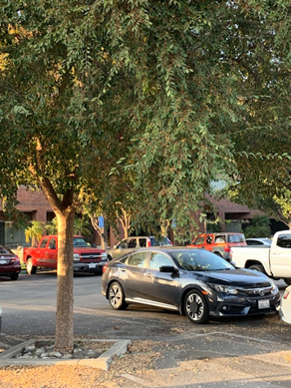
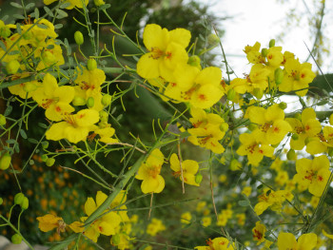
‘Desert Museum’ Palo verde (above) is an underplanted tree species in the inland valley that is included in our ‘Climate-Ready’ study designed to expand the palette of trees that can withstand harsh urban heat islands. It is also one of four species of trees included in a second study to evaluate the potential for applications of mulch around the trees to reduce soil evaporation, control weeds, and improve tree growth and health. That study is at the Chino Basin Water Conservation District in Montclair.
Trees for Tomorrow: Reducing the Impacts of Urban Heat Islands

Landscape trees reduce the temperature of asphalt parking lots and other urban heat islands, save energy and reduce cooling costs by shading buildings, beautify our communities and improve property values, and clean our environment by storing carbon dioxide emitted from vehicles and other producers of fossil fuels. Planning today for tomorrow by expanding the palette of trees that can withstand harsh urban environments is important.

To make this a reality, Janet Hartin regularly speaks to professional trade organizations as well as Master Gardeners and home-owners throughout the county on recommended native and climate adapted non-native tree species and the importance of increasing tree canopies (that now average around only 8-10% in many communities) to 20% or greater to maximize the benefits of urban trees.

Janet and colleagues from UCCE and the U.S. Forest Service are also partnering on a 20-year research study to expand the palette of drought-adapted, urban heat island adapted trees. A second study is documenting the benefits of applying organic mulches around landscape trees. Findings indicate that these mulches save water by reducing soil evaporation and reduce weeds. Many species of trees receiving the mulch treatments are also larger than their counterparts which are not mulched.
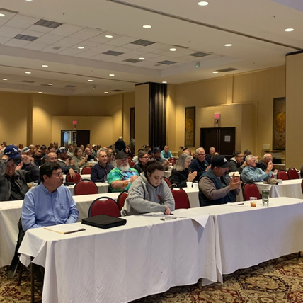
Janet Hartin conducts research on which tree species best withstand urban heat islands (left) and presented information on sustainable, drought tolerant landscapes to over 1,500 professional landscapers, Master Gardeners, and homeowners throughout San Bernardino County (right).

Natural Resource Management Program

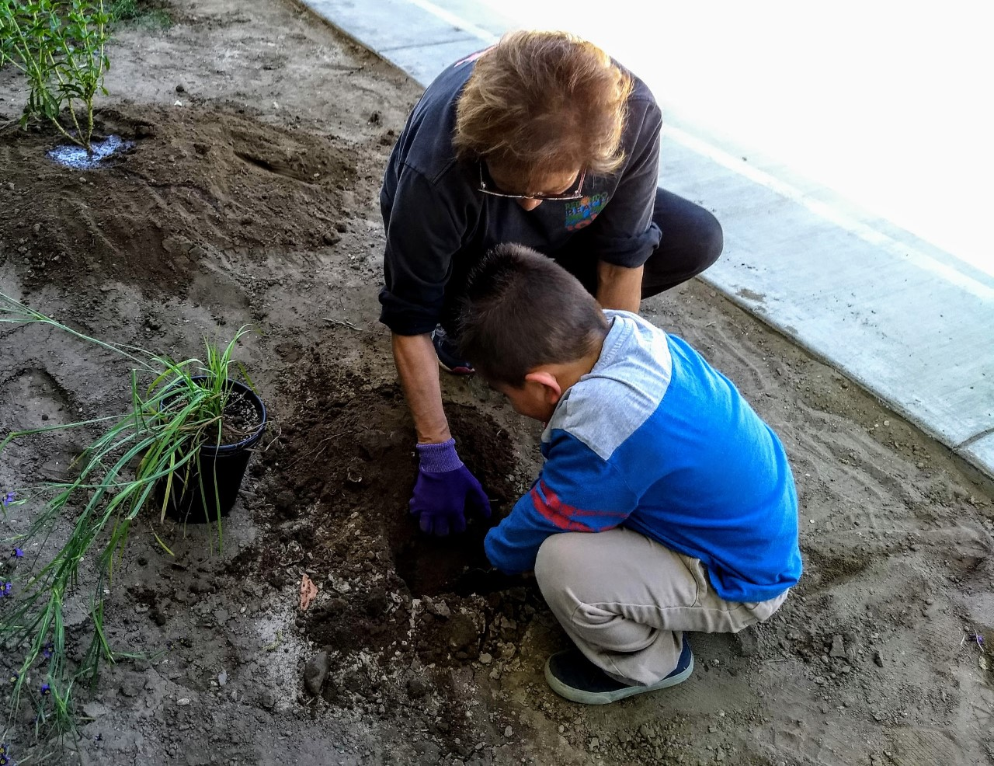
Our Natural Resource Program provides forestry, wildlife, watershed management and other natural resources related information to a wide variety of county residents and visitors. The goal is to promote sound management and conservation of the region’s natural resources, through research, educational activities, and building relationships with a broad range of users. We partner with private landowners; resource management professionals working on private, State and Federal lands; and other groups such as users of public lands, and conservation organizations. The Natural Resources Program works to ensure our lands will provide benefits for generations to come.
Elementary student working on gardening activities
The Natural Resources Program worked with the county on several land management issues. The Natural Resources Program partnered with the Department of Agriculture, Weights and Measures to reduce the population of the invasive yellow star thistle in the west end of the county. This invasive plant is abundant in Northern California and has yet to gain a significant foothold in San Bernardino County, our efforts can help to reduce its spread. The program also has begun a partnership with Regional Parks to develop improved habitat restoration plans.
The natural resource advisor has also started a new environmental education program. Through this program county residents receive information about increasing resource conservation at a variety of events and locations. Educational activities include: teaching residents about resource conservation through gardening and home food preservation, giving presentations at Earth Day events, and teaching residents how to make seed paper. The environmental education program reached over 3,000 residents this fiscal year!
Project leads planning a school vegetable and pollinator garden.

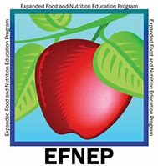
Reaching out Through UCCE Teamwork

‘Game On’ Health Fair
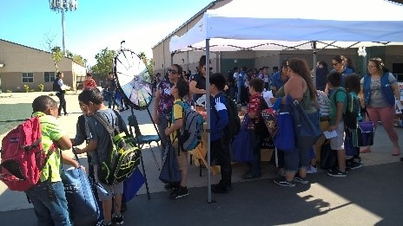
Juanita Blakely Jones, an elementary school in the city of San Bernardino, has been taking steps to improve the health of students and their families. After receiving the ‘Game On’ grant from Action of Healthy Kids whose goal is to help improve the overall health of students through promotion of physical activity and nutrition education, the principal and teachers worked together with UCCE’s Master Gardeners and Expanded Food and Nutrition Education Program (EFNEP) to improve the lives of students and families. After helping implement a garden the previous year, raised beds were built to continue promoting gardening and health education. Sadly, the garden was vandalized multiple times during the beginning of the year leaving the students and staff discouraged. However, everyone banded together to remedy the situation and boost morale. Youth EFNEP worked with 1st, 2nd and 3rd grade students providing nutrition education. The adult program worked with parents to provide a series of nutrition classes. Parents were excited to learn new healthy recipes to share with their families and started to incorporate physical activity with the walking DVD.

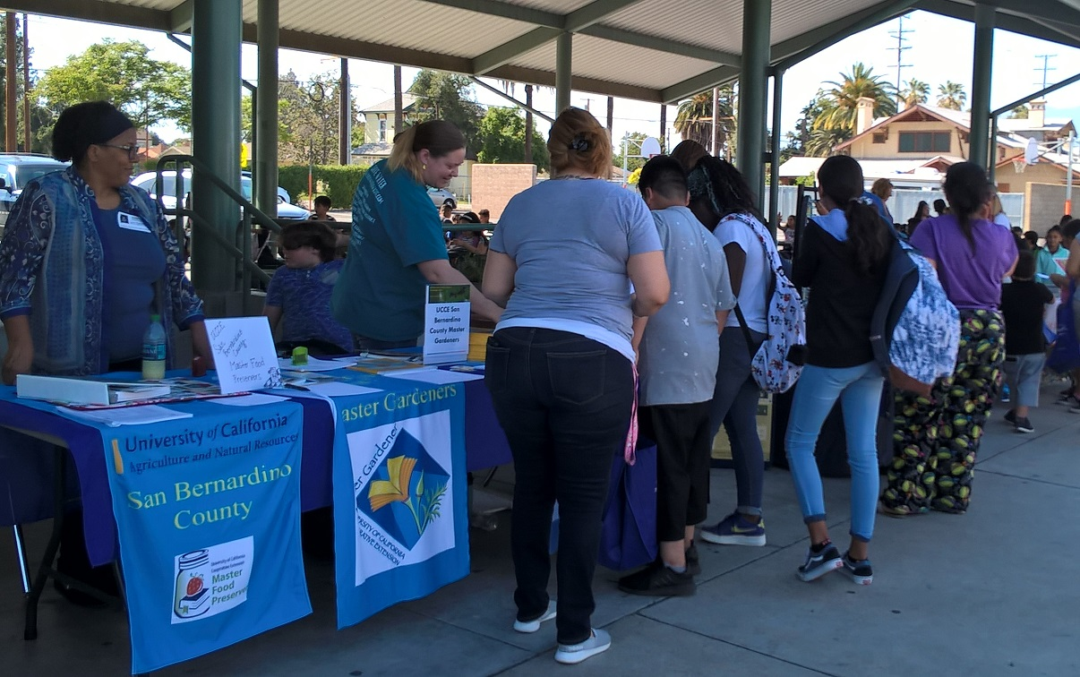
In the spring, EFNEP helped organize the first health fair after school by bringing community partners together. An estimated 250 students as well as parents were in attendance. All students received a passport that was stamped by each vendor as they visited the various booths learning about living a healthy lifestyle. The San Bernardino County Department of Public Health held a ‘Rethink Your Drink’ booth to encourage families to reduce consumption of sugar sweetened beverages. The Department of Public Health Oral Health Program staffed a booth demonstrating proper tooth brushing and oral care techniques. Loma Linda University’s Dental Health Clinic also promoted dental hygiene. The San Bernardino Superintendent of Schools held a booth to promote MyPlate and nutrition. UCCE Master Gardeners brought worms to the delight of students to teach them all about composting, UCCE Master Food Preservers brought fruit leather samples, and UCCE EFNEP engaged students in growing vegetables from seeds. The school staff offered other booths with fun exercises including tricycle races, ring tosses and a hula hoop contest. A highlight of the afternoon was the opportunity to make a smoothie on the infamous smoothie bike. Students lined up to take turns pedaling the bike. All students were entered into a raffle for three bikes to encourage physical activity. Students went home with non-perishable food items provided by Tzu Chi Foundation. In addition, families participating in both the youth and adult EFNEP program were recognized for their dedication to learning about living a healthy lifestyle at the ‘Game On’ Health Fair event. The families went home with a certificate of recognition from EFNEP and a spinning globe from the school principal.

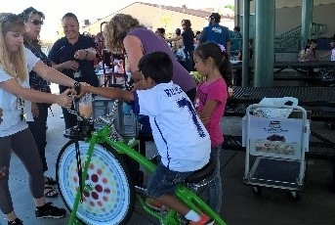

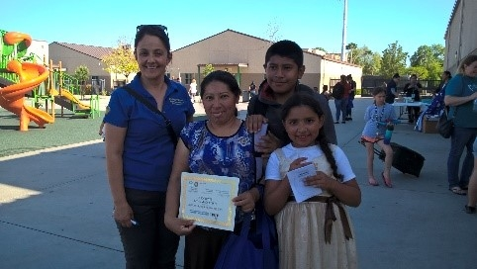

UCCE San Bernardino County Brings Enrichment Activities to Hesperia USD Summer Meals

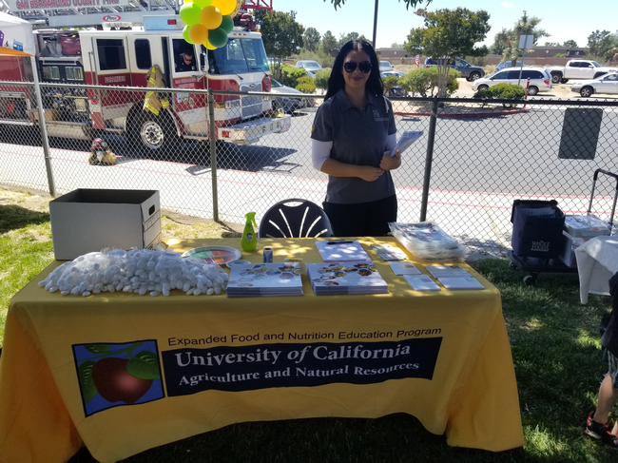
The National School Lunch Program provides nutritionally balanced free and reduced-price lunches to children of low income families in need. Summer can be difficult for those families since not all children receive healthy meals when school is out. The summer meal program helps to alleviate the stress of feeding children nutritionally during the summer break.
Hesperia Unified School District is one of many districts in San Bernardino county that provides summer meals. The district Food and Nutrition Services started the summer with an exciting kick off lunch at Topaz Elementary, one of the meal sites. Over 300 children were served a nutritious meal and were provided enrichment activities for the whole family to enjoy.
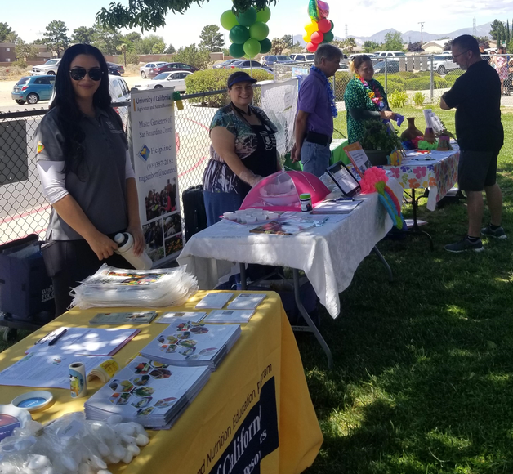
All four UCCE programs were represented at the kick off event, providing information and activities for families on growing, preserving and eating more produce and adopting a healthy lifestyle. EFNEP distributed recipe cards, cutting boards and calendars for parents and signed parents up for the ‘UCCE Connects to You’ distance learning pilot program. Children were given gardening gloves that contained vegetable seeds to grow at home from the ‘Happy Healthy Me’ curriculum. UCCE Master Gardeners demonstrated how to grow herbs in small spaces and vermicomposting with worms as well as promoted the Master Gardener helpline and adult volunteer program. 4-H brought a live rabbit for children to pet, the ‘Living Desert’ sensory station and the ‘Signs of Animals Present in the Forest’ station. UCCE Master Food Preservers promoted their public classes and had a tropical freezer jam tasting, it was a hit!

University of California Cooperative Extension
777 E. Rialto Avenue
San Bernardino, CA 92415
Website: http://cesanbernardino.ucanr.edu

Mission: To develop and extend research based-information on home
horticulture and gardening, 4-H/youth development, natural resource management, urban forestry/sustainable landscaping, livestock management, food and nutrition, agronomy and field crop production, and food safety and preservation to the workforce and residents of San Bernardino County.

County Co-Directors:
Janet Hartin, Email: jshartin@ucanr.edu Ph: (951) 313-2023
Chris McDonald, Email: Cjmcdonald@ucanr.edu Ph: (909) 387-2242

Office Manager: Robin Rowe, Email: rjrowe@ucanr.edu Ph: (909) 387-2171

Master Gardener/Environmental Education Coordinator: Margaret O’Neill, Email: magoneill@ucanr.edu Ph: (909)766-4058

Master Gardener Helpline: Email: mgsanbern@ucanr.edu Ph: (909) 387-2182

4-H/Youth Development: Claudia Diaz-Carrasco, Email: cpdiaz@ucanr.edu
Ph: (951)683-6491 x 222, Stephanie Barrett, Email: slbarrett@ucanr.edu Ph: (909) 387-2179

Master Food Preserver Coordinator: Dee Denton, Email: djdenton@ucanr.edu
Ph: (909) 387-2194

Expanded Food and Nutrition Education Program (EFNEP): Christine Davidson, Email: cjdavidson@ucanr.edu Ph: (909) 387-2193, Chutima Ganthavorn, Email: cganthavorn@ucanr.edu Ph: (951)683-6491 x 223

Sustainable Landscaping/Urban Forestry: Janet Hartin, Email: jshartin@ucanr.edu
Ph: (951) 313-2023

Natural Resource Management: Email: Christopher McDonald, cjmcdonald@ucanr.edu Ph: (909) 387-2242

Livestock/Animal Husbandry: Brooke Latack, Email: Bclatack@ucanr.edu
Ph: (442) 265-7700

High Desert Agronomy/Field Crops/Irrigation Management: Andre Biscaro, Email: asbiscaro@ucanr.edu Ph: (805)645-1465

UC Cooperative Extension San Bernardino Program Impacts
Master Gardener Course Survey Results
- 92% of Master Gardeners indicated that training on landscape water conservation would ‘very likely’ or ‘with certainly’ enhance their ability to help county residents save water
- 92% of Master Gardeners indicated that training on selection and care of landscape trees would ‘very likely’ or ‘with certainly’ enhance their ability to help county residents properly select and care for landscape trees
- 92% of Master Gardeners indicated that training on integrated pest management would ‘very likely’ or ‘with certainly’ enhance their ability to help county residents incorporate practices that reduce overreliance on pesticides
- 92% of Master Gardeners indicated that training on weeds and invasive species identification and control would ‘very likely’ or ‘with certainly’ enhance their ability to help county residents reduce populations of weeds and invasive species
- 90% of Master Gardeners indicated that training on selection and care of fruit trees would ‘very likely’ or ‘with certainly’ enhance their ability to help county residents properly select and care for fruit trees
- 90% of Master Gardeners indicated that training on vegetable selection and care would ‘very likely’ or ‘with certainly’ enhance their ability to help county residents properly select and care for vegetables in home, school, and community gardens
Arborists/Landscape Contractors Seminars/Workshops Survey Results
- 93% of arborists and landscapers indicated that training received on landscape tree selection and care would ‘definitely’ lead to adoption/improvement in at least one recommended practice
- 90% of arborists and landscapers indicated that training received on working with planners and public works directors to increase tree canopies to 25% to cool urban heat islands would ‘definitely’ lead to adoption/improvements in at least one recommended practice

