SECRETARY'S
BOOK
For 4-H in
California

President: ___________________________________

Secretary: ___________________________________

Kings County

___________________________4-H Club

Community Leader(s): _______________________________

__________________________________________________

Club Year: ______________________

TIPS TO HELP YOU AS SECRETARY

Study the 4-H Secretary's Book as soon as you receive it.

At the beginning of the year, record property on hand and money on hand (from the treasurer's report or last year's 4-H Secretary's Book), and list 4-H leaders and 4-H members.

When the yearly program is planned, complete "Calendar of Meetings and Events” and "Meeting Plan for the Year."

Write up the minutes right after each meeting. See sample minutes on pages in this book.

Be accurate with names, motions, places, dates, etc.

After each meeting bring the 4-H Secretary's Book up to date:
- Summary of treasurer's report
- Roll call
- Additions and/or corrections to previous meeting's minutes
- Reports of events
- Purchase of equipment

*Answer letters right away.

Sit at a table in front with the president.

Stand when reading minutes.

Let the president and organization leader know if you must miss a meeting. See that the 4-H Secretary's Book gets to the meeting. As soon as you can, after the meeting, check with the secretary pro tem to make sure the minutes were recorded and signed and that you have all the information you need to bring the 4-H Secretary's Book up to date.

Work closely with the 4-H president and the 4-H leader. Ask for help when you need it.

Be friendly, courteous, on time and dependable!

*If your group has a correspondence secretary, this is their responsibility.
.
YOU, THE 4-H SECRETARY

The 4-H officers cooperate with the organization leader to.guide the group program meetings, events, project work, and participation in county events-so that each 4-H member learns something and has a happy, satisfying experience.

The position of secretary is as important as any other office and carries more responsibility than most. At the end of the 4-H year, the 4-H Secretary's Book becomes a permanent historical record for your group for the year.

As secretary, it is your job to:

- Keep minutes of all business meetings
- Take roll and keep a record of attendance
- Report to the president the old business to come before the 4-H
Meeting. (This is found in previous meeting's minutes)
- Advise president on matters of business for the 4-H members' action
- At the president's request, read the motion as stated
- *Read correspondence received
- *Write all letters required for the group's business
- When the president and vice president are absent, call meeting to order
to elect a temporary chairperson
- Record all committee assignments
- Collect and record reports of all committees
- Collect and record reports of all 4-H events
- Send required reports to county Extension office
- Complete the 4-H Secretary's Book at the close of the 4-H year.

As an officer, it is your job to help:

- Plan the year's program
- Plan and arrange for 4-H meetings
- Start and close meetings on time
- Keep members informed of new things in 4-H work
- Develop a public relations program to inform community about 4-H work
- Represent your club at special occasions
- Contact other youth groups in the community like FFA, Scouts, and others
- Keep in touch with the 4-H Youth advisors
- Help new members get started
- Be hospitable to parents and visitors at meetings and events.

*If your group has a correspondence secretary, this is their responsibility.

SAMPLE 4-H CLUB BYLAWS FOR KINGS COUNTY, CA
(? ARE FOR AREAS THAT CLUBS CAN CHANGE.)

- NAME: The name of this club shall be _________________________________ 4-H Club.

- PURPOSE: The purpose of this club is to aid in the development of its members through project work, club meetings, demonstrations, judging, community service, club and county events and other activities.

- MEMBERSHIP: Any boy or girl who is in the 4th grade or above or at least nine before January 1 of the current club year, and is not nineteen before January 1 of the current club year shall be eligible for regular 4-H membership. For those who are home schooled, only the age will be considered. Youth remain eligible for membership until the end of the calendar year in which they turn nineteen years old.
?
  - Youth are eligible to participate in 4-H as Primary Members if they are 5 years old or in kindergarten as of January 1 of the program year. They pay the 4-H program fee. The only approved animal projects for Primary Members are dogs, rabbits, rats, cats, poultry, cavies, mice, embryology, entomology, marine science, pygmy goats and therapeutic animal projects. They are not eligible to participate in activities beyond the club level, unless specific provisions are made for them by the event planners. They do not participate in county awards programs or keep record books.
Clubs may choose not to have Primary Members

  - Primary Members may receive participation recognition only. Structured competition, including the use of the American and Danish Systems of judging, is not permitted for Primary Members.

  - Membership is open to all youth without regard to race, creed, religion, national origin, or mental or physical handicap.
?

  - Membership for members enrolled in a Kings County 4-H Club during the previous year shall close on ___________________.

?
  - New members may join until ____________________.

  - Members transferring from other counties and states will be accepted at any time.

?
- VOTING: Only enrolled members (not Primary Members) of the club shall have a vote in matters before the club.

?
- OFFICERS: The officers of this club shall be president, vice-president, secretary, treasurer, reporter, song leader and recreation leader(s), and sergeant(s)-at-arms.

?
- MEETINGS: There shall be at least ____ meetings of the club each year.

?
- ELECTION OF OFFICERS: The officers shall be elected at the _________________________ meeting each year.
  - VACANCY: If an officer is no longer a member of the club, the president can appoint someone to fill the vacancy until the next election with the approval of the club and the Community Club Leader
Clubs may adjust specific duties as necessary
- DUTIES OF OFFICERS: The president shall preside at all meetings of the club and have in mind at all times the best interests of the club. S/he may call special meetings with the consent of the Community Club Leader.

  - The vice-president shall perform the duties of the president in the absence of the president. S/he shall serve as chair of the yearly program committee.

  - The secretary shall keep minutes of all club meetings, act as a club correspondent, and keep a correct enrollment of club members. At the end of the club year, the secretary and the Community Club Leader will submit a year-end club report to the county Cooperative Extension office.

  - The treasurer shall receive and keep all money belonging to the club and shall pay it out upon order of the president, after club action. S/he shall keep an accurate record of all money received and paid out and provide an accurate monthly report to the secretary for inclusion in the minutes. S/he shall assist the secretary and club leader with the year-end financial summary.

  - The reporter shall write a news report of special activities in the club and submit it to local news media and the Cooperative Extension office.

  - The song and recreation leader(s) shall be responsible for the singing and recreational activities at club meetings and events.

  - The sergeant(s)-at-arms shall set-up the meeting room before each meeting and maintain order during club meetings.

?
  - (other officers?)

?
- NOMINATIONS AND ELECTIONS: Officers shall be elected at the _____________________ meeting and shall assume office at the _____________________ meeting.

?
  - Nominations shall be limited to three persons for each office.

  - Officers may hold any one office for no more than two years in succession.
?

  - Officers shall be responsible for all club materials in their possession. Outgoing officers shall present materials pertaining to their office to incoming officers.

- COMMITTEES: Committees will be appointed by the president and shall consist of a leader and at least two members.

- AUDIT: An annual audit of the treasurer's records is to take place at the end of each club year by a committee appointed by the president in accordance with the instructions provided by the Kings County UC Cooperative Extension Office and an audit report filed with the office by the due date each year.

- MEETINGS: The regular meeting of the club shall take place on the ___________ ____________ of each month with the exception of the month(s) of _________________________. Special meetings may be called by the president with the consent of the Community Club Leader.
?
?
- QUORUM: A quorum shall consist of a majority (50% plus one member) of the membership. A quorum shall be required at a club meeting to conduct club business.

- PROGRAM OF WORK: A written plan of work for the year shall be adopted not later than the third meeting of the club year and submitted to the UC Cooperative Extension Office

- MEMBERSHIP FEES: No fee for membership will be collected except for the Program Fee specified by Cooperative Extension each year.

- ATTENDANCE: Members missing ______ or more club meetings without a valid excuse shall be expelled from the club for the remainder of the club year. To be excused, a member must _____________________

- ROLE OF PARENTS: Parents are welcome, encouraged and expected to attend community club meetings. Should parental attendance not be possible, parents must designate another adult to supervise the member at the meeting and the parents must make arrangements for the member's timely transportation to and from the meeting.
?
3 meetings are required by
?
UC Cooperative Extension

- PROJECT GROUPS: Cooperative Extension requires that an adult 4-H leader be assigned to each project offered by the club and that there shall be at least three project meetings between July 1 and June 30, however, a minimum of six meetings during the entire club year is recommended by the Cooperative Extension office. The size of project groups and the requirements for meeting attendance and completion shall be determined by the project leader and communicated to members and their parents at the beginning of the club year.

?
- GUESTS: A club member may bring a guest to a club meeting, project meeting or club activity only with the approval of the Community Club Leader, president and/or project leader.

- CODE OF CONDUCT: Reasonable conduct is expected from 4-H members at all times. Obscene language, rough-housing, and insubordination will not be tolerated. The possession and use of alcoholic beverages, drugs or tobacco (for those under 18) by 4-H members is prohibited. The 4-H Code of Conduct available at the Extension Office will be in effect for all trips.

- AMENDMENTS:

  - These by-laws may be amended by a majority vote of the members present at a regularly scheduled meeting after discussion at a previous regular meeting or after the proposed changes have been mailed to all members and leaders at least one week before the meeting at which the vote is to occur. Changes in the by-laws must be immediately reported to the county Cooperative Extension office and are subject to staff approval.

  - All members shall receive a copy of the by-laws after they are amended. All new members shall receive a copy at the time of enrollment.

Instructions

Appoint a by-law committee to review the by-laws. Have the committee recommend changes to these pages, especially where there is a ? in the right margin. Write those changes in the margin or on the back and submit them to the club membership as described in #21 above. You may wish to review possible changes with the 4-H Youth Development Advisor before submitting changes to the membership. Once the club has voted, submit a final draft to the Cooperative Extension Office for approval. The office will maintain the by-laws in the computer and print a clean copy for the club.

These by-laws were adopted on ________________.

Signature of Club President ____________________________________

Signature of Community Club Leader _____________________________

Staff approval:_________________________________ Date:__________________.
4-H Youth Development Advisor
OFFICERS AND LEADERS

OFFICE | NAME | PHONE
President
Vice President
Secretary
Treasurer
Reporter
Historian
Sunshine Secretary
Sergeant at Arms
Sergeant at Arms
Song and Recreation Leader
Song and Recreation Leader

RESPONSIBILITY | FIRST NAME | LAST NAME | PHONE

MEETING PLAN FOR THE YEAR

Kings County 4-H Clubs

Use this guide to plan your club's monthly meetings for the year. Clubs wishing to earn seals for their club charters should submit their completed plan to the Cooperative Extension Office by November 1.

MONTH | BUSINESS | PROGRAM  Presentations, speakers, etc.
September
October

November

December

January

MONTH | BUSINESS | PROGRAM  Presentations, speakers, etc.
February
March

April

May

June

In accordance with applicable State and Federal laws and University policy, the University of California does not discriminate in any of its policies, procedures, or practices on the basis of race, religion, color, national origin, sex, marital status, sexual orientation, age, veteran status, medical condition, or handicap. Inquiries regarding the this policy may be addressed to the Affirmative Action Director, University of California, Agriculture and Natural Resources, 1111 Franklin Street, 6th Floor, Oakland, CA 94607-5200 (510) 987-0097
ROLL OF MEMBERS

PHONE | NAME | DATE OF MEETING |  |  |  |  |  |  |  |  |  | AGE  (AS OF Jan. 1) | PARENT
ROLL OF MEMBERS

PHONE | NAME | DATE OF MEETING |  |  |  |  |  |  |  |  |  | AGE  (AS OF Jan. 1) | PARENT

NEW MEMBERS

NAME | DATE ENROLLED

COMMITTEES

COMMITTEE | CHAIR(S) | MEMBERS

4-H CLUB MEETING MINUTES (Page 1 of 2)

The meeting of the 4-H Club

was called to order by (name and title)

At (time) On (date) At (location)

Flag salute and 4-H pledge led by:

Action on previous meeting’s minutes:

Treasurer’s Report (include expenditures since last meeting, income since last meeting, and current balance)

Correspondence:

Other Officers’ Reports:

4-H Council Report:

Committee Reports:

4-H CLUB MEETING MINUTES (Page 2 of 2)

Old Business:

New Business:

Announcements:

Next Meeting: Business Meeting Adjourned:

Program:

Recreation:

Date: Signed:

Correction and/or additions:

Date: Signed:

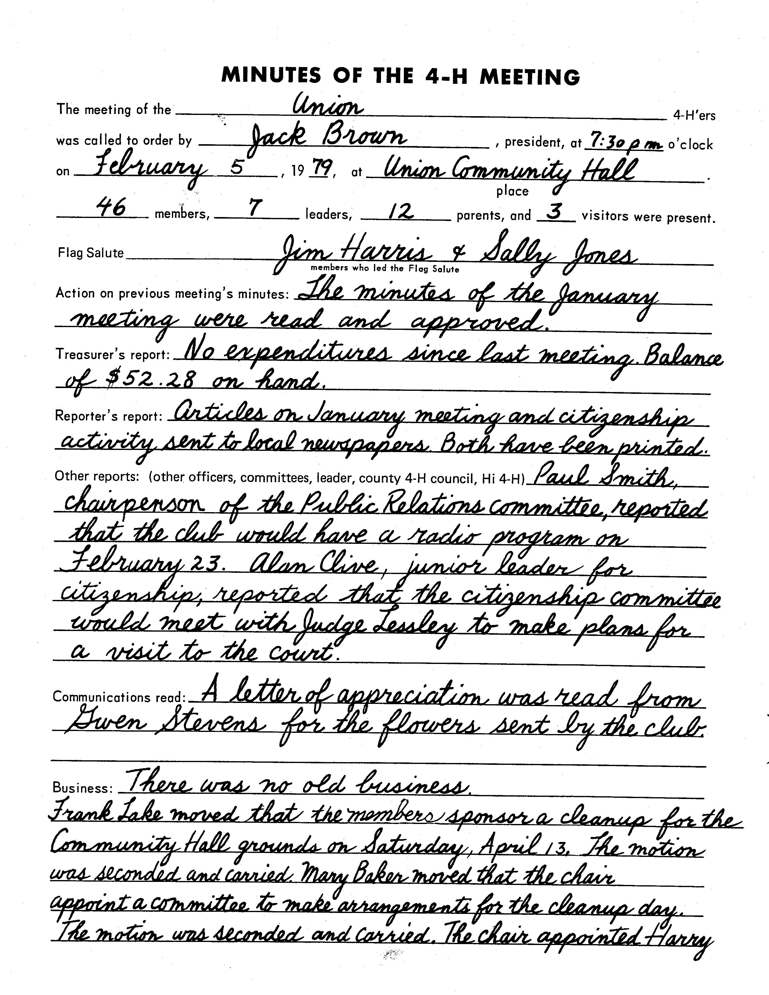

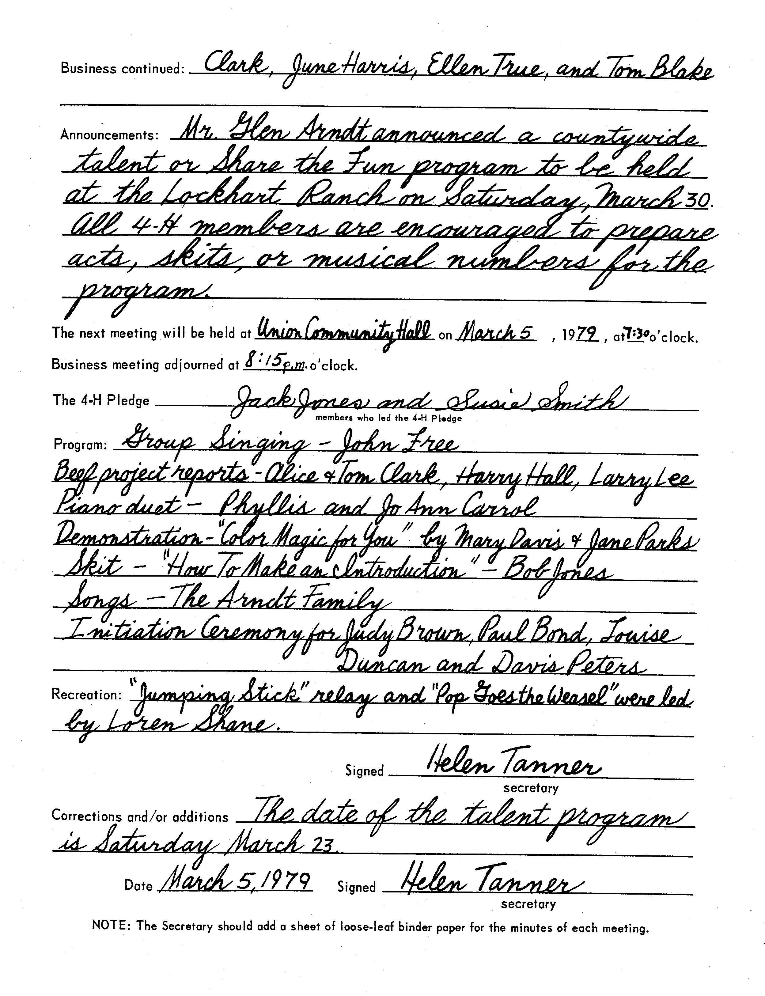

ANNUAL INVENTORY REPORT
CLUB NAME
LOCATION
DATE
Date Acquired | Item and Description | Dollar Value | Storage Location | Disposal (Date Disposed)
 |  | $0.00
 |  | $0.00
 |  | $0.00
 |  | $0.00
 |  | $0.00
 |  | $0.00
 |  | $0.00
 |  | $0.00
 |  | $0.00
 |  | $0.00
 |  | $0.00
 |  | $0.00
 |  | $0.00
 |  | $0.00
 |  | $0.00
 |  | $0.00
 |  | $0.00
 |  | $0.00
 |  | $0.00
 |  | $0.00
 |  | $0.00
 |  | $0.00
 | TOTAL INVENTORY VALUE | $0.00

ANNUAL FINANCIAL REPORT
COUNTY |  | TREASURER'S NAME
CLUB NAME |  | TREASURER'S PHONE
EIN |  | TREASURER'S EMAIL
Bank Account |  | Bank Account
[] Checking [] Savings [] Other |  | [] Checking [] Savings [] Other
Bank Name |  | Bank Name
Last 4 Digits of Account Number __________ |  | Last 4 Digits of Account Number __________
 |  | BALANCE AT THE END OF PREVIOUS YEAR | $0.00
MONTH | TOTAL INCOME | TOTAL EXPENSES | BALANCE
July | $0.00 | $0.00 | $0.00
August | $0.00 | $0.00 | $0.00
September | $0.00 | $0.00 | $0.00
October | $0.00 | $0.00 | $0.00
November | $0.00 | $0.00 | $0.00
December | $0.00 | $0.00 | $0.00
January | $0.00 | $0.00 | $0.00
February | $0.00 | $0.00 | $0.00
March | $0.00 | $0.00 | $0.00
April | $0.00 | $0.00 | $0.00
May | $0.00 | $0.00 | $0.00
June | $0.00 | $0.00 | $0.00
Total for the Year | $0.00 | $0.00 | $0.00
 |  | Inventory Total Value | $0.00
Please attach any comments to an additional page.

REPORT OF GROUP EVENTS

An event is a planned program with an educational purpose. It should be an opportunity for 4-H members to learn and/or to practice project and/or leadership skills. This could include field trips, picnics, camping, exhibit days, judging, demonstrations, tours - and you can add to the list.

The chairperson of the committee for each event should give the secretary a brief report. The information in the following list will give helpful suggestions to the committee planning the event next year.

- List chairperson and all committee members:

- Tell what was done, how it was done, etc,

- Include names, addresses, and phone numbers of all people contacted:

- Food (quantities, prices, number of people served, etc.)

- Location and facilities (who was contacted, where, what facilities were used)

Publicity (how publicized, special invitations, etc.)

- Decorations (what was used, costs, etc.)

- Program (who was contacted, when, for what)

- Budget, including all expenditures and income
Item | Expense

- Evaluation and suggestions (tell what helped make this event a success and, if it did not go as well as you expected, what hindered its success)

