UNIVERSITY OF CALIFORNIA COOPERATIVE EXTENSION

UC MASTER GARDENER PROGRAM
OF SAN LUIS OBISPO COUNTY

The UC Master Gardener Program is a public service and outreach program under the University of California Division of Agriculture and Natural Resources (UC ANR), administered locally by participating UC Cooperative Extension offices (UCCE). Our mission is to extend research based knowledge and information on home horticulture, pest management, and sustainable landscape practices to the residents of California.

WINTERIZE YOUR GARDEN
Ron Whisenand and Kim McCue, UC Master Gardeners
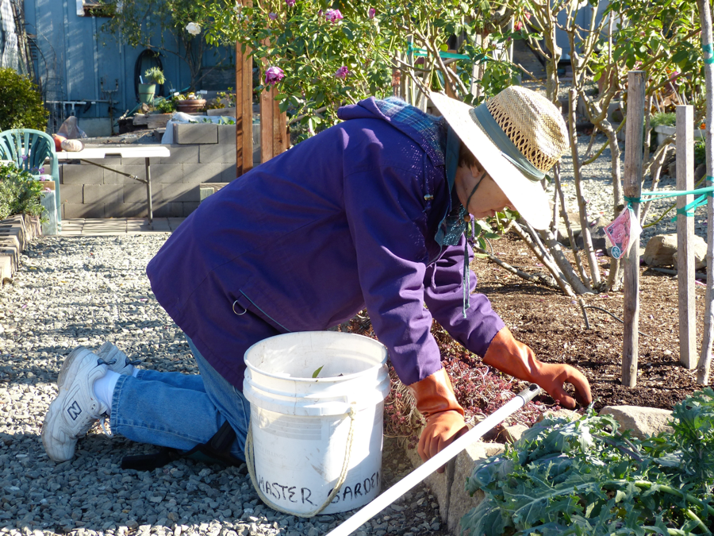
- Garden Care and Clean Up:
- Rake up leaves: leaf litter and mummified fruit can harbor disease and pests. This is especially important around fruit trees.
- Good Leaf Litter: Healthy oak leaf litter should be left alone.
- Spent Plants: Deadhead flowering shrubs like azalea and rhododendron. Herbaceous perennials can be cut to the ground or to a small mound, depending on the plant. Annuals and vegetables should be pulled out and discarded or composted

- Winter Lawn care:
- Lawn growth slows, especially in colder climates, and requires less frequent mowing. Lower mower height one position.
- Winter fertilizer: Cool season grasses, such as bluegrass, fine fescues, and ryegrass should be fertilized in fall and winter as they need 75% of their nitrogen this time of year. Warn season grasses need 50% of their food during the fall and winter.
- Rake up leaves since leaves block sunlight and can impact lawn health.

- Pruning Basics:
- Principal rules of pruning established plants is to remove dead, damaged, diseased or badly placed wood. Pruning keeps plants healthy and maintains a desirable size and form.
- Spring flowering plants that bloom on year old wood: prune after they flower. Plants that flower on new growth: prune while dormant.
- Dormancy is after leaf drop for deciduous shrubs and roses, usually mid-December to late January. Pruning techniques: pinching removes terminal growth; heading removes part of the shoot; and thinning eliminates the entire shoot. Use thinning cuts for deciduous or evergreen shrubs.
- Natives: prune to remove dead diseased or damaged wood, usually late winter or spring.
- Roses:
  - Repeat blooming climbers should be pruned in fall and single blooming ramblers after summer flowering.
  - Hybrid Teas: reduce them to a manageable 2 - 4 feet. Limit your selection of canes to 4 - 5 healthy, young canes for the largest, finer blooms. Prune small canes 4 - 6 inches from the graft, medium canes 8 - 12 inches from graft, and largest canes less than or equal to 2 - 3 feet or just above lowest bud.
  - Floribunda roses: Prune by cutting back the canes to 12-18 inches from the graft, leaving some twiggy growth. Thin the canes and reduce side shoots by 1/3 - 2/3 of their length.
  - Shrub and “old roses”: Minimum pruning is desirable and should be delayed until after flowering. Mature plants benefit from cleaning out dead, damaged, diseased or weak wood and cutting a few main stems to the base.
- Bulbs:
- Divide bulbs every 3-5 years. Locally, fall and winter are the best time to divide bulbs, after the leaves have withered.
- Gently pull the bulbs apart discarding diseased or unhealthy material. Replant them immediately or store in a cool dark place such as a garage.
- Fall and early winter is the best time to plant hearty bulbs: tulips, daffodils, iris, crocus and lilies. Tender bulbs such as dahlia, begonias, and gladiolus should be planted in spring.

- Vegetable Gardening:
- Cold winter areas of SLO county: November is too late to plant seeds in North County. It’s typically too cold in north county for tender lettuce to survive.
- Mild winter areas of the county: In sunny plots, sow beets, carrots, onions, peas, chard, onions, radishes and turnips from seed. Salad greens may grow in mild coastal areas.
- Cold and mild winter areas of the county: Plant starts for slower developing broccoli, cabbage and cauliflower. Add color with ornamentals – stock, cyclamen, pansies, ornamental kale/cabbage, etc.
- If not growing winter vegetables this year, consider a cover crop of clover, fava beans, rye or vetch to enrich the soil for next season’s veggies.

- Winter Irrigation:
- Watering can be reduced. Test soil moisture periodically during dry cool winter months. Water if soil is dry 3-4” below the surface.
- Coastal sandy soils need more water than moisture holding clay soils even during cold winter months.
- Our average evapotranspiration rate from Apr-Oct. is 37.5 inches. Between Nov and March it is 10.8. Evapotranspiration, or ET, is a term used for water lost from the soil due to evaporation and the water transpired or lost by the plant itself.
- Reduce timer intervals by 30-40% of mid-summer watering schedules.
- Lawn irrigation may not be needed at all, or only on occasion. Winter rains coupled with short days often provide enough moisture.

- Mulch:
- Apply 2 to 6 inches of mulch to conserve soil moisture. Mulch helps the soil to soak up and retain more water.
- Mulch reduces fluctuations in soil temperature, reduces soil erosion and weed growth.
- Organic mulch improves soil fertility as it decomposes, reducing the need for fertilizers. Examples include shredded leaves, compost, leaf litter, shredded bark, pine needles, straw.
- Non-organic materials include gravel, plastic, rubber and straw.
- Mulch anywhere there is bare ground and you want to discourage weeds.

- Dormant Disease Control: Preventative applications of fungicidal sprays are critical in the control of peach leaf curl and other recurring diseases. Fungicides generally only prevent infection of plant tissue that comes in direct contact with the fungicide. Fungicides do not travel systemically through the plant to kill existing pathogens; therefore, repeated applications may be necessary during critical growth stages. Synthetic fungicides are often more effective, easier to apply, and are less likely to damage susceptible plants; some have systemic activity. Fungicides applications require precise timing to be effective.

- Tool Maintenance:
- Well-maintained tools can last a lifetime. Choosing quality tools that have replacement parts is a great start.
- Inspect tools for damage. Check wooden handles for cracks.
- Remove dirt with water and a wire brush. Disassemble to remove grime and rust.
- Oil parts that scissor.
- Use diamond files to sharpen cutting edges. File only the beveled edge. File away from edge and clean up burs on the flat edge.
- Use a scissor/knife sharpener as an alternative on fine steel and cutting implements.
- Use a vice and large file for shovels and digging tools
- Protect wooden handles with beeswax, turpentine, or a linseed oil mix.
- Replace broken handles; don’t toss out a usable tool.
- Protect metal surfaces.
- Consider taking power equipment in for tuning/repairs/sharpening.
- Store clean and thoroughly dried tools.

- Other Tasks
- Plant bare root plants, roses and fruit trees.
- Consider freeze protection for plants and hoses.
- Cleanup garden shed.
- Get pots cleaned and ready for spring planting.
- Clean gutters before the first rains.
- Browse seed catalogs and order potatoes seeds.
- Test your soil in anticipation of new landscape projects.
- Spend a rainy day looking at landscape magazines and the internet for ideas to implement next spring. Develop plans and a budget for new landscape projects.
- Install hardscape and garden structures.
- Dig trenches while soil is soft.

References:

Hagen, Bruce. 1990. Keeping Native California Oaks Healthy. PDF. CA Department of Forestry and Fire Protection. http://ucanr.edu/sites/gsobinfo/files/58914.pdf.

Jensen, Juliana. 2015. "UC Marin Master Gardener: Knowing When To Prune Is Key To Healthy Plants". Marinij.Com. http://www.marinij.com/article/NO/20151030/FEATURES/151039984.

"Landscape Trees And Shrubs" Sjmastergardeners.Ucanr.Edu. http://sjmastergardeners.ucanr.edu/Landscape_Trees/

Pittenger, Dennis R. 2002. California Master Gardener Handbook. Oakland, CA: University of California, Agriculture and Natural Resources Communication Services. p. 332--332

"Landscape Trees And Shrubs" Sjmastergardeners.Ucanr.Edu. http://sjmastergardeners.ucanr.edu/Landscape_Trees/

"Pruning Small Trees And Shrubs" Ceventura.Ucanr.Edu. http://ceventura.ucanr.edu/Environmental_Horticulture/Landscape/Pruning/.

Tree Care: Mature Tree Pruning. PDF. UC ANR. http://ucanr.edu/sites/gardenweb/files/28922.pdf

UC MASTER GARDENERS 2156 SIERRA WAY, SUITE C SAN LUIS OBISPO, CA 93401 email: anrmgslo@ucanr.edu

GARDENING QUESTIONS? ASK THE MASTER GARDENERS AT HELPLINE: 805-781-5939

Website: Master Gardeners San Luis Obispo

Availability |  | on VMS > Documents/Presentations > INFORINFO DOCS > Winterize Your Garden
History |  | Original: 11/1/16 | Revised: month/year:

