**UC Master Gardeners of Placer County**   
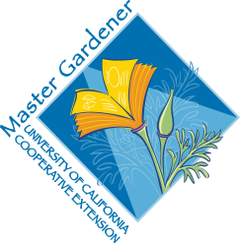University of California, Placer County Cooperative Extension

The Backyard Orchard: Top 10

# Public Website: [**http://pcmg.ucanr.org**](http://pcmg.ucanr.org)

# Questions: Hotline (530) 889-7388

# ROT Line (530) 889-7399

## **HANDOUTS**

Resource Sheet

**RESOURCE LINKS**

Tree Ring Irrigation Contraption <https://ccuh.ucdavis.edu/tric>

NRCS web soil survey <https://websoilsurvey.sc.egov.usda.gov/App/HomePage.htm>

UC Home Orchard <http://homeorchard.ucanr.edu/>

UC IPM site <http://ipm.ucanr.edu/>

Placer Co Master Gardeners <http://pcmg.ucanr.org/>

Nevada Co Master Gardeners <http://ncmg.ucanr.org/>

Kevin Marini [Krmarini@ucdavis.edu](mailto:Krmarini@ucdavis.edu)

**BOOKS**

Ingels, Chuck. *The Home Orchard*. (2007).

**MORE**

Dave Wilson Nursery <https://www.davewilson.com/>

Four Winds Growers (Citrus) <https://www.fourwindsgrowers.com/>