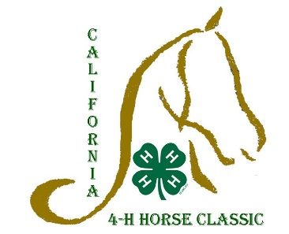**Sponsorship Opportunity:   
California 4-H Horse Classic**

The 17th Annual California 4-H Horse Classic takes place June 25-29th at the Brookside Equestrian Park in Elk Grove. The Classic will again be one event dedicated to over 3,000 4-H horse project members statewide. We invite everyone to join us in sharing a passion for horses. Participation has continued to increase, over 500 youth and adults will be in attendance.

The State championship horse show provides the opportunity for 4-H riders to compete at a level beyond local, county or regional events, while the educational contests allow members to showcase their equine knowledge. This one event continues to build networks between counties with a common interest in strengthening 4-H equine education and establish new friendships between 4-H members and leaders.

The goals of the CA Horse Classic are to:

* **Encourage networking between counties to build leadership with a common interest**
* **Provide opportunities for youth statewide to share their passion for horses**
* **Participate in social and educational programs by being a participant, not a spectator**
* **Experience and develop greater personal growth**
* **Continue to develop leadership, citizenship, and speaking skills**
* **Share personal experiences with others through meaningful growth and development**
* **Promote good sportsmanship**
* **Provide a unique opportunity for horse project members to compete on a level beyond the county, district or regional basis**

Sponsorship Opportunities

Event Sponsor( $15,000.00) - Supports facility cost, grounds maintenance, judges, class awards, and door prizes

* **1 event sponsor**
* **Banner displayed during duration of show and logo included on event T-shirts and vendor space available**

Day Sponsor ($2,000.00) - Fully supports one day of events, includes: facility, judges, and class awards.

* **1 event sponsor**
* **Banner displayed during day of sponsor, donor announced throughout the day, and vendor space available**

Educational Event Donor ($1000.00) – Fully Supports Public Speaking/Demonstrations, or Horse Bowl, or Hippology, or Horse Judging

* **4 sponsors total, 1 per educational event**
* **Recognition given during Educational contest with signage and announcements**

Participant pins ($600.00)- Hat pin for all participants

* **1 sponsor-each Participant receives a Horse Classic Hat pin**

High Point Award ($250.00) - High Point features a custom design engraved buckle.

Event Vendor ($125.00)- Vendor Space for four days (June 25-29)

Horse Show Class ($100.00) – Funds 1st through 10th place ribbons per class

PROGRAM ADS

$250 Full Page, black & white

$100 1/4 Page, black & white

$150 ½ Page, black & white

$ 30 Business card size- Please include print-ready business card

Donors are recognized before and during the Horse Classic through a wide variety of methods. These include recognition on the registration materials, banners, website, program, and announced throughout the show. Please make checks payable to: U.C. Regents

For more information about sponsorship opportunities, please contact  
Sarah Watkins, [spwatkins@ucanr.edu](mailto:spwatkins@ucanr.edu) or 530-750-1340

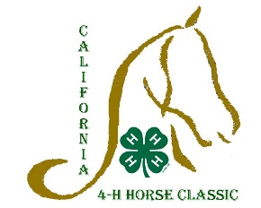**2014 4-H California State 4-H Horse Classic**June 25-29, 2014  
Brookside Equestrian Center, Elk Grove, CA

Donor Form

Name/contact person: __________________________________________________________

Business or Organization: _______________________________________________________________________

Address: _________________________________________________________ email: ______________________

City, state, zip: ___________________________________________________ Phone: ______________________

**Sponsorship opportunities:**

$_______ General Support

$_______ Horse Show Class ($100.00) 1st choice _________ 2nd choice ___________ 3rd choice________

$_______ High Point Award ($250.00) 1st choice _________ 2nd choice ___________ 3rd choice________

$_______ Participant pins ($600.00)

$_______ Educational Event Donor ($1000.00) 1st choice _________ 2nd choice _________ 3rd choice________

$_______ Day Sponsor ($2,000.00)

$_______ Event Sponsor ($15,000.00)

**PROGRAM ADS**

**_____** $250 Full Page, black & white

_____ $100 1/4 Page, black & white

_____ $150 ½ Page, black & white

_____ $ 30 Business card size- Please include print-ready business card

Donors are recognized before and during the Horse Classic through a wide variety of methods. These include recognition on the registration materials, banners, website, program, and announced throughout the show. Please make checks payable to: U.C. Regents

Please return this form to: For more information contact   
California State 4-H Horse Classic, Sarah Watkins, [spwatkins@ucanr.edu](mailto:spwatkins@ucanr.edu) 530-750-1340Sarah Watkins2801 2nd St.Davis, CA 95618

Sponsorship credited to: ____________________________________  
 Name of exhibitor

All donations are tax deductible