Citricola Scale Field Day at Lindcove

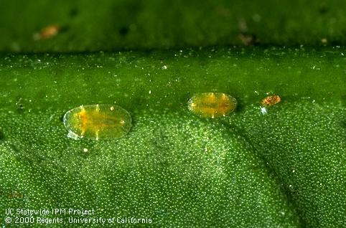

Tuesday September 24, 2024
9:00-11 am
Lindcove Research and Extension Center
22963 Carson Ave., Exeter, CA 93221
Register for the event using this link

Instructor: Dr. Sandipa Gautam

Course Objective: To teach PCAs how to recognize the various life stages of citricola scale and the natural enemies that attack them. Identify between a dead and a live scale and field demonstration of pesticide efficacy. Citricola scale management strategies will be discussed.

9-9:30 a.m. Registration: Lindcove REC
9:30-11 a.m.
A. Powerpoint presentation by Sandipa Gautam on the biology of citricola life cycle, identification, and its natural enemies. Efficacy of foliar and soil applications for citricola scale control will also be discussed.
B. Identification citricola scale and differentiation between live and dead scale
C. Field demonstration of citricola scale infestation, sampling methods, and effects of insecticide treatments to control scale.
Continuing Education 2.0 other units pending approval.

