# **Important Information Regarding Proposals Submitted via Grants.gov**

* **Effective 12/31/17, you will no longer be able to download the legacy single PDF application forms that you’re used to working with on Grants.gov submissions.**
* **Workspace is now the new standard application method on Grants.gov.** Creating a workspace package opens an online project application that will allow project team members to collaborate and edit application forms.

**What does this mean for you?**

Previously you could download an application without needing a grants.gov login. Now, each team member who will need access to the application must have a grants.gov login. ANR team members who do not already have a grants.gov login must follow the registration instructions below several weeks in advance of the submission due date.

* How To Register in Grants.gov:
* Go here: <https://www.grants.gov/web/grants/register.html> and click Register in the upper right corner.
* 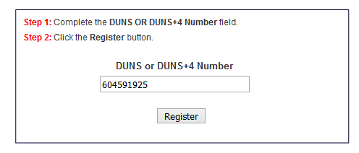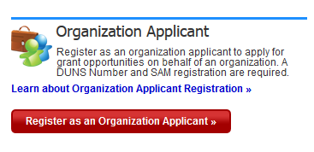Click Register as an Organization Applicant
* Enter UC ANR’s DUNS Number 604591925 (Non UC-ANR team members would register with their institution)
* Fill out the requested applicant information
* Click Continue at the bottom of the form
* Review the confirmation page for accuracy
* Click Submit
* After creating the account ANR’s EBiz POC will be notified and will assign the appropriate role to your account.
* The different grants.gov user roles you may be assigned are 1) No Role (may be added to a workspace project, but limited to filling in form data); or 2) Manage Workspace Role (are able to create a workspace). Submit access is limited to the Authorized Organizational Representative (AORs) which is the Office of Contracts and Grants at UC ANR.

In addition to the grants.gov system roll, **each workspace will have individual access level roles specific to that one project.**

* **Workspace Participant Role:** registered grants.gov user and can edit data and forms within the workspace project.
* **Workspace Owner Role:** The person who sets up the project workspace will automatically be identified as the Workspace Owner, but they can reassign this to someone else if needed. The Workspace Owner manages other users’ access to the workspace, complete forms, and would notify the Authorized Organization Representative (AOR) (Office of Contracts and Grants) when the proposal is ready for submission.

**Workspace Resources provided by Grants.gov. Please be sure to familiarize yourself with the workspace process well in advance of your submission due date.**

**Workspace Overview:** <https://www.grants.gov/web/grants/applicants/workspace-overview.html>

**Step 1: Create a Workspace Package:** <https://www.grants.gov/web/grants/applicants/workspace-overview/step-1-create-a-workspace-package.html>

**Step 2: Complete a Workspace Package:** <https://www.grants.gov/web/grants/applicants/workspace-overview/step-2-complete-a-workspace-package.html>

**Grants.gov Youtube Videos  
Webforms in Workspace:** <https://www.youtube.com/watch?v=Qjd3X-LHCvY&feature=youtu.be>

**Introducing Workspace Functionality on Grants.gov:** <https://www.youtube.com/watch?v=oTflTcJyQTg>

**Screenshots**

**In Grants.gov: search for the funding opportunity, open that opportunity and click the Package tab. From there click “Apply”**

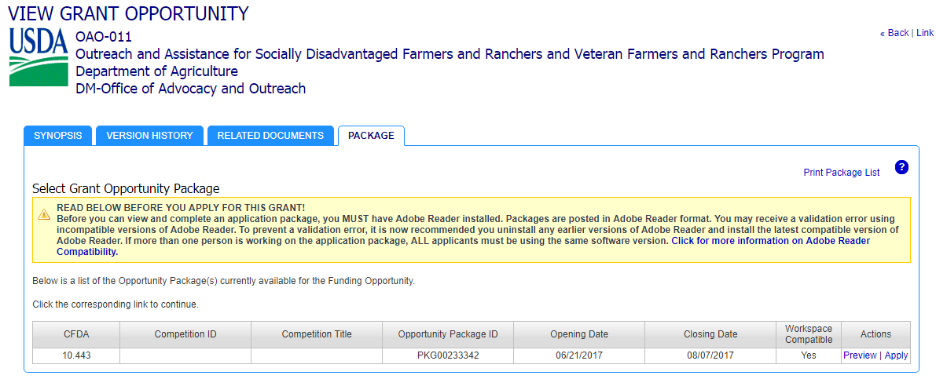

Select Option 1: Apply Now Using Workspace and enter the Application Firing Name and click Create Workspace. (The application filing name is used solely by the applicant for tracking the application through the Grants.gov submission process.)

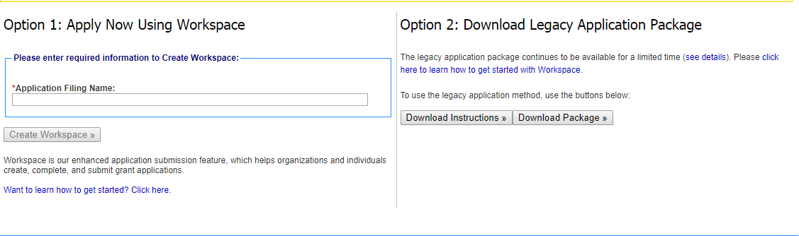

**Workplace Package Example**

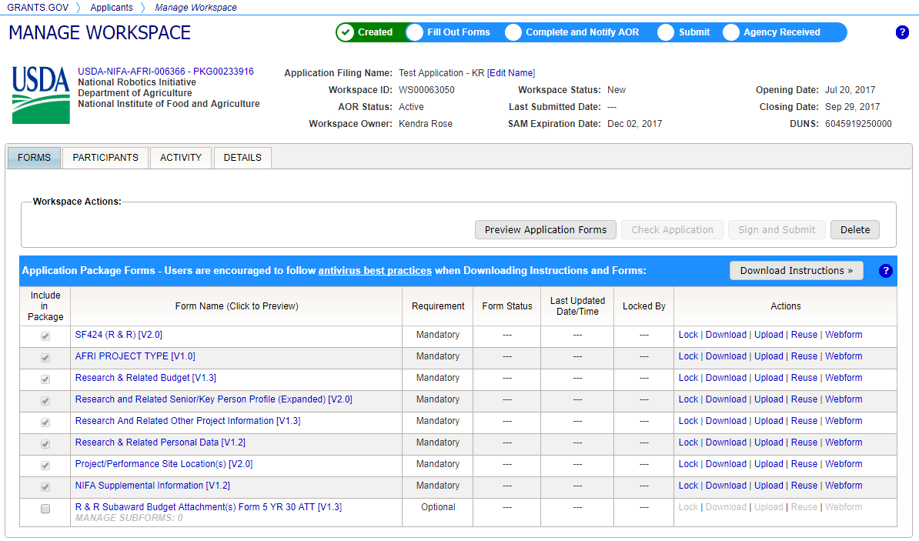

**Forms to be completed will have check marks here. Some additional forms, like the R&R Subaward Budget, may need to be manually checked if applicable to your specific project.**

**You can lock forms to prevent other team members from editing.**

**Either Download and Upload completed forms, OR use the online Webform.**

**If Subawards on your project, check this box to include in workspace package, then download the R&R Subaward Budget form under the Actions column and email to the subawardees for completion. Once received back from the subawardee, click Upload under Actions.**

**The Workspace Owner can add additional team members to the workspace**

