[](https://www.google.com/imgres?imgurl=http://florida4h.org/news/marketing/page22clipart/blackclover.gif&imgrefurl=http://florida4h.org/about/emblem/clip-art/newsletter/&docid=8f6-5noIek9OXM&tbnid=fJqqzK1dYTkbMM&w=209&h=197&ei=sQUHVcmLE47ooASgs4GgDg&ved=0CAQQxiAwAg&iact=c)[](https://www.google.com/imgres?imgurl=http://florida4h.org/news/marketing/page22clipart/blackclover.gif&imgrefurl=http://florida4h.org/about/emblem/clip-art/newsletter/&docid=8f6-5noIek9OXM&tbnid=fJqqzK1dYTkbMM&w=209&h=197&ei=sQUHVcmLE47ooASgs4GgDg&ved=0CAQQxiAwAg&iact=c)

[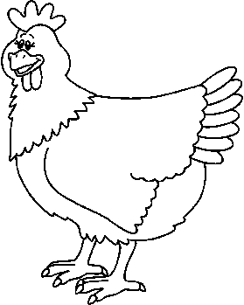](http://www.google.com/url?sa=i&rct=j&q=&esrc=s&frm=1&source=images&cd=&cad=rja&uact=8&ved=0CAcQjRw&url=http://animal-kid.com/chickens-clipart-black-and-white.html&ei=VQIHVfWEFI3hoATs6oGoDw&bvm=bv.88198703,d.cGU&psig=AFQjCNG0G4zejnZaJZeDIj_1wn3jTw-5-A&ust=1426609095719608)

**4-H OPEN HOUSE & BBQ, May 3, 2015**

**Sonoma County Fairgrounds**

**11:30am – 4:30pm**

**Sonoma County 4-H is proud to host the**

**54th Annual Chickenque!**

We are encouraging you to stop by and learn what

Sonoma County 4-H is all about!

Sonoma County 4-H is hosting a chicken bbq fundraiser and the public is invited to attend. 4-H members and their families from all over the county come together to host the largest single day chicken bbq west of the Mississippi! They have been doing this for the last 54 years without fail.

Our 4-H members host interactive booths featuring many of the projects they are involved in. You will also meet club leaders, where you can ask questions. This is a great family event and an opportunity to learn about

4-H. Please come out and be part of this wonderful event and enjoy a delicious meal, Rain or Shine!

You can purchase tickets from a 4Her, the 4-H Office (707-565-2681)

or at the event.

$10 per meal (1/2 chicken, beans, coleslaw and bread)

The 4-H Open House is free.  You can purchase tickets for the BBQ at the event. You can also enjoy cake slices and drinks for $1each.

**A drive thru** is also available!!!

‘LIKE’ us on Facebook: *Sonoma County 4-H Chickenque*