GREEN VALLEY 4-H SHEEP FETCH AND FEED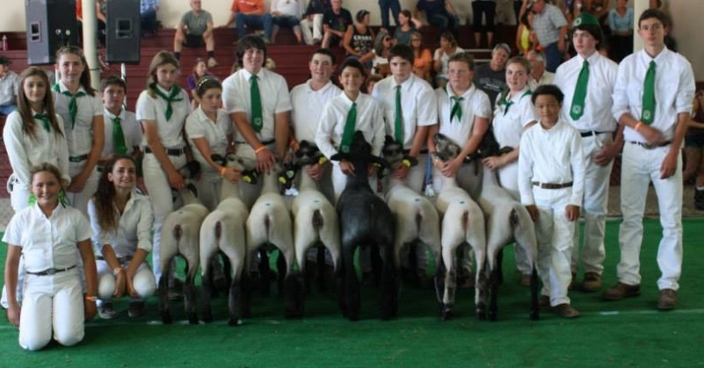
July 15th 4:30 to 6:30 $40.00
Tri-tip BBQ dinner includes tri-tip roast, Caesar salad, chili and rolls. No cooking – just drive through and pick up your dinner to go! Green Valley 4-H Sheep group is raising money to purchase their blankets and show equipment for the fair. Please help support this great group of kids!
Drive thru for pick up at:
Cameron & Cameron Supply
Corner of River and Fulton Road, Santa Rosa
Questions or to reserve tickets 707-490-2607
Credit card payment is available

Fundraising for Green Valley 4-H
through West County 4-H/FFA Boosters

