ART ADVENTURES

Rincon Valley Library
Ages 5-8
March 2 - April 6, 2017
Thursdays 3:30-4:30pm

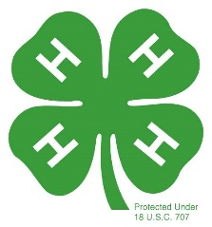

Brought to you by Sonoma County 4-H
It is the policy of the University of California (UC) and the UC Division of Agriculture & Natural Resources not to engage in discrimination against or harassment of any person in any of its programs or activities (Complete nondiscrimination policy statement can be found at http://ucanr.edu/sites/anrstaff/files/215244.pdf )Inquiries regarding ANR’s nondiscrimination policies may be directed to John I. Sims, Affirmative Action Compliance Officer/Title IX Officer, University of California, Agriculture and Natural Resources, 2801 Second Street, Davis, CA 95618, (530) 750-1397.

