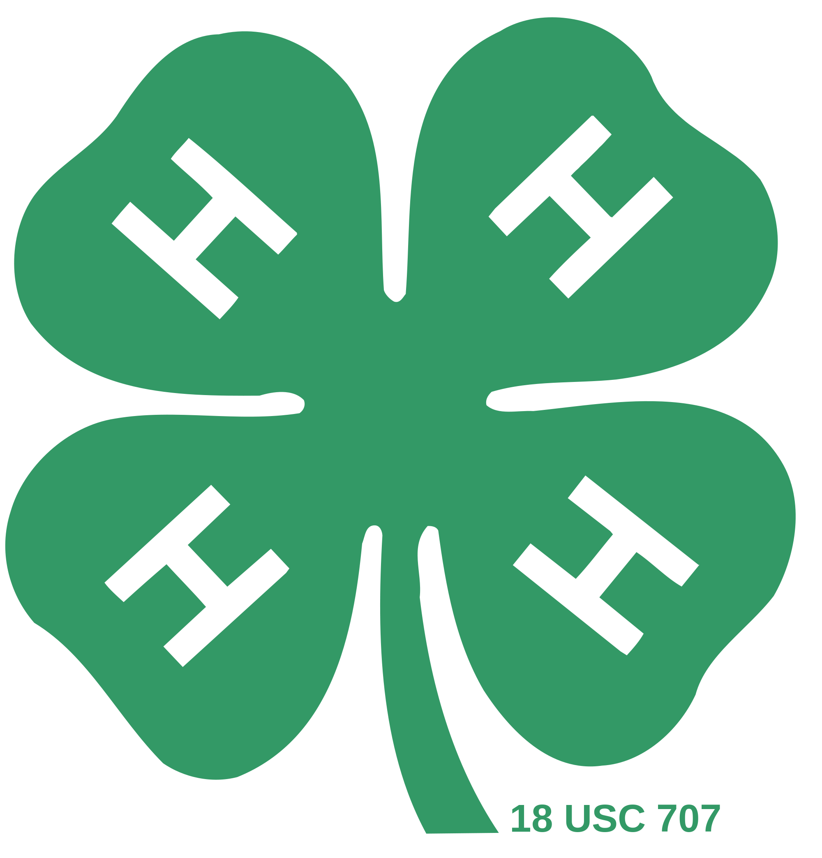
Food Fiesta
Saturday November 12, 2016
Summit Intermediate School
5959 East Avenue
Etiwanda, CA 91739

It’s FOOD FIESTA TIME! Come join the FOOD FUN! Everyone is invited to participate in this event. We have table setting, Food, Fruit and Vegetable classes. BACK AGAIN THIS YEAR!-- Food Jeopardy and Chopped contests. We also have Cupcake Wars, Judging Contests and the Blind Taste Test again. Be sure to enter in all the classes you want to compete in. A Continental Breakfast will be served and water bottles will be for sale @ $1.00 each.

The Deadline for entries is November 1, 2016.

Late and Same Day entries will be accepted with a $10.00 late fee for Category numbers 2 and 3 only. You must pre-enter for all other contests. Registration will begin at 8:30 a.m. and judging will begin at 9:00 a.m. Come early to set up your entries. Parents WILL NOT be allowed in the judging area during judging. If your registration is received by the deadline, we will be able to include your recipes in the 2016 Foods Fiesta Cookbook that each participant will receive.

Mail complete entries to: High Desert Challengers 4-H
c/o William Claflin
1043 Woodlawn Ave
Devore, CA 92407

Or you can email them to amber.claflin@gmail.com.

DO NOT depend on having a stove, oven, microwave, or refrigerator available. If you would like to participate in the Taster’s Choice award, please bring extra samples of your dish to be shared after the final judging.

Food Fiesta Registration Form
Entries Due November 1st, 2016-Tuesday

Category 1. Foods and Home Environment (all entries include table setting.)
Awards offered:
(1) County winner & (3) medalists for each class and age division
(1) Best of Show will be chosen from County Winners
Ribbons 1st thru 3rd `
Category 2. Foods and Nutrition (entries DO NOT include table setting.)
Awards offered:
- Best of Show will be selected per class from all 1st pl. entries
Ribbons 1st thru 3rd
Category 3. Produce Grown or Selected (entries DO NOT include table setting.)
Awards offered:
- Overall Best of Show will be selected from all 1st pl. entries
Ribbons 1st thru 3rd
Category 4. Just for Fun
Awards offered:
- Overall Best of Show will be selected from all 1st pl entries
Ribbons 1st thru 3rd

Name: _________________________________________ Age: ___________

Address: _______________________________________________________

Telephone: _________________ Club: ________________________________

Primary (K-3) ____ Junior (4-5) ____ Intermediate (6-8) ____ Senior (9-12) _____

Category Class Description
____________ ___________ __________________________________
____________ ___________ __________________________________
____________ ___________ __________________________________
____________ ___________ __________________________________
____________ ___________ __________________________________
____________ ___________ __________________________________

Note: you may enter more than one class. Please enter in order of preference for County Winner consideration (Category 1 only). We would like to provide a copy of your recipe to those that are attending the Food Fiesta.

Mail complete entries to:
High Desert Challengers 4-H
c/o William Claflin
1043 Woodlawn Ave
Devore, CA 92407
Or email to amber.claflin@gmail.com
CHOPPED/BLIND TASTE TEST/FOOD JEOPARDY
Entry Form
***Must Pre-Enter***
***Teams May Be Formed the Day of the Event***

Circle One: Jr. Int. Sr. TEAM

Name_______________________ Age:______

Address ___________________ Grade:____

Phone:____________________________________

Club:______________________________________

Email:_____________________________________

Member Signature:___________________________

Leader Signature:_____________________________

PLEASE NOTE:

Blind Taste Test: Four members to a team. You will be sampling food items while blind-folded. Correct answer scores one point for your team per food item.

Food Jeopardy: Four members to a team. Jeopardy game format where you will given food related questions on a rotating system with each member taking a turn.

Chopped: You may enter as an individual and form your team the day of the event. Teams will be given a bag of mystery ingredients to make a dish. You will have 20 minutes to prepare your dish for judging on taste and presentation.
Mail complete entries to:
High Desert Challengers 4-H
c/o William Claflin
1043 Woodlawn Ave
Devore, CA 92407
Or email to amber.claflin@gmail.com

Come Join the
7th Annual 4-H Cupcake Wars

November 12th @ Food Fiesta

Come prepared to decorate (4) different themed cupcakes.
Each entrant must bring all their own decorating supplies
The cupcakes will be provided
All decorations must be edible
No plastic picks or store bought figures allowed

The four themes are:
Favorite Movie, 4-H, Mother’s Day, and Favorite Book

Best of Show for each age category will be selected with Cupcake Wars Champion being selected from Best of Shows.
Competitors MUST PRE-ENTER !

4-H Cupcake Wars Competition Entry Form

Circle One: Primary Jr. Int. Sr.
Name_______________________ Age:______

Address ___________________ Grade:____

Phone:____________________________________

Club:______________________________________

Email:_____________________________________

Member Signature:___________________________

Parent Signature:_____________________________

Leader Signature:_____________________________

PLEASE NOTE:
Each entrant acknowledges by entering that they must provide their own decorating supplies and will be asked to decorate four different themed cupcakes. A time limit of thirty minutes will be given for decorating time.

Mail complete entries to:
High Desert Challengers 4-H
c/o William Claflin
1043 Woodlawn Ave
Devore, CA 92407
Or email to amber.claflin@gmail.com

*PLEASE NOTE CHANGE IN NUMBER OF PLACE SETTINGS
4-H Foods and Home Environment Food Fiesta

Eligibility
All youth that are enrolled in the 4-H program. You need NOT BE ENROLLED in the foods, food preservation or any home environment projects.

Primary members are also invited to join the fun but are not considered to be competing.

A member may enter into as many categories as they wish to. However, you may be a County Winner in only one category.

Category 1 4-H Foods and Home Environment
*(May use 2 place settings if desired)
Please specify on entry if using 2 settings
Class 1 4-H Foods

Things needed: Place setting/ Menu/ Copy of recipe/ one food item from your menu in appropriate dish, casserole, etc.

Prepare a favorite food from any source. No need to be limited to your project book. Select something that fits within your ability to make successfully. Foods prepared exclusively from prepared mixes are not allowed unless mixes are used in the unit in which you are enrolled. From your menu, bring only one complete recipe of food already cooked and prepared. Any container on the table will be judged.
Bring 3 copies of your recipe.

Plan a menu (i.e. breakfast, dinner snack, etc.,) which includes your favorite food. Consider nutrition (include on the menu something from each of the different food groups on the Food Pyramid), color, texture, and flavor.

Select a coordinated place setting (place mats, dishes, flatware, etc.) suitable for the menu. Bring only service (flatware and dishes needed to complete the place setting. Bring valuable tableware at your own risk. NO CENTERPIECE.

You will be judged on: 1) the quality of the prepared food; 2) the menu; 3) the place setting; 4) your knowledge about your exhibit (a judge will talk to each participant); and 5) appropriately dressed, well-groomed appearance (4-H uniform is acceptable, but not necessary).

Class 2 Home Environment

Things needed: Place setting/ menu/ original, creative centerpiece suitable to Menu and place setting

Plan a menu, (i.e. breakfast, snack, etc.) which includes your favorite food. Consider nutrition (include in the menu something from each of the different food groups on the Food Pyramid), color, texture, and flavor.

Select a coordinated place setting (place mats, dishes, flatware, etc.) suitable for the menu. Bring only the service (flatware and dishes) needed to complete the place setting. Bring valuable tableware at your own risk.

Add an original, creative centerpiece suitable to menu and place setting.

You will be judged on: 1) the quality and appropriateness of the centerpiece; 2) the menu; 3) the place setting; 4) your knowledge about your exhibit (a judge will talk to each participant); and 5) appropriately dressed, well-groomed appearance (4-H uniform is acceptable, but not necessary).

Class 3 Foods and Home Environment

Things needed: Place setting/ Menu/ Copy of recipe/ One food item from your menu in appropriate dish, bowl, casserole, etc. / Original creative centerpiece suitable to menu and place setting.

Prepare a favorite food from any source. Select something that fits within your ability to make successfully. Foods prepared exclusively from prepared mixes are not allowed unless mixes are used in the unit in which you are enrolled. From your menu, bring only one complete recipe of food already cooked and prepared. Any container on the table will be judged.

Plan a menu, (i.e. breakfast, snack, etc.) which includes your favorite food. Consider nutrition (include in the menu something from each of the different food groups on the Food Pyramid), color, texture, and flavor.

Select a coordinated place setting (place mats, dishes, flatware, etc.) suitable for the menu. Bring only the service (flatware and dishes) needed to complete the place setting. Bring valuable tableware at your own risk.

You will be judged on: 1) the quality of the prepared food; 2) the menu; 3) the place setting; 4) your knowledge about your exhibit (a judge will talk to each participant); and 5) appropriately dressed, well-groomed appearance (4-H uniform is acceptable, but not necessary).

Class 4 Foods Preservation

Things needed: Place setting/ Menu/ copy of recipe/ One jar of your home persevered food/ Favorite food prepared from home preserved food (i.e. homemade spaghetti sauce made from home preserved tomatoes).

Plan a menu, (i.e. breakfast, snack, etc.) which includes your favorite food. Consider nutrition (include in the menu something from each of the different food groups on the Food Pyramid), color, texture, and flavor.

Prepare a favorite recipe using food you have canned. From your menu, bring only ONE complete recipe already cooked and prepared. Any container on the table will be judged.

Bring 3 copies of the recipe.

Include which food was canned by you and how. Example: Peach Cobbler - recipe and peaches - water bath for 20 minutes on open kettle, or pressure canned for 10 minutes). Bring valuable tableware at your own risk.

You will be judged on: 1) the quality of the prepared food; 2) the menu; 3) the place setting; 4) your knowledge about your exhibit with emphasis on food preservation (a judge will talk to each participant); and 5) appropriately dressed, well-groomed appearance (4-H uniform is acceptable, but not necessary).

Class 5 Cake Decorating

Things needed: Place setting/ Menu/ Copy of recipe/ Decorated Cake (after decoration is judged, cake will be cut and judged on flavor, texture, etc.)

Plan a menu, (i.e. breakfast, snack, etc.) which includes your favorite food. Consider nutrition (include in the menu something from each of the different food groups on the Food Pyramid), color, texture, and flavor.

Select a coordinated place setting (place mats, dishes, flatware, etc.) suitable for the menu. Bring only the service (flatware and dishes) needed to complete the place setting. Bring valuable tableware at your own risk.

You will be judged on: 1) the quality of the decorated cake; 2) the menu; 3) the place setting; 4) your knowledge about your exhibit (a judge will talk to each participant); and 5) appropriately dressed, well-groomed appearance (4-H uniform is acceptable, but not necessary).

Category 2 4-H Foods and Nutrition
(Stand alone Category-Exhibitor need not be present)

Class 6 Foods Savory/Main Dishes/Soups
(NO PREPACKAGED INGREDIENTS)

Things needed: Recipe/ Food Item (well presented)

Prepare a favorite food from any source. You may not use any ingredients that are prepackaged (i.e. chili con carne in a can, Hamburger Helper. etc). Select something that fits within your ability to make successfully. Select an appropriate container for presentation. Bring copies of your recipe to be shared.

You will be judged on: 1) the quality and 2) the presentation of the entry.

Class 7 Appetizers

Things needed: Recipe/Food Item (well presented)

Prepare an appetizer from any source. You may not use any ingredients that are prepackaged. Select something that fits within your ability to make successfully. Select an appropriate container for presentation. Bring copies of your recipe to be shared.

You will be judged on: 1) the quality and 2) the presentation of the entry.

Class 8 Favorite Desserts

Things needed: Recipe/ Food Item (well presented)

Prepare a favorite food from any source. You are allowed to use any type of ingredient appropriate to your recipe. Select something that fits within your ability to make successfully. Select an appropriate container for presentation. Bring copies of your recipe to be shared.

You will be judged on: 1) the quality and 2) the presentation of the entry.

Class 9 Decorated Cake

Things needed: Frosting Recipe/ Cake or Decorated Styrofoam (well presented)

Prepare and decorate a cake or you may decorate Styrofoam. Select one that fits within your ability to do successfully. Select a container that presents your cake appropriately. Bring copies of your recipe to be shared.

You will be judged on: 1) your skills and 2) the presentation of your work.

NOTE: Please be prepared to cut & serve your cake if you decorated an actual cake.

Class 10 Preserved Foods

Things needed: Recipe/ Sealed jar of preserved food (well presented)

Prepare a favorite recipe of preserved food. Select one that fits within your ability to do successfully. Select an appropriate container for canning. Bring copies of your recipe to be shared.

You will be judged on: 1) the quality of prepared food and 2) the appearance of preserved food.

Class 11 Food Crafts

Things needed: Recipe/ Food Item (well presented)

Put together a food craft (i.e. Gingerbread houses, Sugar Easter Eggs, Hamburger Yo-Yo cookies, Sculptured Vegetables) and decorative food item that is also edible. No homemade candies, chocolates, or confections, with the exception of the Sugar Easter Eggs above will be judged. They may be used as a part of the food craft. Bring copies of your recipe and instructions to be shared.

You will be judged on: 1) the overall appearance of the craft and 2) the effective use of ingredients.

Class 12 Breads/ Rolls

Things needed: Recipe/ Food Item (well presented)

Prepare and bake any bread or rolls. Select one that fits within your ability to do successfully. DO NOT USE A BREAD MACHINE. DO NOT USE PREPACKAGED INGREDIENTS. Select an appropriate container for presentation. Bring copies of your recipe to be shared.

You will be judged on: 1) the quality and 2) the Presentation of bread or rolls.

Class 13 Cookies

Things needed: Recipe/ Food Item (well presented)

Prepare and bake any type of cookie. Select one that fits within your ability to do successfully. DO NOT USE PREPACKAGED MIXES. Select an appropriate container for presentation. Bring copies of your recipe to be shared.

You will be judged on the quality of the cookies.

Class 14 Candies/ Confections

Things needed: Recipe/ Food Item (well presented)

Prepare any candies or confections. Select one that fits within your ability to do successfully. Select an appropriate container for presentation. Bring copies of your recipe to be shared.

You will be judged on: 1) the quality and 2) the Presentation of Candies/ Confections.

Class 15 Primaries

Things needed: Recipe/ Food Item (well presented)
Prepare any food item. Select one that fits within your ability to do successfully.

You will be judged on the quality of the food.

DO NOT depend on having a stove, oven, microwave, or refrigerator available for use.

Category 3 4-H Agriculture Vegetable Gardens & Crops

The quality desired in agricultural exhibits is the quality that brings the best financial return in the commercial market, and such exhibits must be at least equal in maturity as the state of ripeness required by Section 42513 of the California Agriculture Code.

Section 42513, Mature means having reached that state of ripeness which will insure palatability, after the removal of product from the tree, plant, or vine.@
Section 42515, Overripe means having an advance state of maturity which causes the product to be undesirable for human consumption in a fresh state.

Class 16 Vegetable Plate Display

Vegetables must be produced by exhibitor. Variety of products must be adequately and correctly labeled. Specimens must have stems, roots, or vines attached. Plate to contain at least 3 specimens (unwashed).

You will be judged on the uniformity of the specimens: size, color, and ripeness.

Class 17 Fruit Plate Display

Fruit must be produced by exhibitor. Variety of products must be adequately and correctly labeled. Specimens must have stems, and leaves attached. Plate to contain at least 3 specimens (unwashed).

You will be judged on the uniformity of the specimens: size, color, and ripeness.

Class 18 Vegetable Selection Display

Vegetables must be selected or purchased by exhibitor. Variety of products must be adequately and correctly labeled. Plate to contain at least 3 specimens (unwashed).

You will be judged on the uniformity of the specimens: size, color, and ripeness.

Class 19 Fruit Selection Display

Fruit must be selected or purchased by exhibitor. Variety of products must be adequately and correctly labeled. Specimens must have stems, and leaves attached. Plate to contain at least 3 specimens (unwashed).

You will be judged on the uniformity of the specimens: size, color, and ripeness.

Category 4 Just for Fun
(One Best of Show will be selected from all 1st place entries.)

Class 20 Decorate a Cookie Jar

Things needed: Decorated cookie jar, cookie recipe and plate of cookies for judging.

You will be judged on:
Decorated Jar 60%
Design, creativity and function. (i.e. washable and useable)

Cookies 40%
Taste and appearance.
______
100%

Agricultural Cooperative Extension
University of California
San Bernardino County
Table Setting Guidelines

Points to consider: Remember that table setting is not an exact science, but rather a creative and artistic arrangement. However there are certain things that must be done. Your arrangement should be appropriate for your menu, occasion and tableware use. Be creative but follow the proper placement of items you use.

- Placemats on a tablecloth may or may not be used. If they are used, placemats should be 2 inch up from edge of placemat, and silverware even with bottom edge of plate (see diagram)

- The only time a formally folded napkin (see diagram) is needed is with a formal placesetting (i.e. a Presidential State Dinner would require a formal napkin, as would a Golden Wedding Anniversary Dinner using crystal, china, and eight pieces of sterling silverware.) A formal napkin is placed ONLY on the dinner plate (in the case of Fair Tablesettings, where all courses such as soup, salad or cereal have to be placed on the table at the same time, the napkin would be placed next to the forks). An informally folded napkin may be used with anything BUT formal occasions, may be folded any size or shape, and may be located anywhere on the placesetting or table.

- The menu may be placed anywhere on the table and must list all food items for tablesetting. There must be a dish, glass, silverware, etc., for each item of food on menu (one exception: see Rule #22). Optional items for table would be salt and pepper shakers and cream and sugar bowls, provided there is a use for them (if your menu consisted of ice cream, cake and punch, there would be no need for salt/pepper shakers or cream/sugar). If the above items complement your tablesetting, use them.

- The centerpiece must be appropriate to tablesetting and must not be so large or tall that it blocks the view of the person seated opposite you.

- A salad plate or bowl may be used for salads.

- Salad plate is to the left of forks anywhere between middle of fork handles and top of forks (see diagram).

- If there is a salad plate on the table, there must be a salad fork.

- Salad and bread plate may be the same or different size.

- Bread plate is placed anywhere from of fork (or forks) to middle of plate top (see diagram).

- Butter knife is placed straight across top of bread plate, blade down, OR slanted on right side of bread plate, blade facing in (see diagram).

- If menu says: Buttered rolls or bread, NO butter knife is needed.

- If menu says: Rolls or bread with butter, butter knife IS needed.

- Cup and saucer are to the right of knife and teaspoon, anywhere between middle of teaspoon and top of teaspoon (see diagram).

- Cup handle faces five o’clock or to the right.

- Water or milk glass to the top of knife. Juice or wineglass to the top of teaspoon (see diagram).

- If soup or cereal is listed on menu, a soupspoon must be on the place setting to the right of teaspoon (see diagram).

- If soup or cereal is listed on menu, soup or cereal bowl will sit on the dinner, lunch, or breakfast plate (if no other main entrees).

- An iced tea spoon may or may not be used (a tall glass would require an iced tea spoon). And it would be placed to the right of the teaspoon or soupspoon (see diagram).
- Dinner knife blade always faces plate (see diagram).

- WINE: Remember, white wine is served with white meat (fish, poultry, veal, etc.) and red wine served with red meat (beef, pork, lamb, etc.). If wine is on your menu, list it as Red Wine or White Wine, or if you know the name of the wine you wish to serve list it.

- On the food pyramid, milk for adults is as important as milk for children. But if you are having a Formal dinner, milk and wineglass placed together might look a little odd, so state on your menu in parentheses (Milk for Children), and do not include a milk glass on your tablesetting. Also, if you are serving wine and no milk, try to incorporate milk into your menu using sauces, topping, ingredients, salads, etc., made with whole, skim, butter, evaporated, condensed or dry milk, cheese, cream cheese, sour cream, ice cream, sherbet, etc.

- A desert, if needed, must be listed on the menu, but you NEVER need a dessert plate as the dessert is always served after the meal is finished and the table has been cleared.

- DO NOT CROWD YOUR PLACESETTING. Do not set anything BUT the breakfast, lunch, or dinner plate (and if you use them, the soup or cereal bowl) on the mat along with the silverware. All other dishes and glasses are to go on the outside of the placemat (see diagram).

Formal setting

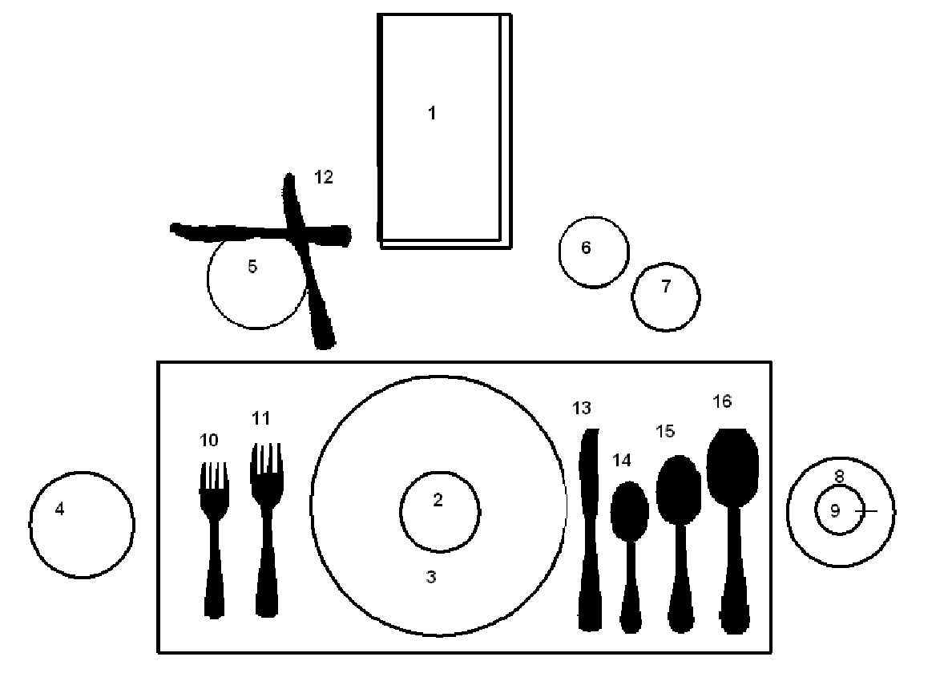
- Formally folded napkin
- Soup or cereal bowl
- Breakfast, lunch, or dinner plate
- Salad plate
- Bread plate
- Water or milk glass
- Juice or wine glass
- Saucer
- Cup
- Salad fork
- Dinner fork
- Butter knife
- Dinner knife
- Teaspoon
- Soup/Cereal spoon
- Iced tea spoon

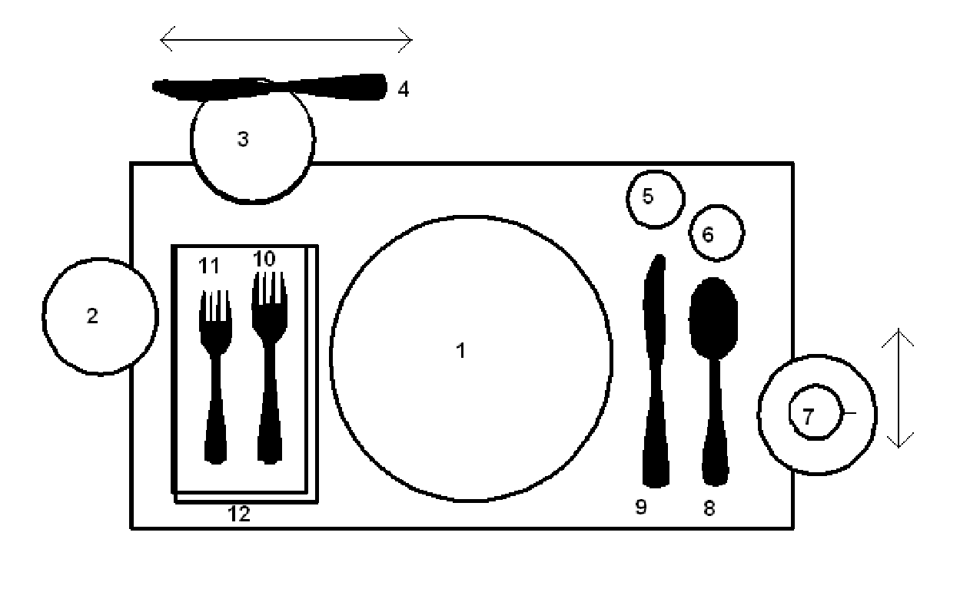

Informal setting

- Dinner plate
- Salad plate
- Bread plate
- Butter knife
- Water/milk glass
- Juice/wine glass
- Cup and saucer
- Teaspoon
- Dinner knife
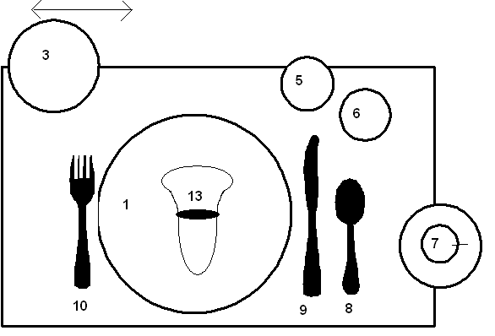
- Dinner fork
- Salad fork
- Formal napkin
- Informal napkin

Centerpiece Guidelines

Creativity is the key. Let your imagination help you. Some of the most unlikely materials can become works of art.

- A piece of driftwood with colorful flowers
- An old serving dish
- An old Easter basket with wild flowers or a fried floral arrangement
- A pretty house plant with bows
- That interesting piece you rescued from the trash heap
- A bowl of fruit
- Old candles melted in a strange and interesting shape

A garage sale, the Salvation Army, an auction, or even your everyday dishes can be hidden treasures. Recycle Christmas ornaments.

Holiday themes will give you a bundle of items - green shamrocks for St. Patrick’s Day, red hearts for Valentine’s Day, or a basket full of brightly colored Easter eggs.

Although creativity is the key, there are a few simple rules to follow.

- Keep the size of the table and type of meal planned in mind - you would not put a huge, tall flower arrangement in the middle of the table so guests could not talk, nor a small piece in the background of a buffet table.

- Keep in mind your theme and choose appropriate colors. If candles are used in the centerpiece, they must be lit. Candles are generally used only on tea, dinner, or buffet tables after dusk. Generally, 15 to 20 inch candles are used to keep flames above eye level.

Remember to take advantage of those long walks and add to your collection some dried flowers, driftwood, etc.

Some of the most beautiful and creative centerpieces are the least costly.

Agricultural Cooperative Extension
University of California
San Bernardino County
Food Safety

How Food Poisoning Develops

Bacteria enter food and lurk everywhere, in the nose, throat, skin, utensils, clothes and occasionally in food products.

Bacteria grow and multiply with:

Food - Bacteria will grow in almost any food except one that is very acidic (pickles). Most proteins - meat, fish, egg, poultry, milk, cream, cream sauce, salad dressings, and mayonnaise are particularly vulnerable.

Moisture - Bacteria will not grow in dried foods, but may grow is moisture is added.

Temperature - Lukewarm or room temperature is ideal for bacterial growth. At temperatures above 140 and below 40 food poisoning bacteria do not grow readily.

Time - In less than 2 hours, food may be unsafe if the right conditions prevail.

How Can You Prevent Food Poisoning

Your only protection against this unseen enemy is proper food handling

- Avoid contamination. Use strictly fresh ingredients, clean equipment, clean hands, avoid sneezing or coughing into food; keep pets, sick people, insects and dust out of food preparation areas.

- KEEP HOT FOOD HOT - above 140͒ KEEP COLD FOODS COLD - below 40͒.

- Take special precautions with foods when they are refrigerated and reheated. If a hot food is prepared the day before, refrigerate immediately when removed from the range. Just before you leave home, preheat the food thoroughly. Take hot or cold foods to the kitchen as soon as you arrive at the event.

- To carry hot or cold foods: use well insulated containers, cardboard cartons thickly lined with newspapers will work well.

DO NOT DEPEND ON HAVING A REFRIGERATOR AVAILABLE!

Menu Planning Guidelines

ALWAYS CHECK FOR THE BASIC GROUPS IN THE FOOD PYRAMID:

- Milk
- Fruits and vegetables
- Legumes
- Breads and cereals
- Meat
- Fats
- Extras

KEEP IN MIND:

- Color
- Texture
- Nutrition
- Color coordination

- Do NOT repeat foods. (Potato soup and potato salad).

- Avoid same types. One strong flavored food per meal. Serve difficult to digest foods only once.

- Balance solids with softs.

- Balance sweet and sours.

- Balance hot and cold combinations.

SUMMARY:

- Contrast hot and cold, bland and high flavors, liquids and solids, tarts and sweets.

- Serve one kind of relish except when substituted for salad.

- Watch amount of foods.

- Serve leftovers in a variety of ways and not the very next day.

- If you do, dress them up! (Think through your leftovers.)

- Keep meals simple. (Company/family.)

- Don’t crowd the table.

- Expensive foods are NOT necessary! The way they are cooked and served are most important.

- Eye appeal. Main dish should be enhanced.

- Remember color of foods and setting.

- Color of linen and dishes is a BACKGROUND.

- Never allow beautiful setting to over dominate your food.

- Never permit ANYTHING to overpower your foods.

Cupcake Wars Judging Scorecard

Name_________________
Jr. Int. Sr. (circle one)
Age:__________________

Creativity of Decorations 25% ____
(Variety and use of decorations)

Workmanship 50%_____
(Skills used and exhibited by decorator at competition)

Originality 25%_____
(Presentation and use of themes)

Total Score: 100%_____

