Tree Wraps
Neil O’Connell
Installing tree wraps on young trees provides protection to the trunk from applications of herbicides during weed management operations. Additionally, the wraps minimize light interception by trunk tissue thereby reducing sucker growth. During hot weather tree wraps provide shade to the trunk and reduce the incidence of sunburn. With the increasing incidence of earwigs, damage to young trees and the tendency for the insect to congregate under the wraps, tree wraps are being removed in some cases. Recent laboratory data from Dr. Beth Grafton-Cardwell (confirmed by observations in the field) suggests that as the season progresses adults become less and less interested in feeding on leaves (peak of feeding in March and April, declines to next to nothing by June). So, a management consideration would be to check the earwigs in the wraps in the summer, and if there are only adults present there is less concern than if there are immatures present. Another point would be to consider treatment with an insecticide such as Lorsban if wraps are to be left on for sunburn protection.
If wraps are removed a uniform coating of sun protective material should be applied to the trunk to protect against sun damage. Trunk surfaces should be monitored to ensure that a uniform coating is in place. Sun damage to unprotected trunk tissue can result in partial or complete girdling of the tree.
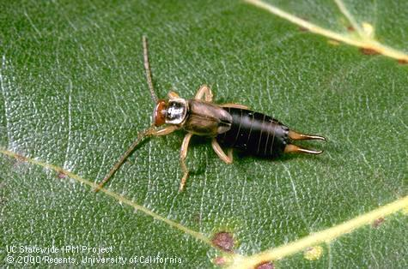

Figure 1 – European Earwig
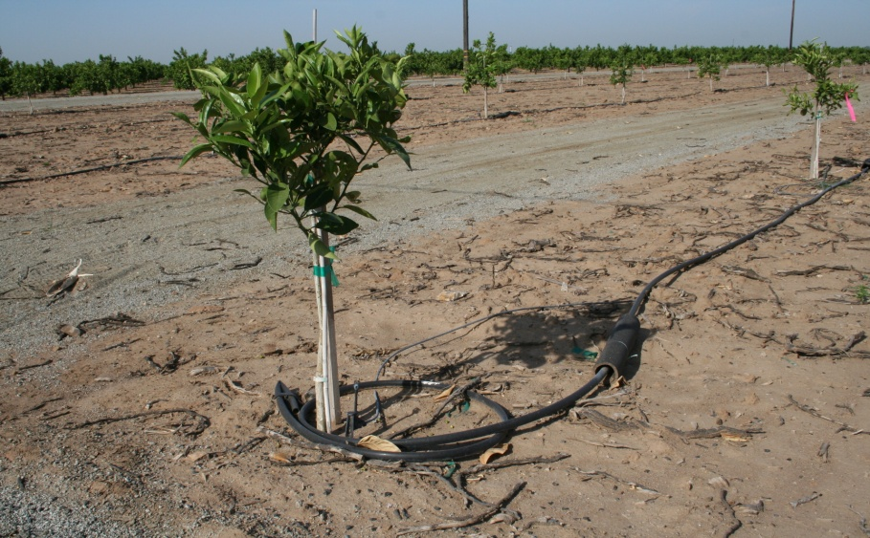

Figure 2 – Wrap removed - whitewashed

