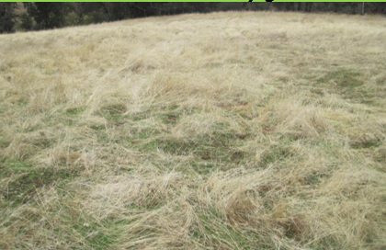
Figures 1. Medusahead cover on day of Milestone treatment, Oct 19, 2009.
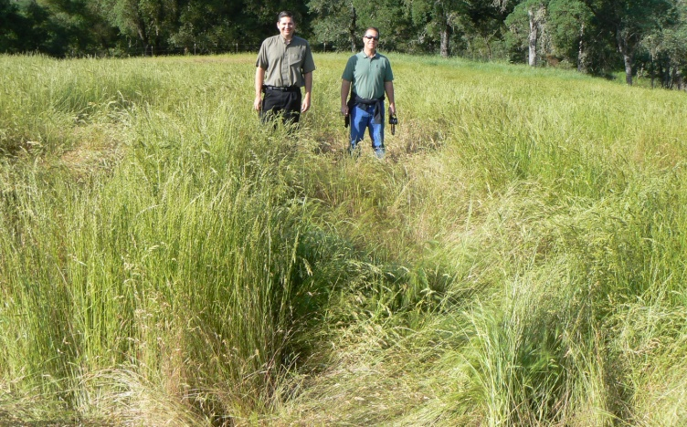
Figure 2. Scott Oneto (left), UC Extension Farm Advisor pictured with Rick Miller (right), Dow AgroSciences in the 7 oz/acre Milestone treatment photo taken on April 27, 2010. There is little medusahead present and the site is dominated by other more desirable forage grasses.

