4-H California Focus information night

October 17th, 2014 @6pm

Meeting to be held in the County Ag conference room, 1432 Abbott Street, Salinas
Jaime Burroughs, Stanislaus County 4-H volunteer leader, has been involved with the California Focus Program for 17 years. Her staff is comprised of professionals, college students and 4-H alumni from various colleges and universities in California. This year, the site of the program will be at the Capital Plaza Hotel.
She will offer a presentation to Monterey County 4-H members and their families on the benefits, the memories and the life-long impacts this state wide 4-H conference will make.
There will be a slide show presentation, handouts, registration details, chaperone opportunities and refreshments!

California Focus - A unique citizenship educational experience for 4-H youth ages 14-19.
Scheduled for June 19-23, 2015
Held at the Holiday Inn Capital Plaza- Sacramento

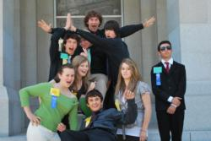

California Focus can be the beginning of a life of public participation that leaves you with a strong determination to become involved in your community!

At California Focus, 4-H members will:
Witness California’s government in action by participating in the legislative, political, and judicial processes. As a conference delegate you will:
- Register to vote, conduct a primary election, and develop a political campaign through a two party system.
- Elect constitutional offices.
- Analyze the needs and issues of your district and enact legislation with the goal of securing the governor's signature to make your bill a law.
- Create a service plan of action for your community
- Meet California law makers
- Tour the State Capitol, Governor's office and 3rd Court of Appeal
- Participate in fun recreational activities, tours and cultural events
- Make new friends
Don't miss being a part of this stimulating, fun-filled learning adventure in Sacramento with opportunities to gain new ideas, experiences, and perspectives.

RSVP by 10/3/14 to attend by contacting the 4-H program offices at 831-759-7386 or lhofmannlurz@ucanr.edu to open your mind to a great state!

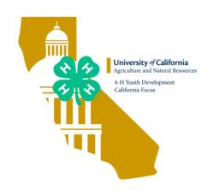

The University of California Division of Agriculture & Natural Resources (ANR) prohibits discrimination or harassment of any person in any of its programs or activities (Complete nondiscrimination policy statement can be found at http://ucanr.org/sites/anrstaff/files/107778.doc ) Inquiries regarding ANR’s equal employment opportunity policies may be directed to Linda Marie Manton, Affirmative Action Contact, University of California, Davis, Agriculture and Natural Resources, One Shields Avenue, Davis, CA 95616, (530) 752-0495.

