UCCE MASTER GARDENER ADVICE TO GROW BY WORKSHOP
JUNE 19, 2010
Selecting the right subtropical tree for your climate: Some varieties are more tolerant of our “cooler” conditions during the foggy summer months. Varieties that require a lot of heat may never ripen. Rule of thumb – the more acid in the fruit, the less cold tolerant.
CITRUS VARIETIES - see last page for San Luis Obispo County
Citrus for the Home Garden in Contra Costa County http://ucce.ucdavis.edu/files/filelibrary/434/32989.pdf

AVOCADO VARIETIES – see last page for San Luis Obispo County
California Rare Fruit Growers http://www.crfg.org/pubs/ff/avocado.html

Select the best location in your yard and recognize micro-climates that occur even in small areas:
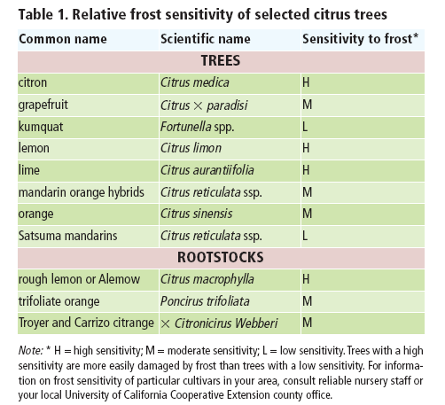
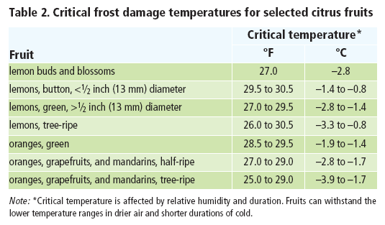
To protect your trees from frost.
Frost/Freeze Protection for Horticultural Crops – http://www.ces.ncsu.edu/depts/hort/hil/hil-705.html
Frost Protection for Citrus and Other Subtropicals http://ucanr.org/freepubs/docs/8100.pdf

To plant the tree and suggested spacings:
Avocados: http://homeorchard.ucdavis.edu/Fruits_&_Nuts/Avocado/
Citrus: http://homeorchard.ucdavis.edu/Fruits_&_Nuts/Citrus/

Water needs and irrigation of citrus and avocado:
Mature trees in warmest months will need 60 gallons of water/week.
Watering citrus: http://ipm.ucdavis.edu/PMG/GARDEN/FRUIT/CULTURAL/citruswatering.html
Citrus for the Home Garden in Contra Costa County http://ucce.ucdavis.edu/files/filelibrary/434/32989.pdf
Watering avocado http://ipm.ucdavis.edu/PMG/GARDEN/FRUIT/CULTURAL/avocadowater.html

Weed Management for citrus and avocado

.Both citrus and avocado are very shallow rooted – only hand weeding and mulch underneath trees
Weed identification and control measures: http://www.ipm.ucdavis.edu/PMG/menu.weeds.html

Fertilizer requirements for citrus and avocado

Suggested application rates of nitrogen - Divide into 2 or 3 applications
- 1st year: 1 tablespoon nitrogen fertilizer 3 times per year, per tree.
- 2nd year: 0.25 lb actual nitrogen per tree
- 3rd year: 0.5lb actual nitrogen per tree
- 4th year: 0.75lb actual nitrogen per tree
- 5th year:1 lb actual nitrogen each year
1 pound of actual nitrogen equals about 5 lb of ammonium sulfate (21% nitrogen) per year, or 100 lb of composted cow manure each year. Organic fertilizers such as manure, bloodmeal, etc. could be applied in the fall under the tree canopy

Pest identification, including methods of reducing pest populations using the least toxic methods.
Avocados - http://www.ipm.ucdavis.edu/PMG/GARDEN/FRUIT/avocados.html
Citrus - http://www.ipm.ucdavis.edu/PMG/GARDEN/FRUIT/citrus.html

Subtropical Fruits for San Luis Obispo County
SUBTROPICAL FRUITS |  |  | Coastal Gardens |  | Inland Gardens
AVOCADO |  | Gwen |  | † | Duke
 |  | Hass or Lamb Hass |  | † | Jim
 |  | Fuerte |  | † | Stewart
 |  | Reed
 |  | Pinkerton
 |  | Wurtz (Littlecado) or Holiday are dwarf varieties
LEMON |  | Eureka |  | † | Lisbon
 |  | Variegated Pink |  | † | Improved Meyer
LIME |  | Bearss
MANDARIN |  | Tango |  | † | Fairchild
 |  | Pixie |  | † | Gold Nugget
 |  | Kinnow (seeded) |  |  | Owari Satsuma
 |  | Gold Nugget |  |  | Dancy (seeded
ORANGE |  | Robertson Navel |  |  | Washington Navel (protected areas)
 |  | Valencia MidKnight |  |  | Skaggs Bonanza
 |  | Trovita (indoors too!) |  |  | Cara Cara
 |  |  |  |  | Lane Late
GUAVA (FEIJOA) |  | Coolidge (pineapple type)
 |  | Cattley (strawberry type)

The University of California prohibits discrimination or harassment of any person on the basis of race, color, national origin, religion, sex, gender identity, pregnancy (including childbirth, and medical conditions related to pregnancy or childbirth), physical or mental disability, medical condition (cancer-related or genetic characteristics), ancestry, marital status, age, sexual orientation, citizenship, or service in the uniformed services (as defined by the Uniformed Services Employment and Reemployment Rights Act of 1994: service in the uniformed services includes membership, application for membership, performance of service, application for service, or obligation for service in the uniformed services) in any of its programs or activities.

University policy also prohibits reprisal or retaliation against any person in any of its programs or activities for making a complaint of discrimination or sexual harassment or for using or participating in the investigation or resolution process of any such complaint.

University policy is intended to be consistent with the provisions of applicable State and Federal laws.

Inquiries regarding the University’s nondiscrimination policies may be directed to the Affirmative Action/Equal Opportunity Director, University of California, Agriculture and Natural Resources, 1111 Franklin Street, 6th Floor, Oakland, CA 94607, (510) 987-0096.

