Quest for Speed
TechXcite: Discover Engineering Curriculum
4-H Science, Engineering, and Technology
2011 Winter Workshops

For all youth educators including: 4-H volunteers & teen leaders, after school and classroom teachers, other youth educators and extenders

February 5, 2011 from 9:00am – 4:00pm
Hosted by Butte County 4-H Youth Development
HR Conference Room, Suite G, 2279 Del Oro Ave., Oroville, CA. 95965

Workshops are FREE! Lunch is provided.
FREE curriculum given to those registered by Jan. 24.

2011 Curricula Themes  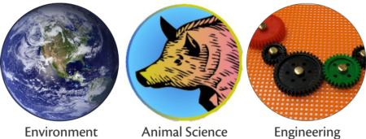 | Enhance student learning through hands-on education!  Increase your abilities as a teacher!  Connect with other educators and teen leaders from around the state!  Try out new 4-H science and engineering curriculum!

The workshop emphasizes experiential and inquiry-based learning: hands-on activities that invite youth discussion, promote active questioning, and application to the real world; and engages youth in science process skills: observing, communication, comparing, organizing, relating, inferring, applying, building, and testing.

Registration due January 24, 2011 at http://ucanr.org/set
Late registration by January 31st– call 445-7351
Space is limited so register EARLY!
For more information, contact Dr. Matthew Portillo, (530) 538-7201
Or Steven Worker at
smworker@ucdavis.edu or (530) 754-8519.

Support for the workshops provided by the Thomas and Dorothy Leavey Foundation.

