FREE COMPOSTING WORKSHOP

Sponsored by the Morongo Basin Master Composters

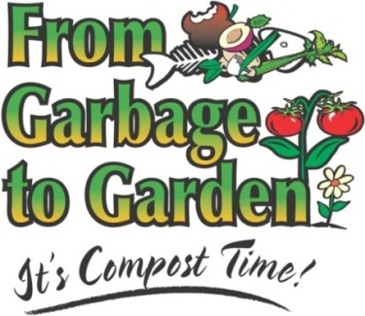

Turn your green, food scraps into useful soil amendment.
Improve the health of your soil and retain water.
Reduce what goes into the landfill.
Save money.
Composting is educational, and
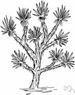
IT’S A PILE OF FUN!!!

Learn the dos, don’ts, and maybes of composting in the desert! Our environment is unique and general composting techniques and uses may differ from our environment’s needs.

Saturday, November 23^{rd.} at 1:00 p.m.

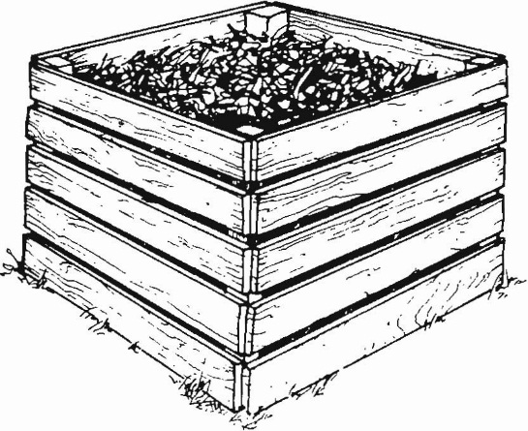
Facilitated by Dr. Francene Kaplan,
Master Composter

Workshop Location:

Radio Free Joshua Tree
61597 29 Palms Highway
Joshua Tree CA 92252

For more information e-mail: priestessofrot@yahoo.com

