Asian citrus psyllid and Huanglongbing disease online training class for Master Gardeners

General information about ACP and HLB biology and management in a residential setting (plus a quiz). To access the course:

1. Go to http://class.ucanr.org

2. Register if you’re a new user, or log in if you already have an account

3. Click on the “Asian Citrus Psyllid and Huanglongbing” link under “Master Gardener Classes”

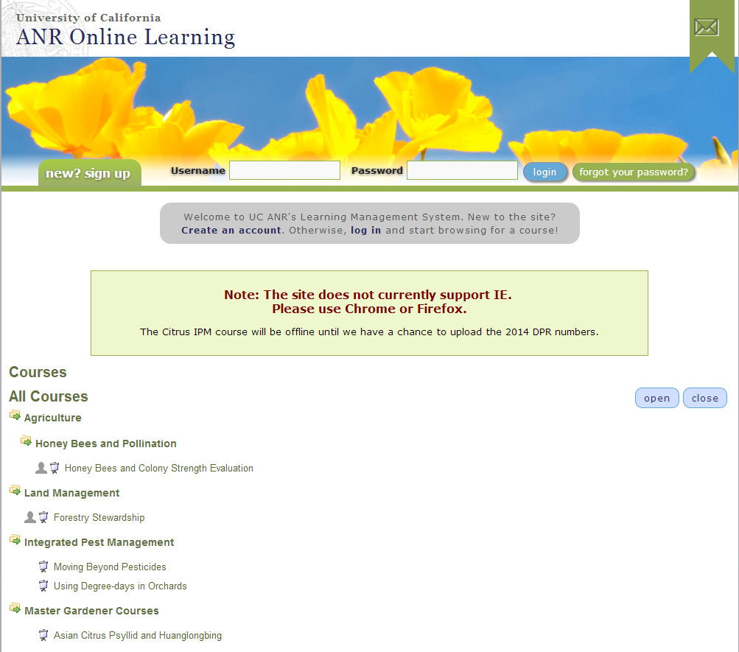

For more information please also visit the “ACP/HLB Distribution and Management” site: http://ucanr.edu/sites/ACP/

