Frequently Asked Questions about Camp

Q: What will campers be doing all day?
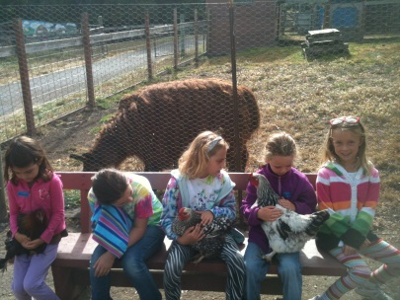
A: A typical time line for camp is as follows:
9:00 – 9:15: Check in and visit with the chickens
9:15- 9:30: Review of rules; break into self-selected groups
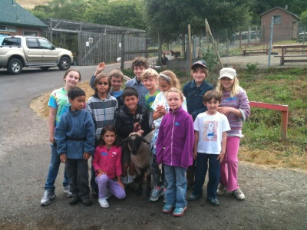
9:30 – 10:30: First round of “chores” which are intended to engage campers in some of the real work that is required to keep livestock healthy and gardens productive. We maintain a ratio of 1:10, adults to campers, and have numerous teen helpers as well. Campers receive instruction in how to safely use tools.
10:30 – 10:50: Morning snack. Children are encouraged to drink water and eat a small snack from their lunchbox.
10:50 – 11:45: Second round of chores. At this point some children may elect to choose a different chore (i.e., if they were doing animal chores first, they may choose to do a garden chore second)
11:45 – 12:15: Free animal time. Campers can visit with the goats, donkeys, chickens and rabbits. Campers are supervised by staff and teen helpers at all times but are free to move from one area to another.
12:15 – 1:00: Lunch. As campers finish their lunch they can explore the play area where they have been known to build forts, swing on tire swings, climb on hay bales, and hide in tunnels. Occasionally a teen helper will facilitate a game of camouflage in the garden.
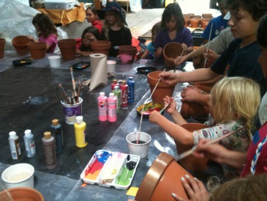
1:00 – 2:00: Craft (or special event). On most days your camper will have the opportunity to create a project using natural or recycled materials. Common projects include clay animals, decorated picture frames or horse shoes, painted walking sticks, decorated pots and vases. Occasionally we may use this time to hike to the creek or up to the water tower, cook something from the garden, or play a game.
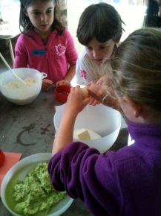
2:00 – 2:30: Afternoon snack provided by Elkus. Our afternoon snacks usually include a fruit or vegetable, crackers and water. Occasionally we will bake or cook with the campers in the morning and serve it for snack. Favorite recipes include chocolate chip zucchini cookies, stone soup, tortillas and salsa, and salad and bread.
2:30 – 3:00: Free animal time, organized games, and putting the chickens in for the night (It takes a village to get them all in).
3:00 Time to go home. Most likely they will be tired, dirty, and excited about coming back.

Q: What is an eco-friendly lunch?
A: We encourage you to involve your child in preparing an ecologically friendly lunch and snack that limits the amount of trash that will be produced. Some suggestions include reusable lunch bags, water bottles, and containers. Try to limit the use of plastic bags, individual serving size packaging and other products that go directly to the landfill. We will either feed food scraps (apple cores, banana peels) to the goats and chickens or compost them.

Q: I have to work from 8 – 5 but camp only runs from 9-3. Is before or after care available?
A: Elkus Ranch does not provide any before or after camp supervision. However, one of our staff is a licensed child care provider and may be available to provide before/after care. Contact the office (712-3151) for a referral.

Q: I have to cancel a day (or more). What is your refund policy?
A: We require 72 hours advance notice of cancellation for a refund. A $20 cancellation fee will be assessed. If we receive less than 72 hours notice, we are not able to process a refund but are happy to provide a credit for a future session of camp or other event such as Sheep to Shawl, Preschool Days, or Winter Camp.

