Alameda County 4-H Horse Field Day
Sunday, March 12th, 11-3
Alameda County Fairgrounds, Pleasanton
Livestock Barn


University of California
Division of Agriculture and Natural Resources

Horse Field Day will be held on Sunday, March 12th, 11-3, at the Alameda County Fairgrounds, Pleasanton, in the Livestock Barn. Sessions will be held demonstrating Showmanship, Horsemanship and Equitation (demo of patterns and how to read), Trail from the judges view and Horse Skills test with medal awards. We are also looking at having a pack animal demonstration (not yet confirmed).
Lunch will be offered at a nominal cost as a fund raiser with all profits benefiting the 4-H/FFA horse show hi-point awards.
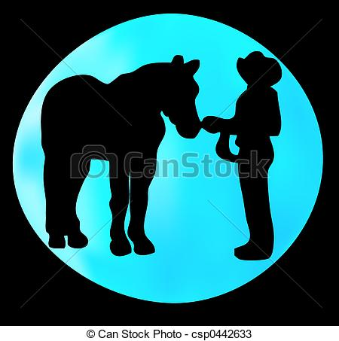

Please RSVP by March 1 to cm1862@att.com
This is necessary for planning lunch items.

It is the policy of the University of California (UC) and the UC Division of Agriculture & Natural Resources not to engage in discrimination against or harassment of any person in any of its programs or activities (Complete nondiscrimination policy statement can be found at http://ucanr.edu/sites/anrstaff/files/187680.pdf )
Inquiries regarding ANR’s nondiscrimination policies may be directed to Linda Marie Manton, Affirmative Action Contact, University of California, Agriculture and Natural Resources, 2801 Second Street, Davis, CA 95618, (530) 750-1318.

