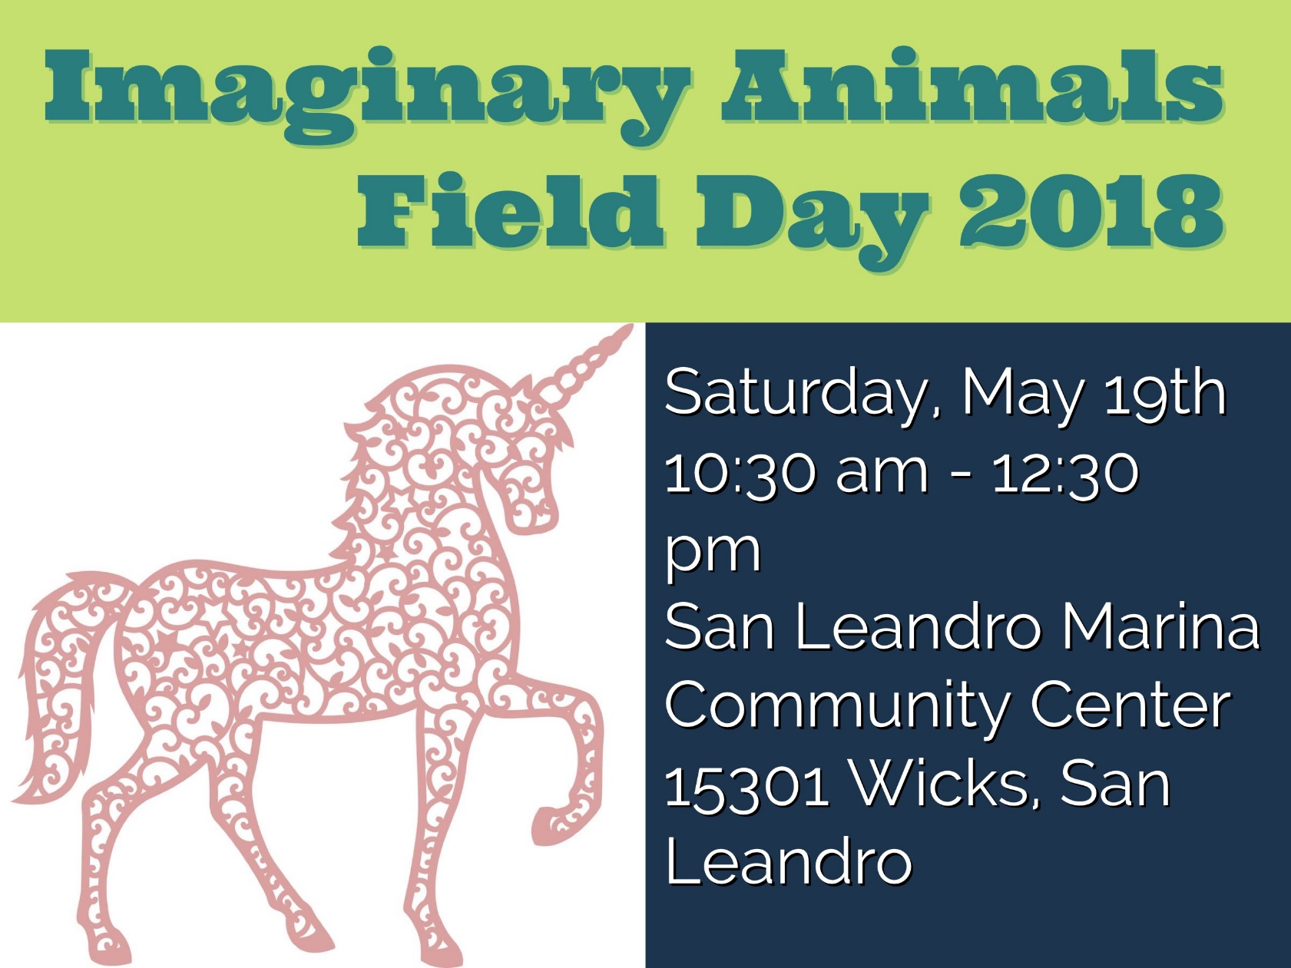
Saturday October 13, 2018

9:30 am – 12:30 pm

at East Hills Community Church
12000 Campus Drive
Oakland, Ca 94619

Come for Fun! Crafts! Snacks!

Imaginary Animals Art Contest
Design your own Imaginary Animal Contest

Make a Cat Toy Community Service

Puppet Show

Put on by East Hills 4-H Imaginary Animals Field Day Committee

Contact Felix King for more information: fowypup527@gmail.com




UCCE Alameda County 4-­‐H Office | 510-670-5639| cyfraser@ucanr.edu| http://4halameda.ucanr.edu

The University of California prohibits discrimination or harassment of any person in any of its programs or activities. (Complete nondiscrimination policy statement can be found at http://ucanr.org/sites/anrstaff/files/107734.doc)
Inquiries regarding the University’s equal employment opportunity policies may be directed to John Sims, Affirmative Action Contact, University of California, Davis, Agriculture and Natural Resources, 2801 2nd Street, Davis, CA 95618, (530) 750-1397.
It is the policy of the University of California (UC) and the UC Division of Agriculture & Natural Resources not to engage in discrimination against or harassment of any person in any of its programs or activities (Complete nondiscrimination policy statement can be found
at http://ucanr.edu/sites/anrstaff/files/215244.pdf ) Inquiries regarding ANR’s nondiscrimination policies may be directed to John I. Sims, Affirmative Action Compliance Officer/Title IX Officer, University of California, Agriculture and Natural Resources, 2801 Second Street, Davis, CA 95618, (530) 750-­‐ 1397.

