

2019 Contra Costa County 4-H Showmanship Clinic
Saturday, March 16 9:00-11:45 am
Borges Ranch, 1035 Castle Rock Road, Walnut Creek
8:30 Registration table opens Tassajara 4-H will be selling coffee, tea, and morning snacks
9:00 Welcome! Pledge, Introductions, and Overview of how the clinic runs
9:15 Demonstrations begin. Groups rotate through stations every 25 minutes
Meet the animals and learn from the experts how to show at fairs and competitions
10:30 Coffee (and bathroom) break!
11:45 4-H State Exchange serves up a pulled pork lunch plate for just $5. All proceeds support the exchange program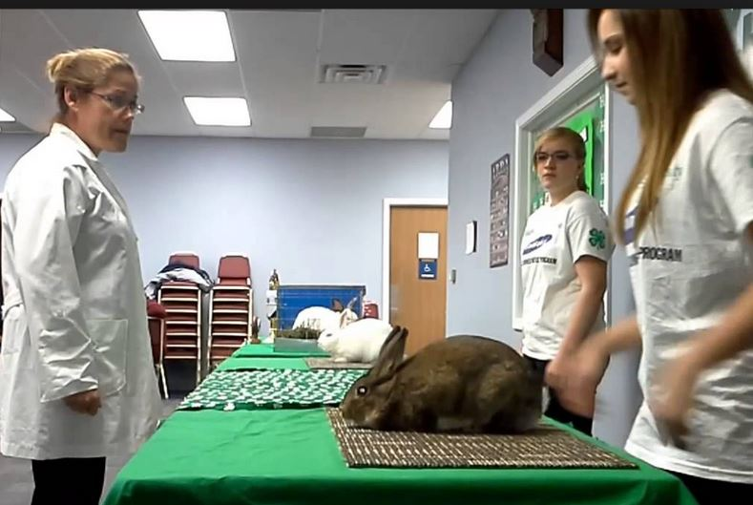 
It is the policy of the University of California (UC) and the UC Division of Agriculture & Natural Resources not to engage in discrimination against or harassment of any person in any of its programs or activities (Complete nondiscrimination policy statement can be found at http://ucanr.edu/sites/anrstaff/files/215244.pdf) Inquiries regarding ANR’s nondiscrimination policies may be directed to UCANR, Affirmative Action Compliance & Title IX Officer, University of California, Agriculture and Natural Resources, 2801 Second Street, Davis, CA 95618, (530) 750-1397.

