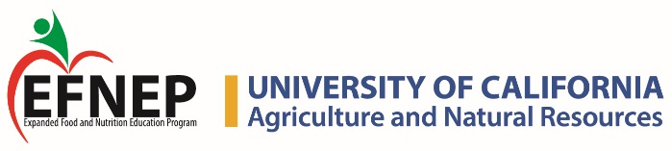

CERTIFICATE OF APPRECIATION
California Expanded Food and Nutrition Education Program
Is presented to

Teacher’S Name

in grateful appreciation for partnering with EFNEP to provide a minimum of six evidenced-based youth nutrition education lessons. Thank you for your dedication to student health.

___________________________________________________________________
Nutrition Educator

__________________
Date

