Live Well in the Garden
Planting Herbs Lesson Plan Walkthrough

MATERIALS

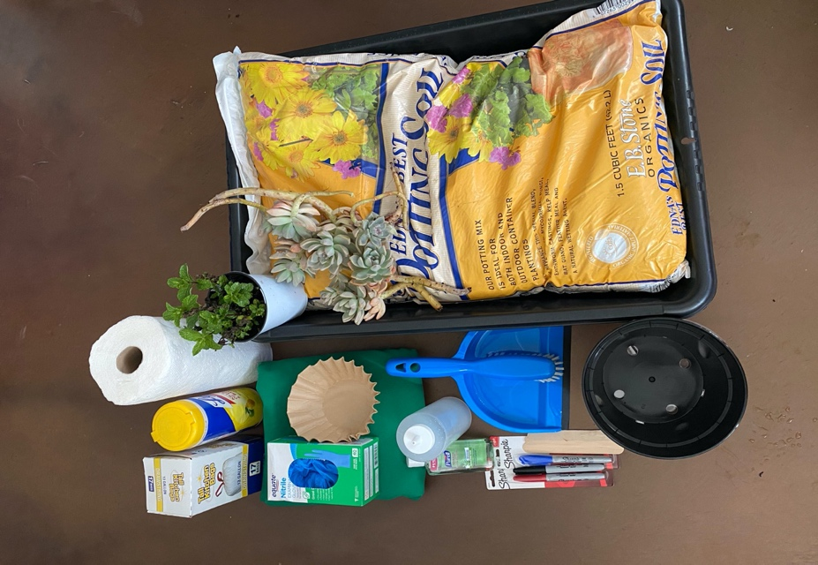
- Broom, brush, dustpan, wipes, Paper towels for cleanup
- Coffee filters (for bottom of pot)
- Gloves (nitrile, disposable)
- Plant labels (popsicle sticks) & markers
- Plants
- 8” Plastic Pots & saucers
- Potting soil
- Squirt bottles for watering plants (Watering cans– small or large will work)
- Tablecloth
- Trash bags
- Tubs for soil (cement mixing tub, tidytray)
- Nearby Faucet or 1-gal container for filling squirt bottles + funnel

OTHER:

- Lesson plan / script
- Sign-in Sheet
- Handouts or other paper resources
- General supplies (Scissors, Twine, Tape)
- Apron
- Name badge/tag
- 1-gal container for filling squirt bottles + funnel (if no running water on site)
- Sample of finished product (potted-up herbs, salad greens, edible flowers, etc.)

Broom, Brush, Dustpan, Wipes, Paper Towels, Trash Bags.  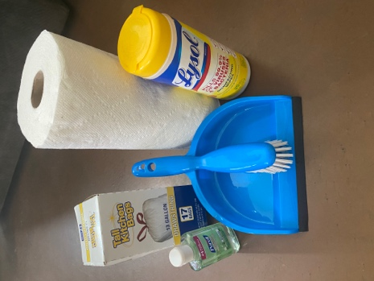 | Coffee Filters  (Unbleached, for Bottom of Pot)  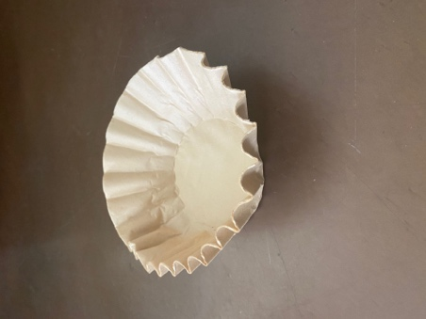 | Gloves  (Nitrile, Disposable)  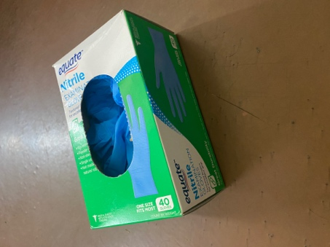
Plant Labels  (Popsicle Sticks) & Markers  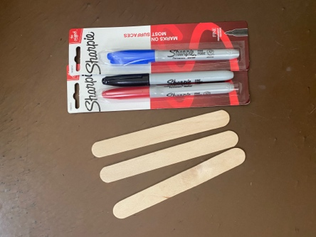 | Plants  (Purchased or Cuttings from Home)  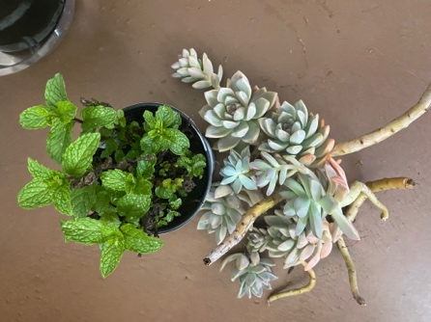 | Tub for soil  (Mortar Mixing Tub or Tidy Tray)  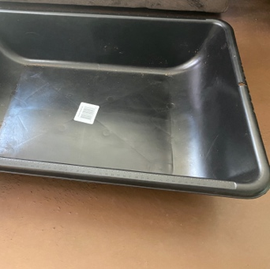
Potting Soil  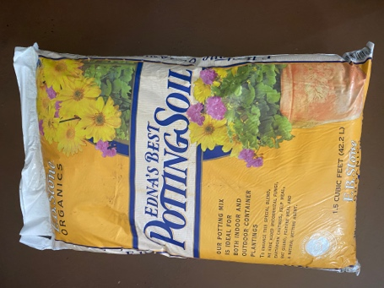 | Squirt bottles (or watering can)  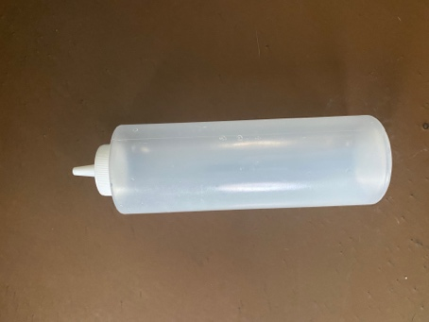 | Tablecloth  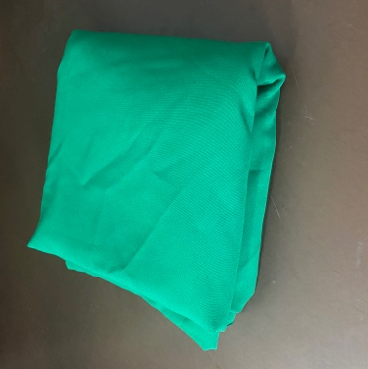
8” Plastic Pot  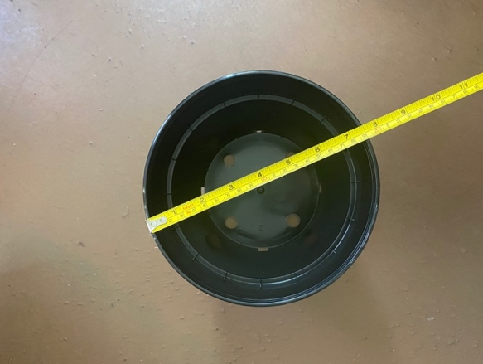 | Saucer (to catch water)  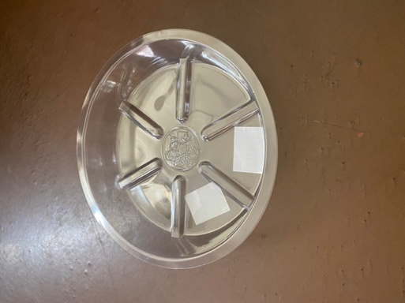 | Example of completed project  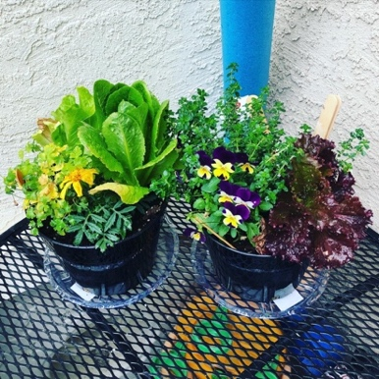
Planting Steps . . .

- SET UP YOUR WORKSTATION
  - Put a tablecloth down on your workstation/table.
  - Fill a mortar tub, tidy tray, or other shallow container 1/3 full of organic potting soil.
  - Have your other materials set up on the same table within arm’s reach. You can put your plants in your tub for easy access while planting.
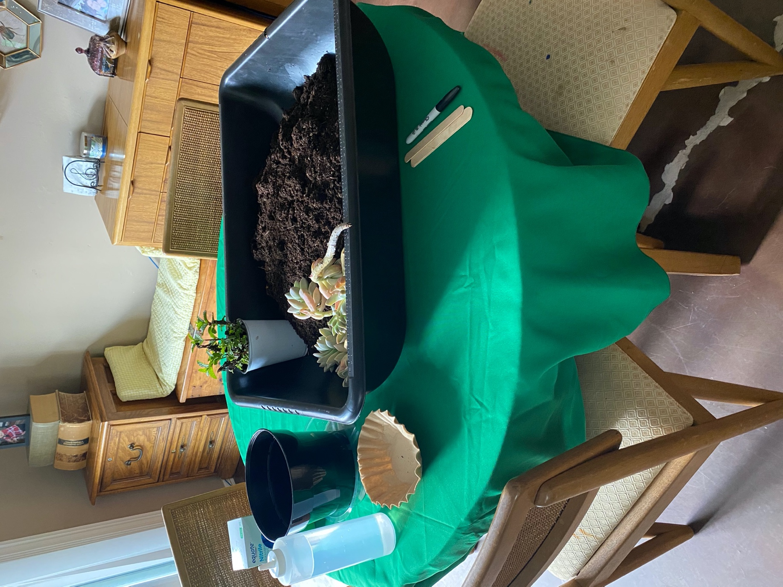

- WET SOIL
  - Soil is moist enough when you take a fist full of soil, squeeze it in your hand, and when you open your hand, the soil stays compact in a ball shape.

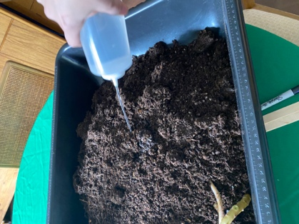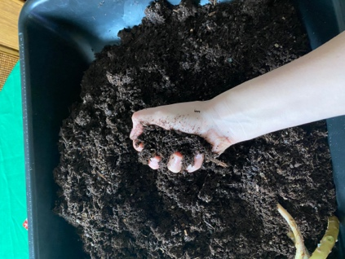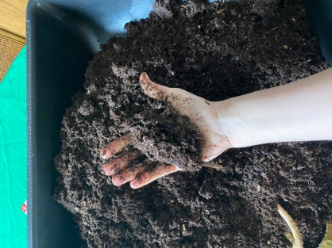

- PLACE COFFEE FILTER IN THE BOTTOM OF THE POT.

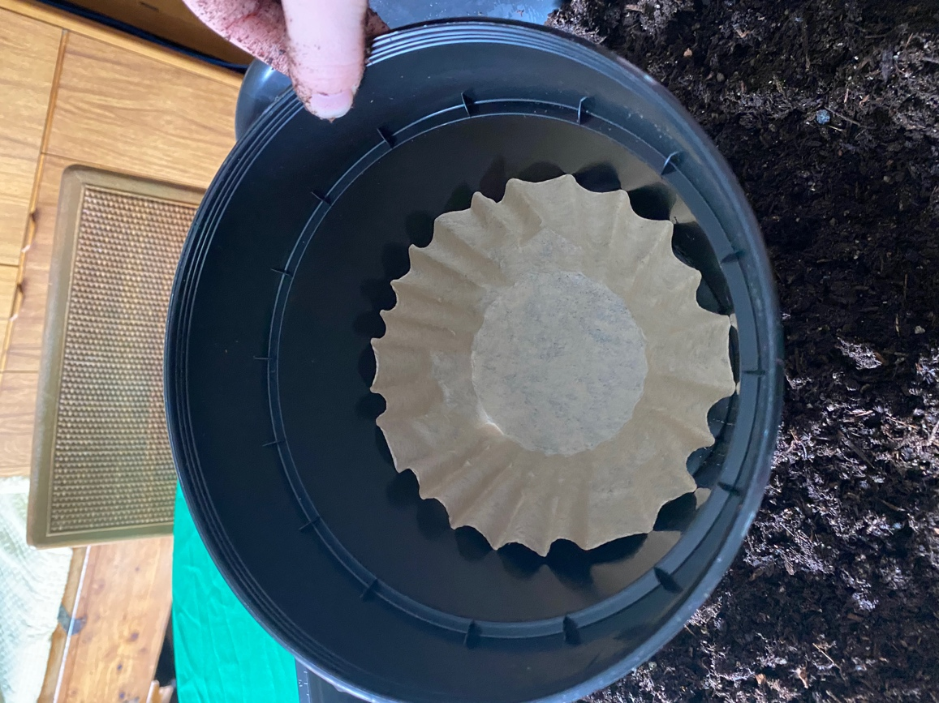

- FILL POT WITH SOIL TO ABOUT 3 INCHES BELOW THE RIM.

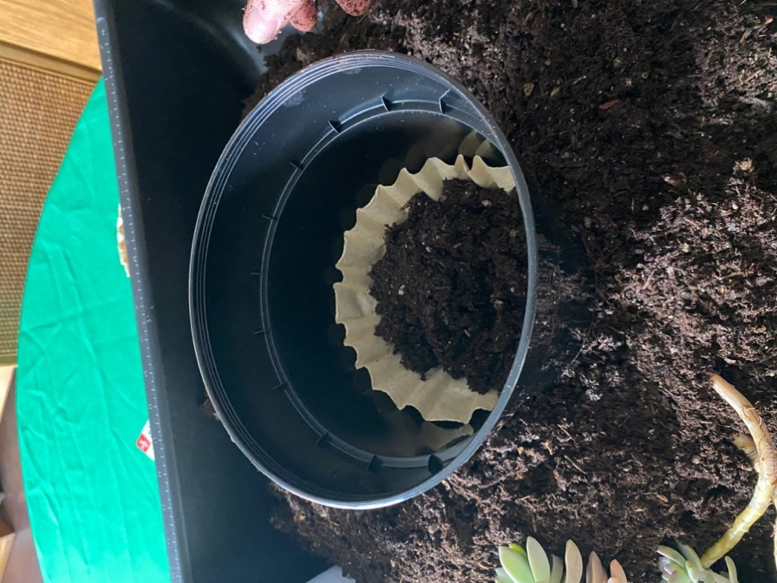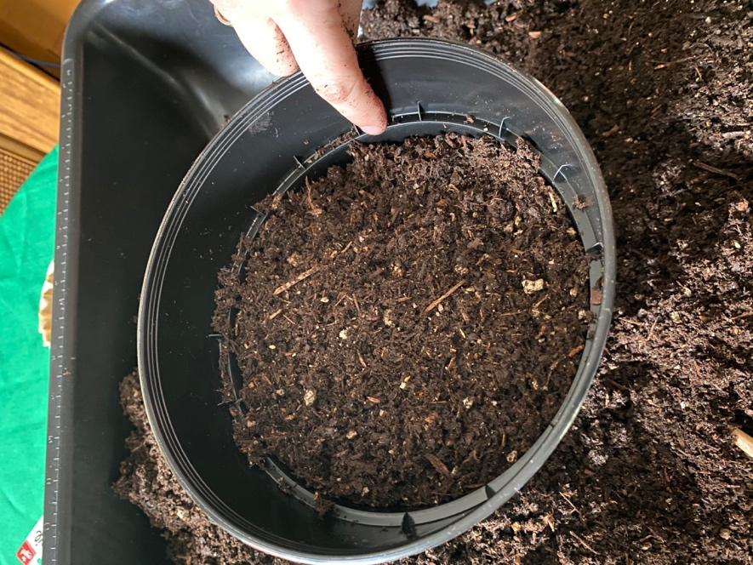

- REMOVE PLANTS FROM POTS
  - Remove plant pots/pony packs, explaining the process. Squeeze plants at the bottom of the plastic pot, tilting them slightly downward, and gently letting them slide out into your hand.

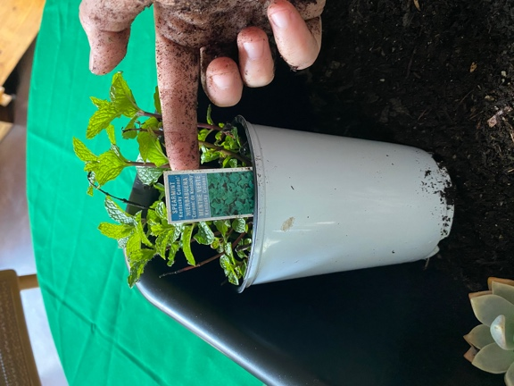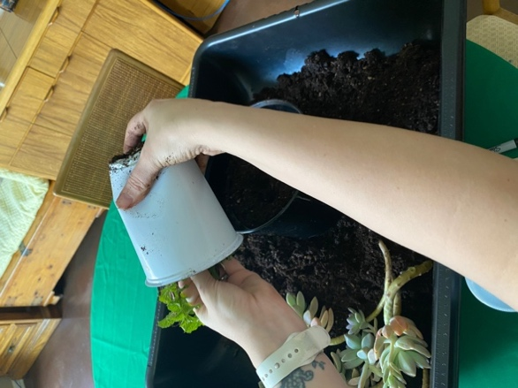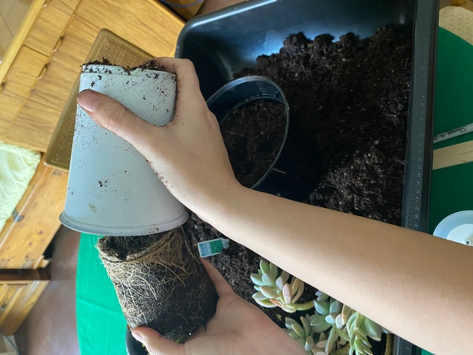

- ROOTS
  - If the plants have wound up roots, tease them out gently to encourage their growth downward.

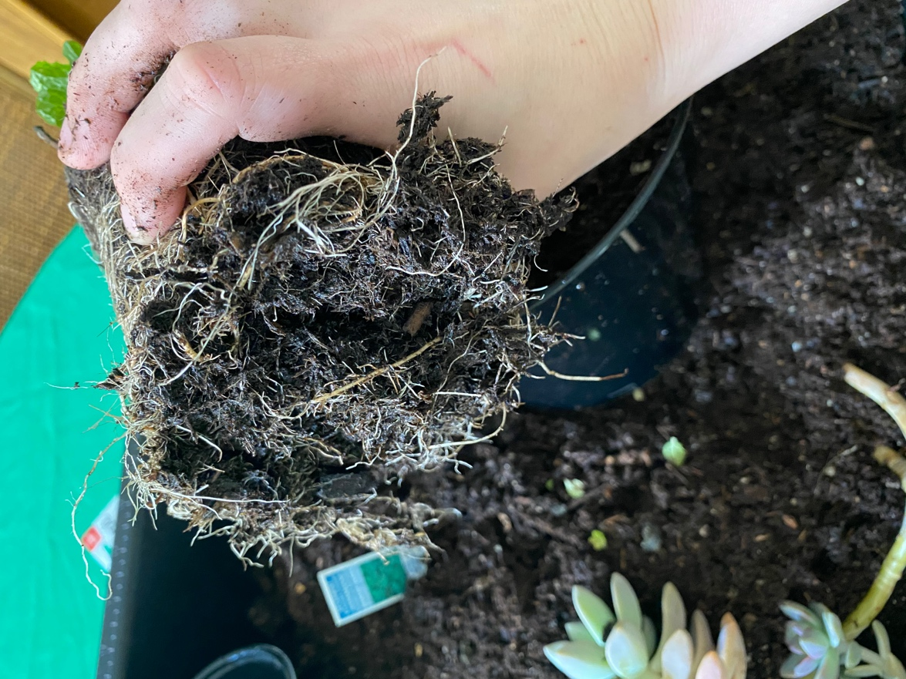

- PLANT IN SOIL
  - Place plants on soil and add more soil around the edges to bring soil level to 1 inch below pot’s rim.
  - Gently tuck plants in to remove air pockets.

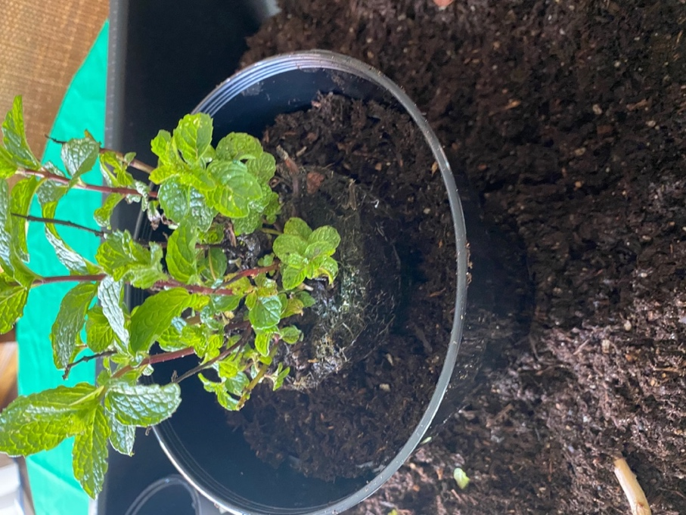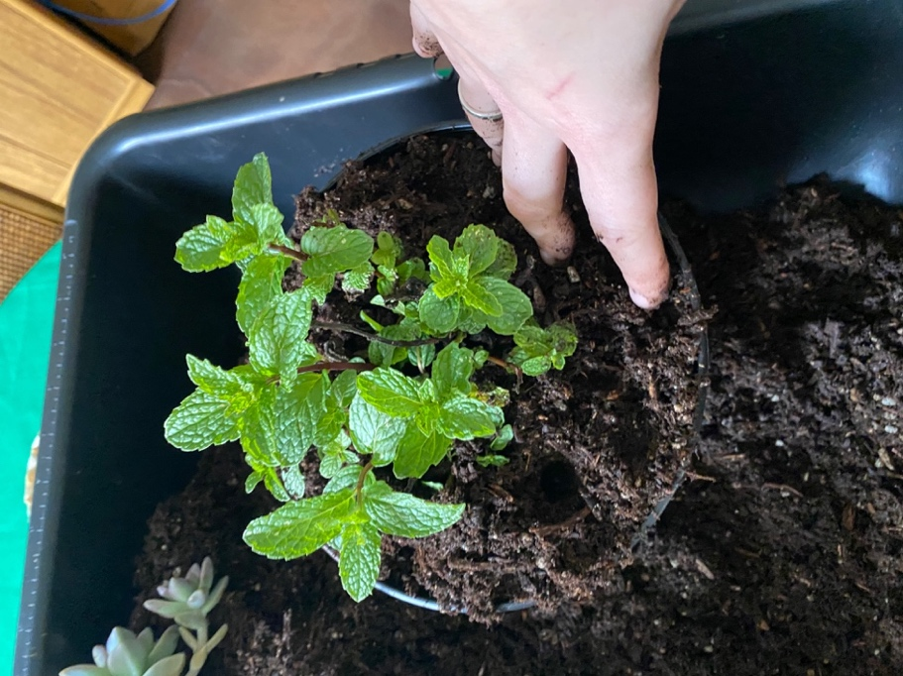

- WATER LIGHTLY WITH SQUIRT BOTTLE.

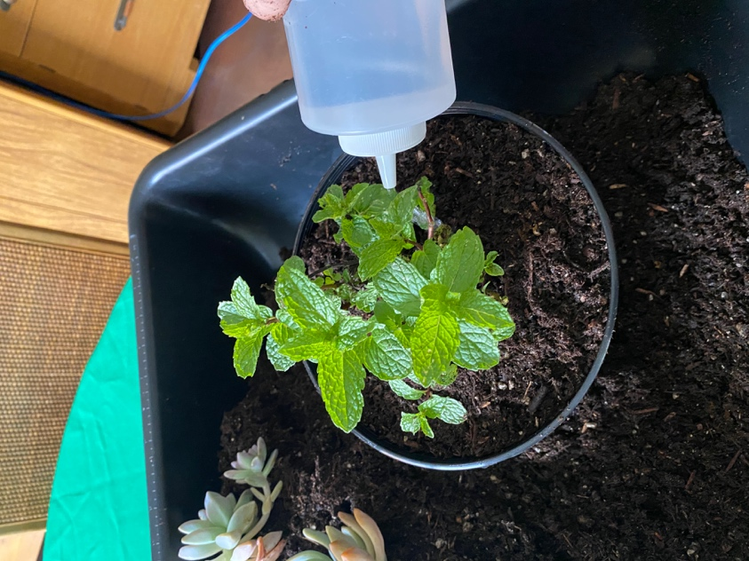

- LABEL THE PLANT
  - Create a label for your plant(s) with a popsicle stick and permanent marker.

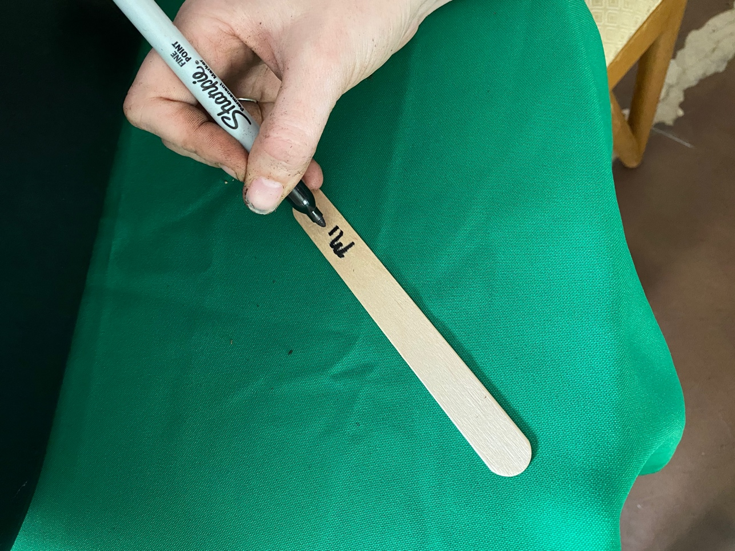

- PLACE FINISHED POT ON SAUCER.

