HOW TO: SQUARE FOOT GARDEN

Build a Box Fill it with grow mix Add a Grid Start Planting

” x 8” wood
1

4
’

4
’

4

3

2

1

5

6

7

8

9

10

11

12

13

1
4

15

16

Plant Spacing in Each Square
Cabbage Lettuce Spinach Carrots
Pepper Marigold Beans Radishes

1 per sq. 4 per sq. 9 per sq. 16 per sq.

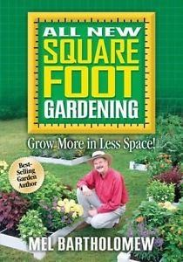
Square Foot Gardening

FG takes only: 20% of the space
15% of the water
10% of the labor
5% of the seeds
0% of the fertilizer
Yet produces: 100% of the harvest

- Most plants grow plants in only 6 to 8 inches of growing medium.
- Growing medium: 1/3 blended compost, 1/3 peat moss, 1/3 course vermiculite.
- As you harvest, add a trowel full of blended compost to the empty square and plant your next crop.
- SFG needs no fertilizer (compost does it all).
- LITTLE TO NO WEEDS
- NO DIGGING
- NO ROTO-TILLING
Square Foot Garden courtesy of:


University of California Cooperative Extension Master Gardeners of Tulare-Kings Co. Have a gardening question? The UC Master Gardeners offer free information On gardening. Call anytime and we will return your call.
Tulare: (559) 684-3325 & 684-3326 Hanford: (559) 852-2736

TEN BASICS

1. Layout | Arrange garden in squares, not rows. Layout 4’ x 4’ planting areas. For higher yield production, try some 4’ x 8’ or 12’ boxes.
2. Boxes | Build bottomless boxes to hold new soil mix. Add plywood bottoms for tabletop gardens.
3. Aisles | Space boxes 3’ apart to form walking aisles.
4. Soil | Fill boxes with special “Soil” mix: 1/3 blended compost, 1/3 peat moss, and 1/3 course vermiculite.
5. Grid | Make a square foot grid for the top of each box. A MUST!
6. Care | NEVER WALK ON YOUR GROWING SOIL. Tend your garden from the aisles.
7. Select | Plant a different flower, vegetable, or herb crop in each square foot; using 1, 4, 9, or 16 plants per square foot.
8. Plant | Conserve seeds. Plant only a pinch (2 or 3 seeds) per hole. Transplants are planted in a slight saucer-shaped depression.
9. Water | Water by hand or drip irrigation system.
10. Harvest | When you finish harvesting a square foot, add compost and replant it with a new different crop.

LOCATION


Pick an area that gets 6 – 8 hours of sunshine daily. (Most plants need this.)

Be sure it is not near trees and shrubs. (Watch for roots and shade.)



Have it as close as possible to the house. (For convenience, and protection.)

Existing soil is not really important. (Since you won’t be using it.)
Area has no puddles after a heavy rain. (Drainage is important.)
What could be easier than this? And start planting!
Build a box | 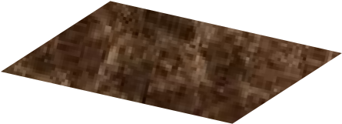  Fill with “Soil” Mix | 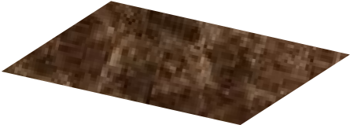  Add a grid

Square Foot Gardening Plant & Seed Spacing

Looking at the back of the seed packet…if instructions indicate “thin to”

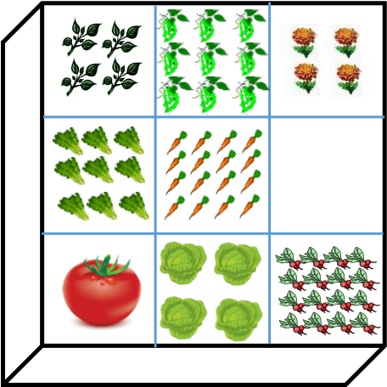
12” spacing = 1 plant / square foot (tomato)
6” spacing = 4 plants / square foot (lettuce)
4” spacing = 9 plants / square foot (spinach, onions)
3” spacing = 16 plants / square foot (radish, carrot)

XL L M S XS
1 plant per 2 square feet 1 plant 4 plants 9 plants 16 plants

Watermelon Tomato Lettuce Bush bean Radish
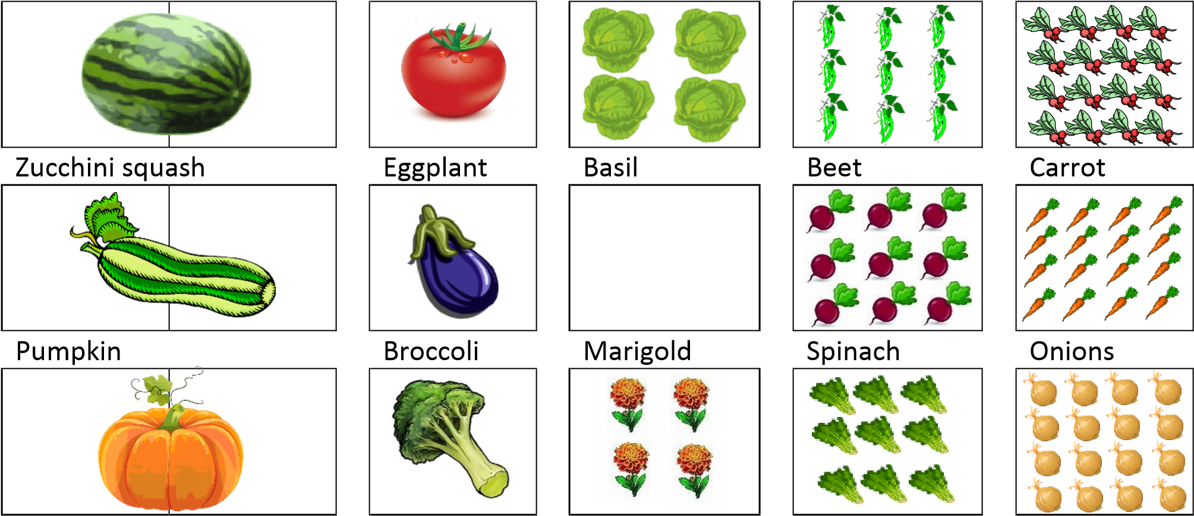
Melon Cabbage Corn
Winter squash Cauliflower Parsley
Summer squash Cucumber Potato
Okra Strawberry
Pepper Turnip

