Lesson 4 - Introduction to Epidemiology: Spreading Sickness in Middle School
Worksheet: Pass it On

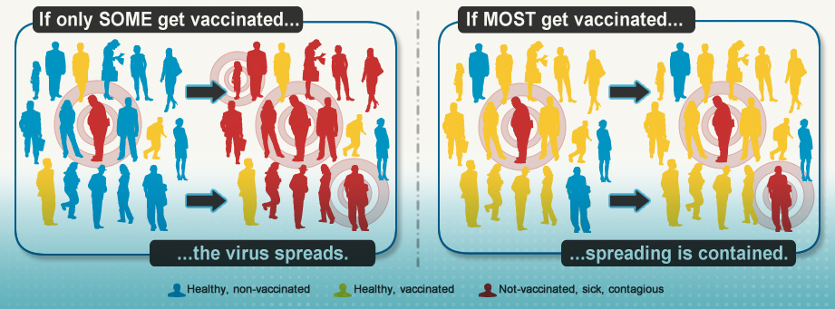

Directions: You are an epidemiologist who is studying the spread of a contagious disease in your class. You will be taking part in a simulation of disease transmission.
Background Pathogens such as viruses and bacteria can cause diseases, many of which are vaccine-preventable. Many infectious diseases are spread from person to person. If one person in a community gets an infectious disease, he or she can spread it to persons without immunity. However, persons immune to a disease because they have been vaccinated are considerably less likely to get that disease and will not be able to spread it to others. An increase in the number of persons vaccinated for a certain disease reduces the potential for that disease to spread. If one or two cases of an infectious disease are introduced into a community in which the majority of persons are not vaccinated, outbreaks are more likely to occur. In 2013, for example, multiple measles outbreaks occurred around the country, including substantial outbreaks in New York City and Texas, mainly among groups with low vaccination rates. If vaccination rates were to drop to low levels nationally, herd immunity (i.e., protection against infectious disease that occurs when a substantial percentage of the population has become immune to an infection, often through vaccination) would diminish; as a result, diseases could return and be as common as when vaccines were not available. Vaccination programs have low costs in terms of money; however, the cost of not vaccinating can lead to high direct costs (e.g., medical costs) and indirect costs (e.g., missed work days) that can affect a person, family, or whole society. (See http://www.cdc.gov/vaccines/vac- gen/whatifstop.htm for more information.)
This lesson uses an interactive activity where students simulate disease transmission with vaccinated and unvaccinated persons and work to identify the original carriers of the disease.

Disease Transmission Activity Steps

- Get your “Card” with your Card # and Card Code and write your Card # and Card Code on the top of Table 1 in the designated area.

- Complete the First Exchange – Grocery Store visit when given the signal.

- Record the other student’s name, Card # and Card Code in Table 1 under Grocery Store Exchange.

- Complete the second, third, and fourth Exchanges when given the signal. For each exchange, record the student’s name, Card # and Card Code in Table 1.

- Using the key for the Card Codes, complete Table 1 section for the Infected and Not Infected columns.

- Complete Figure 1. For each Exchange, write the student’s Card # and Card Code in the circle. Then circle Sick or Healthy for each exchange. If you are Sick, circle the arrow leading to each person(s) you infected. If you became Sick from another Sick person, circle the arrows to each person who infected you.

- On Table 2, write your Card #, vaccination status, and check if you are Sick or Healthy. As a class complete all of Table 2 with information for all people who became Sick from another Sick person.

- As a class, attempt to draw Figure 2 to help identify the original carriers of the disease. Hint: Start with those who are Sick and work backward. For example, look at those who are Sick and their exchange partners.

- Complete Analysis Questions.

Table1. Exchanges 1 - 4 and Sick or Health status of each person.
Your Name: ___________________________________
Card #: _________ Card Code: __________________________
Exchange | Student Name | Card # | Card Code | Sick  (Infected) | Healthy  (Not Infected)
1
Grocery Store
2
Restaurant
3
School
4
4-H Club Meeting

Figure 1. Disease transmission diagram for student exchanges 1-4, including student card numbers and Sick/Healthy status. Note: Circle the Arrow(s) associated with each person you made Sick and each person who made you Sick.
Exchange 3 School
Card # _______
Card Code ______
Sick or Healthy
(Circle one)
Exchange 1 Grocery Store
Card # _______
Card Code ______
Sick or Healthy
(Circle one)

You
Card # _______
Card Code ______
Sick or Healthy
(Circle one)

Exchange 2 Restaurant
Card # _______
Card Code ______
Sick or Healthy
(Circle one)
Exchange 4 4-H Club Meeting
Card # _______
Card Code ______
Sick or Healthy
(Circle one)

Table 2. Class exchange data of Sick (infected) and Healthy (not infected) students.
Card # | Vaccinated Yes or No | Sick  (Infected)  Mark with a | Healthy  (Not Infected)  Mark with a
1
2
3
4
5
6
7
8
9
10
11
12
13
14
15
16
17
18
19
20
21

Figure 2: Class Transmission Diagram
Directions: Draw a diagram by using Table 2. For those not vaccinated use a circle and include the Card # in the circle. For those vaccinated, use a square and include the Card # in a square. Attempt to retrace the infection back to two to three students.
Hints: 1) Start with those who are Sick (Infected) and work backward (For example, look at those who are Sick and their exchange partners), 2) Identify those who were made Sick by someone else (use directional arrows), 3) Identify those who made someone else Sick (use directional arrows).

Example of Figure 2.

Analysis Questions
- What is the proportion of students Sick (infected) compared to students Healthy (not infected)?
Hint: To calculate the proportion of Sick (infected) students, divide the number of Sick students by the total number of students.

- Explain how you figured out who made someone sick (infected a person).

- Explain how a student could be Healthy, although he or she exchanged with one or more Sick persons.

- Explain how a student could be Sick, although he or she was vaccinated and exchanged with one or more Sick persons.

- What do you think might have happened if certain students had not been vaccinated? How does this relate to disease transmission and herd immunity?

