Berries, Berries and More

Basic Food Safety
Wash Hands Frequently
- Personal cleanliness is a must. Wash your hands thoroughly and frequently. E. coli bacteria reside in the human nose and intestines. Wash your hands if you rub your nose, or if you wipe your face or skin.
- Bandage any cuts or burns on hands before handling food or use disposable gloves.
Avoid Cross Contamination
- Rinse all fresh fruits and vegetables well under running water before preparing or eating them. Dry them with a clean cloth or paper towel.
- ALWAYS wash your hands, knives, cutting boards, and food preparation surfaces thoroughly with hot soapy water before and after any contact with raw meat, fish, or poultry.
- Use a disinfecting solution of 1½ teaspoon of chlorine bleach to 1 pint of water. Apply with a spray bottle to disinfect countertops, cutting surfaces, sinks, etc. Let the solution sit on the surface one minute, then wipe it off. Make a new solution daily.
When In Doubt, Throw It Out
- Never taste food that looks or smells strange to check whether it is safe to eat.
- Most bacteria that cause foodborne illness are odorless, colorless, and tasteless.

Get Ready, Be Prepared

- Read the recipe thoroughly before you begin.
- Measure out all ingredients. Do not change the quantities in any recipe that calls for pectin. Follow directions for the pectin or the finished product will not gel correctly.
- Have all necessary utensils at hand.
- Wash jars, lids and rings in hot soapy water and rinse well.
- Place clean jars into the boiling water canner and heat them to 180°F.
- To prepare lids, follow the manufacturer’s directions on the lid package; some say to heat and some say just wash.
- Fill hot jars with hot mixture. Leave headspace as specified in the recipe.
- Wipe the jar rim.
- Place lids and rings on jars. Tighten the rings only finger tight.

Boiling Water Canner Processing

- Place jars in a canner with a rack.
- Water should be 140° for raw pack jars and 180° for hot pack jars. Add enough water to cover the tops of the jar by at least 1" to 2". Cover with 2" of water if processing time is more than 30 minutes.
- Place lid on canner. Bring the water to a rolling boil, then reduce heat to a gentle boil.
- Begin to count processing time when the water comes to a boil.
- Process for the time indicated in the recipe.
- All recipes are developed using sea level as the criteria for processing time. If you are at a higher altitude, adjust the processing times according to the following chart:

Altitude Chart
Altitude in feet | Increase processing time
1000 - 3000 | 5 minutes
3001 - 6000 | 10 minutes
6001 - 8000 | 15 minutes
8001 - 10000 | 20 minutes

- Remove lid and let sit for 5 minutes, then remove jars from the canner. When you take the jars from the canner after processing, hold upright; do not disturb the seal. Do not retighten the rings. Place the hot jars on a rack or folded towel away from drafts or cool surfaces. Keep the jars separated so they will cool evenly.
- Leave the ring bands on the jars until they have cooled (approximately 24 hours). Do not try to dump the water off the lids.
- Do NOT invert jars: Some canning books still recommend inverting the jars after removing them from the boiling water canner. The USDA does not recommend this method.
- After the jars have cooled, remove the ring bands. Look at the top of each jar. If the lid is slightly concave, it indicates a seal. Test the seal by pressing on the lid with your finger; the lid should not give. If you are not sure a jar is sealed, carefully lift the jar by the lid after removing the ring band. If not properly sealed, the lid will come off.
- Wash and dry bands. Store rings for future use. Storing jars with rings attached is not recommended. Clean the jars with a damp cloth. Label and date the jars, and store in a cool, dark, dry area.

Reprocessing - If a jar did not seal, refrigerate and use within a few days, or reprocess it within 24 hours using a new lid. Check the jar for flaws. Process by the method originally advised and for the full length of time.

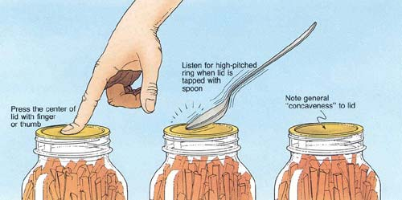

Atmospheric Steam Canner Processing

- Use a research tested recipe and processing time developed for a boiling water canner when using an atmospheric steam canner. An atmospheric steam canner may be used with recipes approved for half-pint, pint, or quart jars.
- Add enough water to the base of the canner to cover the rack. (Follow manufacturer recommendations.)
- Preheat water to 140°F for raw packed foods and to 180°F for hot packed foods. Food preparation can begin while this water is preheating. Do not have the water boiling when you add the jars.
- Heat jars prior to filling with hot liquid (raw or hot pack). Do not allow the jars to cool before filling.
- Load filled jars, fitted with lids, onto the canner rack and place the lid on the canner base.
- Turn heat to its highest position to boil the water until a steady column of steam (4-6 inches) appears from the vent hole(s) in the canner lid. Jars must be processed in pure steam environment.
- If using a canner without a temperature sensor, begin processing time when a steady stream of steam is visible from the vent hole(s). I
- If using a canner with a temperature sensor, use the temperature gauge only as a guide.
  - The processing time should begin only after a full column of steam (approximately 6 -8 inches) appears through the canner vent holes at the bottom of the cover. Some canners come with built-in temperature sensors, which can be used to monitor the temperature. A full column of steam should be present throughout the process time. If there is an interruption in the steam, the product should be reprocessed for the full processing time.
  - The temperature gauges on steam canners cannot be tested, therefore it is not recommended that they be relied upon to know when to start the processing time.
- Set the timer for the total minutes required for processing the food, adjusting for altitude. Processing time must be limited to 45 minutes or less, including any modification for elevation. The processing time is limited by the amount of water in the canner base. When processing food, do not open the canner to add water.
- Monitor the temperature sensor and/or steady stream of steam throughout the entire timed process. Regulate heat so that the canner maintains a temperature of 212°F. A canner that is boiling too vigorously can boil dry within 20 minutes. If a canner boils dry, the food is considered under-processed and therefore potentially unsafe.
- At the end of the processing time, turn off the heat, wait 5 minutes then remove the lid, lifting the lid away from you.
- Using a jar lifter, remove the jars without tipping and place them on a towel, leaving at least 1 inch spaces between the jars during cooling. Let jars sit undisturbed to cool at room temperature for 12 to 24 hours.
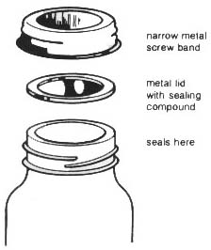
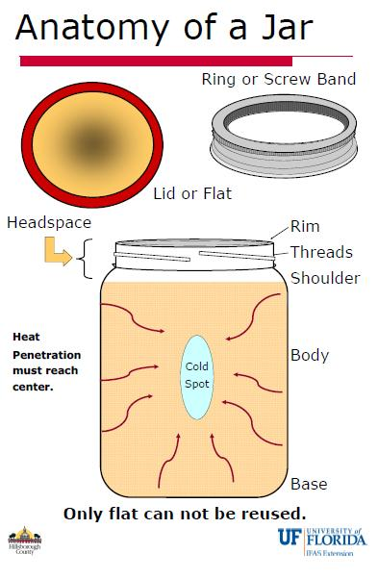
Dehydrating Berries
Blackberries (all varieties) and raspberries are not recommended for drying because of their high
seed content and slow drying time. They do make excellent fruit leathers.

Blueberries
Select large, firm, fully ripe berries that have a deep, blue color. Wash berries and remove the stems. Blueberries may be dried without any pretreatment but will dry faster if they are dipped in boiling water to crack the skins before drying. When blueberries are dried with no pretreatment, they will be puffy in appearance and texture. Those dipped in boiling water will be raisin-like in quality.

Blueberries are dry when they are leathery and pliable with no pockets of moisture. They are excellent eaten as a snack or added to cereal, baked products, and pancakes.

Strawberries
The sweeter varieties are best for drying. Select firm, ripe, red berries with a solid color. They should be picked when fully ripe for best flavor. Wash berries remove caps and cut into ½ inch slices or cut smaller berries in half. Dry skin-side down. No pretreatment is necessary. Strawberries are dry when they are pliable and leathery with no pockets of moisture.

Dried strawberries can be eaten as a snack, added to cooked and dry cereals, combined with granola, or added to milk shakes or yogurt. They are better eaten dry because they lose their firm texture when rehydrated.

Berry Leathers
Berries of all kinds can be puréed, either by themselves, or in combination with other fruits, such as apples and pears, to make fruit leathers. It is desirable to remove seeds from the purée since they become very hard after they are dried.
To make fruit leathers, purée berries, strain seeds, sweeten to taste and pour on a leather drying sheet or drying tray or cookie sheet, covered with plastic wrap. Place in a dehydrator or warm oven (145˚ F.) and dry until leathery with no moisture pockets.

Remove from drying tray and roll or cut into bite-size pieces. Wrap and store in a cool, dry place.

Source: Oregon State University http://extension.oregonstate.edu/fch/sites/default/files/documents/sp_50_780_preservingberries.pdf

Freezing Berries

Quick Facts about freezing:
- Freezing is one of the simplest and least time-consuming ways to preserve foods at home.
- Berries and cherries are best frozen soon after harvest. Peaches, plums, and apples may need to fully ripen before freezing.
- Small whole fruits, such as berries or cherries, can be frozen individually on trays, packaged in bags and later used in salads or garnishes.
- Most fruits maintain high quality for 8 to 12 months at 0 degrees F or below.

Preparing the Fruit
Sort, wash and drain fruits carefully, discarding parts that are green or of poor quality. Do not allow fruit to soak in wash water or it will lose nutrients and flavor. Prepare fruits as they will be used–stemmed, pitted, peeled, or sliced. Prepare enough fruit for only a few containers at a time, especially those fruits that darken rapidly. Do not use galvanized equipment in direct contact with fruit. The acid in the fruit dissolves zinc, which can be harmful in large amounts. Also, be wary of using iron utensils or chipped enamelware, as metallic off-flavors can result.

Freezing without sugar
Arrange dry, fresh berries on a cookie sheet in a single layer. Place the cookie sheet in the freezer. When frozen, transfer berries to freezer bags or containers. Seal and label. Properly frozen berries will last up to two years.

Freezing with sugar
To freeze whole, sliced or crushed berries, add ¾ cup sugar to 1-quart (about 1⅓ pounds) of berries. If you are freezing blueberries with sugar, you would want to crust them before adding the sugar. Stir until most of the sugar dissolves and let stand for 15 minutes before putting berries into containers. Soft sliced berries will yield sufficient syrup for covering if the fruit is layered with sugar and allowed to stand 15 minutes.
When packaging, allow adequate headspace so that syrup does not expand and overflow the container when the berries freeze. Allow ½-inch headspace for berries packed without added sugar or liquid. Allow 1 inch headspace in wide top containers (¾ inch in narrow top pints and 1½ inches in narrow top quarts) when packing in juice, sugar, syrup or water, or the fruit is crushed or pureed.

Artificial Sweeteners
Follow the manufacturer’s directions to determine the amount of artificial sweetener to use for freezing berries. Remember though, they do not provide the beneficial effects of sugar such as color protection and thickness of syrup. An alternative is to add these sweeteners after the berries thaw

Freezing in syrup
Use a 30% syrup pack which is 1 ¾ cups sugar to 4 cups water which would give you approximately 5 cups of syrup. Dissolve sugar in cold or hot water. If hot water is used, cool syrup before using. Syrup may be made the day before and kept covered in the refrigerator. Up to one-fourth of the sugar may be replaced, amount for amount, with corn syrup or honey. Fruits packed in syrup generally are best for most cooking processes. To pack fruit in syrup, pour 1/2 cup cold syrup into each container. Add fruit and cover with additional syrup, leaving sufficient headspace at top of container. Allow 1/2 inch of headspace for wide-top pints, 1 inch for wide-top quarts, 3/4 inch for narrow-top pints and 1 1/2 inches for narrow-top quarts. Allow 1 1/2 inches of headspace for juices packed in narrow-top containers, regardless of size.
Freezing Tips
The more quickly berries freeze, the higher their quality will be and the smaller the ice crystals form. The desirable temperature for storing frozen foods is 0°F or lower.

RECIPE: Berry Blitz Freezer Jam Yield: Makes about 5 8 oz. jars
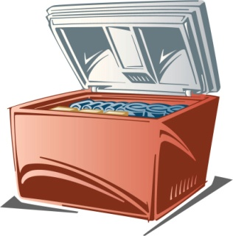
- 5 Tbsp Ball® RealFruit™ Instant Pectin
- 1 ½ cups sugar
- 1 cup crushed blackberries (about 1 ½ 6-oz container)
- 1 cup crushed blueberries (about 2 4.4-oz container)
- 1 cup crushed raspberries (about 1 ½ 6-oz container)
- 1 cup crushed strawberries (about 1 1-lb container)
- Zest of 1 small lemon
- Plastic Ball® (8 oz) Freezer Jars or 8 oz Glass Jars with Lids and Rings
STIR sugar and instant pectin in a bowl until well blended. ADD blackberries, blueberries, raspberries, strawberries and lemon zest. Stir 3 minutes. LADLE jam into clean jars to fill line or leaving 1/2-inch headspace. Twist on lids. Let stand until thickened, about 30 minutes. Serve immediately, refrigerate up to three weeks or freeze up to one year.
Source: https://www.freshpreserving.com/berry-blitz-freezer-jam---ball-recipes-br1088.html
RECIPE: Raspberry Vinegar Yield: about 10 4 oz. jars.
- 4 cups raspberries
- 5 cups white wine vinegar (5% acidity), divided

In a large glass bowl, combine raspberries and 1 cup of the vinegar. Using a potato masher, lightly crush raspberries. Add remaining vinegar, stirring to combine. Cover tightly with plastic wrap and let stand in a dark, cool place (70˚ to 75˚F) for 1 to 4 weeks, stirring every 2 to 3 days. Taste weekly until desired strength is achieved.

Prepare canner, jars and lids. Line a strainer with several layers of cheesecloth and place over a large stainless-steel saucepan. Strain without squeezing cheesecloth. Remove cheesecloth and raspberry pulp. Place saucepan over medium heat and heat vinegar until it reaches 180˚F.

Ladle hot vinegar into hot jars, leaving ¼ inch headspace. Wipe rim. Center lid on jar. Screw band down until resistance is met, then increase to fingertip-tight. Place jars in boiling water or atmospheric steam canner. Process in a boiling water or atmospheric steam canner for 10 minutes at 0-6000 ft., 15 minutes at 6001 ft. and above. Remove canner lid. Wait 5 minutes, then remove jars, cool and store.

Source: Ball Blue Book Guide To Preserving, 2009

RECIPE: Chocolate-Raspberry Sundae Topper Yield: about 6 half-pints
This incredible chocolate raspberry sauce has limitless potential! It is decadent, rich, and fantastically versatile. Serve over ice cream, cheesecake, or fruit. It makes a sure-to-be-appreciated hostess gift.

- ½ cup sifted unsweetened cocoa powder
- 6 Tbsp Ball® RealFruit™ Classic Pectin or
1 box other powdered pectin
- 4 ½ cups crushed red raspberries
- 6 ¾ cups granulated sugar
- 4 Tbsp. lemon juice
- 6 Ball® half-pint (8 oz.) glass preserving jars with lids and bands

Combine cocoa powder and pectin in a medium glass bowl, stirring until evenly blended. Set aside.
Combine crushed raspberries and lemon juice in a large stainless-steel saucepan. Whisk in pectin mixture until dissolved. Bring to a boil over high heat, stirring frequently. Add sugar all at once and return to a full rolling boil, stirring constantly. Boil hard for 1 minute, stirring constantly. Remove from heat and skim off foam.
Ladle hot product into hot jars leaving 1/4-inch headspace. Remove air bubbles. Wipe rim. Center lid on jar. Apply band until fit is fingertip tight. Place jar in boiling water canner. Repeat until jars are filled.
Process jars for 10 minutes, for 10 minutes 0-1000ft., 15 minutes 1001-6000ft, and 20 minutes above 6000 ft. Turn off heat, remove lid, let jars stand 5 minutes. Remove jars and cool. Check lids for seal after 24 hours. Lid should not flex up and down when center is pressed.
Source: Ball Complete Book of Home Preserving, 2006/2012

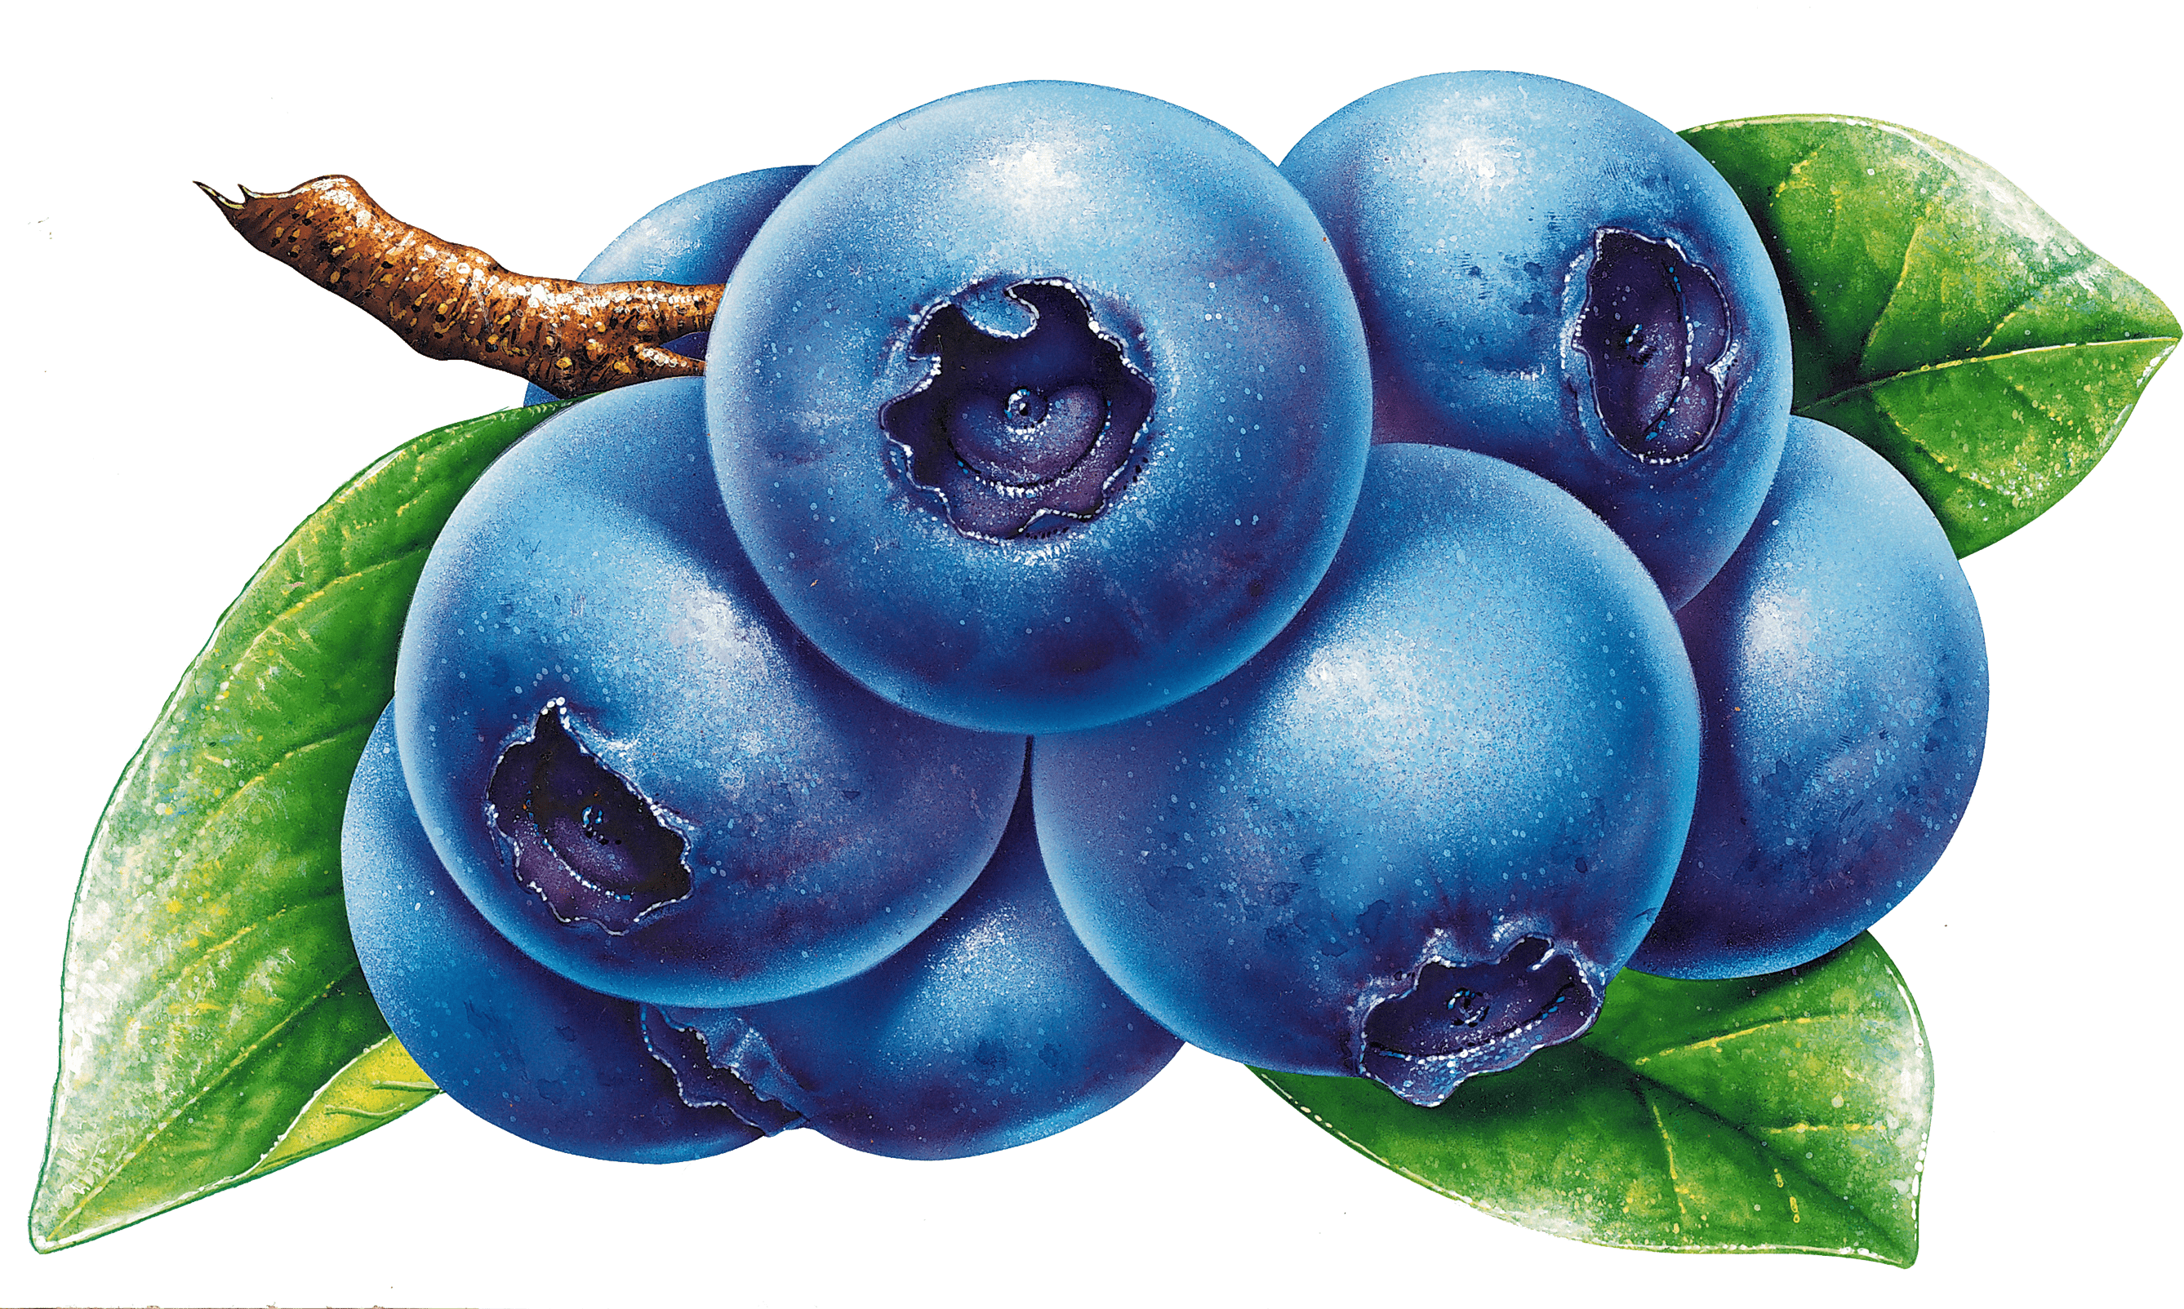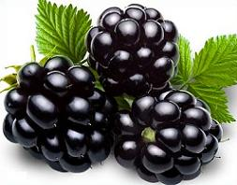

Recipe: Quick and Easy Blueberry Muffins

Makes 8 large, big-topped muffins / 10 standard muffins / 20-22 mini

PREP 10mins COOK 20mins TOTAL 30mins

This easy blueberry muffins recipe makes eight large, big-topped muffins, ten standard muffins or 20 to 22 mini muffins (see note below about baking time for mini muffins). Since most standard muffin tins have 12 muffin cups, if you plan on making the larger muffins, we recommend adding 1 to 2 tablespoons of water to the empty cups. This way the cups with water will heat up at the same rate as the cups with muffin batter, helping the muffins bake evenly.

Ingredients
- 1 ½ cups (195 grams) all-purpose flour
- 3/4 cup (150 grams) granulated sugar, plus 1 tablespoon for muffin tops
- 1/4 teaspoon fine sea salt
- 2 teaspoons baking powder
- 1/3 cup (80 ml) neutral-flavored oil; canola, vegetable and grape seed are great
- 1 large egg
- 1/3 to 1/2 cup (80 ml – 120 ml) milk; dairy and non-dairy both work
- 1 ½ teaspoons vanilla extract
- 6 to 8 ounces fresh or frozen blueberries; see note below about frozen berries (about 1 cup)

Directions
Heat oven to 400 degrees. For big-topped muffins, line 8 standard-size muffin cups with paper liners. For standard-size muffins line 10 muffin cups. Fill the remaining cups with 1 to 2 tablespoons of water to help the muffins bake evenly. Whisk the flour, sugar, baking powder, and salt in a large bowl. Add oil to a

measuring jug that holds at least 1 cup. Add the egg then fill the jug to the 1-cup line with milk (1/3 to 1/2 cup milk). Add vanilla and whisk to combine. Add milk mixture to the bowl with dry ingredients then use a fork to combine. Do not over mix. (The muffin batter will be quite thick — see note below for more details). Fold in the blueberries. Divide the batter between muffin cups. (If making big-topped muffins, the batter will come to the tops of the paper liners). Sprinkle a little sugar on top of each muffin.
Bake muffins 15 to 20 minutes or until tops are no longer wet and a toothpick inserted into the middle of a muffin comes out with crumbs, not wet batter. Transfer to a cooling rack.

To store, place them in a plastic bag, seal, and store at room temperature for 2 to 3 days. To freeze, wrap them tightly in aluminum foil or place them in freezer bags. Freeze for up to 3 months.

Tips
You can make these with fresh or frozen blueberries – if you use frozen, do not thaw the blueberries.
For mini muffins, the baking time will be less — keep an eye on them while they bake and expect them to require 9 to 11 minutes.
Batter Thickness: The batter should be thick and “scoopable” — not runny and not dry or extra thick like dough. If the batter is too runny, add flour, a tablespoon at a time until correct consistency. If the batter is dry or too thick, add milk, a tablespoon at a time until the proper consistency.

Source: Adam and Joanne Gallagher, Recipe inspired by and adapted from Allrecipes.com

Safe resources for preserving:

National Center for Home Food Preservation http://nchfp.uga.edu
USDA Complete Guide to Home Canning
- online (pdf) https://nchfp.uga.edu/publications/publications_usda.html#gsc.tab=0
- print https://mdc.itap.purdue.edu/item.asp?Item_Number=AIG-539
So Easy to Preserve https://setp.uga.edu/
Ball Blue Book Guide to Preserving. 2020. Jarden Home Brands.
Ball Complete Book of Home Preserving. 2006-2020. Jarden Home Brands.
Dehydrating
- https://nchfp.uga.edu/publications/uga/uga_dry_fruit.pdf
- https://extension.colostate.edu/docs/pubs/foodnut/09309.pdf
Freezing https://ucanr.edu/sites/camasterfoodpreservers/files/335867.pdf

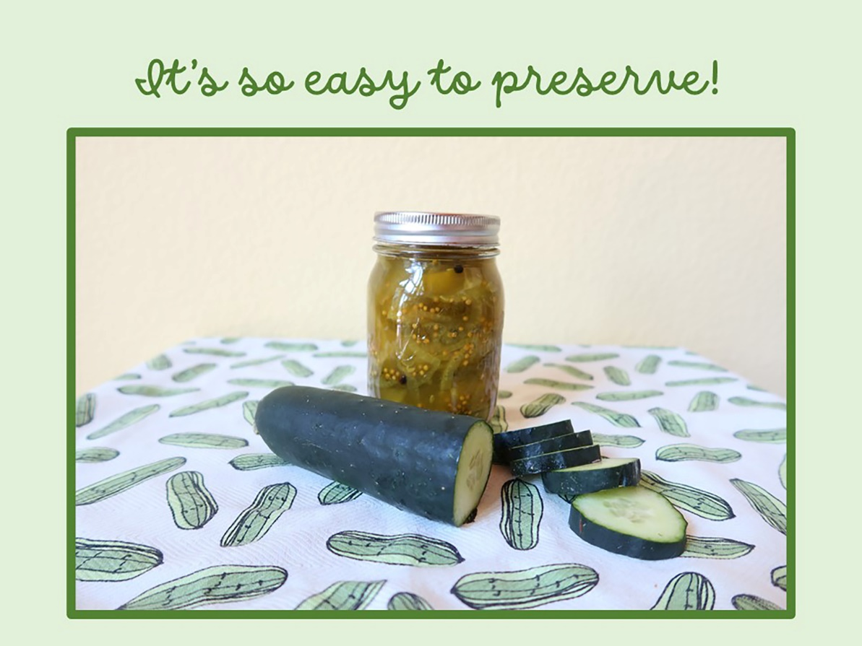

UC ANR is an equal opportunity provider and employer
Should you need assistance or require special accommodations for any of our educational programs, please contact us at 530-621-5502.

