$5.00
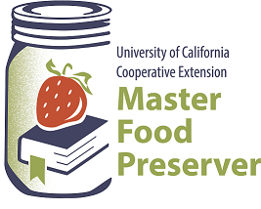
UCCE Master Food Preservers of El Dorado County
311 Fair Lane, Placerville CA 95667
Helpline (530) 621-5506 • Email: edmfp@ucanr.edu • Visit us on Facebook!

“Preserve today, Relish tomorrow”

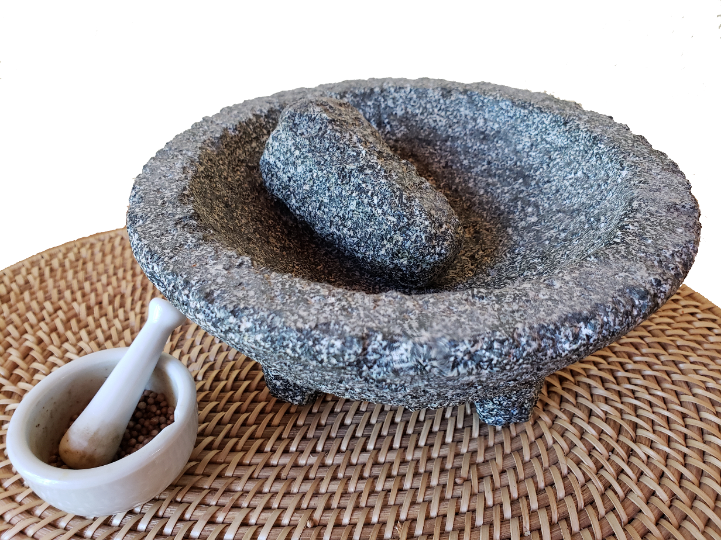
On the (Dry) Spicy-Herbal Trail

Food Safety

To maintain safety and quality, several factors must be considered when drying fruits, vegetables, spices and herbs. Keep in mind that specific food products often have recommendations that are unique to them. Drying removes the moisture from food so that microorganisms such as bacteria, yeasts, and molds are less likely to grow; however, drying does not effectively destroy them. Because there is not a heat treatment that destroys disease-causing microorganisms, it is critical to use safe food-handling practices when growing and handling fruits, vegetables, and herbs for drying.

The optimum drying temperature for most foods is 140°F. (Dry herbs at 95-115°F.) If higher temperatures are used, the food will develop “case hardening” and moisture will not be able to escape from the food; this will lead to a moldy food product. Therefore, do not rush the drying process.

Low humidity is also needed when drying foods. If the surrounding air is humid, the foods will not dry effectively. Increasing the air movement away from the food will assist in the drying process.

Foods can be dried in the oven, under the sun, on the vine, or indoors using a dehydrator.

- When dehydrating foods, using good sanitary practices is critical to reducing the risk of contaminating foods with pathogens and spoilage microorganisms.
- After harvesting produce or herbs, place them in containers and locations that are free from additional contamination. (For example, put them some place where pets, insects, and wild animals will not have access.)
- Begin the dehydration process soon after harvesting.
- Clean and sanitize all utensils, containers, the food-contact surfaces of dehydrating equipment, and work surfaces. To effectively clean, wash with warm, soapy water; rinse thoroughly with warm water; and sanitize* using one of the following methods:
  - Immerse utensils and drying trays in a chlorine bleach** solution (1 1/2 teaspoon. of bleach per gallon of water) for 10 seconds, then air dry (do not use a towel).
  - Or, prepare a sanitizing spray solution of 1/2 teaspoon of household bleach per quart of water, and spray on food-contact surfaces. Let air dry.
- Always wash hands before handling foods—this includes harvesting.
- Consider wearing disposable gloves when preparing foods for dehydrating especially when working with hot peppers. Wash hands before putting gloves on, and always remove gloves whenever you change a task (such as answering the phone or preparing another food item). If your gloves become soiled or torn during food preparation, replace them before resuming food preparation. Do not wash gloves to reuse—use them once, then throw them away. Gloves can give a false sense of security. Change gloves as recommended—do not contaminate food with gloves used incorrectly.

*Source: Michigan State University Extension, Food Safety, E-3446, January 2021, msue.msu.edu/safefood
**Household chlorine bleach (labeled “disinfecting bleach”) is a common sanitizer. Do not use scented or gel bleach solutions for food-contact surfaces and utensils.

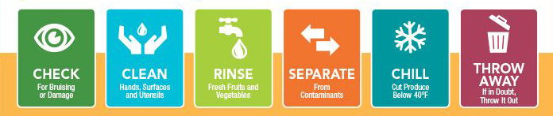

Herbs & Spices

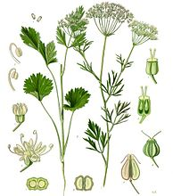
What is the difference between an herb and a spice?
While the terms herb and spice are used interchangeably by cooks and cookbooks, there are distinct differences between the two. It all depends on what part of the plant is used.
Herbs: In general, culinary herbs are the leafy portions of a plant, whether dried or fresh. Examples include basil, bay leaves, parsley, cilantro, rosemary, sage, oregano, mint, chives, and thyme.
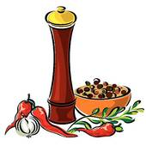
Spices: Spices, on the other hand, are harvested from any other portion of the plant and are typically dried. Popular spices come from berries (peppercorns), roots (ginger), seeds (nutmeg), flower buds (cloves), bark (cinnamon), undeveloped fruit of an orchid (vanilla), or even the stamen of flowers (saffron).
Two In One: Some plants are generous enough to yield both an herb and a spice. Cilantro is the leafy herb of the same plant that gives us the popular spice coriander seed. And dill weed (an herb) and dill seed (a spice) also come from the same plant.
Garlic and onions are, botanically, vegetables, although we use them both like a spice or herb.

Checking for Freshness:
Color: Green, leafy herbs will often fade as they age, while red spices such as paprika, red pepper, and chile powder will turn brown in color.
Aroma: Place a small amount in the palm of your hand and gently rub with your thumb. The aroma should be rich, full and immediate. If not, it probably lost potency.

If in Doubt, Throw It Out.
Store Properly: Store herbs and spices in cool, dry surroundings, away from direct light, heat or humidity. Keep in airtight glass jars and close tightly after each use.
Don’t Shake Over a Boiling Pot: Moisture from steam may diminish the potency of spices or herbs remaining in the jar. Pour a small amount into your hand or a ramekin, then add to the dish you are preparing.
What is a “seasoning”? Seasonings are a mix/blend of food flavorings. Blends may be dry or wet. Dry blends contain only herbs and spices that are mixed--ex. Pumpkin spice mix. Wet blends include (with the herbs and spices) some sort of liquid (often vinegar or oil or both)—ex. Ketchup, mustard, soy sauce.
Approximate equivalent amounts of different forms of herbs are:
- 1 tablespoon finely cut fresh herbs = 1 teaspoon crumbled dried herbs = 1/4 to 1/2 teaspoon ground dried herbs
Source: Purdue University Extension “Add Flavor with Herbs and Spices” April 27, 2022

Salts

Table Salt
Table salt is typically mined from underground salt deposits. Table salt is more heavily processed to eliminate minerals and usually contains an additive to prevent clumping. Some table salt also has iodine added, an essential nutrient that helps maintain a healthy thyroid.

Kosher Salt
Kosher Salt is a coarse edible salt without common additives such as iodine. Used in cooking and not at the table, it consists mainly of sodium chloride and may include anti-caking agents.

Sea Salt
Sea salt is produced through evaporation of ocean water or water from saltwater lakes, usually with little processing. Depending on the water source, this leaves behind certain trace minerals and elements. The minerals add flavor and color to sea salt, which also comes in a variety of coarseness levels.

Fleur de Sel
Fleur de sel has been collected since ancient times (it was mentioned by Pliny the Elder in his book Natural History), although it was traditionally used as a purgative and salve. ("Flower of Salt" in French) is a salt that forms as a thin, delicate crust on the surface of shallow pools of seawater along the coast of France. The name comes from the flower-like patterns of crystals in the salt crust. These crystals form in very limited weather conditions and are skimmed off by hand using special sieves, making Fleur de Sel an expensive, unique salt. Think of this salt almost as a garnish or condiment, to be added to a dish at the last moments before serving.

Pickling Salt
Pickling salt is pure sodium chloride that’s free of the anticaking agents and other additives found in table salt. This means that it dissolves completely in brine, leaving the liquid perfectly clear.

What's the difference between sea salt and table salt?
The main differences between sea salt and table salt are in their taste, texture, and processing.

Since sea salt involves minimal processing, it may vary in color. Its texture is coarse, and the minerals may give a slightly different taste to dishes. Because the large crystals create uneven measurement, it is not recommended for baking. Sea salt is best used for finishing dishes.

Due to the intense processing and elimination of minerals, table salt is usually white in color with small granules, creating a finer (less-course) texture. The smaller crystals are easier for foods to absorb evenly when cooking.

Sea salt and table salt have basically the same nutritional value, even though sea salt is often promoted as being healthier. Sea salt and table salt contain comparable amounts of sodium by weight.
Answer From Katherine Zeratsky, R.D., L.D. https://www.mayoclinic.org/healthy-lifestyle/nutrition-and-healthy-eating/expert-answers/sea-salt/faq-20058512

Drying Herbs and Spices
Drying is the easiest method of preserving herbs. Simply expose the leaves, flowers or seeds to warm, dry air. Leave the herbs in a well-ventilated area until the moisture evaporates. Sun drying is not recommended because the herbs can lose flavor and color.
The best time to harvest most herbs for drying is just before the flowers first open when they are in the bursting bud stage. Gather the herbs in the early morning after the dew has evaporated to minimize wilting. Avoid bruising the leaves. They should not lie in the sun or unattended after harvesting. Rinse herbs in cool water and gently shake to remove excess moisture. Discard all bruised, soiled or imperfect leaves and stems.
Dehydrator drying is a fast and easy way to dry high quality herbs because temperature and air circulation can be controlled. Pre-heat dehydrator with the thermostat set to 95°F to 115°F. In areas with higher humidity, temperatures as high as 125°F may be needed. After rinsing under cool, running water and shaking to remove excess moisture, place the herbs in a single layer on dehydrator trays. Drying times may vary from 1 to 4 hours. Check periodically. Herbs are dry when they crumble, and stems break when bent. Check your dehydrator instruction booklet for specific details.
Less Tender Herbs — The sturdier herbs such as rosemary, sage, thyme, summer savory and parsley are the easiest to dry without a dehydrator. Tie them into small bundles and hang them to air dry. Air drying outdoors is often possible; however, better color and flavor retention usually results from drying indoors.
Tender-Leaf Herbs — Basil, oregano, tarragon, lemon balm, and the mints have a high moisture content and will mold if not dried quickly. Try hanging the tender-leaf herbs or those with seeds inside paper bags to dry. Tear or punch holes in the sides of the bag. Suspend a small bunch (large amounts will mold) of herbs in a bag and close the top with a rubber band. Place where air currents will circulate through the bag. Any leaves and seeds that fall off will be caught in the bottom of the bag.
Another method, especially nice for mint, sage, or bay leaf, is to dry the leaves separately. In areas of high humidity, it will work better than air drying whole stems. Remove the best leaves from the stems. Lay the leaves on a paper towel, without allowing leaves to touch. Cover with another towel and layer of leaves. Five layers may be dried at one time using this method. Dry in a very cool oven. The oven light of an electric range or the pilot light of a gas range furnishes enough heat for overnight drying. Leaves dry flat and retain a good color.
Microwave ovens are a fast way to dry herbs when only small quantities are to be prepared. Follow the directions that come with your microwave oven.
When the leaves are crispy dry and crumple easily between the fingers, they are ready to be packaged and stored. Dried leaves may be left whole and crumpled as used, or coarsely crumpled before storage. Husks can be removed from seeds by rubbing the seeds between the hands and blowing away the chaff. Place herbs in airtight containers and store in a cool, dry, dark area to protect color and fragrance.
Dried herbs are usually 3 to 4 times stronger than fresh herbs. To substitute dried herbs in a recipe that calls for fresh herbs, use 1/4 to 1/3 of the amount listed in the recipe.
Source: "So Easy to Preserve", 6th ed. 2014. Bulletin 989, Cooperative Extension Service, The University of Georgia, Athens. Revised by Elizabeth L. Andress. Ph.D. and Judy A. Harrison, Ph.D., Extension Foods Specialists.

A Rough Guideline for How Long To Keep Herbs and Spices
If spices and herbs are kept as suggested, the shelf life will be as follows:
- Whole spices and dried herbs, leaves, and flowers will keep 1-2 years.
- Seeds will keep 2-3 years, and whole roots (i.e. ginger root or galangal root) will keep 3 years.
- Ground spices and herb leaves will keep 1 year.
- Ground roots will keep for 2 years.
- Seasoning blends will keep 1-2 years.
- Extracts will last 4 years.
Just because a spice or a seasoning blend is outside the date range listed above doesn't mean that the spice needs to be tossed in the trash. To determine if a spice or seasoning is still good, you must remember "appearance" and "aroma". A spice that is no longer acceptable will have lost much of its vibrant color and will instead appear dull and faded. The bigger key, though, is smell. To determine whether a ground spice is still good, gently shake the container with the cap on. Remove the cap and smell the spice to see if the potent aroma of the spice is still present. If it is, then your spice is still in good shape. Spices don't just all of a sudden go from “good” one day to “bad” the next. From the time they're harvested, they slowly begin to deteriorate and what you want to do is to prolong their optimum flavor for as long as possible with proper grinding and storage.

Never store your spices above your stove as the additional heat will more quickly lead to degradation of their quality. Also, don't store them directly above your dishwasher as the increased humidity will shorten their shelf life. Stored spices do best in temperatures below 70°F and in lower humidity environments. While achieving both may be challenging in your kitchen, the closer you can get to the ideal storage of them the better off you'll be.

Information source from: Spice Islands and http://www.spicesinc.com/p-780-what-is-the-shelf-life-of-spices-and-herbs.as

Recipe: Sierra Herb Salt Yield: ¾ cup

- 4-5 garlic cloves, peeled
- Scant ½ cup kosher salt
- About 2 cups loosely packed pungent fresh herbs mix of fresh rosemary, sage, basil, and thyme leaves

Cut each garlic clove lengthwise through the center, remove the sprout (if any) in the center and discard. Mound the salt and garlic on a cutting board. Use a chef’s knife to mince the garlic, blending it with the salt as you work.

Place herbs in a mound and coarsely chop them. Add the herbs to the garlic salt and chop them together to the texture of coarse sand.

Spread the salt on a baking sheet or in wide flat bowls and leave near an open window for a couple days to dry or use a dehydrator on a low heat setting appropriate for the herbs for 4-8 hours (read instruction manual for your dehydrator), checking periodically for dryness. Date, label, and store in air-tight clean jars.

Source: UC Master Food Preservers of Inyo and Mono Counties

Recipe: Tuscan Herb Salt Yield: approximately ¾ cup

- 4 to 5 garlic cloves peeled
- Scant ½ cup kosher salt

- About 2 cups loosely packed, pungent fresh herbs such as sage,rosemary,thyme, savory, basil, or small amounts of lavender

- Cut each garlic clove lengthwise through the center, remove the sprout (if any) in the center and discard.
- Mound the salt and garlic on a cutting board. Use a chef’s knife to mince the garlic, blending it with the salt as you work.
- Place herbs in a mound and coarsely chop them. Add the herbs to the garlic salt and chop them together to the texture of coarse sand.
- Spread the salt on a baking sheet or in wide flat bowls and leave near an open window for a couple of days to dry. Date, label, and store in clean, dry jars.

Alternate drying method: Heat oven to 200°F. Turn off oven, insert cookie sheet with salt mixture. Close door and let sit overnight. Break up any clumps with a fork and let air dry if needed.

Recipe: Smoked Paprika and Ancho Salt Yield: approximately ¾ cup

- 4 dried Ancho chiles
- 1/4 cup smoked paprika
- ¾ cup fine sea salt

Remove stems and seeds of dried Ancho chiles. Using a mortar and pestle, break up chiles. Using a spice grinder, and working in batches, if necessary, pulse until coarsely ground. Date, label, and store in airtight container.

Adapted from source: Country Living

Recipe: Lemon Pepper Salt Yield: approximately ½ cup

- 5+ large lemons
- 4 tablespoons crushed peppercorns
- 2 tablespoons garlic powder
- 2 tablespoons onion powder
- 2 teaspoons ground coriander
- 1 teaspoon ground allspice
- ¼ cup kosher salt

Zest lemons and mix with crushed peppercorns, coriander, and allspice. Mix in onion and garlic powders. Spread on a parchment lined baking sheet and bake at lowest oven temperature until the zest is completely dried. Add dried lemon-pepper mix to a spice grinder and grind to desired texture. Add salt and mix well. Storage: Date, label, and store in an airtight container in a cool, dark place. Ideally, let it sit at least a day before using. Intensity of flavor will diminish over time, but it can last up to a year. Store in cool, dark, dry place.

Source: Solano-Yolo Master Food Preservers--2020 “Gifts from the Kitchen”

Recipe: Citrus Salt Yield: 1 cup

- 1 cup flake salt, such as Maldon sea salt, or coarse sea salt
- 3 tablespoons citrus zest

Mix salt and zest in a bowl. Work zest into salt with your fingers to release oils and flavor. Spread on a baking tray, air-dry until dried completely dry (8 hours to overnight). Date, label, and store in airtight container.

Note: Zests color will fade over time, but this won’t affect taste.
Make ahead 2 months, keep airtight at room temperature.

Recipe: Herbes de Provence Yield: approximately 1/3 cup

- 1 tablespoon dried thyme leaves
- 1 tablespoon dried sweet marjoram leaves
- 1 tablespoon dried summer or winter savory leaves
- 1 tablespoon dried rosemary leaves
- 2 dried bay laurel leaves, finely crushed in a mortar or spice grinder
- 1 teaspoon dried lavender buds
- 2 teaspoons grated and dried orange zest

Place thyme, sweet marjoram, savory and rosemary leaves in small bowl. Lightly crumble leaves with fingertips. Add crushed bay, lavender buds, fennel seeds, and orange zest. Stir together to mix well. Pour into a glass jar and cover tightly. Date, label, and store in a cool, dry, dark place for up to 1 year.

Adapted from source: Herbs - A Country Garden Cookbook, Rosalind Creasy and Carole Saville

Recipe: Italian Herb Blend Yield approximately 1/3 cup

- 1 tablespoon dried oregano
- 1 tablespoon dried sweet marjoram
- 1 tablespoon dried chives
- 2 teaspoons dried rosemary
- 1 teaspoon dried fennel leaves
- 1 teaspoon dried sage
- 1 teaspoon dried mint

Combine ingredients in small bowl and transfer to glass container. Use to enhance pizzas, frittatas, various fillings, and tomato sauces. Date, label, and store in a cool, dry, dark place for 6 months.

Source: A Country Garden Cookbook, Rosalind Creasy and Carol Saville

Recipe: Mediterranean Herb Rub Yield: approximately 1 cups

- 3 tablespoons dried oregano
- 3 tablespoons dried dill
- 3 tablespoons dried thyme
- 3 tablespoons dried rosemary
- 2 tablespoons coarse salt
- 2 tablespoons lemon pepper
- 1 tablespoon dried garlic flakes

Combine all ingredients. Date, label, and store in an airtight container for up to six months.

Recipe: Dill Pickle Seasoning Mix Yield: approximately ½ cup

- ¼ cup dry buttermilk*
- 1 tablespoon dry dill
- 1 tablespoon citric acid (often found in canning aisle or order online)
- 1 tablespoon onion powder
- ½ teaspoon granulated garlic
- ½ teaspoon ground black pepper
- ½ teaspoon salt
- ¼ teaspoon lemon pepper

Mix all the ingredients together using a fork or whisk (to be sure everything is well mixed).
Place seasoning mixture in an air-tight jar with a shaker lid (so the seasoning can be distributed evenly when used). Date, label, and store in refrigerator for up to six months.

Because there is no anti-caking agent in this seasoning mix, be sure to shake the jar well (or stir to break up clumps) before using.

Instead of sprinkling plain garlic or buttered French bread to make “garlic bread”, try this seasoning mix. Or perhaps sprinkle some over buttered popcorn. Or try adding 2 tablespoons of this seasoning to 1 cup of plain yogurt (or sour cream) for a tasty dip.

*NOTE: Because dried buttermilk is a milk product, this seasoning CAN NOT be used in canning.

Adapted from source: created by-diane.com

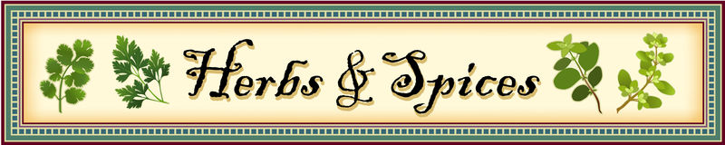

Recipe: Vegetable Bouillon Powder Yield: 3 cups

- 1 cup nutritional yeast*
- 1 tablespoon flaky sea salt
- 2 tablespoons onion powder
- 1 tablespoon garlic powder
- 1 tablespoon dried parsley
- 1 tablespoon dried thyme
- ¾ teaspoon celery seed
- ½ teaspoon ground black pepper
- ¼ teaspoon ground turmeric
- 2 teaspoons sugar (optional)
- ½ teaspoon sumac (optional)
- 1 ½ cups of dehydrated, powdered vegetables of choice (zucchini, potatoes, carrots, parsnip, fennel, tomatoes, peas, spinach, kale)

Add all the ingredients to a blender or food processor. Blend well. Transfer to a clean, dry jar or airtight container. Store in a dark, cool, dry place.

To use: Add 2 teaspoons of powder for every 1 cup of water; or just sprinkle into your recipes for extra flavor.

*NOTE: Nutritional yeast CAN NOT be used in canning.

Adapted from: asaucykitchen.com

Recipe: Shichimi Togarashi, Japanese Spice Mix Yield: ¼ cup

- 1 teaspoon Sichuan or Sancho* ground peppercorns
- 1 tablespoon granulated dried orange peel
- 1 teaspoon poppy seeds
- 1 tablespoon white sesame seeds
- 1 teaspoon ground Nori (dried seaweed)—about ¼ sheet of nori
- 1 teaspoon ground ginger
- ¼-1 teaspoon ground cayenne pepper (optional, to taste)

Combine all ingredients. Date, label, and store in an airtight container for 3 months.
*Sancho peppercorns have a citrusy flavor as well as an element of heat—however, the heat will not linger, unlike the heat of a chile.

Adapted from sources: mccormick.com ; masterclass.com ; thespicehouse.com

Recipe: Tzatziki Seasoning Mix Yields: approximately ½ cup

- ¼ cup cucumber powder*
- 1 tablespoon crushed dried dill weed
- 2 teaspoons onion powder
- 1 ½ teaspoons garlic powder
- 2 teaspoons lemon powder**
- 1 teaspoon kosher salt
- 1 teaspoon crushed black pepper
- 1 tablespoon dried spearmint (or mint)
- 2 ½ cups plain yogurt (or sour cream)—added when you make a dip/sauce

Combine all ingredients well, EXCEPT yogurt (or sour cream). Date, label, and store in an airtight container up to 6 months.

To create Tzatziki dip/sauce, fold in ½ cup of Tzatziki seasoning mix into 2 ½ cups yogurt (or sour cream). Mix thoroughly.
Store in the refrigerator. Make ahead for at least 2 hours, allowing flavors to meld and herbs/cucumber to hydrate.

*Dehydrating cucumbers:
- Wash cucumbers, cut lengthwise, and remove seeds.
- Slice ¼ inch thick.
- Dry at 125 degrees F for 6-10 hours. Cucumbers should snap and crush easily when dry.
- Place dried cucumber pieces in grinder of choice and process until a fine powder.
- Continue to dry powder in a warmed (but off) oven for 15-20 minutes.
- Store in an airtight container (with desiccant if preferred).
- 1 English Cucumber = 3 ½ cups raw = 1 cup dried = 2 tablespoons powder
**Lemon powder: Dehydrated lemons. Can substitute 1 teaspoon lemon juice or 1 teaspoon of fresh lemon zest.

Adapted from source: thepurposefulpantry.com

Recipe: Cucumber Ranch Dressing Blend Yields: approximately ¾ cup

- ½ cup buttermilk powder*
- 1 ½ tablespoons cucumber powder
- 1 tablespoon dried parsley
- 1 tablespoon dried dill weed
- 1 tablespoon green onion powder (OR onion powder)
- 1 tablespoon dried chives, roughly crushed
- 1 tablespoon garlic powder
- 1 teaspoon kosher or sea salt
- ½ teaspoon ground pepper
- 1 teaspoon dried ancho chile powder (optional)

Dry Mix:
Combine all ingredients well. Date, label, and store in the refrigerator in an airtight container.

Cucumber Ranch Dressing:
Mix equal parts water and cucumber ranch dressing blend

Or use the mix dry: Sprinkle on a chicken before baking, sprinkle over oven-fries, or sprinkle over buttered popcorn.

*NOTE: Because dried buttermilk is a milk product, this seasoning CAN NOT be used in canning.

Adapted from:: thepurposefulpantry.com

Recipe: Taco Seasoning Mix Yield: approximately ¼ cup

- 1 tablespoon chili powder
- 1 teaspoon ground cumin
- 1 teaspoon sea salt
- ½ teaspoon garlic powder
- 1 teaspoon ground black pepper
- ½ teaspoon ground paprika
- ½ teaspoon onion powder
- ¼ teaspoon dried oregano
- 1-2 tablespoons powdered dehydrated tomatoes
- ½ tablespoon ancho chile powder
- 1/8 to ¼ teaspoon crushed red pepper flakes (to personal taste)
- ½ teaspoon ground coriander

Combine all ingredients. Date, label, and store in an airtight container for up to six months.
Adapted from source: allrecipes.com

Recipe: Persian Advieh Spice Mix Yield: approximately 5 Tbls.

- 4 teaspoons ground cumin
- 4 teaspoons ground cinnamon
- 2 teaspoons ground coriander
- 2 teaspoons ground cardamom
- 2 teaspoons ground turmeric
- 2 teaspoons dried rose petals
- 1 teaspoon ground black pepper
- 1/8 teaspoon ground nutmeg

Combine all ingredients. Date, label, and store in an airtight container for up to 4 months.
Adapted from source: silkroadrecipes.com

Recipe: Curry Powder Yield: approximately ½ cup

- 3 tablespoons ground turmeric
- 2 tablespoons ground cumin
- 2 tablespoons ground coriander
- 2 teaspoons ground ginger
- 1 teaspoon ground cinnamon
- 1 teaspoon dry mustard
- 1 teaspoon ground fenugreek
- ½ teaspoon ground black pepper
- ½ teaspoon ground cardamom
- 1/8 teaspoon cayenne pepper

Combine all ingredients. Date, label, and store in an airtight container for up to 3 months.

Adapted from source: silkroadrecipes.com

Recipe: Berbere Seasoning Mix Yield: approximately 1 cup
A wonderful combination of spicy, bitter, and sweet spices used in Eritrea, Djibouti, Ethiopia, and Somalia.

- ½ cup ground dried New Mexico chiles
- ¼ cup paprika
- 1 tablespoon cayenne pepper
- 1 teaspoon onion powder
- 1 teaspoon ground ginger
- 1 teaspoon ground cumin
- 1 teaspoon ground coriander
- 1 teaspoon ground cardamom
- 1 teaspoon ground fenugreek
- ½ teaspoon garlic powder
- ½ teaspoon ground cinnamon
- ¼ teaspoon ground nutmeg
- ½ teaspoon ground allspice
- ¼ teaspoon ground cloves

Place the ground chilies, paprika, and cayenne pepper into a bowl; stir. Add onion powder, ginger, cumin, coriander, cardamom, fenugreek, garlic powder, cinnamon, nutmeg, allspice, and cloves. Gently whisk together until thoroughly mixed. Date, label, and store in airtight container in a cool, dry place for up to 1 year.

Source: Solano-Yolo County Master Food Preservers—2020 “Gifts from the Kitchen”

Recipe: Ethiopian-Style Spinach & Lentil Soup Yield: approximately 5 cups

- 2 tablespoons butter
- 1 tablespoon olive oil
- 3 tablespoons dehydrated red onion*
- 1 teaspoon garlic powder
- 3 teaspoons Berbere seasoning
- 2 cups red lentils*
- 8 cups water or broth
- 2 teaspoon salt (optional)
- ¼ teaspoon pepper
- 2 cups dehydrated spinach*
- 2 teaspoons finely chopped, dehydrated or crystalized lemon

Saute butter, oil, onion, garlic, and Berbere seasoning for 1-2 minutes. Add lentils and water for 10 minutes. {Less water if you want “stew” rather than “soup”.} Add spinach; cook for another 10 minutes. Remove from heat. Add salt, pepper, lemon.

*Dehydrated onion equal to 1 medium red onion; dehydrated spinach equal to 4 packed cups fresh spinach; red lentils cook faster than brown, green, or black.

Source: Adapted from Solano-Yolo Master Food Preservers—2020 “Gifts from the Kitchen”

Recipe: Persian Rice with Advieh Yield: approximately 3 cups

- 1 ½ tablespoons dehydrated onion*
- 1 ½ tablespoons butter or olive oil
- 1 cup basmati rice
- 1 teaspoon salt (optional)
- 1-2 teaspoons Persian Advieh spice mix
- 2 cups boiling water, divided

Lightly saute onion and Persian Advieh in butter for 1-2 minutes. Add 1 cup boiling water and stir to emulsify with onions and spice. Add rice; stir vigorously to coat; add remaining boiling water and salt. Return water with rice and spices to a boil and reduce heat to a very low simmer. Stir once more. Cover. Let cook 30 minutes.

*Dehydrated onion equal to ½ medium onion.

Adapted from: Solano-Yolo Master Food Preservers—2020 “Gifts from the Kitchen”

Recipe: Ty’s Herbed Beer Bread Mix Yield: 4 ½ cups (one loaf bread)

- 3 cups all-purpose flour
- 3 tablespoons granulated sugar
- 1 ½ tablespoons baking powder
- 1 tablespoon dried parsley flakes
- 1 tablespoon dried sage
- 1 tablespoon dried rosemary
- 1 tablespoon dried thyme
- 1 ½ teaspoons salt

- Combine all dry ingredients in a medium bowl and gently whisk to combine.
- Pour mix into a clean 1-quart jar. Date, label, and store in airtight container in cool, dry place until ready to use or give as a gift.

To use the mix:

- Preheat oven to 350°F.
- Butter a 9”x5” loaf plan
- In a medium bowl combine the bread mix with 12 ounces of warm beer and still until just combined (a few lumps are ok).
- Pour into prepared pan and dot with 2 tablespoons butter (cut into small pieces).
- Bake for 45-50 minutes, until crust is golden brown.

Recipes: Popcorn Seasonings

Dorito Popcorn: 2 tablespoons nutritional yeast, ¼ teaspoon garlic powder, ¼ teaspoon onion powder, ¼ teaspoon ground cumin, ¼ teaspoon paprika, ¼ teaspoon ancho chile powder (or other powdered dried pepper of your choosing/taste), ¼ teaspoon salt

Coconut Curry Popcorn: 1 tablespoon unsweetened shredded coconut, ½ teaspoon curry powder, ¼ teaspoon salt

Cajun Popcorn: 2 teaspoons paprika, 1 teaspoon onion powder, 1 teaspoon garlic powder, 1 tablespoon salt, ½ teaspoon fresh ground black pepper, pinch crushed oregano, pinch cayenne pepper (optional)

Truffle Popcorn: 6 tablespoons melted butter, 1 ½ tablespoon truffle oil (or 1 ½ tablespoons truffle shavings), ¼ cup grated Parmesan cheese, 1 teaspoon kosher salt, ½ teaspoon black pepper

Gingerbread Popcorn: 1 ½ tablespoons powdered sugar, 1 teaspoon cinnamon, ¼ teaspoon ground ginger, ¼ teaspoon ground cloves

Mexican Chocolate Popcorn: 1 tablespoon unsweetened cocoa powder, 1 tablespoon powdered sugar,
1 teaspoon cinnamon, ¼ teaspoon salt, pinch of cayenne pepper

Source: Solano-Yolo Master Food Preservers—2020 “Gifts from the Kitchen”

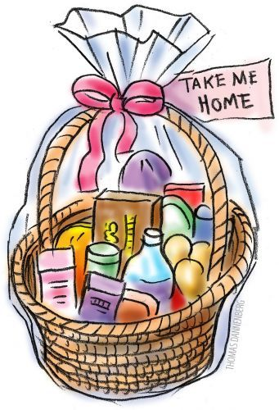

Resources:

Websites:
National Center for Home Food Preservation: http://nchfp.uga.edu/index.html
Ball© freshpreserving: http://www.freshpreserving.com/
Bernardin: https://www.bernardin.ca/recipes/default.htm?Lang=EN-US

Books:
So Easy To Preserve, Sixth Edition http://setp.uga.edu/
Ball© Blue Book Guide to Preserving, 2017
Ball© Complete Book of Home Preserving: 400 Recipes, 2020
The Spice Lover’s Guide to Herbs and Spices by Tony Hill

No endorsement of any product/company is intended, nor is criticism implied of similar products or companies that are not included.

It is the policy of the University of California (UC) and the UC Division of Agriculture & Natural Resources not to engage in discrimination against or harassment of any person in any of its programs or activities (Complete nondiscrimination policy statement can be found at http://ucanr.edu/sites/anrstaff/files/215244.pdf )

Should you need assistance or require special accommodations for any of our educational programs, please contact us at 530-621-5502.

