Heritage Rose Garden – Last Open Garden Day and Rose Sale – October 21, 9 to 11 a.m.

The last open garden day of the year at the Heritage Rose Garden in Jackson will be Saturday, Oct. 21, at the garden at 1334 Jackson Gate Road.

Not only will it feature fall blooming heritage roses and California natives, but there also will be heritage roses for sale.

About 30 or 40 roses, with very limited quantities of each, will be on sale, including two of our favorites, ‘Mutabilis’ and “Gatewood San Andreas.” Both bloom for months. ‘Mutabilis’ an old China rose, often sports pink, yellow and crimson blossoms all at the same time. “Gatewood San Andreas”, a “found” old rose, produces a profusion of small white double flowers throughout spring and summer, and makes a wonderful sprawling, low-growing hedge.

Two climbing old roses, ‘Cecile Brunner’ and ‘Yellow Lady Banks’ will also be available. They are spectacular one-time spring bloomers. Both have been popular for generations and are sentimental favorites. ‘Cecile Brunner’, which is also known as the “Sweetheart Rose,” impresses with its clusters of tiny pink buds in spring. ‘Lady Banks’ dazzles with its large clusters of butter yellow flowers. It commonly grows to heights of 20 feet or more, gracing fences and arbors with abandon. Both these climbers have few or no thorns.

All the heritage roses for sale are clones of roses at least 100 years old. They are grown on their own roots (not grafted) which has made them extra hardy, surviving years of neglect. Growing them alongside California natives has made the garden a living example of their compatibility. The biodiverse garden is increasingly becoming a haven for pollinators. We welcome visitors to come see what’s growing and what we’ve learned along the way.

For further information visit the UCCE Master Gardeners of Amador County website: https//ucanr.edu/sites/Amador_County_MGs/

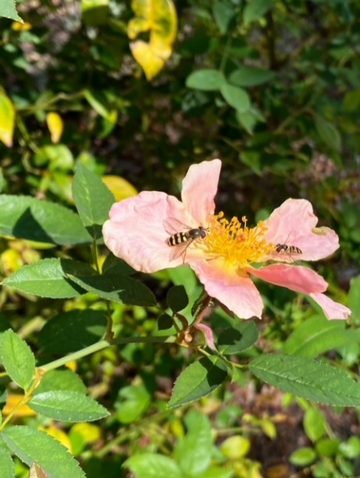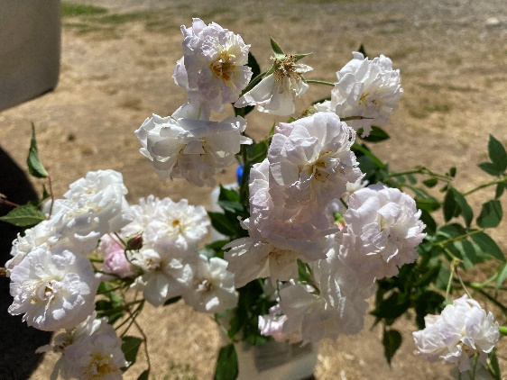
Figure 1 Mason bees on 'Mutabilis' Figure 2 "Gatewood St. San Andreas"

