CFHL Retail Intervention Webtool Overview
This tool is for use with CFHL Retail PSE and Indirect Education interventions. To review the webtool’s features click on a section of the screenshot to skip to that section’s overview or continue reading.
Table of Contents
Webtool Overview 1
Navigation Features 2
Reach Estimates and site data. 3
Data tile Contents 4
Additional Map Features 4

Webtool Overview
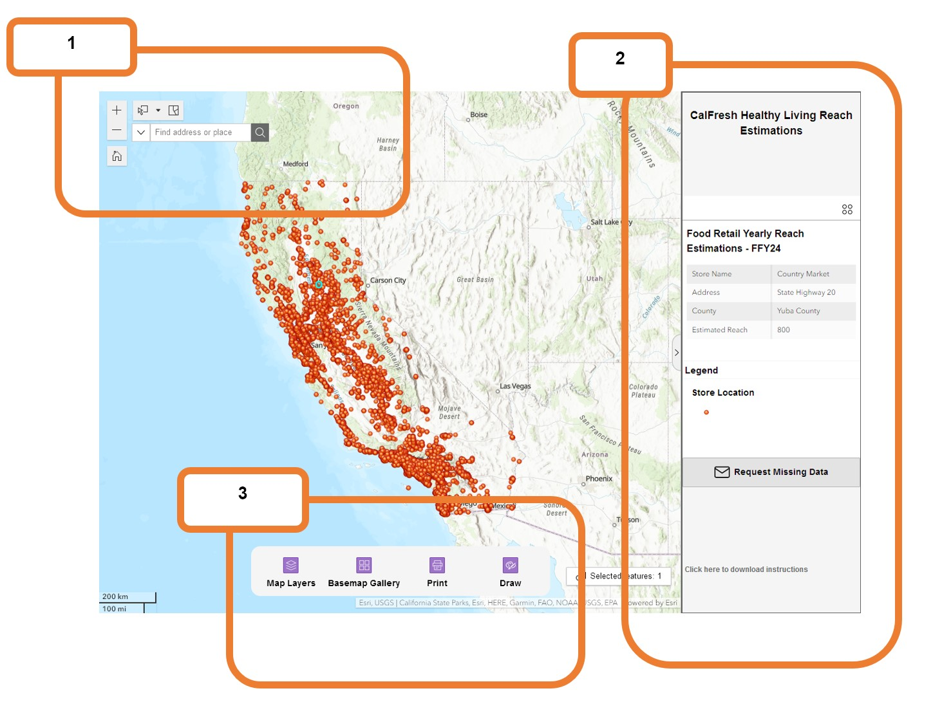

Navigation Features
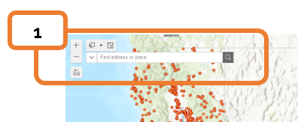
Zoom the map view in and out

Home – Returns the map view to the original view of California

Selection Tools – The leftmost button enables different types of selection tools and options. The rightmost button clears any existing selections.
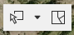
Search – Search for a store by name or address.
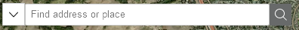
Note: Stores with multiple locations with the same name will appear once in the search results. To expand the list of stores and view their locations, click on the store name.

Reach Estimates and Site Data
Title tile: Webtool header and data usage warnings.
Data tile: Data from stores selected on the map, including estimated reach for PEARS reporting. An overview of the data available is below.
Store type legend tile: Color key for the visible layers.
Request Missing Data button. This button opens an email message to EvaluateSNAPEd@ucanr.edu so that users can request missing store data.
NOTE: Only use the request button to request stores that will have CFHL interventions to report in the current fiscal year.
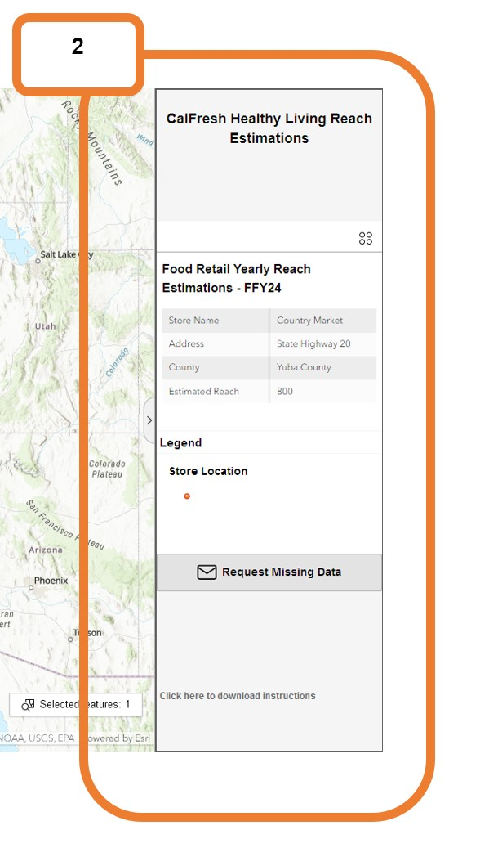

Data tile Contents
Site Name | Store name
Address | Store address
County | County of selected store
Estimated Reach | Use this to report estimated one-year reach in PEARS.
Exporting the data can show additional information used in the reach estimations. This includes population estimates, store information, and a food access indicator. To access additional store data, select the four dots at the top of the store data box.
Then click “Export selected”
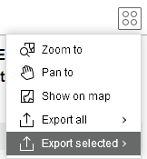
This will download an Excel sheet with the following additional information. To retain store data privacy, most data is presented in the form of a modifier or index. Raw data regarding staffing and sales will not be made available.
Subdv | Subdivision or neighborhood of selected store
Low Access Tract | Is the store located in a census tract with low grocery store access. 1 = Yes
SNAP-Ed Eligible Households | Number of CFHL/SNAP-Ed eligible households in the store’s buffer zone.
Household Foot Traffic | Number of households estimated to visit the store in a 1-month period.
Individual Foot Traffic | Number of individuals estimated to visit the store in a 1-month period.
Chain Store | Yes/No if the store is a chain
Store Type | Type of store
Size (square feet) | Square footage of the selected store
Sufficient Staff Present | Staffing estimates calculated from demographics and store data.

Additional Map Features
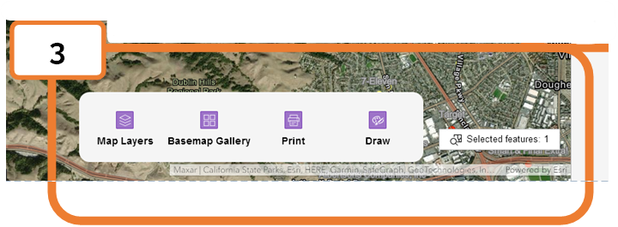
Map Layers – Change the map layers available in the webtool. Right now, only one layer is available.
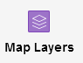
Basemap Gallery – Change the background map similar to changing Google maps between traffic and satellite views.
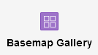
Print – Prints the current screen

Draw – Drawing tools to aid in notes and annotations before printing or screenshotting the webtool.

Selected Features – Gives the count of map features currently selected.
