
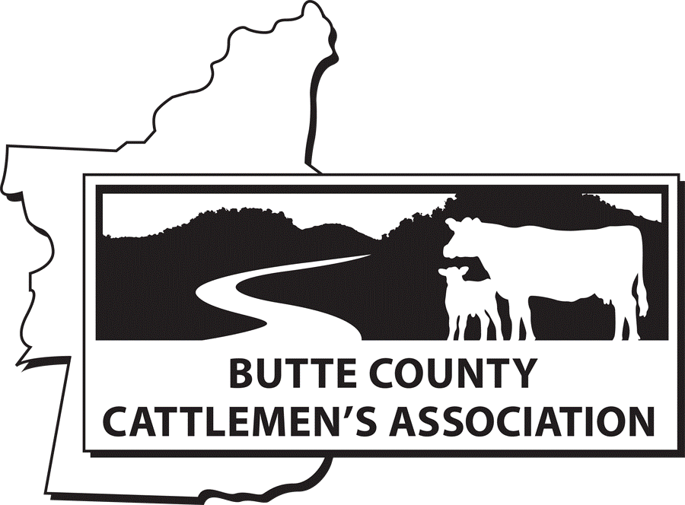
Grazing for Fire Prevention

Guided Notes

Student Learning Objectives

- The curriculum developed with this grant will focus on grazing to reduce fire fuels through innovative and interactive materials meeting California Career Technical Education Model Curriculum Standards under: E. Forestry and Natural Resources Pathway, including E4.0 Explore rangeland management, E9.0 Explore the role of fire in natural resource management.
  - Expose students to the use of livestock as a tool to reduce fire risks.
  - Knowledge of vegetated landscapes
  - Understanding benefits and challenges of grazing to reduce fire fuels
  - Principles of how to implement grazing for fire prevention
  - Recognize elements of fire behavior
  - Learn about where grazing is used as a tool to reduce fire fuels

Rangelands

Rangelands are predominantly ____________________, ____________________plants, ____________________, or ____________________and are managed as a natural ecosystem.
Examples of rangelands:
Place rangeland type by definition: Desert, Grassland, Wetlands, Meadow, Savanna, Shrubland and Tundra.

Area in which the vegetation is dominated by a nearly continuous cover of grasses.

Area where vegetation is dominated by woody plants generally less than 9 feet in height.

Areas that are frequently or continually inundated and are dominated by herbaceous plant species adapted to these hydrologic conditions.
An area with frigid temperatures, short growing seasons, and little precipitation.

Area composed of one or more plant communities dominated by herbaceous species that use surface or shallow ground water. May have woody vegetation like trees and shrubs, but it is not dominate.
Grassland area that contains small shrubs and a few trees.

Area that is extremely dry with sparse vegetation and well adapted plants that is receiving no more than 10 inches of precipitation a year.
Western Rangeland Types
Color the California map using the Western Rangelands map. Create your own color key to correspond to each rangeland type.
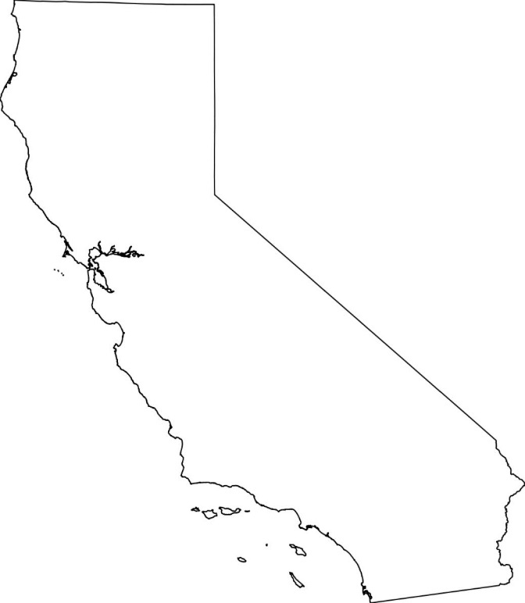
  - California Grasslands
  - Oak Woodlands
  - Pinon-Juniper Woodlands
  - Sagebrush Steppe
  - Ponderosa Pine Woodlands
  - Chaparral
  - Desert Shrublands
  - Cactus/Succulent Dessert
  - Other

57 Million Acres of California Rangeland
_____ million acres grazed
_____ million acres privately owned
_____ million acres public lands

List some public land management agencies in California:

  - _______________________________________________
  - Bureau of Land Management
  - California Department of Fish and Wildlife
  - ______________________________________________
  - Local entities such as parks and water districts, etc.
Sketch California’s Forage Calendar
Principles of Grazing for Fire Prevention

What are the 3 primary domestic livestock grazers in US and California and what type of vegetation do they prefer?

Species | Vegetation Preference

What is Prescribed grazing?
Prescribed grazing combines controlled implementation to achieve specific goals.
List the 6 Prescribed Grazing Program Elements
  - _____________________________________________________________________
  - _____________________________________________________________________
  - _____________________________________________________________________
  - _____________________________________________________________________
  - _____________________________________________________________________
  - _____________________________________________________________________
Implementation of Grazing for Fire Prevention

Examples of infrastructure needed for livestock grazing?

Infrastructure is dependent on ____________________ ___________________ and _______________ _____________.

What are key considerations if you are using grazing for fire fuel load reduction?

Effectiveness of Grazing for Fire Prevention

What are some of the grazing potentials to mitigate wildfire intensity and frequency?

  - Create Gaps in Fuel Continuity
  - _____________________________________________________________________
  - Reduce Wildfire Flame Length
  - _____________________________________________________________________
  - _____________________________________________________________________
Co-Benefits from Grazing
Primary goal of targeted grazing is reducing “1-hour fine fuels” vegetation – but there are other co-benefits if you consider timing and implementation that RESEARCH has found including:

  - _____________________________________________________________________
  - _____________________________________________________________________
  - _____________________________________________________________________
  - _____________________________________________________________________
  - _____________________________________________________________________
Potential challenges you must consider when using grazing to reduce fire fuel?
Bare Ground = Invasive Weeds
Soil Stabilization

Grazing for fuel load reduction makes rangelands more fire _________ NOT Fire __________.
Partners of Grazing for Fire Prevention
Case Studies
Where are some places where grazing is used to reduce fire fuels?
  - _____________________________________________________________________
  - _____________________________________________________________________
  - _____________________________________________________________________
Partners in Prevention Fire Board Experiment
Give an example of partners. Describe two things you learned from the fire board.



