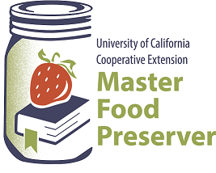
UCCE Master Food Preservers of El Dorado County
311 Fair Lane, Placerville CA 95667
Helpline (530) 621-5506 • Email: edmfp@ucanr.edu
Visit us on Facebook and Instagram!

“Preserve today, Relish tomorrow”
Yes, You Can Can!
Beginning High Acid Canning
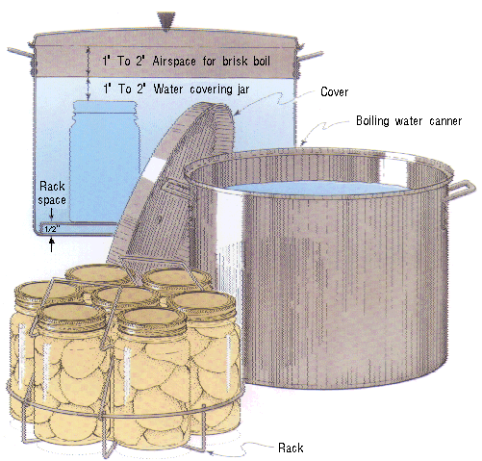
Download our
High Acid Canning Fundamentals:
Saturday, May 18, 2023
9:30 a.m. – 11:30 a.m.

It is the policy of the University of California (UC) and the UC Division of Agriculture & Natural Resources not to engage in discrimination against or harassment of any person in any of its programs or activities (Complete nondiscrimination policy statement can be found at http://ucanr.edu/sites/anrstaff/files/215244.pdf
RECIPES
To be sure your home-canned food is safe and of high quality, follow the guidelines outlined in our publication High Acid Canning, which is available to download for free from our website: https://ucanr.edu/sites/mfp_of_cs/files/395907.pdf

Whether you’re brand new to canning in general or could simply use a refresher, you’ll find all the current information you need to know, including the types of canners (and which to use when), preparing jars for canning, basic do’s and don’ts of canning, and safe food handling.

Grape Jelly Yield: about 8-9 half-pint jars
- 5 cups grape juice (about 3½ pounds Concord grapes and 1 cup water) or use unsweetened commercially bottled grape juice
- 1 package powdered pectin
- 7 cups sugar

To prepare juice from fresh grapes. Sort, wash, and remove stems from fully ripe grapes. Crush grapes, add water, cover, bring to boil on high heat. Reduce heat and simmer for 10 minutes. Extract juice. To prevent formation of tartrate crystals in the jelly, let juice stand in a cool place overnight, then strain through two thicknesses of damp cheesecloth to remove crystals that have formed.

To make jelly. Measure juice into a kettle. Add pectin and stir well. Place on high heat and, stirring constantly, bring quickly to a full rolling boil that cannot be stirred down. Add sugar, continue stirring, and heat again to a full rolling boil. Boil hard for 1 minute. Remove from heat; skim off foam quickly.

LADLE hot jelly into hot jars leaving 1/4 inch headspace. Remove air bubbles. Wipe rim. Center lid on jar. Apply band until it is fingertip tight.

PROCESS in a boiling water or atmospheric steam canner for: 0-6000 ft. = 10 minutes, above 6000 ft. = 15 minutes.

For boiling water canning, turn off the heat, remove canner lid and wait 5 minutes. For atmospheric steam canning, turn off the heat, leave canner lid on and wait 2-3 minutes.

Check lids for seal after 24 hours. Lid should not flex up and down when center is pressed. Label and store in a cool, dry place.

Source: Nation Center For Home Food Preservation
https://nchfp.uga.edu/how/make-jam-jelly/jellies/grape-jelly-powdered-pectin/#gsc.tab=0

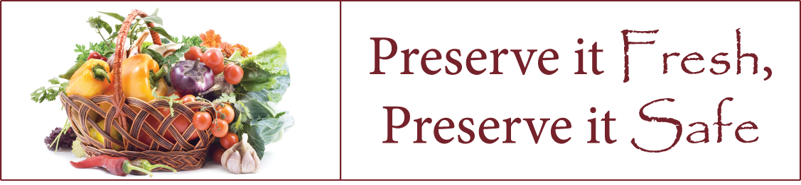
Red Wine Jelly Yield: about 6 half-pint jars

- 1 bottle (750 ml) dry red wine (3 ¼ cups)
- ½ cup (125 ml) lemon juice
- 1 pkg regular powdered pectin
- 4 ½ cups (1125 ml) granulated sugar

Pour wine and lemon juice into a large, deep stainless steel saucepan. Whisk in the pectin until dissolved and add 1/2 tsp (2 ml) butter or margarine to reduce foaming, if desired.

Measure sugar; set aside.

Over high heat, bring mixture to a full rolling boil. Add all the sugar. Stirring constantly, return mixture to a full rolling boil that cannot be stirred down. Boil hard 1 minute. Remove from heat; skim foam if necessary.

Quickly ladle hot jelly into a hot jar to within 1/4 inch (.5 cm) of top rim (headspace). Using a nonmetallic utensil, remove air bubbles. Wipe jar rim removing any stickiness. Centre sealing disc on clean jar rim. Screw band down until resistance is met, then increase to fingertip tight. Return filled jar to rack in canner ensuring jars are covered by water. Repeat for remaining jelly.

PROCESS in a boiling water or atmospheric steam canner for: 0-6000 ft. = 10 minutes, above 6000 ft. = 15 minutes.

For boiling water canning, turn off the heat, remove canner lid and wait 5 minutes. For atmospheric steam canning, turn off the heat, leave canner lid on and wait 2-3 minutes.

Check lids for seal after 24 hours. Lid should not flex up and down when center is pressed. Label and store in a cool, dry place.

Source: Ball Complete Book of Home Preserving

Drunken Peaches Yield: about six 1 pint jars

Bourbon and other fine spirits do double duty when it comes to fruit, acting as both a preservative and a flavor booster. Other liquors or liqueurs may be substituted for bourbon. Try these boozy babies straight up for dessert or blended into a cocktail.

- 1 lemon
- 5 pounds fresh freestone peaches, halves or slices
- 3 cups water
- 2 ½ cups sugar
- 3 vanilla beans. halved crosswise
- 6 thick Naval orange slices
- ¾ cup bourbon

Fill a large non-reactive pot with water and bring it to a boil. Fill a large bowl two-thirds full of ice water. Cut lemon in half, and squeeze juice into ice water. Working in batches, place peaches in a wire basket, lower into boiling water, and blanch for 60 seconds. Place immediately in lemon juice mixture. When cool enough to handle, peel peaches, cut in half, and remove the pits. Cut each half into 4 wedges, return to lemon juice mixture.

Stir together 3 cups water and sugar in a large non-reactive saucepan. Split vanilla bean halves lengthwise, scrape out seeds. Add vanilla bean and seeds to the sugar mixture, cook over medium-high heat, stirring until sugar dissolves. Bring to and maintain a low simmer.

Place 1 orange slice and 1 vanilla bean half into a hot jar. Ladle hot syrup into jar, leaving 1 1/2 inch headspace. Add 2 Tbsp. bourbon to jar. Add more hot syrup to jar, leaving 1/2 inch headspace. Remove air bubbles. Wipe jar rim clean. Center lid on jar. Apply band, and tighten to finger-tip tight. Repeat until all jars are filled.

Process in a boiling water our atmospheric steam canner using Table 1:

Table 1.Recommended process time for Peaches, halved or sliced in a boiling-water canner.
– |  | Process Time at Altitudes of
Style of Pack | Jar Size | 0 - 1,000 ft | 1,001 - 3,000 ft | 3,001 - 6,000 ft | Above 6,000 ft
Hot | Pints  Quarts | 20 min  25 | 25  30 | 30  35 | 35  40
Raw | Pints  Quarts | 25  30 | 30  35 | 35  40 | 40  45

Turn off heat, remove lid, and let jars stand for 5 minutes. Remove jars and cool. Once completely cooled, remove rings, and thoroughly wash jars to remove any sticky syrup. Label with name and date. Store in a cool dark place.

Tip: If canning peach halves, layer them in the jar such that the pit side is facing the bottom of the jar

Source: ballmasonjars.com

Pickled Dilled Green Beans Yield: about 8 pint jars

- 4 lbs fresh tender green or yellow beans (5 to 6 inches long)
- 8 to 16 heads fresh dill or ½ tsp. dill seeds per jar
- 8 cloves garlic (optional)
- ½ cup canning or pickling salt
- 4 cups white vinegar (55 acidity. Read label on container.)
- 4 cups water
- 1 teaspoon hot red pepper flakes (optional)

Wash and trim ends from beans and cut to 4-inch lengths. In each pint jar, place 1 to 2 dill heads and, if desired, 1 clove of garlic, sliced. Place whole beans upright in jars, leaving 1/2-inch headspace. Trim beans to ensure proper fit, if necessary. Combine salt, vinegar water, and pepper flakes (if desired). Bring to a boil. Add hot solution to beans, leaving 1/2-inch headspace. Remove air bubbles.
Wipe rim. Center lid on jar. Apply band until fit is fingertip tight.

Process in a boiling water canner or atmospheric steam canner for 10 minutes 0-6000 ft., 20 minutes above 6000 ft. For boiling water canning, turn off the heat, remove canner lid and wait 5 minutes.
For atmospheric steam canning, turn off the heat, leave canner lid on and wait 2-3 minutes.
Tip: beans may be pickles whole or cut into bite-size pieces.
Source: So Easy To Preserve

Blackberry Vinegar Yield: about 5 half pint jars
- 4 cups whole blackberries (or raspberries or strawberries)
- 4 cups white distilled vinegar (5% acidity – read label)
- 2/3 cup sugar or to taste (optional)

Wash berries gently in small batches in a colander.

In a large non-reactive bowl or container, combine blackberries with 1 cup of vinegar, lightly crush the blackberries. Add remaining vinegar. Cover tightly with a lid or plastic wrap and let stand in a cool, dark place for up to 4 weeks, stirring every 2-3 days. Taste weekly until desired strength is achieved.

Line a strainer with many layers of clean cheese cloth, clean muslin, or coffee filters. Strain vinegar without squeezing. Strain several times until vinegar is clear or sediment.

Pour flavored vinegar into a non-reactive saucepan and heat to 180°F. Add sugar if using and heat until dissolved completely.

Ladle hot preserves into hot jars leaving 1/4 inch headspace. Remove air bubbles.
Wipe rim. Center lid on jar. Apply band until fit is fingertip tight.

Process in a boiling water or atmospheric steam canner for: 0-6000 ft. = 10 minutes, above 6000 ft. = 15 minutes.

For boiling water canning, turn off the heat, remove canner lid and wait 5 minutes. For atmospheric steam canning, turn off the heat, leave canner lid on and wait 2-3 minutes.

Check lids for seal after 24 hours. Lid should not flex up and down when center is pressed. Label and store in a cool, dry place.

Variation: to make a mulled berry vinegar add the following ingredients to the crush berries:
2 cinnamon sticks about 4” each, broken into pieces.
1 Tbsp. whole cloves
1 Tbsp. whole allspice

Source: Ball Complete Book Of Home Preserving

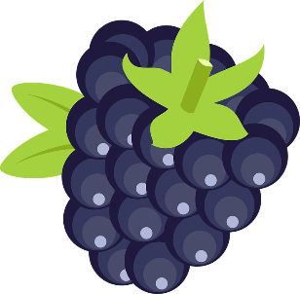

Thai Dipping Sauce Yield: about 9 half-pint jars

The perfect accompaniment for cold Thai rice paper spring rolls, this sauce is also delicious with any deep-fried Asian appetizer, such as egg rolls, potstickers, or wontons. It's also delicious with grilled chicken, and the addition of a tablespoon or two perks up classic oil-and-vinegar salad dressings. More ideas - in a stir fry, over fried rice, and great for lettuce wraps.

- finely chopped garlic
- 1 Tbsp. pickling salt
- 6 cups cider vinegar
- 6 cups sugar
- ½ cup hot pepper flakes

Combine garlic and salt and set aside.

Heat vinegar in a stainless steel saucepan. Add sugar, stirring until dissolved. Reduce heat and simmer for 5 minutes. Remove from heat. Add garlic mixture and hot pepper flakes.

Ladle hot mixture into hot jars leaving 1/4 inch headspace. Remove air bubbles. Wipe rims. Center lid on jar. Apply band until fit is fingertip tight.

Process in a boiling water or atmospheric steam canner for: 0-6000 ft. = 10 minutes, above 6000 ft. = 15 minutes.

For boiling water canning, turn off the heat, remove canner lid and wait 5 minutes. For atmospheric steam canning, turn off the heat, leave canner lid on and wait 2-3 minutes.

Check lids for seal after 24 hours. Lid should not flex up and down when center is pressed. Label and store in a cool, dry place.

Ladle hot sauce into hot jars, leaving ½-inch headspace. Remove air bubbles and adjust headspace, if necessary, by adding hot sauce. Wipe rim. Center lid on jar and screw band down until resistance is met, then increase to fingertip tight.

Process half-pint jars in a boiling water bath or atmospheric steam canner for: 0-1000 ft. = 15 minutes, 1001-6000 ft. = 20 minutes, above 6000 ft. = 25 minutes. Before removing canner lid, wait 5 minutes for boiling water or 2-3 minutes for steam canner, then remove jars, cool, and store.

Source: Ball Complete Book of Home Preservation

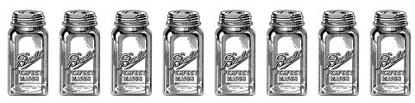

Resources for tested recipes:
National Center for Home Food Preservation: https://nchfp.uga.edu/#gsc.tab=0

Complete Guide to Home Canning. 2015. https://nchfp.uga.edu/resources/category/usda-guide#gsc.tab=0
Also available in paper copy from Purdue Extension (online store is located at https://mdc.itap.purdue.edu/item.asp?item_number=AIG-539)

So Easy to Preserve, Sixth Edition. 2016. Bulletin 989. Cooperative Extension/University of Georgia, Athens

Ball Blue Book Guide to Preserving. 2024. Newell Corporation.
Ball Complete Book of Home Preserving, 2024. Bernardin, Newell Corporation.
Bernardin: https://www.bernardin.ca/
Ball: https://www.ballmasonjar.com

