School Site-Level Assessment Questionnaire (SLAQ) Protocol for LHDs
Have a question?
Send an email to EvaluateSNAPEd@ucanr.edu

Website and Resources
All SLAQs and related resources can be found on the NPI Assessment Questionnaires website:
Website URL: https://ucanr.edu/sites/SLAQ/

On the main SLAQ Questionnaires page, navigate to the page for school SLAQs.
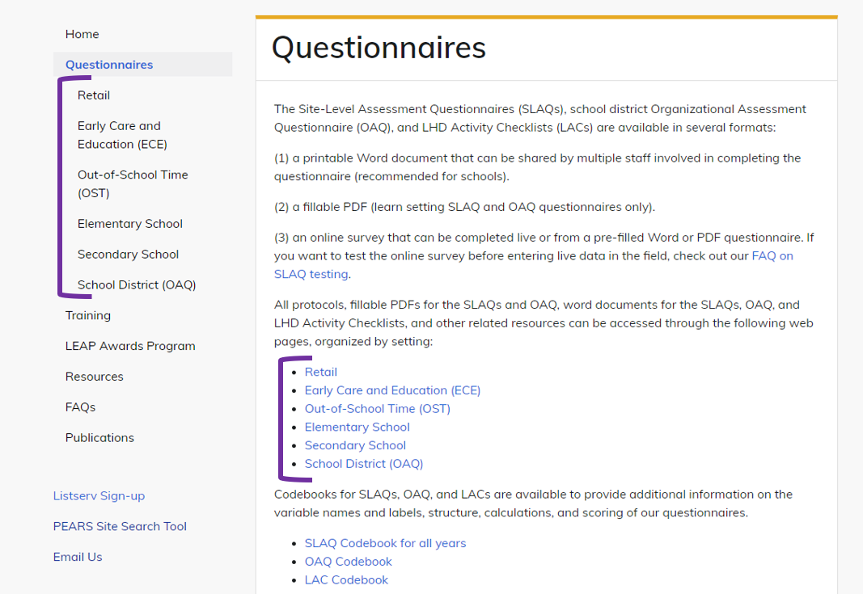
From there, you can download copies of SLAQs, protocols, LHD activity checklists (LACs), and find Survey 123 links to enter and submit completed questionnaires.

Throughout the NPI Assessment Questionnaires website, you can also…
- Access trainings.
- Access resources, like the SLAQ one-pager and the action planning materials to help introduce and use SLAQs with sites.
- Review FAQs and get help with SLAQs or LACs.

Each school you are working with to implement school-level Policy, Systems and Environmental (PSE) changes should complete a SLAQ before PSE implementation begins for the year:

Checklist for Completing a SLAQ
Use to track your progress towards SLAQ completion. Step-by-step instructions found below.

- From the main SLAQ Questionnaires page, navigate to the page for School SLAQs. Links for downloads and online surveys are all accessed through this sub-page.
- Initiate a conversation with your partner school about filling in the questionnaire.
  - Identify a Site Lead to coordinate SLAQ completion.
  - Talk to the school about the value and purpose of the SLAQ and how to complete it.
  - Set a date by which SLAQ should be completed.
- Work with school to ensure completion of the questionnaire.
  - Complete the LHD questions on the “Site Information” page of the SLAQ (pg. 2).
  - Send a Word or PDF version of the SLAQ to the site by email or mail.
  - Collect the completed SLAQ and review for completion. Follow up as needed.
- Enter the completed SLAQ responses into Survey123.
- Follow up with sites
  - Share the site’s final responses and scores
  - Discuss action planning

LHDs should complete a LAC annually for each school with a completed SLAQ, by the end of the school year:

Checklist for Completing a LHD Activity Checklist (LAC)
Use to track your progress towards LAC completion. Step-by-step instructions found below.

- Check off boxes for policies or practices your LHD’s CalFresh Healthy Living program was involved in adopting or improving.
- Submit the LAC via Survey123.

Helping schools complete the SLAQs

Prepare and plan before sending the SLAQ to a school

- The first step in completing a SLAQ is to initiate a conversation with your partner school to share the purpose of the questionnaire and develop a plan for completion:
  - Explain to your school partner that the questionnaire assesses the current state of the nutrition and physical activity environment and is used to help guide conversations and inform future CalFresh Healthy Living efforts at the school.
  - Emphasize that the responses should reflect only the current status at the school, not any anticipated changes. This helps to establish a baseline and accurately measure improvement.
Helpful tip: You can remind your partner schools that periodic assessment of public schools' compliance with the local school wellness policies is a required part of the Healthy Hunger Free Kids Act. The SLAQ can help fulfill that requirement!
  - Identify and work with a Site Lead to coordinate SLAQ completion and communication with your LHD. This person can help identify the most appropriate school staff who can complete the questionnaire. Depending on the school, SLAQ completion may require multiple people, as a single person may not be aware of all of the relevant policies and practices in place at the school.
  - School district staff might also be useful for answering certain questions. More information on when to reach out to a school district is detailed in our FAQ on working with district offices.
  - If you already use or plan to use a Memorandum of Understanding (MOU) with your school, we recommend adding in language about the SLAQ.
Helpful tip: Even if you don’t have a formal agreement with your site, the MOU language may be a helpful reference for you to guide conversations with Site Leads about SLAQ completion.
  - Identify whether there are sections of the school’s SLAQ that you may want to pre-fill. This is something you may want to consider in these situations:
    - Certain policies or practices are set at the district-level and responses are the same for all schools in the district. In this case, you can ask district-level staff to respond to specific items and pre-fill before sending to the school.
NOTE: When it is possible for policy implementation to vary between schools, it is best for each school to respond independently.
    - You need to collect SLAQs from a school and an Out-of-School site located at the school, and some policies or practices are shared.
    - You are involved closely enough with specific policies and practices to report them accurately.
NOTE: When the LHD pre-fills items or sections, ask the school site to verify accuracy.

- Work with sites to ensure completion of the questionnaire.

How to complete the SLAQ on paper/MS Word/PDF (Preferred method of completion):
We recommend having the school complete the SLAQ either on paper, PDF, or a shared MS Word document and then have an LHD staff member enter the responses into Survey123. By using this method, you ensure all questions have been completed by the site.
To help a school complete the SLAQ on paper, MS Word, or PDF, do the following:
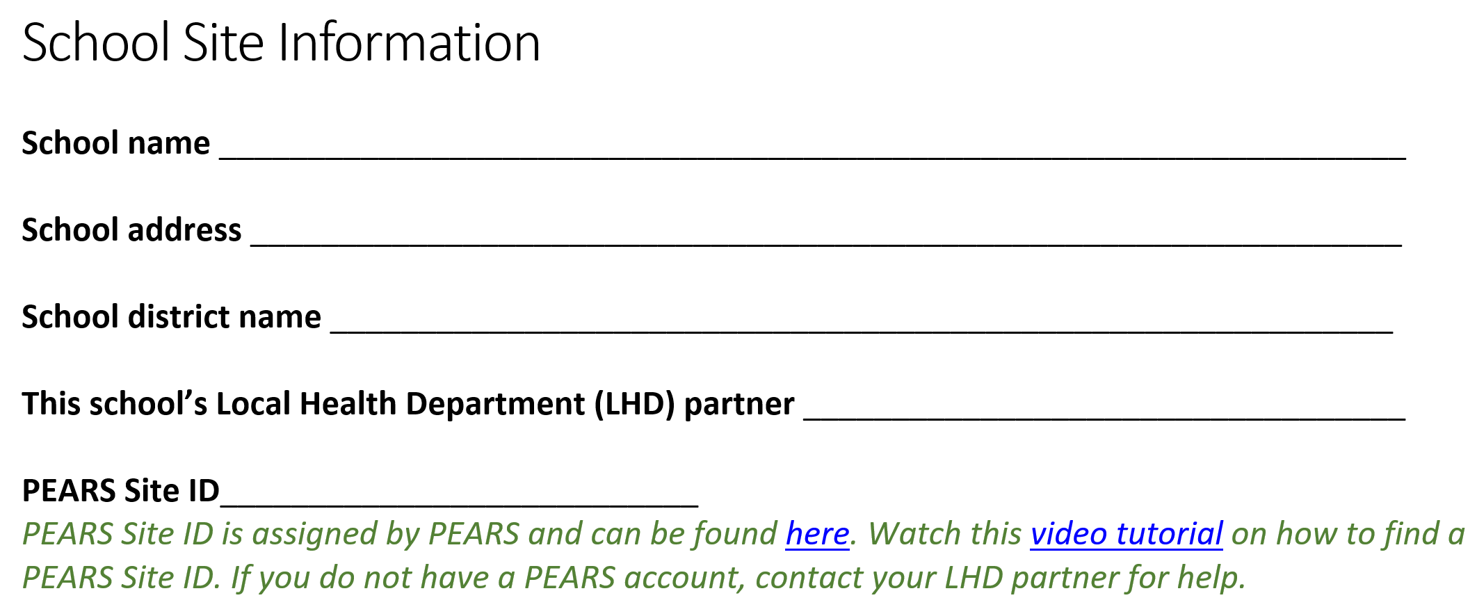
        - Before sending the form to the school, fill out the LHD name and PEARS Site ID questions in the “Site Information” section of the SLAQ (pg. 2 and pictured below). Make sure the site knows how to return their completed SLAQ to you, whether electronically, by “snail mail”, or in-person.

The PEARS Site ID can be found using the NPI PEARS Site Search Tool. Watch this video tutorial on how to use this tool to search for a PEARS Site ID.
        - Send the SLAQ paper form to the school along with the site-facing version of the SLAQ completion protocol. Check in as needed to ensure timely completion of the SLAQ.
  - Ways for school staff to complete the SLAQ together include:
    - Send individual SLAQ sections to the corresponding school staff.
    - Convert the SLAQ to a Google Doc or other type of shared Word document and share the link with the appropriate school staff. You can separate the SLAQ into multiple shared documents or keep it as one.
    - Email fillable PDF SLAQ and ask the Site Lead to pass along to appropriate staff who will help complete the SLAQ.
  - Collect the SLAQ from your site and check for completion. If questions are left blank, please contact the site to complete the missing questions.

3) Enter the completed SLAQ responses into Survey123.

        - At the very beginning of the questionnaire in Survey123, you can designate someone to receive an emailed copy of the SLAQ responses and score summary.

          - Two emails can be listed to receive the SLAQ report (pictured below). We recommend listing a site contact and an LHD contact.

Important note! Only enter ONE email address into each field. When multiple addresses are entered into one field, the email summary will not be sent.
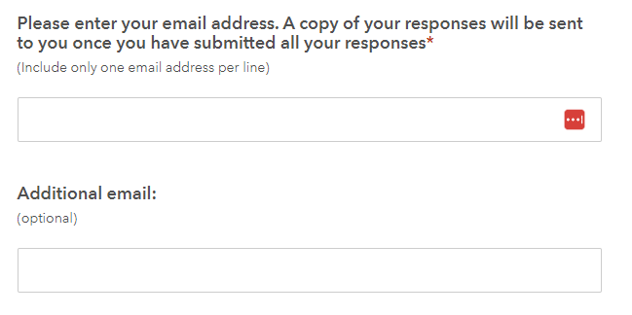

If the school wants to complete the SLAQ directly in Survey123:
Only use this method if your partner school is not able to complete the SLAQ by paper/MS Word/PDF or requests to complete the SLAQ online. We do not recommend that sites complete their SLAQs directly in Survey123 because LHDs are not able to check for completeness and accuracy of responses prior to submission. However, we understand that sometimes this is the best method for you and your partners.

        - If the site opts for online completion, provide the site with the information needed to complete the “Site Information” section. Sites will be asked to provide the following information: Site name, address, PEARS Site ID and Local Health Department (LHD) name.
          - The PEARS Site ID can be found using the NPI PEARS Site Search Tool. Watch this video tutorial on how to use this tool to search for a PEARS Site ID.

        - Send the Survey123 link along with the site-facing version of the SLAQ completion protocol to the site. Check in as needed to ensure timely completion of the SLAQ.
          - Instruct Site Lead or LHD subcontractor on how to designate someone to receive a copy of the SLAQ responses and score summary.
          - At the very beginning of the questionnaire, two emails can be listed to receive the SLAQ report (pictured below). We recommend that you list a site contact and an LHD contact (one per email field).
NOTE: Only enter ONE email address into each field. When multiple addresses are entered into one field, the email summary will not be sent.
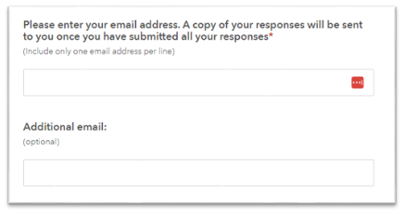

After the SLAQ is completed
4) Use the results to guide CalFresh Healthy Living efforts at the school:
a. Share a copy of the final SLAQ responses and scores with the school.
b. Use the scores in each section to guide discussions on what items have room for improvement and what areas schools may want to focus on as part of CalFresh Healthy Living efforts. Consider using the SLAQ Action Planning Tool or School Wellness Policy Action Plan Template to guide these discussions.

LHD Activity Checklist (LAC) steps:

LHDs should complete LACs at the end of each program year for each site the LHD is working with, once all CalFresh Healthy Living (CFHL) related activities are completed. The LAC is a way for LHDs to report on where CFHL efforts were focused at a specific site and to provide additional detail on what is reported in PEARS. The LAC can include in-progress and other work planned but not yet implemented, unlike in PEARS reporting. This is also different from the SLAQ reports, which assess the current status of best practices at the site.

- Access a digital copy of the LAC from the SLAQ questionnaires webpage.

- Check the box for each practice and each written policy that your LHD or subcontractor was involved in improving or adopting at the site during the past year. If your CFHL program contributed to policies or practices at a site in only specific areas, you may save time completing the LAC by only reviewing and completing the relevant areas of the checklist. It is not uncommon to have many sections of the LAC blank.

Example: Your LHD worked with School A to install hydration stations and change beverage policy. This was the only area of practice and policy your CalFresh Healthy Living efforts were involved with during the current school year. You may skip to the relevant items about water access and beverages and mark those check boxes. Please note that sometimes related items may appear in more than one section.

NOTE: A box can be checked even if a school has not yet implemented any changes. LACs are intended to capture the important work that occurs prior to adopting or improving policies and practices, such as providing resources and holding meetings.

- Go to the SLAQ questionnaires webpage to submit the LAC via Survey123.
URL: https://ucanr.edu/sites/SLAQ/SLAQ_Questionnaires/
- LACs should only be completed by LHD staff and subcontractors working on CFHL projects – you do not need to consult the site to complete the LAC.

If you have questions about when to complete the LAC, check the out the FAQ on the LHD Activity Checklist (LAC).

