Food Systems Program

Creating Value-Added Products on Small Farms

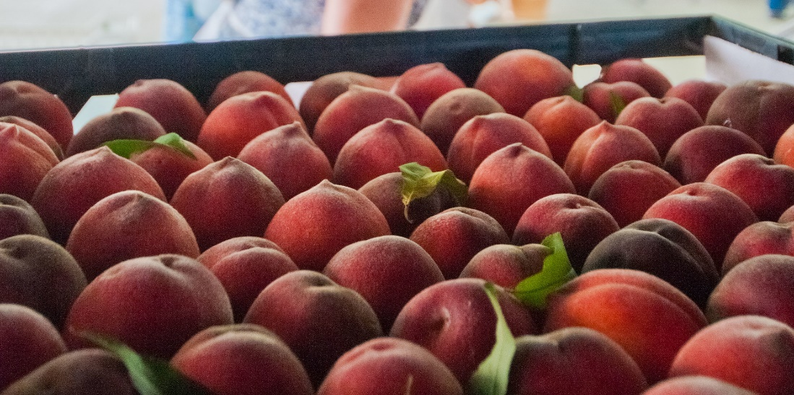
When
Tuesday, Oct. 8, 4-5:30 p.m.

Zoom Link
https://ucanr.zoom.us/j/92333557128

Call In
1-669-900-6833
Meeting ID: 923 3355 7128

Agenda
Participant Resources
Website: UC Food Safety: Starting a Food Business
PDF: Value-Added On-Farm Processing - Regulatory Considerations
PDF: California Processed Food Registration timeline
PDF: California Cannery License timeline
Website: California Cottage Food Operations

4:00 p.m. Introductions
4:15 p.m. Presentation by UCCE Advisor Olivia Henry
- Fundamentals of Value-Added Enterprises
- Licensing Pathways
- Marketing Pathways
- Profitability Calculator
4:30 p.m. Presentations by Producers
    - Tree Kilpatrick, The Cloverleaf Farm
    - Pat Calvert, Ciarlo Fruit & Nut
    - Josh Rickett, Sun & Cellar
5:00 p.m. Panel Q&A
5:30 p.m. Evaluation & Close

