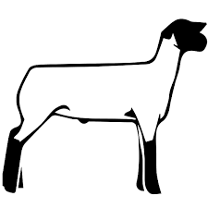
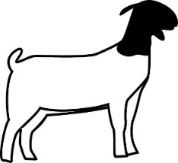

FANTASTIC FIELD DAY
LIVESTOCK JUDGING ACTIVITY
February 22, 2025 – Salinas Valley Fair Grounds
Hosted by Chualar 4-H
The purpose of Livestock Judging is to give 4-H members the opportunity to exhibit their animal evaluation & identification skills at a fair.
Each participant will learn about Market Swine, Market Lambs, Market Goats, Dairy Goats, Dairy Cows, & Market Beef to enhance their knowledge of these species.

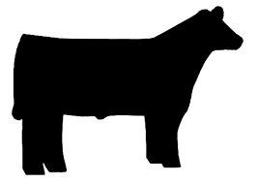
A 4-H study guide on Market Livestock Judging can be found:
http://cemonterey.ucanr.edu/4-H_Program/Curriculum_Resources/

Goals: Members will learn about how a Livestock Judging contest would run at a local fair without being judged. Using visual techniques and accurate terminology, members will quickly learn how to identify healthy livestock. A 4-H member will learn the skills to be able to participate in a Livestock Judging competition at a local county fair.

Format for the Livestock educational activity during the rotation:
- Each member will be given instructions by the Chualar club committee members.
- The members have an opportunity to review different species of livestock that would be shown at a fair for competition.
- All members will be given the proper names of livestock species and varieties.
- This will be a non-competitive rotation. Members can ask questions to help clarify and gain additional understanding.
- Material addressed will encompass today’s current market and breeding standards.
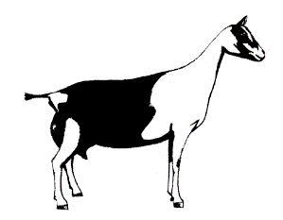
- Members will be given additional resources to go over at home.
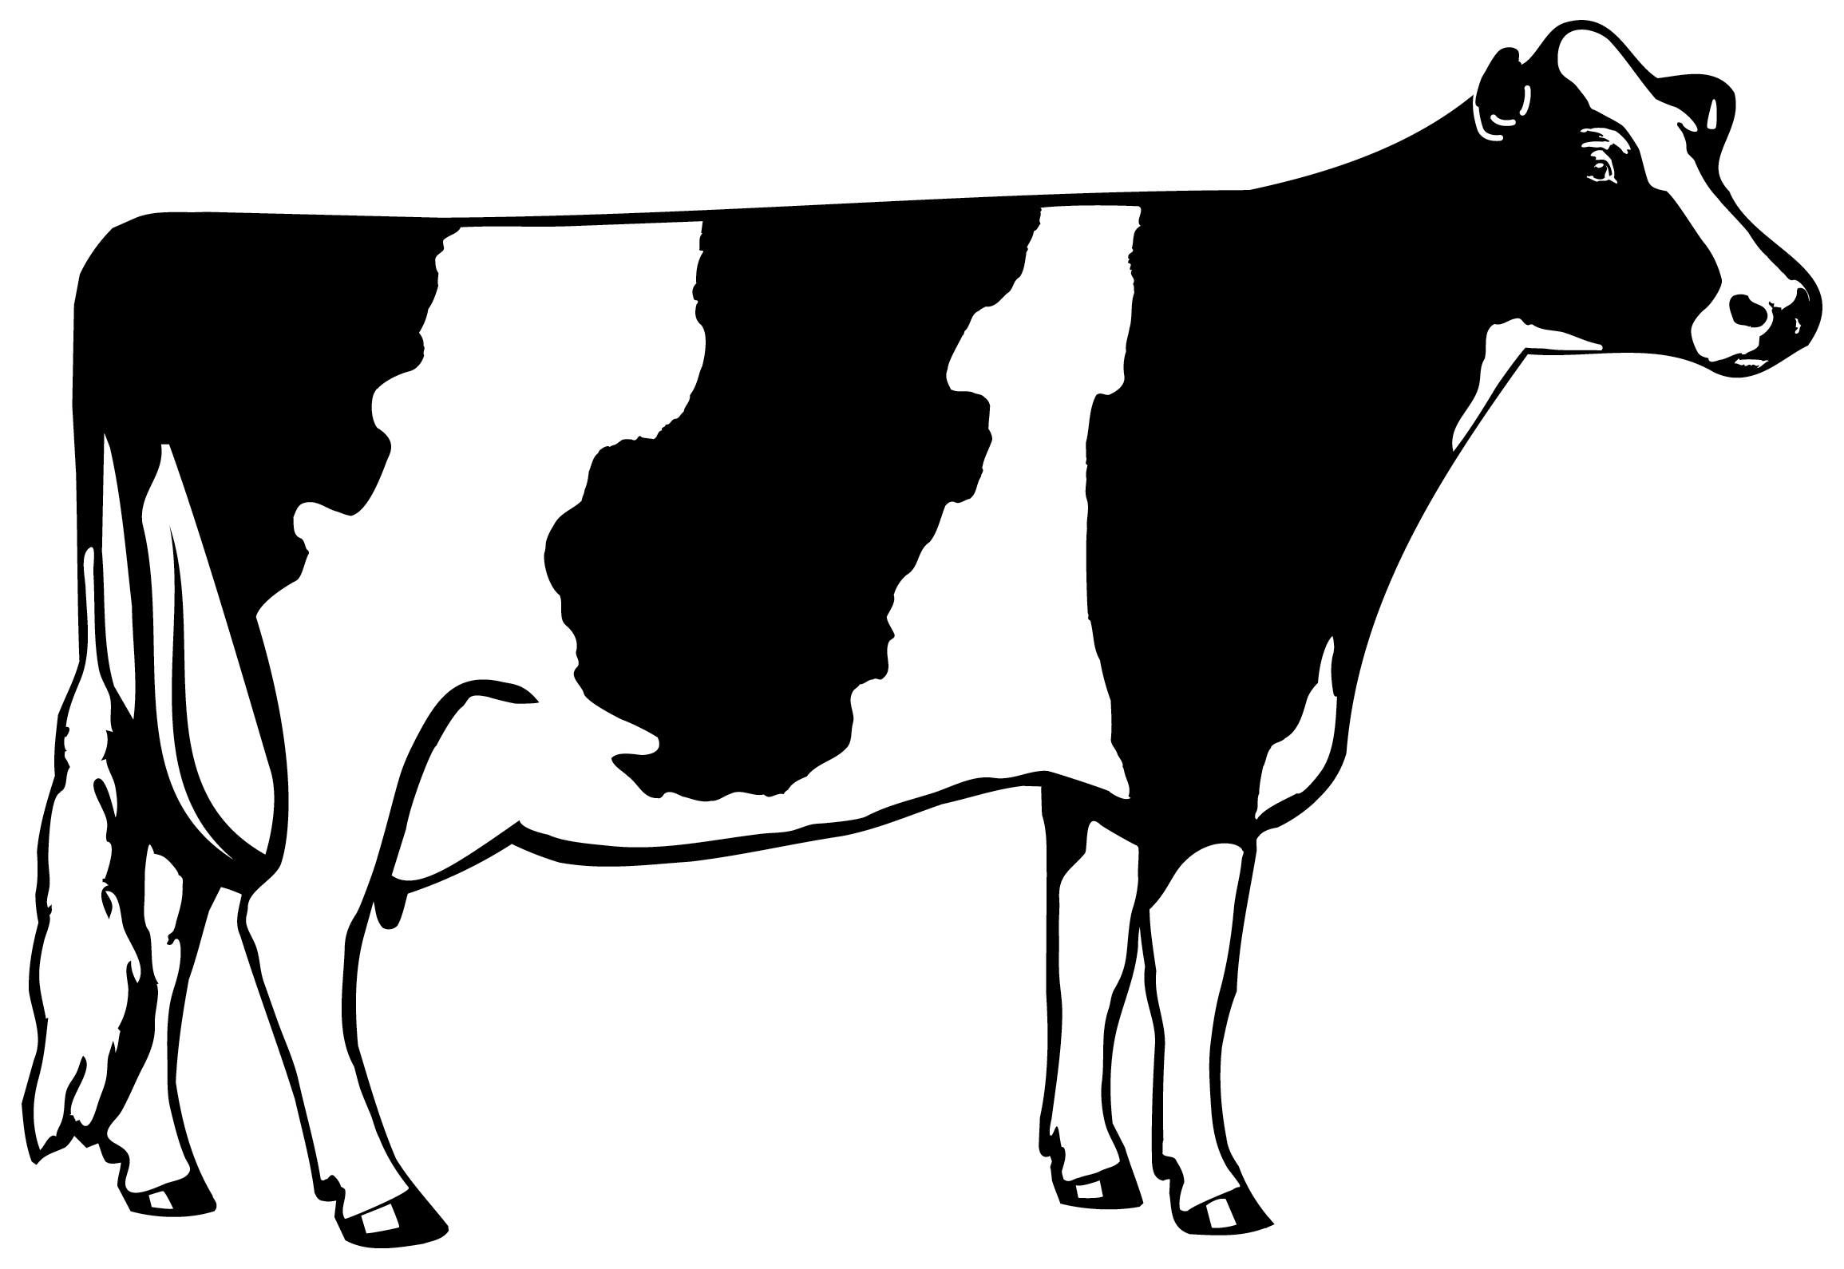

Have questions or ideas? Contact the Chualar 4-H Club at: chualar4hclub@gmail.com

It is the policy of the University of California (UC) and the UC Division of Agriculture & Natural Resources not to engage in discrimination against or harassment of any person in any of its programs or activities (Complete nondiscrimination policy statement can be found at http://ucanr.edu/sites/anrstaff/files/215244.pdf )
Inquiries regarding ANR’s nondiscrimination policies may be directed to John I. Sims, Affirmative Action Compliance Officer/Title IX Officer, University of California, Agriculture and Natural Resources, 2801 Second Street, Davis, CA 95618, (530) 750-1397.

