
In a Nutshell
Fresno County


February 2023

How Late is Too Late for NOW Winter Sanitation?

Cameron Zuber, Orchard Crops Farm Advisor, Merced and Madera Counties
Elizabeth Fichtner, Orchard Systems Advisor, Tulare and Kings Counties

The removal of nuts remaining on almond trees from the prior year’s crop is an important winter sanitation practice for the management of navel orangeworm (NOW), Amyelois transitella. Residual nuts are called ‘mummies’ and the process of removing the mummies is referred to as a ‘mummy shake’ because they are mechanically shaken from trees. This practice is conducted during the dormant and delayed dormant season, a time when orchard access may be thwarted by the winter rains.

Most growers strive to have the mummy shake complete by mid-January when buds are dormant and less likely to abscise from the vibration caused by a mechanical shaker. As the flower buds progress toward bloom, they become more sensitive to the shaker vibration and more likely to abscise. Studies conducted in the 1980s (Sibbett et al.) established that the shaking of mummies by January 31 (approximately 8 days prior to bloom) at a Kern County site did not adversely affect yield; however, the authors cautioned growers of the risk of delaying mummy shakes further, particularly on early blooming varieties and in locations in the southern San Joaquin Valley1. Because bud development and bloom date advance with increasing latitude, the potential risk of early and mid-February mummy shakes was investigated by W. Asai (Pomology Consulting, Turlock, CA) in the northern San Joaquin Valley. This work, conducted at a more northern latitude, suggested shakes conducted in early February may not compromise yield².

The lack of yield detriment attributed to a mummy shake-mediated bud loss may seem counterintuitive; however, simple concepts of tree physiology may help explain this phenomenon. Consider that only approximately 30% of the flowers on a tree set a crop. A given tree does not have the carbohydrate stores needed to set every flower. As a result, the loss of a subset of flower buds may have little effect on overall yield. Naturally, the risk of crop loss increases the closer the shake approaches bloom, and both research groups suggested that mummy shakes be complete prior to the pink bud stage of development.

Although rainy years make it difficult for growers to access orchards and complete orchard sanitation tasks, the heightened soil moisture adversely affects NOW survival in comparison to dry winters. Mummy nuts on the ground support enhanced NOW survival on a dry orchard floor than on moist soil with winter vegetation in the row middles. The next step in managing overwintering populations of NOW is destruction of mummies by flailing or mowing. Flailing and mowing should be completed by March 1, prior to the emergence of NOW. The emergence profile of NOW varies by location, but the first flight generally starts in late March.

Growers who have not completed their winter sanitation practices by the end of January should walk their orchards to assess bud development in consideration of a delayed mummy shake. Winter sanitation can reduce now damage by up to 80%, so an early February shake may be worth the effort if orchard access is possible and bud development has not advanced into pink tip. For more information on NOW management, visit www.ipm.ucdavis.edu.
Page 1
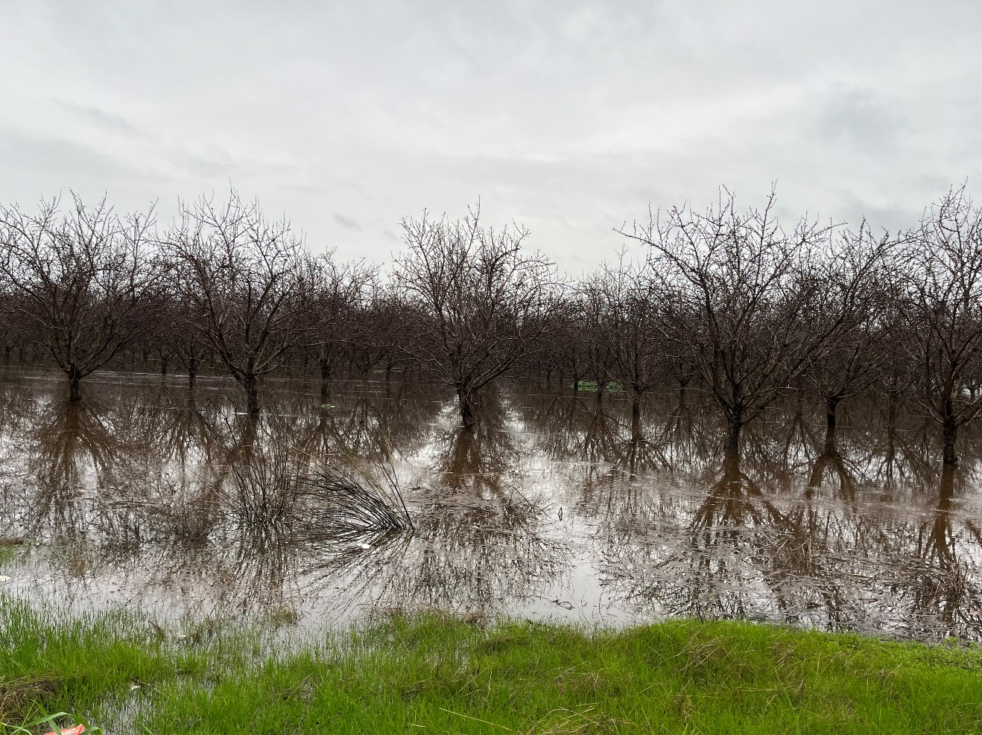
Photo of flooded Merced County almond field in January.

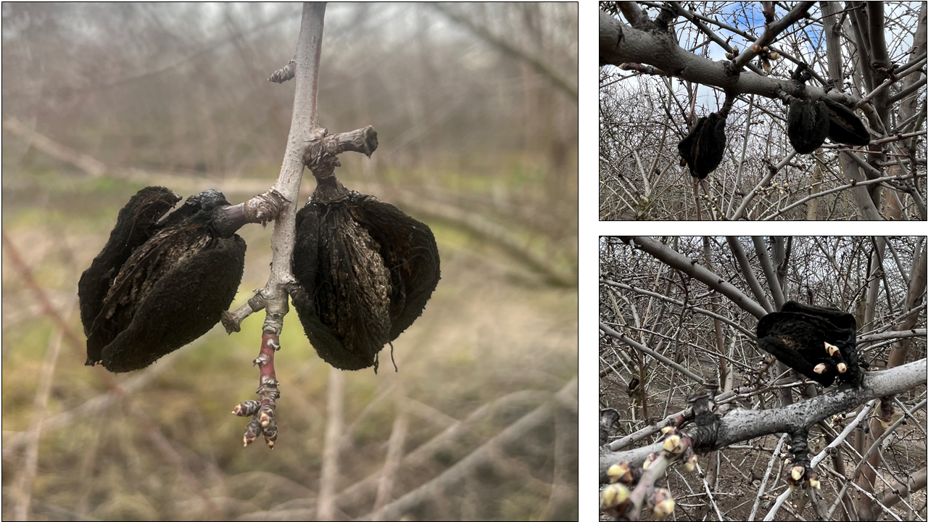
Photos of residual nuts after harvest. Left photo source Elizabeth Fichtner.

Page 2
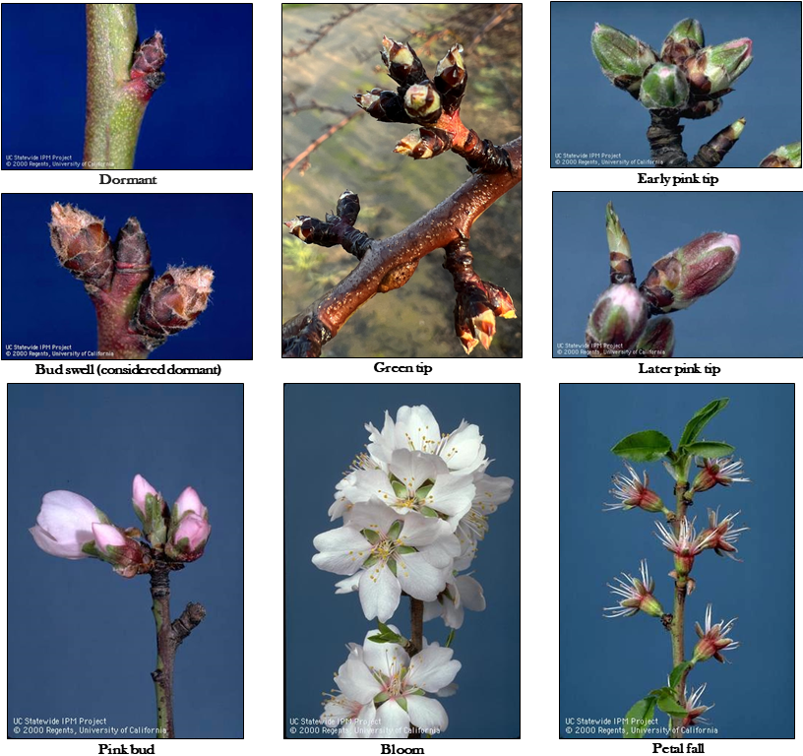
Photos of different dormant and bloom stages for almond buds and flowers. Green tip photo source Elizabeth Fichtner. Remaining photo source UC IPM.

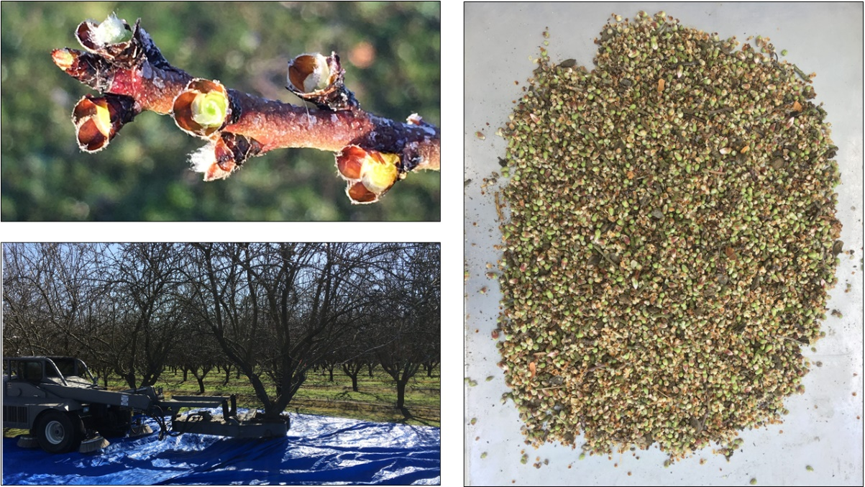
Photos of removed buds (top-left), shaker performing mummy shake with blue tarp on ground to capture removed buds (bottom-left), and buds captured after shake (right). Photos source Wes Asai.
Special thanks to David Haviland (Farm Advisor for Kern County) for response and additional comments on destroying removed fruit nuts which helped inform this post. Additional thanks to Phoebe Gordon (Orchard Crops Farm Advisor for Madera and Merced counties), Roger Duncan (Pomology Advisor for Stanislaus County), and Greg Browne (Plant Pathologist with UC Davis and USDA) for their comments.

¹Sibbett G.S., C.E. Curtis, M. Gerdts, J.D. Clark. Effect on yield from shaking almond trees for mummy nut removal. California Agriculture, 1983, https://hilgardia.ucanr.edu/fileaccess.cfm?article=172129&p=HNWVWH

²Asai W. Does late winter shaking reduce yield potential in almonds? West Coast Nut, 2020, https://www.wcngg.com/2020/01/06/does-late-winter-shaking-reduce-yield-potential-in-almonds/

U.S. EPA proposed changes to rodenticide labels for agricultural use:
opportunity for public comment
Roger A. Baldwin, Professor of Cooperative Extension, UC Davis
Niamh Quinn, Cooperative Extension Advisor, UC South Coast Research and Extension Center

Rodents cause substantial damage and health risks in agricultural productions systems through direct consumption of fruit, nuts, and vegetative material; damage to the plant (e.g., girdling of stems and trunks); by providing a food safety hazard from contamination; damage to irrigation infrastructure; damage to farm equipment; burrow systems posing a hazard to farm laborers; posing a health risk through potential disease transmission; and increased soil erosion by water channeling down burrow systems, among other potential damage outcomes. They also cause substantial damage and food contamination risks in livestock holding facilities, food processing facilities, barns, and other agricultural-related structures. As such, effective management is needed to minimize these risks. The use of rodenticides is often considered the most efficacious and cost-effective tool for managing rodent pests, and as such, it is often included in Integrated Pest Management (IPM) programs designed to mitigate rodent damage and health risks. Given the significance of rodenticides in managing rodent pests, it is important to know that the U.S. EPA has recently released a list of Proposed Interim Decisions (PIDs) for public comment that, if approved, will substantially alter if and how rodenticides may be used to manage rodent pests in the near future. As such, we felt it was important to inform California’s agricultural producers as to the extent of these proposed changes, and if you are so inclined, we have provided a link for you to provide public comment on the PIDs, as well as links to contact your Senate and Congressional representatives to ensure your opinion is heard.

All rodenticides are currently under review. These include first-generation anticoagulants (FGARs; chlorophacinone, diphacinone, and warfarin), second-generation anticoagulants (SGARs; brodifacoum, bromadiolone, difethialone, and difenacoum), zinc phosphide, strychnine, bromethalin, and cholecalciferol. Of these, only FGARs, zinc phosphide, and strychnine have labels for use against field rodents (e.g., ground squirrels, pocket gophers, voles, rats, and mice found in agricultural fields), but not all of these active ingredients can be used for all rodent species. As always, it is imperative to fully read a rodenticide’s label before determining if it is appropriate for use against a particular species and in a specific situation. That said, the following are some significant changes that have been proposed that you should be aware of. Other potential changes have been proposed as well, so please check out the PIDs for additional details (linked at the end of this document).

- All rodenticides for field applications will become restricted-use products. This means that applicators will need to be certified to use restricted-use products in these settings. They will also have increased reporting requirements for their use.
Page 4
- Above ground applications would be eliminated in rangeland, pastureland, and fallow land. This is a substantial deviation, as many/most applications in these areas have traditionally been through broadcast applications or spot treatments. This change would leave only bait stations for ground squirrels and voles.
- Within-burrow applications of FGARs will generally not be allowed in croplands during the growing season. This would eliminate FGAR application for pocket gophers for much of the year, and would eliminate it for all uses in some crops (e.g., citrus and alfalfa in certain areas of the state).
- Carcass searches will be required every day or every two days (starting 3-4 days after the initial application), depending on the product used and where applied, for at least two weeks after the last application of the rodenticide. When carcasses are found, they must be disposed of properly. Any non-target mortalities must be reported to the U.S. EPA. Collectively, this will require a major increase in labor, potentially making rodenticide applications impractical in many settings.
- Extensive endangered species designations are anticipated that will limit or eliminate the potential to apply rodenticides. This could have large-scale impacts, although the full extent is not known at this time.
- New labels will require the use of a PF10 respirator and chemical resistant gloves during application. This is a substantial change for some rodenticide labels, requiring fit testing for all applicators, with the requirement of respirators ultimately making rodenticide application more physically challenging.

Additional details on these proposed changes can be found at the following websites:

- Anticoagulant PID: https://www.regulations.gov/document/EPA-HQ-OPP-2015-0778-0094
- Zinc phosphide PID: https://www.regulations.gov/document/EPA-HQ-OPP-2016-0140-0031
- Strychnine PID: https://www.regulations.gov/document/EPA-HQ-OPP-2015-0754-0025
- Bromethalin and cholecalciferol PID: https://www.regulations.gov/document/EPA-HQ-OPP-2016-0077-0024

As mentioned previously, these proposed changes are likely to have a substantial impact on the use of rodenticides in agricultural settings. However, these changes are currently open for public comment. If you would like to comment on these proposed changes, the required links and useful guidance can be found at the following website: https://responsiblerodenticides.org/.

You may also comment on these proposed changes to your Senate and Congressional representatives. If you are unsure who they are or how to contact them, check out: https://www.congress.gov/contact-us.

The deadline for making comments to the U.S. EPA is unfortunately short, with a final deadline of February 13, 2023. Therefore, you will need to provide your comments in short order.

Page 5

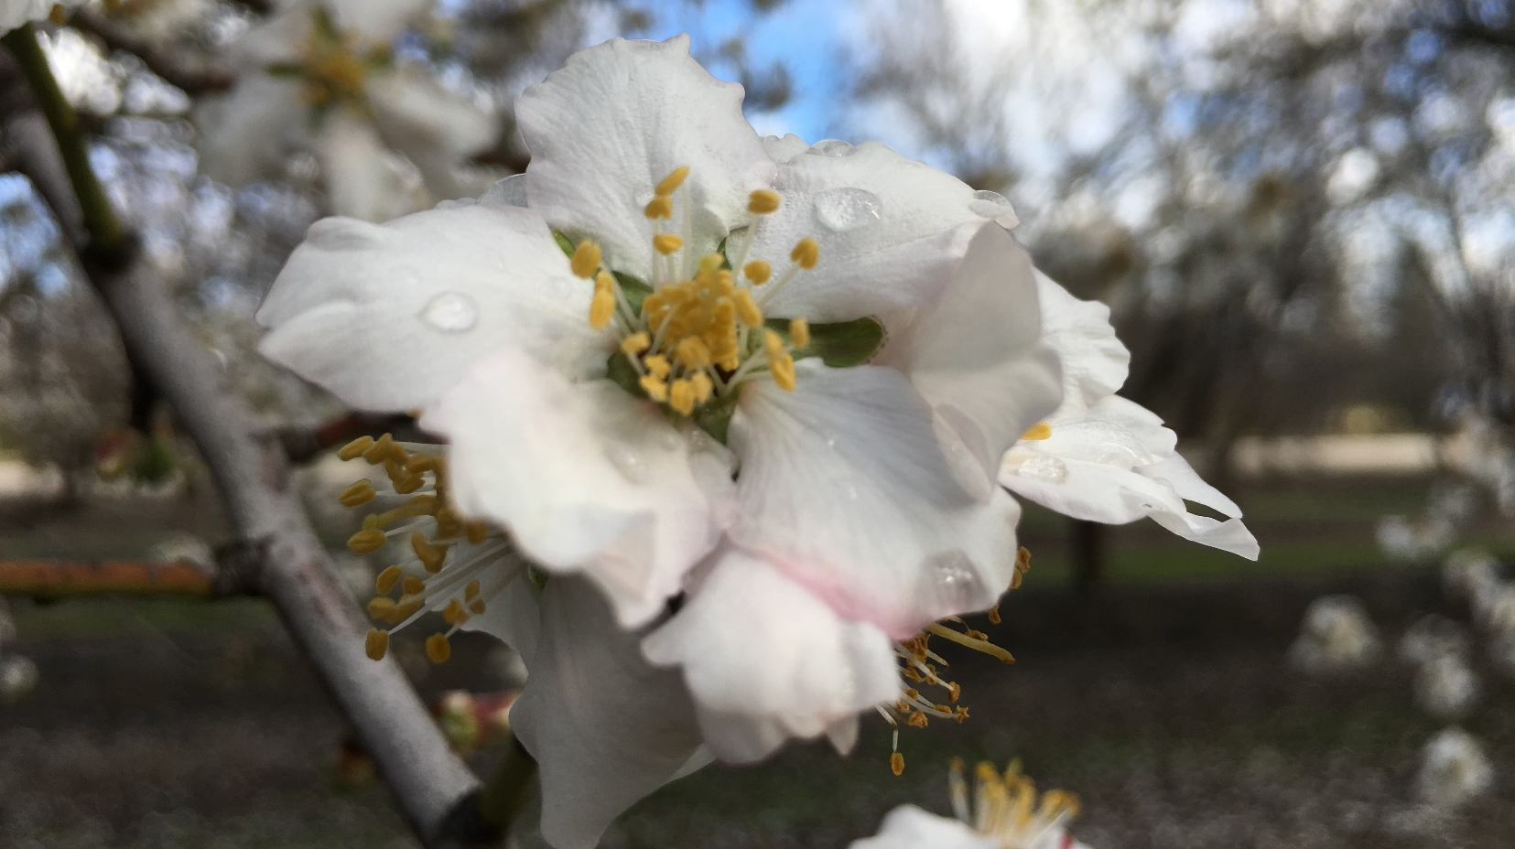


Madera County Almond Day
March 23, 2023

Madera County Farm Bureau
1102 South Pine Street, Madera, CA 93637

Check www.sjvtandv.com for current information
DPR, INMTP, and CCA units requested
Light refreshments will be available
8:00-8:30 Registration
8:30– 9:30 Laws and regulations
9:30 – 10:00 Phosphorus fertilization
10:00 – 10:30 Irrigation management
10:30 – 10:45 Break
10:45 – 11:15 Wood canker management
11:15 – 11:45 Navel Orangeworm management
11:45 – 12:15 Groundwater recharge research update
Agenda

Page 6

7:30 – 8:00 Registration
8:00– 9:00 Laws and regs update
9:00 – 9:30 Nitrogen management
9:30 – 10:00 Irrigation management
10:00 – 10:15 Break
10:15 – 10:45 Research update on dormancy research in pistachio
10:45 – 11:15 Plant bug management
11:15 – 11:45 Cover crops: what can we learn from research in other crops?
Agenda
Madera/Merced Pistachio Day
April 13, 2023
Merced County Cooperative
Extension Building
2145 Wardrobe Avenue, Merced, California 95341
Light refreshments will be provided
Questions? Email pegordon@ucanr.edu or
text 559-825-7632
DPR, CCA, and INMTP units requested

Pa
Page 7
In Memoriam:

University of California Cooperative Extension Farm Advisor G. Steven Sibbett,
Nut Crops, Prunes, Olives, Apples and Pears Farm Advisor, Tulare County

By Robert Beede, UCCE Farm Advisor, Emeritus, Kings County

Steve Sibbett passed unexpectedly at his Visalia home last November. Most of his illustrious 35-year career was spent serving agriculturists in Tulare County. His acquired expertise in walnuts, olives, and prunes was recognized statewide by his UC colleagues and growers. Steve was also well known internationally for his sound horticultural advice in these crops, which resulted in many exchanges of knowledge and experiences that benefited California producers.

Steve ushered in a relatively new era of county-based production problem solving using detailed experiments established in the orchards of cooperating growers. These experiments subscribed to the rigorous scientific standards of UC and included the on-farm participation of campus-based professors and Extension specialists of many disciplines. Leading UC scientists traveled from Davis, Berkeley and Riverside to cooperate with Steve because of the great respect they had for his critical thinking, capacity to secure grower cooperators willing to be inconvenienced by the special requirements of the experiment, and diligent follow-through and oversight of the experiment to insure its integrity was not compromised. These local research efforts yielded many major advancements in our understanding of complex production problems. Examples include: elucidating the role that excessive pollen played in causing major walnut crop loss from female flowers abscising shortly after bloom; development of pruning, thinning, bee management, and harvest guidelines to increase the yield and size of dried prunes; cooperating with Blain Farming to establish pecans as a viable statewide crop; determining optimal harvest guidelines for olive growers to maximize production and value; participating in the 1970’s state-wide team to study the effects of walnut harvest timing and ethephon, then a new plant growth regulator, on kernel quality; and cooperating with Lory Bennett’s in evaluating the major walnut varieties under high planting density for their long-term yield performance.

Steve was admired for his tremendous writing skills. In addition to a monthly grower newsletter, he authored or coauthored 124 scientific papers and chapters for peer-reviewed UC publications. He also wrote hundreds of articles for trade publications and books. Steve also served as the UC representative for founding the World Ag Expo.

Steve was instrumental in developing the concept of short courses for growers; walnuts was the first in 1976. Scores of UC short courses for scores of commodities and subjects have been offered since. Additionally, Steve was instrumental in creating a county/campus-based group to increase collaboration. This became known as PECC (Pomology Extension Continuing Conference), which was so successful that it became the model for all other Extension groups. Steve was also a mentor to dozens of budding farm advisors, myself included. Each of us, as well as every grower he visited or had coffee with, has their own rendition of Steve, and stories to tell!

Steve officially retired from UC in 2000. He remained active in consulting and advising current UC staff. Many enjoyed participating with Steve in his love for fishing and hunting. His wit, stories, wisdom, and bravado will be missed. We will continue to pursue excellence as his legacy!

Page 8

February 2023
In A Nutshell:

It is the policy of the University of California (UC) and the UC Division of Agriculture & Natural Resources not to engage in discrimination against or harassment of any person in any of its programs or activities on the basis of race, color, national origin, religion, sex, gender, gender expression, gender identity, pregnancy (which includes pregnancy, childbirth, and medical conditions related to pregnancy or childbirth), physical or mental disability, medical condition (cancer-related or genetic characteristics), genetic information (including family medical history), ancestry, marital status, age, sexual orientation, citizenship, or service in the uniformed services (as defined by the Uniformed Services Employment and Reemployment Rights Act of 1994 [USERRA]), as well as state military and naval service. This policy is intended to be consistent with the provisions of applicable state and federal laws and University policies. University policy also prohibits retaliation against any employee or person in any of its programs or activities for bringing a complaint of discrimination or harassment pursuant to this policy. This policy also prohibits retaliation against a person who assists someone with a complaint of discrimination or harassment or participates in any manner in an investigation or resolution of a complaint of discrimination or harassment. Retaliation includes threats, intimidation, reprisals, and/or adverse actions related to employment or to any of its programs or activities. In addition, it is the policy of the University and ANR to undertake affirmative action, consistent with its obligations as a Federal contractor, for minorities and women, for persons with disabilities, and for covered veterans. The University commits itself to apply every good faith effort to achieve prompt and full utilization of minorities and women in all segments of its workforce where deficiencies exist. These efforts conform to all current legal and regulatory requirements and are consistent with University standards of quality and excellence. In conformance with Federal regulations, written affirmative action plans shall be prepared and maintained by each campus of the University, including the Division of Agriculture and Natural Resources. Such plans shall be reviewed and approved by the Office of the President and the Office of the General Counsel before they are officially promulgated. Inquiries regarding the University’s nondiscrimination policies may be directed to Linda Marie Manton, Affirmative Action Contact, University of California, Agriculture and Natural Resources, 2801 Second Street, Davis, CA 95618, (530) 750-1318.

