

EFNEP How to Use:
The Cultural Foods Substitution Guide

- Assists educators with entering cultural foods into Web-NEERs
- Use with the Food Tracker….What I ate yesterday form and Cultural Foods Substitution Guides

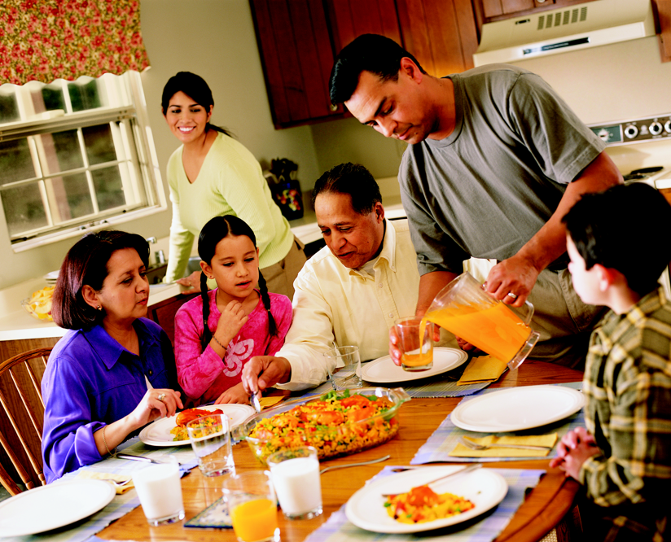

How to Use: The Cultural Foods Substitution Guide

Purpose: This guide will help you find substitutions for ethnic foods that are not in NEERS.
Supplies List:
- The Cultural Foods Substitution Guide
- Participant’s Food Tracker
- Computer with NEERS

- Find the first food on the participant’s Food Tracker.

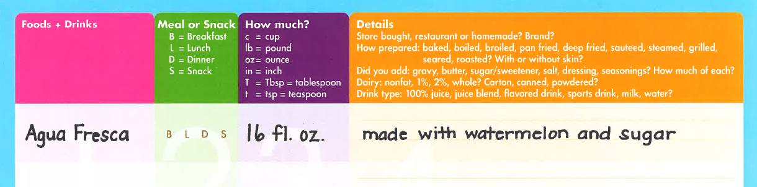

- Search for the food in NEERS.

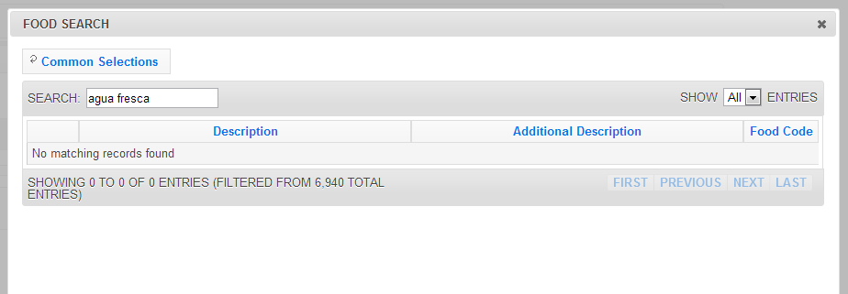

- If the food does not show up in NEERS, double-check the way you have entered it.
- Is the food spelled correctly?
- Does the item need to be translated? For example, Arroz Mexicano is not in WebNEERS, but Mexican Rice is.
- Have you tried entering the words in a different order? For example, Cooked Chinese Cabbage isn’t found in NEERS, but Cabbage, Chinese, Cooked is.
Quick Tip: Circle foods not in WebNEERS. Come back to these foods after you enter the foods that are in WebNEERS.

- If the food is not in WebNEERS and alternate searches do not work, use The Cultural Foods Substitution Guide.
- Look up the food in the Cultural Foods Substitution Guide. Foods are organized by category. If you are not familiar with the food, look it up in the Food Item Index in the guide.
If the food is not listed, see Trouble Shooting below.
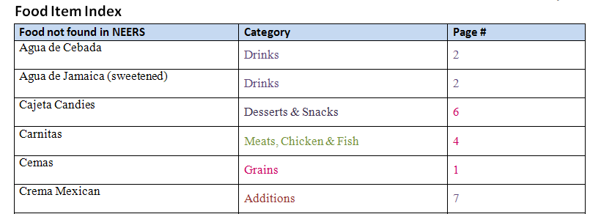

Trouble Shooting: If the food is not listed in the Cultural Foods Substitution Guide’s Index:

- Check with your advisor or other educators to see if they are familiar with the food and can give you a description. Then find a food item in WebNEERs with similar components.

- Contact the participant. Find out other names for the food, what was in the food, how much of each ingredient, and how it was prepared.

- Find the original ethnic food listed on the participants’ Food Tracker in the “Food Not in NEERS” column.

- The comparable WebNEERS food will be listed in the “NEERS Food Substitution” column.

- In participant’s recall, enter the WebNEERS food substitution name.

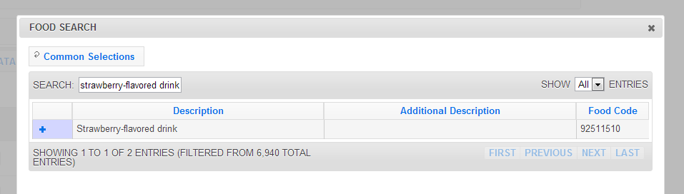

- Find the quantity listed in the “NEERS Portion Size” column.

- In WebNEERS, select this quantity in the “Portion Size” box.

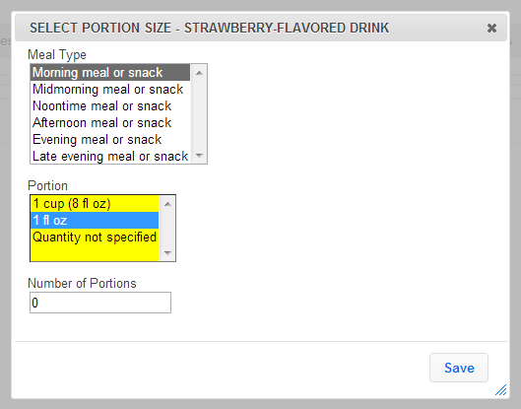

- On the participant’s Food Tracker, find the amount in the “How Much” column.

- Find this amount of the ethnic food in the “Qty on Food Tracker” column.

- Find the corresponding number listed in the “NEERS # of Portions” column.

- In WebNEERS, type this number into the “Number of Portions” box.

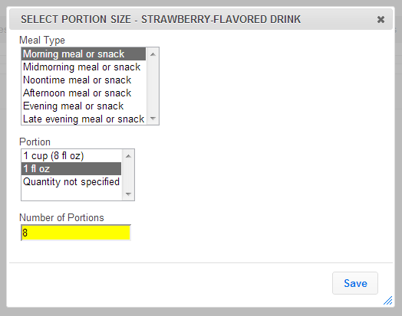
- Go back to the participant’s Food Tracker and continue on to the next food. Click “Done” on the food search window when you have added all the foods on the participant’s Food Tracker

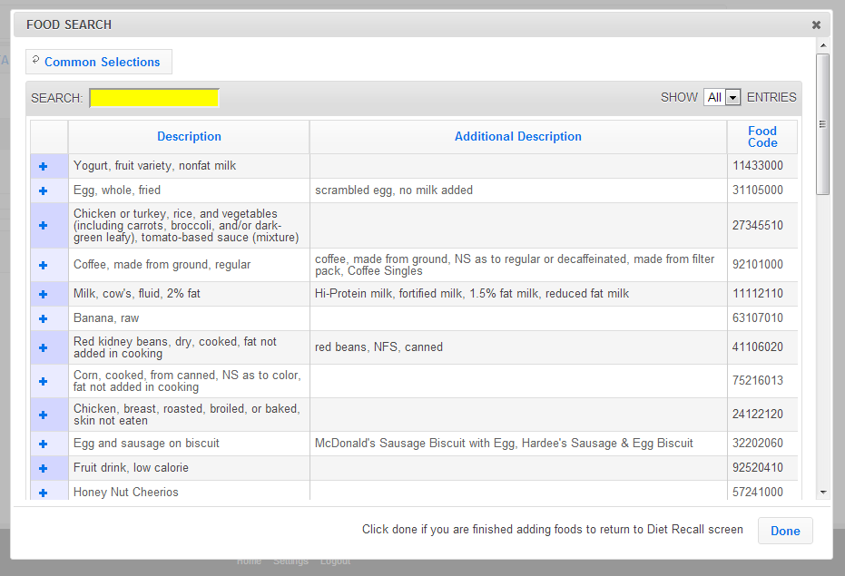

- The food(s) has successfully been entered into the participant’s dietary recall in WebNEERS

