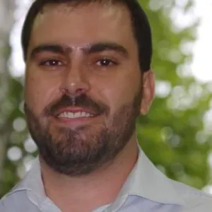  Doug Amaral  Area Farm Advisor  amaral@ucanr.edu  (559) 852-2737  Pomology and Water/Soils | 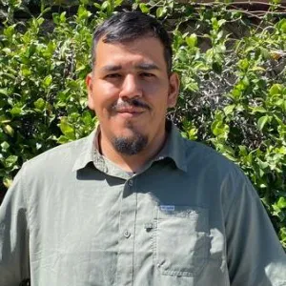  Jorge Angeles  Weed Management Advisor  jaangeles@ucanr.edu  (559) 684-3300  Orchard and Vine Crops |   Brianna Antunez  Lab Assistant 2  bgantunez@ucanr.edu  (559) 852-2730 |  | 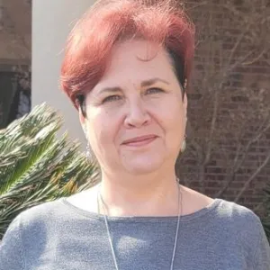  Aliya Bayless  Master Gardner Program Coordinator  ambayless@ucanr.edu  (559) 684-3343 |  | 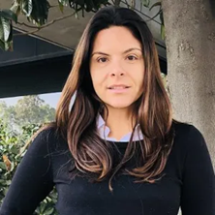  Daniela F Bruno  Dairy Advisor  dfbruno@ucanr.edu  (559) 241-7552 |  | 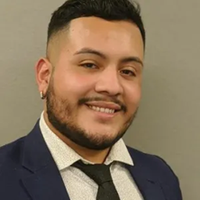  Ruben Chavez  Lab Assistant 2  rjrchavez@ucanr.edu  (559) 852-2730


Nicholas Clark
Agronomy & Nutrient Management Farm Advisor
neclark@ucanr.edu
(559) 852-2788

