Instructions and Forms Packet for Stanislaus County Record Book Competition PLACE FORM A LOOSE IN FRONT OF BOOK
(Form A – Submission Form)

Formatting Instructions
If you plan to submit your Record Book to any competition, you must follow these guidelines to receive the maximum points for this section.
- The 4-H Online Record Book (ORB) is the Record Book of choice. All ORB default print features are acceptable.

- You may handwrite or use the computer to prepare paper forms.

Paper:
  - 8 ½ inch x 11 inch plain white copier paper for most sections. The Title Page may be any color or special paper and still must be 8 ½ inch x 11 inch.
  - Double-sided is okay.
  - Photo quality paper is okay only on pages with photographs in the Collection of Work and/or Expression Pages.

Margins:
  - Left margin between 1 inch and 1½ inch. All other margins (top, bottom, and right) should be between ½ inch and 1 inch.
  - If used, headers, footers should be inside these margins.
  - If printing out a Google Sheet, set margins to not less than ½ inch all around.
  - Page numbers can be outside the margins.

Typeface:
  - Typed or handwritten in black ink.
  - Color may be used on the Cover, Table of Contents, Expression Pages, and the Collection of Work.
  - If handwritten, text must be written legibly. If typed, no less than 11 point in an easy-to-read font. Font size may differ for headings and emphasis in text.

Divide and Label Sections:
  - Use tabs and divider pages to separate sections and improve overall organization. Colored paper may be used as section dividers.

Graphics:
  - Graphics, pictures, and drawings may only be included on the Title Page, Table of Contents, Expression Pages and the Collection of Work.

Number the Pages:
  - Use a logical system that matches your Table of Contents to number the pages of your Record Book. Hand numbering is acceptable due to the significant number of inserted pages. Numbering using printed stickers is okay.

Folder or Binder:
  - Use an Acco fastener folder or 3-ring binder, not more than 1” wide. Acco Record Book Covers may be purchased from the Shop 4-H.

Other:
  - Do not exceed the page limits for each section.

Do not use plastic page covers or laminate any pages.
6
2023-2024 California 4-H Record Book Manual
Revised June 22, 2023 (no significant changes from 21-2022 edition)

Inserting Pages in a printed Online Record Book
  - If you print out your Record Book from ORB, you will still need to assemble the book in the proper order as specified in the Record Book Manual. It will be necessary to create the following pages:

Title Page
    - Table of Contents
    - Personal Development Record
    - My 4-H Story
    - Projects
    - Collections of 4-H Work
    - Leadership Development Reports
    - 4-H Resume

And either:
- Upload them into ORB as photographs in a “.jpg” or “.pdf” format and insert after printing where appropriate

OR
- Print out separately and insert where appropriate.

Option one (1) is recommended because then all of your Record Book documents will be archived in your Online Record Book.

Remember, you will need to number the pages, so you may want to upload the Table of Contents last.

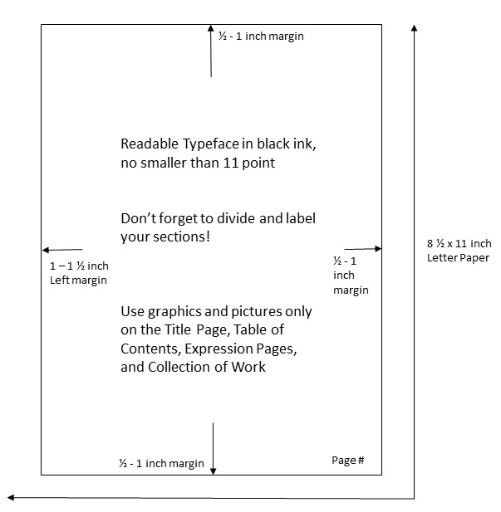
ANOTHER LOOK AT PAGE GUIDELINE
Organization Overview
A California 4-H Record Book contains the following items.

Section 1: Preliminary Information
  - Title Page
  - Table of Contents

Section 2: Personal Development Record
  - Complete one Personal Development Report (PDR) form each year.
  - Already have a Platinum Star? New short version PDR is acceptable. See PDR section for more details

Section 3: My 4-H Story Section 4: Projects*
  - One Annual Project Report (APR) form for every project you have completed.
  - One expression page for every project.

Section 5: Collection of 4-H Work (see section of manual for page limits)

Section 6: Leadership Development Report (Intermediate and Senior Members Only)
  - Complete one Leadership Development Report (LDR) Part 1(Pre) and Part 1(Post) per year.
  - Complete one Leadership Development Report (LDR) Part 2(Pre) and 2(Post) per leadership role, per year.

Section 7: 4-H Resume (Senior Members Only)
  - Senior members create a 4-H Resume that highlights their skills, leadership, and citizenship development throughout their 4-H career.
**Stanislaus County 4-H prefers to see all your previous records--please leave them in! **

A Note about previous year’s records:
All of your previous years records can be inserted at the back of the current year’s book, in reverse chronological order (that means by year and the year you started is in the back and you work forward to the current year in the front) or you can have a separate book for each year—the option is up to you. Some county competitions want to see all your previous records—so be sure to find out what your county wants before you compete.

Sending to State Competition? Only submit the current year’s records—do not send any previous year’s records. The last section will be Section 7: 4-H Resume, there should not be anything behind that.

Are you a Junior, Intermediate, or Senior Member?
Ages 9 through 10 Junior Member
Ages 11 through 13 Intermediate Member
Ages 14 through 19 Senior Member

*You must complete at least one Annual Project Report (APR) form to receive a year stripe and pin.
To see all formatting and content instructions, please download the full 2021-2022 Record Book Manual on the state page.

Form A
2023 Stanislaus County 4-H RECORD BOOK ID FORM _ Junior (9-10 yrs old, and 4th graders) for 2022-2023 4-H PROJECT AWARDS (RECORD BOOKS) Intermediate (11 - 13 years old) IDENTIFICATION (ID) FORM AND CHECKLIST _ Senior (14 years old & older)
NAME PHONE ( )

BIRTH DATE / / (age as of December 31, 2022)
AGE
GRADE IN SCHOOL (2022-2023)

ADDRESS YRS in 4-H (include current year)
CITY ZIP EMAIL ADDRESS
CLUB CLUB LEADER’S NAME
CLUB LEADER'S EMAIL ADDRESS PHONE ( )
LIST PROJECTS in which you are enrolled and applying for awards: 1st
2nd
Years in Project
Years in Project


Senior members only: (14 yrs old or older by December 31, 2022) State Records Competition
I plan to submit my record book to the State Competition*: Yes No Please review my resume in Section 7: Yes No
*If you plan to apply to the State Competition, don't forget to fill out the Intent to Submit form online by September 30, 2023.

Books are due:
August 15, 2023 by 4:00pm
Stanislaus County Ag Center
3800 Cornucopia Way, Ste A Modesto, CA 95358

ALL SIGNATURES ARE MANDATORY. All signatures provided on application certify that 4-H records are accurate, have been completed by this 4-H member and that the club community leader and project leaders support the member's application.
**** RECORD BOOKS MISSING SIGNATURES AND/OR NOT USING THE 2022-2023 MANUAL OR ONLINE STATE FORMS WILL NOT BE CONSIDERED FOR COUNTY MEDAL AWARDS OR SPECIAL AWARDS. ****

Member’s Signature Date

As Club Community Leader, I am verifying that this member is enrolled in the project(s) and that the records are true and accurate.

Your Club Community Leader's Signature Date

_____________________________________________________________________________________________ _________________________________________________________________
Parent/Guardian Signature Date

Include form A as the first pages in the record book before Section 1.

