DESIGN STYLE GUIDE NOTES:
Colors:
Teal (RGB 0 155 172) (HEX 009bac)
Header font:
Calibri (body) —bold
Font size 18
Teal color (RGB 0 119 139) (HEX 00A3AD)
Main font:
Times New Roman
Font size 13
Value of volunteer time:
Calculated at a rate of $37.32 according to the California Independent Sector. (total hours x $37.32 = TOTAL value of volunteer service hours) https://independentsector.org/wp-content/uploads/2023/04/Value-of-Volunteer-Time-by-State-2001-2022.pdf
Data call out:
Place the most important piece of data for your audience from local or statewide evaluation efforts in this section.
Quotes:
Pull quotes from surveys, post workshops, giving days, helpline emails, etc.
Additional Styles Guides Info:
- https://mgcoord.ucanr.edu/Marketing/Branding/
- https://ucanr.edu/sites/communicationstoolkit/
- https://brand.universityofcalifornia.edu/

Questions? Contact:
Melissa Womack
Assistant Director Impact & Communications
mgwomack@ucanr.edu
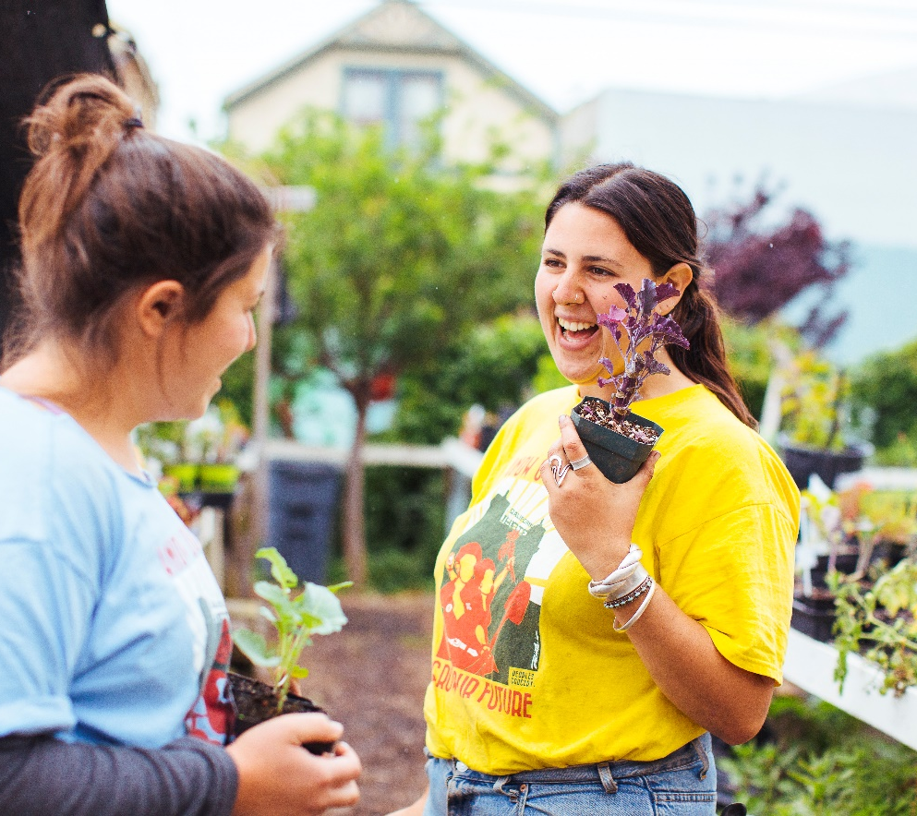

“This is such an important program, the resources and service provided will continue to benefit our communities and especially our children with a greener and cleaner environment for their future.”
- Lynn P.
395,239 hours donated
6216 volunteers
$12.5 million annual value of hours
68%%
75%
of clientele are spending more time outdoors, improving overall health
of clientele start or improve how they grow edible plants, leading to improved nutrition
Connecting with plants at home, school, and within the community is critical to physical and emotional well-being at both the individual and community level. This connection to nature is missing in many Californians' lives but can be re-kindled through community-based extension provided by the UC Master Gardener Program.
The UC Master Gardener Program teaches people how to grow food, garden sustainably to protect California's natural resources, and educates communities on pest management best practices. By customizing local gardening outreach to account for unique local landscapes and the diversity of California's residents, we strive to meet the needs of all the communities we serve.
The UC Master Gardener Program:
» Hosts educational workshops and events about how to garden sustainably to protect California's natural resources
» Answers questions by email or phone, about how to grow fruits and vegetables, or manage pests in the garden
» Provides hands-on demonstrations at school, community and demonstration gardens
» … and so much more!
Safeguarding sufficient and healthy food
Missy Gable
Statewide Director
mjgable@ucanr.edu
(530) 750-1200
CONTACT US:
Promoting healthy people and communities
COMMUNITY IMPACT:
FISCAL YEAR 2022-23
GROWING COMMUNITIES
Research has shown that living near green spaces may actually help you live longer. With 95% of California’s population living in urban areas, green spaces are critical in helping reduce anxiety and stress.

