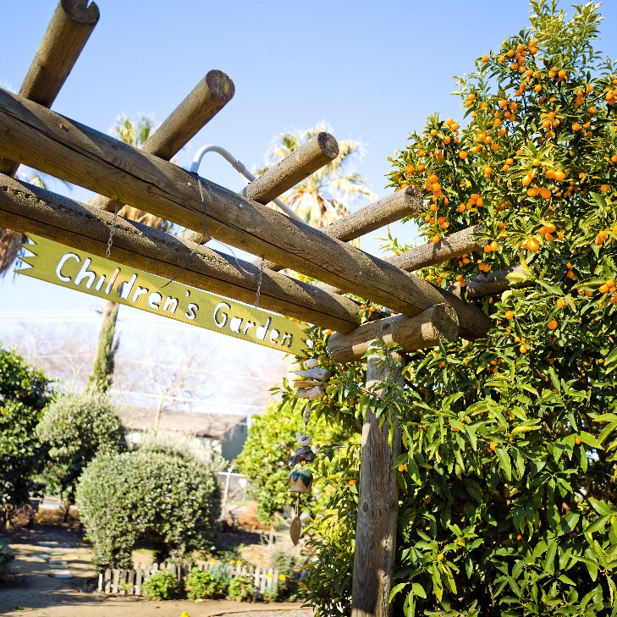
UC Master Gardeners of XYZ County present…
XYZ Garden Tour
Sponsorship Prospectus
Event Date:
Time:
Location:
Attendees:
Website:
EVENT
Our XYZ Garden Tour is one of our signature events presented annually to the residents of XYZ County and beyond. It attracts attendees who are avid gardeners looking for inspiration and education regarding a variety of subjects including: sustainable gardening, soil development, drip irrigation, integrated pest management, habitat gardening, growing fruits and vegetables, water catchment, firewise landscaping, and much, much more.
Replace photo with local image and include caption here. Photo credit: Name, Used with permission.
This year # gardens will be selected for their beauty and their displays of sustainable gardening practices. Each of the gardens will be featured in articles published on our website in which we will cover topics such as: goals of the gardener, special features of each garden and important gardening practices.
This year’s tour will mark our programs # year in presenting the tour. We continue to grow in size and anticipate approximately # attendees this year.
ABOUT US
Established in year, the UC Master Gardeners of XYZ County is a volunteer-led organization with currently # active volunteers. We improve communities by promoting science literacy and connecting people to the environment through educational outreach in: food production, sustainable gardening, green waste reduction, water quality & conservation, and pest management.
Our volunteers are well educated, civically minded, and passionately connected and loyal to our mission of extending research based gardening information to all Californians. On average, volunteers stay in our program for 7 years and provide over 600 hours of service to their communities.
WHY PARTNER?
- Strengthen connections with a unique audience of avid gardeners, passionate about home horticulture and sustainable gardening
- Increase brand awareness and product knowledge
- Build rapport with master gardener volunteers, who are leaders in the community
A complete listing of sponsorship levels and benefits are listed on the next page. Custom packages may be available to best fit the needs of your organization. For more information, please contact:

Name| Program Coordinator | Phone | Email (over please)
Yes, I support the UC Master Gardener Program of XYZ County with a gift of:

Give Online: donate.ucanr.edu
or, Charge my credit card:
□Visa □Master Card □Amex □Discover

__________ - __________ - __________ - _________

Exp. ______________ Security code: ____________

Name: _______________________________________
Gold Level - $2,000
Silver Level - $1,000
Bronze Level - $500
Other _____________

Make checks payable to: UC Regents
Mail to: Address

XYZ Garden Tour sponsorship opportunities

Thank you for your consideration. Partnerships are an integral piece in producing quality programming. We look forward to building strong, mutually beneficial relationships with our partners. Funds raised will directly support the UC Master Gardeners of XYZ County Program and enable us to continue our ongoing education and community engagement to home gardeners on a year-round basis. Please do not hesitate to contact us with any questions.

UC Master Gardeners of XYZ County
Address
Please send an acknowledgement of my gift to:
Company Name: ____________________________________________________________________________________
Contact Name: ______________________________________________________________________________________
Address: ___________________________________________________________________________________________
City, State, Zip: ______________________________________________________________________________________
Phone: ____________________________________________________________________________________________
Email: _____________________________________________________________________________________________

