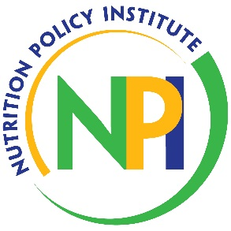

Impact Outcome Evaluation Quarterly Call

Date: Tuesday, July 15, 2025
Time: 10:00 am
Host: Amanda Linares

Pre-register: https://ucanr.zoom.us/j/94663584673

Agenda
Time | Topic | Presenter
10:00 – 10:05 | Announcements | Amanda
10:05 – 10:15 | IOE Process & Timeline | Amanda
10:15 – 10:40 | EATS: Protocol & Administration Best Practices | Amanda
10:40 – 10:45 | Online Resources | Amanda
10:45 – 10:50 | Next Steps & Takeaways | Amanda
10:50 – 11:00 | Q & A | Amanda

