Steps to completing a County Spotlight
WHEN
- County Spotlights are due on November 1st of each year.
WHY
- Government Relations and UC ANR leadership use these documents to showcase the importance of your county’s work and how funding has led to positive impacts in the community. You can also use it to communicate with partners, to meet local reporting requirements, and for advocacy at the local level.
HOW
- This product should be used and modified to fit your county's needs and to highlight the best of your county's programming. Modify the template and replace sections based on what is relevant to you, your partners and other stakeholders.
- Review the steps below to complete page 1 and 2 of the County Spotlight
- Follow the UC ANR Communications Toolkit for fonts, colors, and more style guidance.
- Page 3 of the template is a library of options you can copy/paste onto pages 1 and 2 of the document. It should be deleted before submitting your final copy to the Google Drive folder.
- Find more tips and support for completing County Spotlights on the Government Relations website.
- Before submitting, review your document. Move and resize the elements of the pages (photos, text boxes, lines, etc.) to make sure they are evenly spaced and do not overlap. Since these documents will be shared publicly with county and state officials, please ensure your County Spotlight looks presentable for professional audiences.
- Once the formatting and content are finalized, save the document as a PDF with the title format: County Name_2024 County Spotlight
- If you plan to post your County Spotlight online, use this guide to ensure your PDF is ADA compliant: https://helpx.adobe.com/acrobat/using/create-verify-pdf-accessibility.html. You can reach out to Christina Becker (christina.becker@ucop.edu) for technical assistance.
- You can upload your final document to the “Final draft County Spotlights (shared by counties).” Login to my.ucdavis.edu before clicking on this link to the folder.
  - Page 1
Page 1 should provide a broad overview of your county, offering readers a quick sense of the research and extension activities taking place. It should also highlight key successes and show how the work benefits the county or its communities.
Page 1 instructions:
- Update your county name and logo in the header


- Replace placeholder photos with photos relevant to your county/counties. To replace photos, you can right click on the photo, select “change picture” and choose another photo from your files. Make sure to update the photo caption and photo credit.
Note: For high quality printing, photos need to be at least 300 dpi. For further ANR guidance on photos, visit UC ANR Communications Toolkit. It includes information such as tips for taking/using your own photos, media release forms, and UC ANR’s photographic style guide.
- Replace the “lorem ipsum” in the top left with an introduction to your county and replace the photo with one that represents some of the work that UCCE does for the county. The introduction should be high-level and answer questions like:
  - What work does UCCE do?
  - How does UCCE do the work?
  - Who does UCCE work with?
  - What communities does UCCE reach?

- Replace the “lorem impsum” in the green boxes with highlights from your county. Examples: the number of academics, community educators and staff in your county, list of programs, research and extension areas, clientele groups, partnerships, etc. Resize, delete or add boxes as needed.

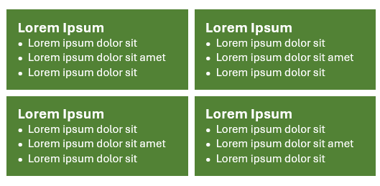
- Add metrics from your county in the “By The Numbers” boxes and replace the “lorem ipsum” with information about how those metrics benefit the county and/or county residents.
Note: Program Planning and Evaluation shares data sourced from statewide programs and academics assigned to your county/counties (volunteer numbers, contacts, publications and more). This information can be found in the Google Drive folder shared with County/Area Directors. You can also add other metrics collected by your county.
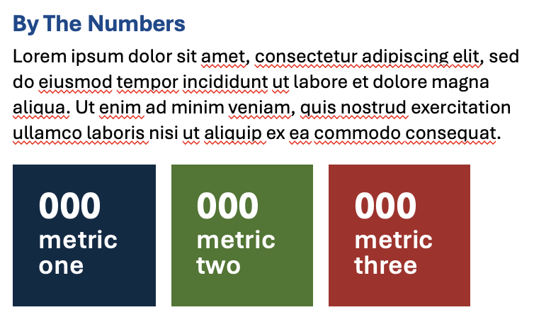
- Add an impact or outcome story and title – something to illustrate how your work makes a difference to the lives of people in your county/counties.

Note: If you need help sourcing stories to include, you have several options:
- Use the annual Condition Change Impact Stories compilation – download the most recent document and search your county’s name or the name of Advisors in your county to find outcomes to write about. You can also view some of these stories featured in the 2024 UC ANR Annual Report here.
- Reach out to Advisors and staff for stories and outcomes
- Use the Project Board “Explore” feature, available for anyone to look up who is working on specific topics. You will need to reach out directly to academics to learn more about their projects.
For guidance and resources on writing impact statements, visit Program Planning and Evaluation’s Impact Writing webpage.
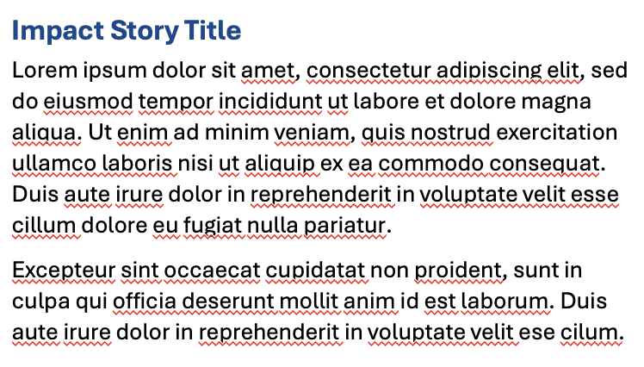
- Add a testimonial from someone in your county who has been positively affected by UCCE. Include their name and/or affiliation with UCCE.
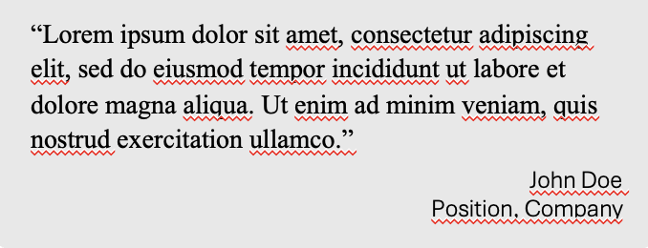

- Add your county’s website url to the footer.

  - Page 2
Page 2 should offer a deeper look at individual programs, research areas, or other key activities. You can choose what to highlight. The logos and titles in the template are placeholders and should be customized to reflect what is relevant to your county.
Page 2 Instructions:
- Replace placeholder photos with photos relevant to your county/counties. To replace photos, you can right click on the photo, select “change picture” and choose another photo from your files. Make sure to update the photo caption and photo credit.
Note: For high quality printing, photos need to be at least 300 dpi. For further ANR guidance on photos, visit UC ANR Communications Toolkit. It includes information such as tips for taking/using your own photos, media release forms, and UC ANR’s photographic style guide.
- For each section on page 2:
Insert the relevant logo from the logo library on page 3 of the template or delete if not applicable

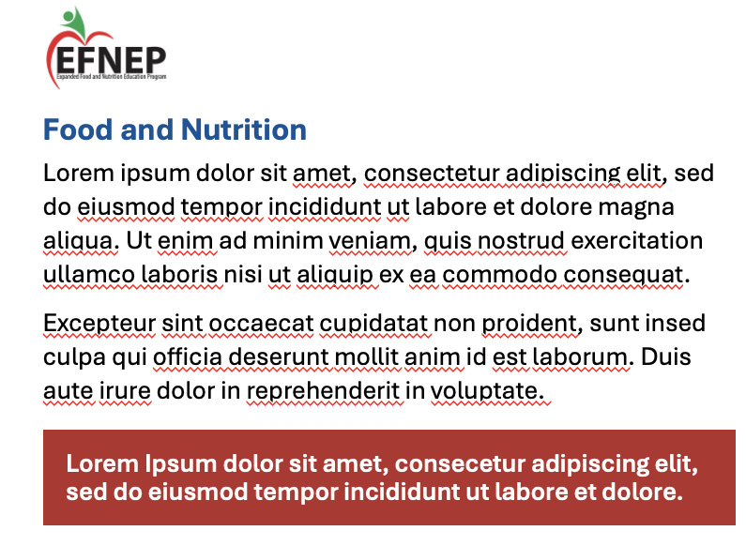
The body of each section can include a variety of information:
- Testimony from clientele or program participants
- Outcomes/impact (see step 6 in page 1 instructions for more info)
- Human interest stories
- Research or program metrics
Add call-out boxes like this (see page 3 of the template for more options) to highlight exciting outcomes or successes
Add the program name or a relevant title for the section

- Update the footer with:
  - Social media handles (Bluesky, Instagram, Facebook, Youtube, etc.)
  - County/Area Director Name
  - County website

  - ADA Compliance
County Spotlights posted online should be reviewed for ADA compliance.
For guidance on creating an ADA compliant PDF, use Adobe’s PDF accessibility guide: https://helpx.adobe.com/acrobat/using/create-verify-pdf-accessibility.html
You can also find more information on UCOP’s website: https://www.ucop.edu/electronic-accessibility/web-developers/create-accessible-pdfs.html
For technical assistance, reach out to Christina Becker (christina.becker@ucop.edu).

