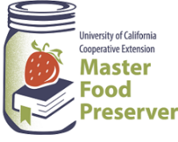
UCCE Master Food Preservers of El Dorado County
311 Fair Lane, Placerville CA 95667
Email: edmfp@ucanr.edu • Visit us on Facebook and Instagram!

$2.00

“Preserve today, Relish tomorrow”

Culinary Herbs
From Garden to Table

Saturday, May 3, 2025
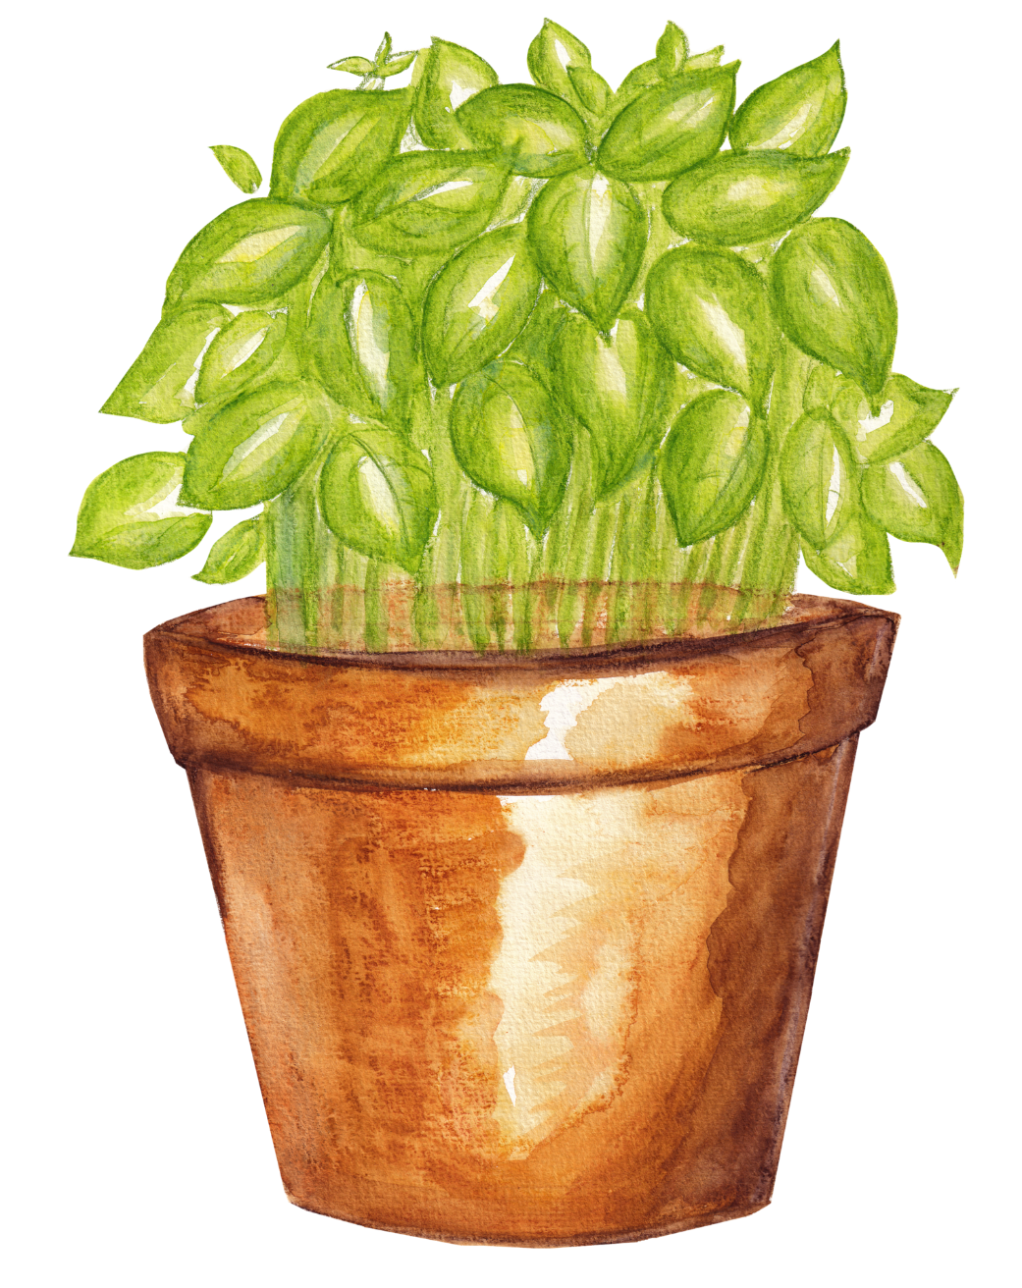
9:00 a.m. – 12:00 p.m.

Food Safety / Preserving Basics
Food preservation starts with food safety. Cleaning and sanitizing your work area, washing hands frequently, properly handling produce and meat, and avoiding cross-contamination are all part of the process in avoiding food-borne illness.

Following recipes from trusted resources is the next step in ensuring safety when preserving food. This is especially important when canning: It’s critical to follow a current, research-based recipe and to use the correct canning method for the food being processed.

For further details on food safety in general, as well as information on a variety of food preservation topics, visit our Food Safety website, where you’ll find free, downloadable publications and educational posters.

Before beginning any of the projects in this handout, we especially recommend reviewing the following Preserving Fundamentals publications:

- Introduction to Food Safety
- Cleaning and Sanitizing
- Low Acid Canning Basics – Using Pressure Canners*

These materials may be accessed here: https://ucanr.edu/sites/mfp_of_cs/Food_Safety/. You can also access this site by scanning this QR code with your smartphone or tablet.


*A pdf of this publication was emailed to you as part of your workshop registration. A direct link to the publication is here: https://ucanr.edu/sites/mfp_of_cs/files/395607.pdf.

Additional Food Safety and Preserving Resources:

UC Master Food Preservers of Central Sierra https://ucanr.edu/sites/mfp_of_cs/
UC Master Food Preserver Program https://mfp.ucanr.edu/
National Center for Home Food Processing https://nchfp.uga.edu/
USDA Complete Guide to Home Canning https://nchfp.uga.edu/publications/publications_usda.html#gsc.tab=0
So Easy to Preserve https://setp.uga.edu/
Ball Blue Book Guide to Preserving. ©2024. Newell Brands Inc.
Ball Complete Book of Home Preserving. ©2024. Newell Brands Inc.
All New Ball Book of Canning and Preserving. ©2023. Newell Brands Inc.

Preserving Herbs https://extension.sdstate.edu/preserving-herbs
Making Flavored Vinegars https://extension.colostate.edu/topic-areas/nutrition-food-safety-health/flavored-vinegars-and-oils-9-340/
How to safely Make Infused Oils https://extension.psu.edu/how-to-safely-make-infused-oils

Herbs & Spices

What is the difference between an herb and a spice?
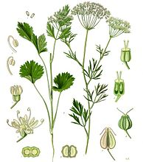
While the terms herb and spice are used interchangeably by cooks and cookbooks, there are distinct differences between the two. It all depends on what part of the plant is used.
Herbs: In general, culinary herbs are the leafy portions of a plant, whether dried or fresh. Examples include basil, bay leaves, parsley, cilantro, rosemary, and thyme.
Spices: Spices, on the other hand, are harvested from any other portion of the plant and are typically dried. Popular spices come from berries (peppercorns), roots (ginger), seeds (nutmeg), flower buds (cloves), or even the stamen of flowers (saffron).
Two in One: Some plants are generous enough to yield both an herb and a spice. Cilantro is the leafy herb of the same plant that gives us the popular spice coriander seed. And dill weed (an herb) and dill seed (a spice) also come from the same plant.
Checking for Freshness:
Color: Green, leafy herbs will often fade as they age, while red spices such as paprika, red pepper and chile powder will turn brown in color.
Aroma: Place a small amount in the palm of your hand and gently rub with your thumb. The aroma should be rich, full and immediate. If not, it probably lost potency.
If in Doubt, Throw It Out.
Store Properly: Store herbs and spices in cool, dry surroundings, away from direct light, heat or humidity. Keep in airtight glass jars and close tightly after each use.
Don’t Shake Over A Boiling Pot: Moisture from steam may diminish the potency of spices or herbs remaining in the jar. Pour a small amount into your hand or a ramekin, then add to the dish you are preparing.

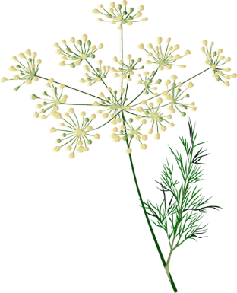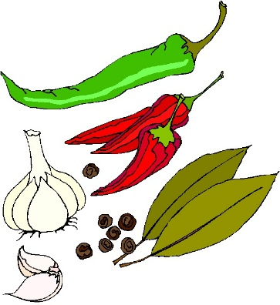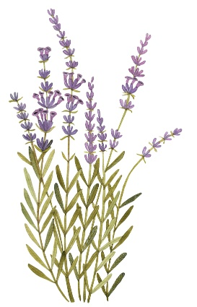
Salts

Table Salt
Table salt is typically mined from underground salt deposits. Table salt is more heavily processed to eliminate minerals and usually contains an additive to prevent clumping. Some table salt also has added iodine, an essential nutrient that helps maintain a healthy thyroid.
Kosher Salt
Kosher Salt is a coarse edible salt without common additives such as iodine. Used in cooking and not at the table, it consists mainly of sodium chloride and may include anti-caking agents.
Sea Salt
Sea salt is produced through evaporation of ocean water or water from saltwater lakes, usually with little processing. Depending on the water source, this leaves behind certain trace minerals and elements. The minerals add flavor and color to sea salt, which also comes in a variety of coarseness levels.
Fleur de Sel
("flower of salt" in French; is a salt that forms as a thin, delicate crust on the surface of seawater as it evaporates. Fleur de sel has been collected since ancient times (it was mentioned by Pliny the Elder in his book Natural History), although it was traditionally used as a purgative and salve. It is now used as a finishing salt to flavor and garnish food. The name comes from the flower-like patterns of crystals in the salt crust.
Pickling Salt
Pickling salt is pure sodium chloride that’s free of the anticaking agents and other additives found in table salt. This means that it dissolves completely in brine, leaving the liquid perfectly clear.
What's the difference between sea salt and table salt?
The main differences between sea salt and table salt are in their taste, texture and processing. Sea salt is produced through evaporation of ocean water or water from saltwater lakes, usually with little processing. Depending on the water source, this leaves behind certain trace minerals and elements. The minerals add flavor and color to sea salt, which also comes in a variety of coarseness levels.
Table salt is typically mined from underground salt deposits. Table salt is more heavily processed to eliminate minerals and usually contains an additive to prevent clumping. Most table salt also has added iodine, an essential nutrient that helps maintain a healthy thyroid.

Sea salt and table salt have the same basic nutritional value, even though sea salt is often promoted as being healthier. Sea salt and table salt contain comparable amounts of sodium by weight.
Whichever type of salt you enjoy, do so in moderation. The Dietary Guidelines for Americans recommend limiting sodium to less than 2,300 milligrams a day.
Answer From Katherine Zeratsky, R.D., L.D. https://www.mayoclinic.org/healthy-lifestyle/nutrition-and-healthy-eating/expert-answers/sea-salt/faq-20058512
Drying Herbs
Drying is the easiest method of preserving herbs. Simply expose the leaves, flowers or seeds to warm, dry air. Leave the herbs in a well-ventilated area until the moisture evaporates. Sun drying is not recommended because the herbs can lose flavor and color.
The best time to harvest most herbs for drying is just before the flowers first open when they are in the bursting bud stage. Gather the herbs in the early morning after the dew has evaporated to minimize wilting. Avoid bruising the leaves. They should not lie in the sun or unattended after harvesting. Rinse herbs in cool water and gently shake to remove excess moisture. Discard all bruised, soiled or imperfect leaves and stems.
Dehydrator drying is a fast and easy way to dry high quality herbs because temperature and air circulation can be controlled. Pre-heat dehydrator with the thermostat set to 95°F to 115°F. In areas with higher humidity, temperatures as high as 125°F may be needed. After rinsing under cool, running water and shaking to remove excess moisture, place the herbs in a single layer on dehydrator trays. Drying times may vary from 1 to 4 hours. Check periodically. Herbs are dry when they crumble, and stems break when bent. Check your dehydrator instruction booklet for specific details.
Less Tender Herbs — The sturdier herbs such as rosemary, sage, thyme, summer savory and parsley are the easiest to dry without a dehydrator. Tie them into small bundles and hang them to air dry. Air drying outdoors is often possible; however, better color and flavor retention usually results from drying indoors.
Tender-Leaf Herbs — Basil, oregano, tarragon, lemon balm and the mints have a high moisture content and will mold if not dried quickly. Try hanging the tender-leaf herbs or those with seeds inside paper bags to dry. Tear or punch holes in the sides of the bag. Suspend a small bunch (large amounts will mold) of herbs in a bag and close the top with a rubber band. Place where air currents will circulate through the bag. Any leaves and seeds that fall off will be caught in the bottom of the bag.
Another method, especially nice for mint, sage or bay leaf, is to dry the leaves separately. In areas of high humidity, it will work better than air drying whole stems. Remove the best leaves from the stems. Lay the leaves on a paper towel, without allowing leaves to touch. Cover with another towel and layer of leaves. Five layers may be dried at one time using this method. Dry in a very cool oven. The oven light of an electric range or the pilot light of a gas range furnishes enough heat for overnight drying. Leaves dry flat and retain a good color.
Microwave ovens are a fast way to dry herbs when only small quantities are to be prepared. Follow the directions that come with your microwave oven.
When the leaves are crispy dry and crumple easily between the fingers, they are ready to be packaged and stored. Dried leaves may be left whole and crumpled as used, or coarsely crumpled before storage. Husks can be removed from seeds by rubbing the seeds between the hands and blowing away the chaff. Place herbs in airtight containers and store in a cool, dry, dark area to protect color and fragrance.
Dried herbs are usually 3 to 4 times stronger than the fresh herbs. To substitute dried herbs in a recipe that calls for fresh herbs, use 1/4 to 1/3 of the amount listed in the recipe.
Source: "So Easy to Preserve", 6th ed. 2014. Bulletin 989, Cooperative Extension Service, The University of Georgia, Athens. Revised by Elizabeth L. Andress. Ph.D. and Judy A. Harrison, Ph.D., Extension Foods Specialists.
Using Herbs
- Herbs should be used to complement the flavor of food.
- Generally, ¼ teaspoon of dried herbs is adequate for a four serving recipe.
- Substitution guidelines:
  - ¼ teaspoon powdered herb = 1 teaspoon dried herb = 1 Tablespoon chopped fresh herb.
Recipe: Italian Seasoning

- 2 Tbsp. dried basil
- 2 Tbsp. dried oregano
- 2 Tbsp. dried sage
- 2 Tbsp. dried marjoram
- 2 Tbsp. dried rosemary

Mix all ingredients and store in a tightly sealed glass container.
Recipe: Mediterranean Herb Rub

- 3 tablespoons dried oregano
- 3 tablespoons dried dill
- 3 tablespoons dried thyme
- 3 tablespoons dried rosemary
- 2 tablespoons coarse salt
- 2 tablespoons lemon pepper
- 1 tablespoon dried garlic flakes

Combine all ingredients. Store in an airtight container for up to six months.

Recipe: Herbes de Provence Yield: approximately 1/3 cup

- 1 tablespoon dried thyme leaves
- 1 tablespoon dried sweet marjoram leaves
- 1 tablespoon dried summer or winter savory leaves
- 1 tablespoon dried rosemary leaves
- 2 dried bay laurel leaves, finely crushed in a mortar or spice grinder
- 1 teaspoon dried lavender buds
- 2 teaspoons grated and dried orange zest

Place thyme, sweet marjoram, savory and rosemary leaves in small bowl. Lightly crumble leaves with fingertips. Add crushed bay, lavender buds, fennel seeds, and orange zest. Stir together to mix well. Pour into a glass jar and cover tightly. Store in a cool, dry, dark place for up to 1 year.
Source: Herbs - A Country Garden Cookbook, Rosalind Creasy and Carole Saville

Recipe: Tuscan Herb Salt Yield approximately ¾ cup

- 4 to 5 garlic cloves peeled
- Scant ½ cup kosher salt
About 2 cups loosely packed, pungent fresh herbs such as sage, rosemary, thyme, savory, basil, or small amounts of lavender
Cut each garlic clove lengthwise through the center, remove the sprout (if any) in the center and discard.
Mound the salt and garlic on a cutting board. Use a chef’s knife to mince the garlic, blend it with the salt as you work.
Place herbs in a mound and coarsely chop them. Add the herbs to the garlic salt and chop them together to the texture of coarse sand.
Spread the salt on a baking sheet or in wide flat bowls and leave near an open window for a couple of days to dry. Store in clean, dry jars.
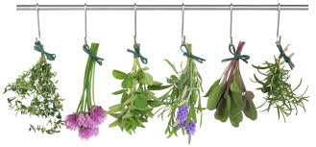
Alternate drying method: Heat oven to 200°F. Turn off oven, insert cookie sheet with salt mixture. Close door and let sit overnight. Break up any clumps with a fork and let air dry if needed.

A Rough Guideline for How Long to Keep Herbs and Spices
For full flavor crush or grind just before using.
Never store your spices above your stove as the additional heat will more quickly lead to degradation of their quality. Also, don't store them directly above your dishwasher as the increased humidity will also shorten their shelf life. Stored spices do best in temperatures below 70°F and in lower humidity environments. While achieving both may be challenging in your kitchen the closer you can get to the ideal storage of them the better off you'll be.
If spices and herbs are kept as suggested, the shelf life will be as follows:
- Whole spices and dried herbs, leaves and flowers will keep 1 - 2 years.
- Seeds will keep 2 – 3 years and whole roots (i.e. ginger root or galangal root) will keep 3 years.
- Ground spices and herb leaves will keep 1 year.
- Ground roots will keep for 2 years.

Just because a spice or seasoning blends is outside the date range listed above doesn't mean that the spice needs to be tossed in the trash. To determine if a spice or seasoning is still good, you must remember "appearance" and "aroma". A spice that is no longer acceptable will have lost much of its vibrant color and will instead appear dull and faded. The bigger key, though, is smell. To determine whether a ground spice is still good, gently shake the container with the cap on. Remove the cap and smell the spice to see if the potent aroma of the spice is still present. If it is, then your spice is still in good shape. Spices don't just all of a sudden go from good one day to bad the next. From the time they're harvested, they slowly begin to deteriorate and what you want to do is to prolong their optimum flavor for as long as possible with proper grinding and storage.
In addition:
- Seasoning Blends 1-2 years
- Extracts 4 years
Source: Information from: Spice Islands and http://www.spicesinc.com/p-780-what-is-the-shelf-life-of-spices-and-herbs.as

