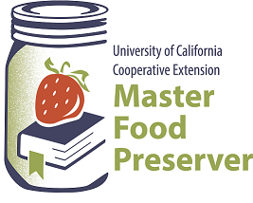
UCCE Master Food Preservers of El Dorado County
311 Fair Lane, Placerville CA 95667
https://ucanr.edu/site/uc-master-food-preservers-central-sierra
Visit us on Facebook and Instagram!

“Preserve today, Relish tomorrow”

All About Berries

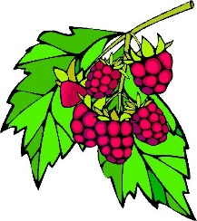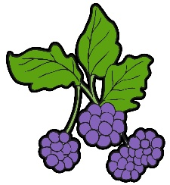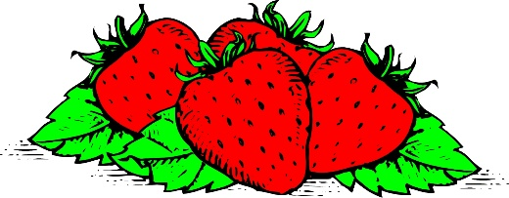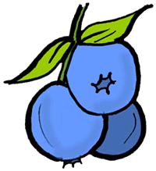
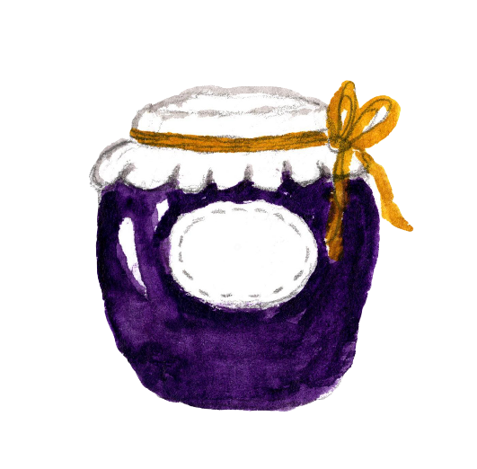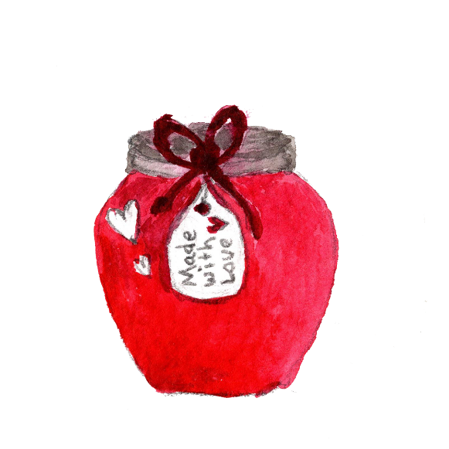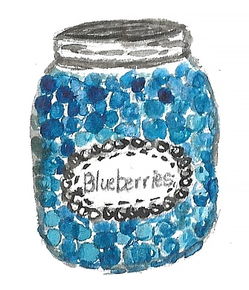

Saturday July 12, 2025
9:00 a.m. – Noon.

It is the policy of the University of California (UC) and the UC Division of Agriculture & Natural Resources not to engage in discrimination against or harassment of any person in any of its programs or activities (Complete nondiscrimination policy statement can be found at https://policy.ucop.edu/doc/1001004/Anti-Discrimination
Food Safety / Preserving Basics
Food preservation starts with food safety. Cleaning and sanitizing your work area, washing hands frequently, properly handling produce and meat, and avoiding cross-contamination are all part of the process in avoiding food-borne illness.

Following recipes from trusted resources is the next step in ensuring safety when preserving food. This is especially important when canning: It’s critical to follow a current, research-based recipe and to use the correct canning method for the food being processed.

For further details on food safety in general, as well as information on a variety of food preservation topics, visit our Food Safety website, where you’ll find free, downloadable publications and educational posters: https://ucanr.edu/sites/mfp_of_cs/Food_Safety/.

You can also access the site by scanning this QR code with your smartphone or tablet.

RECIPES
To be sure your home-canned food is safe and of high quality, follow the guidelines outlined in our publication High Acid Canning, which is available to download for free from our website: https://ucanr.edu/sites/mfp_of_cs/files/395907.pdf

Whether you’re brand new to canning in general or could simply use a refresher, you’ll find all the current information you need to know, including the types of canners (and which to use when), preparing jars for canning, basic do’s and don’ts of canning, and safe food handling.

Dehydrating Berries
Blackberries (all varieties) and raspberries are not recommended for drying because of their high
seed content and slow drying time. They do make excellent fruit leathers.

Blueberries
Select large, firm, fully ripe berries that have a deep, blue color. Wash berries and remove the stems. Blueberries may be dried without any pretreatment but will dry faster if they are dipped in boiling water to crack the skins before drying. When blueberries are dried with no pretreatment, they will be puffy in appearance and texture. Those dipped in boiling water will be raisin-like in quality.

Blueberries are dry when they are leathery and pliable with no pockets of moisture. They are excellent eaten as a snack or added to cereal, baked products, and pancakes.

Strawberries
The sweeter varieties are best for drying. Select firm, ripe, red berries with a solid color. They should be picked when fully ripe for best flavor. Wash berries remove caps and cut into ½ inch slices or cut smaller berries in half. Dry skin-side down. No pretreatment is necessary. Strawberries are dry when they are pliable and leathery with no pockets of moisture.
Dried strawberries can be eaten as a snack, added to cooked and dry cereals, combined with granola, or added to milk shakes or yogurt. They are better eaten dry because they lose their firm texture when rehydrated.

Berry Leathers
Berries of all kinds can be puréed, either by themselves, or in combination with other fruits, such as apples and pears, to make fruit leathers. It is desirable to remove seeds from the purée since they become very hard after they are dried.
To make fruit leathers, purée berries, strain seeds, sweeten to taste and pour on a leather drying sheet or drying tray or cookie sheet, covered with plastic wrap. Place in a dehydrator or warm oven (145˚ F.) and dry until leathery with no moisture pockets.

Remove from drying tray and roll or cut into bite-size pieces. Wrap and store in a cool, dry place.

Depending on the fruit and its moisture content, leather size and type of dryer used, it may take anywhere from 6 hours to several days to dry at 140 degrees Fahrenheit. Leathers can be kept for up to one month at room temperature and up to one year if frozen.

Source: Oregon State University https://extension.oregonstate.edu/food/preservation/preserving-foods-berries-sp-50-780
For a complete guide to dehydrating produce download Dehydrating Basics https://ucanr.edu/sites/default/files/2024-06/398681.pdf

Freezing Berries
Quick Facts about freezing:
- Freezing is one of the simplest and least time-consuming ways to preserve foods at home.
- Berries and cherries are best frozen soon after harvest. Peaches, plums, and apples may need to fully ripen before freezing.
- Small whole fruits, such as berries or cherries, can be frozen individually on trays, packaged in bags and later used in salads or garnishes.
- Most fruits maintain high quality for 8 to 12 months at 0 degrees F or below.

Preparing the Fruit
Sort, wash and drain fruits carefully, discarding parts that are green or of poor quality. Do not allow fruit to soak in wash water or it will lose nutrients and flavor. Prepare fruits as they will be used–stemmed, pitted, peeled, or sliced. Prepare enough fruit for only a few containers at a time, especially those fruits that darken rapidly. Do not use galvanized equipment in direct contact with fruit. The acid in the fruit dissolves zinc, which can be harmful in large amounts. Also, be wary of using iron utensils or chipped enamelware, as metallic off-flavors can result.

Freezing without sugar
Arrange dry, fresh berries on a cookie sheet in a single layer. Place the cookie sheet in the freezer. When frozen, transfer berries to freezer bags or containers. Seal and label. Properly frozen berries will last up to two years.

Freezing with sugar
To freeze whole, sliced or crushed berries, add ¾ cup sugar to 1-quart (about 1⅓ pounds) of berries. If you are freezing blueberries with sugar, you would want to crust them before adding the sugar. Stir until most of the sugar dissolves and let stand for 15 minutes before putting berries into containers. Soft sliced berries will yield sufficient syrup for covering if the fruit is layered with sugar and allowed to stand 15 minutes.
When packaging, allow adequate headspace so that syrup does not expand and overflow the container when the berries freeze. Allow ½-inch headspace for berries packed without added sugar or liquid. Allow 1 inch headspace in wide top containers (¾ inch in narrow top pints and 1½ inches in narrow top quarts) when packing in juice, sugar, syrup or water, or the fruit is crushed or pureed.

Artificial Sweeteners
Follow the manufacturer’s directions to determine the amount of artificial sweetener to use for freezing berries. Remember though, they do not provide the beneficial effects of sugar such as color protection and thickness of syrup. An alternative is to add these sweeteners after the berries thaw
Freezing in syrup
Use a 30% syrup pack which is 1 ¾ cups sugar to 4 cups water which would give you approximately 5 cups of syrup. Dissolve sugar in cold or hot water. If hot water is used, cool syrup before using. Syrup may be made the day before and kept covered in the refrigerator. Up to one-fourth of the sugar may be replaced, amount for amount, with corn syrup or honey. Fruits packed in syrup generally are best for most cooking processes. To pack fruit in syrup, pour 1/2 cup cold syrup into each container. Add fruit and cover with additional syrup, leaving sufficient headspace at top of container. Allow 1/2 inch of headspace for wide-top pints, 1 inch for wide-top quarts, 3/4 inch for narrow-top pints and 1 1/2 inches for narrow-top quarts. Allow 1 1/2 inches of headspace for juices packed in narrow-top containers, regardless of size.
Freezing Tips
The more quickly berries freeze, the higher their quality will be and the smaller the ice crystals form. The desirable temperature for storing frozen foods is 0°F or lower.

For more information download Freezing Basics https://ucanr.edu/sites/default/files/2025-03/Freezing%20Tips%20-%20English.pdf

Berry Freezer Jam Yield: about 5-6 eight ounce jars
This freezer jam may be used with any berries – blackberries, blueberries, raspberries, strawberries.

- 4 cup crushed berries (fresh or frozen)
- 1 pkg. Mrs. Wages No Cook Freezer Jam fruit pectin
- 1 ½ cups sugar or Splenda
- Freezer safe containers

Sort, stem and wash firm, ripe berries. Crush thoroughly. If using frozen berries, allow to thaw. Stir sugar into prepared berries. Let stand about 20 minutes. Stir pectin into fruit-sugar mixture. Continue stirring for 3 minutes. Ladle jam into clean or freezer containers jars leaving ½ inch headspace. Twist on lids.

Serve immediately, refrigerate up to three weeks or freeze up to one year.

Source: mrswages.com

Mulled Blackberry Vinegar Yield: about 5 eight ounce jars

- 4 cups blackberries
- 4 cups apple cider vinegar, divided
- 2 cinnamon sticks (about 4”, broken into pieces)
- 1 Tbsp. whole cloves
- 1 Tbsp. whole allspice
In a large glass bowl, combine blackberries and 1 cup of the vinegar. Lightly crush berries with a potato masher. Add remaining 3 cups vinegar, and spices, stirring to combine. Cover tightly with plastic wrap and let stand in a cool dark place for up to 4 weeks, stirring every 2 to 3 days. Taste weekly until desired strength is achieved.

Line a strainer with several layers of cheesecloth and place over stainless steel saucepan. Strain vinegar without squeezing the cheesecloth. Discard cheesecloth with residue. Place saucepan over medium heat and heat vinegar to 180° F.

Ladle hot vinegar into hot jars, leaving ¼ inch headspace. Wipe rims; place lids and rings on jars. Tighten rings only finger tight.

Place jars in canner a boiling water or atmospheric steam canner. Process for: 0-6000 ft. = 10 minutes, above 6000 ft. = 15 minutes. For boiling water canning, turn off the heat, remove canner lid and wait 5 minutes. For atmospheric steam canning, turn off the heat, leave canner lid on and wait 2-3 minutes.

Cool jars for 12-24 hours, wash, label, and store in a cool dark place.

Source: Ball Complete Book of Home Preserving 2020

Strawberry Jam with A Twist Yield: about 8 eight ounce jars
The addition of balsamic vinegar and black pepper accents the strawberry flavor and gives the jam a robust taste.

- 5 cups crushed strawberries
- 7 cups granulated sugar
- 3 Tbsp. bottled lemon juice
- 1 Tbsp. balsamic vinegar
- 1 pkg regular powdered pectin
- ½ tsp. freshly ground black pepper
- ½ tsp. butter

Wash and hull strawberries. Crush thoroughly, one layer at a time. Measure 5 cups. Measure sugar; set aside.

Combine strawberries, lemon juice, vinegar, and pectin in a large, deep stainless-steel saucepan. To reduce foaming, add ½ tsp butter to the mixture. Bring mixture to a full boil, stirring constantly. Add sugar, stirring until dissolved. Return the mixture to a full rolling boil. Boil for 1 minute more (or per pectin manufacturer’s instructions). Stir in freshly ground black pepper.

Ladle hot preserves into hot jars, leaving ¼ inch headspace. Wipe rims; place lids and rings on jars. Tighten rings according to the manufacturer’s instructions.

Place jars in canner a boiling water or atmospheric steam canner.

Process for: 0-6000 ft. = 10 minutes, above 6000 ft. = 15 minutes. For boiling water canning, turn off the heat, remove canner lid and wait 5 minutes. For atmospheric steam canning, turn off the heat, leave canner lid on and wait 2-3 minutes.

Label and store in a cool, dry place.

Source: Ball Complete Book of Home Preserving

Blueberry Bonanza Yield: about 4 eight oz jars of syrup and 5 eight oz jars of butter
Two recipes in one; blueberry syrup and blueberry butter. Enjoy blueberry butter as you would any other butter; on scones and biscuits, as a filler for cakes and other desserts or use it as a base for BBQ sauce. Blueberry syrup is easy to use - pancakes, ice cream or over pound cake.

- 12 cups blueberries
- Water
- 6 cups granulated sugar, divided
- 2 cups corn syrup
- Grated zest of one lemon
- Juice of two lemons or commercial juice to equal that of two lemons
- 1 tsp. ground nutmeg
- ½ tsp. ground cinnamon

In a large non-reactive saucepan, combine blueberries with 3 cups water. Bring to a boil over medium-high heat, stirring and crushing mixture with a potato masher. Reduce heat and boil gently, stirring occasionally, for 5 minutes.

Transfer blueberries to a dampened jelly bag or a strainer lined with several layers of dampened cheesecloth set over a deep bowl. Let drip until 5 cups juice has been collected, adding water if necessary to yield the required quantity. Set juice aside. Puree remaining pulp and juice in a blender or a food processor fitted with a metal blade.

Prepare canner, jars and lids.

Blueberry Syrup

In a clean large, deep non-reactive saucepan, combine 1 cup water and 3 cups of the granulated sugar. Bring to a boil over high heat, stirring to dissolve sugar. Stir in blueberry juice, corn syrup and half of the lemon juice; return to a boil. Reduce heat to medium-high and boil steadily, stirring occasionally, until mixture is slightly thickened, about 35 minutes. Remove from heat and skim off foam.

Ladle hot syrup into hot jars, leaving ¼ inch headspace. Wipe rims; place lids and rings on jars. Tighten rings only finger tight.

Place jars in canner a boiling water or atmospheric steam canner. Process for: 0-6000 ft. = 10 minutes, above 6000 ft. = 15 minutes. For boiling water canning, turn off the heat, remove canner lid and wait 5 minutes. For atmospheric steam canning, turn off the heat, leave canner lid on and wait 2-3 minutes.

Cool jars for 12-24 hours, wash, label, and store in a cool dark place.

Blueberry Butter

Meanwhile, in a separate clean large non-reactive saucepan, combine blueberry puree, remaining 3 cups sugar, lemon zest, remaining lemon juice, nutmeg and cinnamon. Bring to a boil over medium-high heat, stirring frequently. Reduce heat to medium and boil, stirring frequently, until mixture thickens and holds its shape on spoon.

Ladle hot butter into hot jars, leaving ¼ inch headspace. Remove air bubbles and adjust headspace, if necessary, by adding hot butter. Wipe rims; place lids and rings on jars. Tighten rings only finger tight.

Place jars in canner a boiling water or atmospheric steam canner. Process for: 0-6000 ft. = 10 minutes, above 6000 ft. = 15 minutes. For boiling water canning, turn off the heat, remove canner lid and wait 5 minutes. For atmospheric steam canning, turn off the heat, leave canner lid on and wait 2-3 minutes.

Cool jars for 12-24 hours, wash, label, and store in a cool dark place.

Source: Ball Complete Book of Home Preserving

Strawberry-Lemon Concentrate Yield: about 7 pint jars
- 6 cups hulled strawberries
- 4 cups freshly squeezed lemon juice
- 6 cups sugar

Use a blender or a food processor and purée the strawberries until smooth and put in a large pot. Add lemon juice and sugar and stir to combine.

Heat to 190° F. Stir to dissolve sugar, but do not boil. Remove from heat and skim off foam.

Ladle into hot jars, leave ¼-inch headspace, clean jar rims. Apply lids and rings. Screw band down according to manufacturer’s recommendation.

Process in a boiling water canner or atmospheric steam canner for 15 minutes 0-1000 ft., 20 minutes 1001-6000 ft., 25 minutes above 6000 ft. For boiling water canning, turn off the heat, remove canner lid and wait 5 minutes.
For atmospheric steam canning, turn off the heat, leave canner lid on and wait 2-3 minutes.

Source: Ball Complete Book of Home Preserving

Resources for tested recipes:
National Center for Home Food Preservation: https://nchfp.uga.edu/#gsc.tab=0

Complete Guide to Home Canning. 2015. https://nchfp.uga.edu/resources/category/usda-guide#gsc.tab=0
Also available in paper copy from Purdue Extension (online store is located at https://mdc.itap.purdue.edu/item.asp?item_number=AIG-539)

So Easy to Preserve, Sixth Edition. 2016. Bulletin 989. Cooperative Extension/University of Georgia, Athens

Ball Blue Book Guide to Preserving. 2024. Newell Corporation.
Ball Complete Book of Home Preserving, 2024. Bernardin, Newell Corporation.
Bernardin: https://www.bernardin.ca/
Ball: https://www.ballmasonjars.com

UCCE Master Food Preservers of El Dorado County
https://ucanr.edu/sites/mfp_of_cs/Recipes/Archived_Recipes/

UC Master Food Preserver Program
https://mfp.ucanr.edu/

