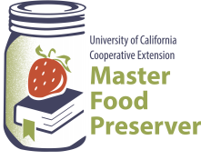
UCCE Master Food Preservers of El Dorado County
311 Fair Lane, Placerville CA 95667
Ask a Master Food Preserver: https://link.ucanr.edu/mfp-cs-ask
Visit us on Facebook and Instagram!

$5.00

Preserve Today, Relish Tomorrow

Making Pickles and Condiments

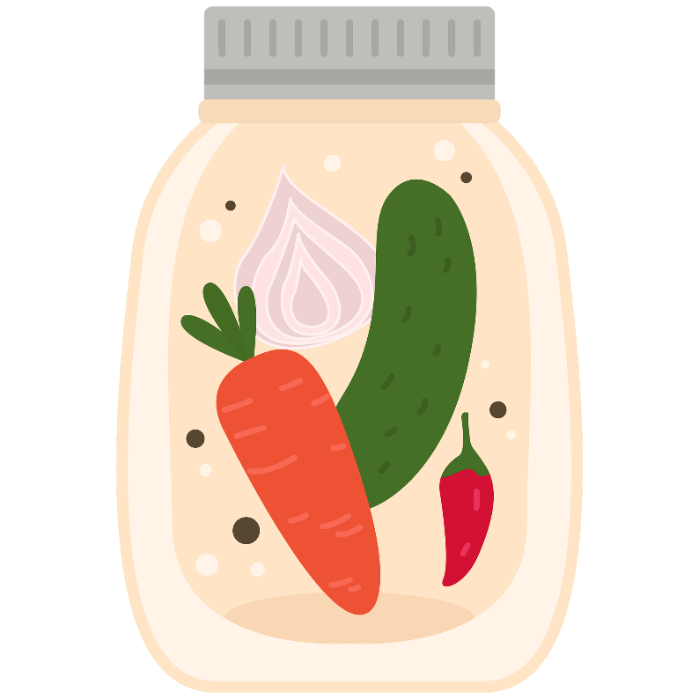
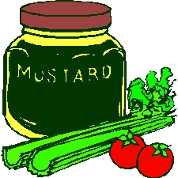



Saturday August 23, 2025
9:00 a.m. – Noon.

It is the policy of the University of California (UC) and the UC Division of Agriculture & Natural Resources not to engage in discrimination against or harassment of any person in any of its programs or activities (Complete nondiscrimination policy statement can be found at https://policy.ucop.edu/doc/1001004/Anti-Discrimination

Food Safety / Preserving Basics

Food preservation starts with food safety. Cleaning and sanitizing your work area, washing hands frequently, properly handling produce and meat, and avoiding cross-contamination are all part of the process in avoiding food-borne illness.

Following recipes from trusted resources is the next step in ensuring safety when preserving food. This is especially important when canning: It’s critical to follow a current, research-based recipe and to use the correct canning method for the food being processed.

For further details on food safety in general, as well as information on a variety of food preservation topics, visit our Food Safety website, where you’ll find free, downloadable publications and educational posters: https://ucanr.edu/sites/mfp_of_cs/Food_Safety/.

You can also access the site by scanning this QR code with your smartphone or tablet.

Recipes

Traditional Bread and Butter Pickles Yield: about 5 pint jars

- 10 cups sliced, trimmed pickling cucumbers (1/4 inch)
- 4 medium onions, sliced thinly
- 1/2 cup pickling/canning salt
- 3 cups white vinegar (5% acidity)
- 2 cups granulated sugar
- 2 Tbsp. mustard seeds
- 1 tsp. celery seeds
- 1 tsp. ground turmeric
- Ball or Bernardin Pickle Crisp (optional)

In a glass or stainless steel bowl, combine cucumbers, onions, and salt. Mix well, cover
with cold water and let stand at room temperature for 2 hours. Transfer to a colander
placed over a sink, rinse with cool running water and drain thoroughly.

In a large stainless steel saucepan, combine vinegar, sugar, mustard seeds, celery seeds,
and turmeric. Bring to a boil over medium heat, stirring to dissolve sugar. Stir in vegetables and return to a boil.

Pack vegetables into hot jars. Ladle hot pickling liquid into jar to cover vegetables, leaving 1/2 inch headspace. Add 1/8 tsp. Pickle Crisp, if using to each pint jar. Remove air bubbles and adjust headspace, if needed, by adding more of the liquid. Wipe jar rims clean with a dampened clean paper towel. Place lids and rings on jars. Tighten rings per manufacturer’s instructions.

Process in a boiling water bath or atmospheric steam canner for:
10 minutes at 0’-1000’, 15 minutes at 1001’- 3000’, 20 minutes at 3001’ - 6000’,
25 minutes above 6001’.

For boiling water canning, turn off the heat, remove canner lid and wait 5 minutes. For atmospheric steam canning, turn off the heat, leave canner lid on and wait 5 minutes. Cool jars for 12-24 hours, wash, label, and store in a cool dark place.

Variation:
British Bread and Butter Pickles:
Substitute 3 cups cider vinegar for white vinegar
2 cups packed brown sugar for the granulated sugar.
Add 1 tsp. ground ginger

Source: Ball Complete Book of Home Preserving 2024

Pickled Corn Relish Yield: about 9 pint jars

- 10 cups corn kernels (about 16-20 medium-size ears of corn) or
- six 10 ounce packages of frozen corn
- 5 cups diced, seeded, mixed red and green bell peppers
- 2 ½ cups diced celery
- 1 ¼ cup diced onions
- 1 ¾ cups granulated sugar
- 5 cups white vinegar
- 2 ½ Tblsp. pickling salt
- 2 ½ Tbsp dry mustard
- 2 ½ tsp celery seeds
- 1 ¼ tsp ground turmeric

Boil ears of corn for 5 minutes. Dip in cold water to stop the cooking process. Cut whole kernels from cob.

Combine peppers, celery, onions, sugar, vinegar, canning salt, and celery seed in a saucepan. Bring to a boil and simmer for 5 minutes, stirring occasionally to dissolve the sugar and salt. Mix mustard and turmeric in ½ cup of the simmered mixture. Add this mixture and the corn to the hot mixture. Simmer another 5 minutes. If desired, thicken the mixture with flour paste (1/4 cup flour blended in ¼ cup water) and stir frequently.

Fill hot jars with hot mixture, leaving ½ inch headspace. Remove air bubbles and adjust headspace, if needed, by adding more of the corn mixture. Wipe jar rims clean with a dampened clean paper towel. Place lids and rings on jars. Tighten rings only finger tight.

Process in a boiling water canner or atmospheric steam canner for 10 minutes 0-1000 ft., 15 minutes 1001-6000 ft., 20 minutes above 6000 ft.

For boiling water canning, turn off the heat, remove canner lid and wait 5 minutes. For atmospheric steam canning, turn off the heat, leave canner lid on and wait 5 minutes. Cool jars for 12-24 hours, wash, label, and store in a cool dark place.

Source: National Center For Home Food Preservation https://nchfp.uga.edu/how/can_06/pickled_corn_relish.html

Zesty Zucchini Relish Yield: about 6 pint jars

- 4 ¼ lb zucchini, about 14 medium
- 1 ½ lb onion, about 5 medium
- 2 large sweet red peppers
- 1 large sweet green pepper
- ⅓ cup pickling salt
- 2 ½ cups granulated sugar
- 1 Tbsp each: ground nutmeg & ground turmeric
- 2 ½ cups white vinegar
- 4 Tbsp prepared horseradish
- 1 large hot pepper including seeds, chopped

Day 1
Pulse zucchini in food processor to finely chop; measure 12 cups (3000 ml). Repeat for onions; measure 4 cups (1000 ml). Place chopped vegetables in a large glass or stainless steel bowl. Remove seeds and membrane from sweet green and red peppers. Finely chop green pepper; cut red pepper into 1/4 inch) cubes; add both to zucchini. Stir in pickling salt. Cover and refrigerate overnight.

Day 2
Drain vegetables; rinse with cold running water. Drain in a cheesecloth-lined colander, twisting cheesecloth to remove excess moisture. Place vegetables in a large stainless steel saucepan. Stir in sugar, nutmeg, turmeric, vinegar, horseradish and hot pepper; bring to a boil. Reduce heat and boil gently until thick, about 45 minutes.

Ladle hot into hot jars leaving 1/2 inch headspace. Remove air bubbles. Wipe rim. Center hot lid on jar. Screw band down according to manufacturer’s directions. Place jar in boiling water canner. Repeat until jars are full.

Process in a boiling water canner or atmospheric steam canner for 10 minutes 0-1000 ft., 15 minutes 1001-6000 ft., 20 minutes above 6000 ft.

For boiling water canning, turn off the heat, remove canner lid and wait 5 minutes.
For atmospheric steam canning, turn off the heat, leave canner lid on and wait 5 minutes. Cool jars for 12-24 hours, wash, label, and store in a cool dark place.

Source: Ball Complete Book of Home Preserving

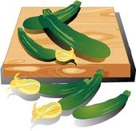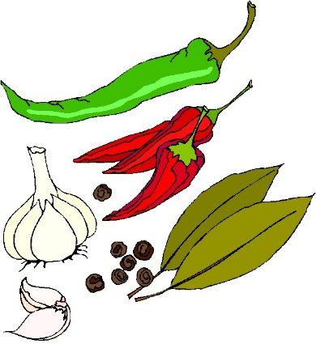

Pickled Cherries Yield: about five 4 oz. jars

- 2 ½ cups white vinegar (at least 5% acidity)
- 2 ¾ lbs fresh sweet cherries, washed, pitted, and stemmed
- 7 (3-inch) cinnamon sticks
- 1 split vanilla bean
- 2 cups sugar
- 2 Tbsp. pickling salt
- 7 whole cloves
- 7 star anise

Combine all ingredients except cherries in a non-reactive sauce pan. Bring to a boil, reduce heat and boil gently, uncovered, for 20 minutes.

Tightly pack cherries into jars, leaving ½” headspace. Remove air bubbles and adjust headspace, if necessary, by adding hot liquid. Wipe rim. Center lid on jar according to manufacturers instructions.

Process in a boiling water bath or atmospheric steam canner for:
0-1000 ft. = 10 minutes, 1001-6000 ft. = 15 minutes, above 6000 ft. = 20 minutes.

For boiling water canning, turn off the heat, remove canner lid and wait 5 minutes. For atmospheric steam canning, turn off the heat, leave canner lid on and wait 5 minutes. Cool jars for 12-24 hours, wash, label, and store in a cool dark place.
Source: Adapted from All New Ball Book of Canning and Preserving, 2023

Zesty Peach BBQ Sauce Yield: about 8 half-pint. jars

- 6 cups finely chopped pitted peeled peaches (about 3 lbs. or 9 medium)
- 1 cup finely chopped red bell pepper
- 1 cup finely chopped onion (about 1 large)
- 3 Tbsp finely chopped garlic (about 14 cloves)
- 1 ¼ cups honey
- ¾ cup cider vinegar
- 1 Tbsp Worcestershire sauce
- 2 tsp hot pepper flakes
- 2 tsp dry mustard
- 2 tsp salt

Combine all ingredients in a large saucepan. Bring to a boil. Reduce heat and simmer, stirring frequently, until mixture thickens to the consistency of a thin commercial barbeque sauce, about 25 minutes. If desired, puree in batches in a food processor or use an immersion blender to help break down the peaches.

Ladle hot sauce into hot jars leaving 1/2 inch headspace. Remove air bubbles. Wipe rim. Center hot lid on jar. Screw band down according to manufacturer’s directions. Place jar in boiling water canner. Repeat until jars are full.

Process in a boiling water bath or atmospheric steam canner for:
0-1000ft. = 15 minutes, 1001-3000 ft. = 20 minutes, 3001-6000 ft. = 25 minutes, above 6000 ft. = 30 minutes.

For boiling water canning, turn off the heat, remove canner lid and wait 5 minutes. For atmospheric steam canning, turn off the heat, leave canner lid on and wait 2-3 minutes. Remove jars, cool 12-24 hours, wash, and store in a cool dark place.
Source: Ball Complete Book of Home Preserving, 2024

Basic Refrigerator Pickles

Onions, cucumbers, peppers, carrots, cauliflower, asparagus, parsnips, radishes, and pea pods are great vegetables to start making quick refrigerator pickles.

Step 1. Prepare Vegetables
Wash and chop vegetables into the desired shape you would like for pickles. These vegetables do not require any cooking prior to pickling.

Step 2. Select Flavorings
Get creative with fresh or dry flavorings. Mix and match from the following suggested list of fresh and dried herbs and spices to add up to 2 tablespoons per jar.

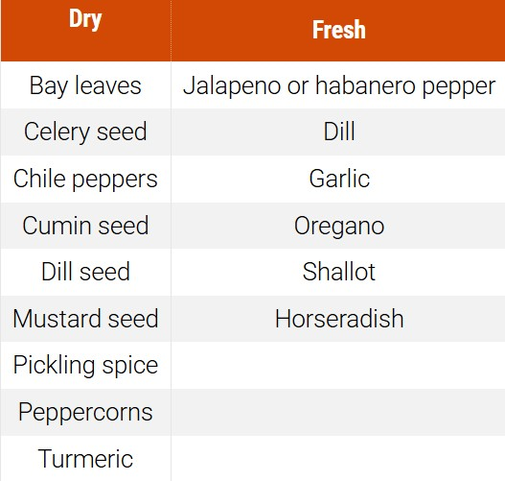

Step 3. Pack Vegetables
Pack prepared vegetables snugly into washed pint-sized canning jars or similar sized glass or heatproof plastic containers with lids.

Step 4. Make Brine
Make either sweet or sour brine using the following recipes:

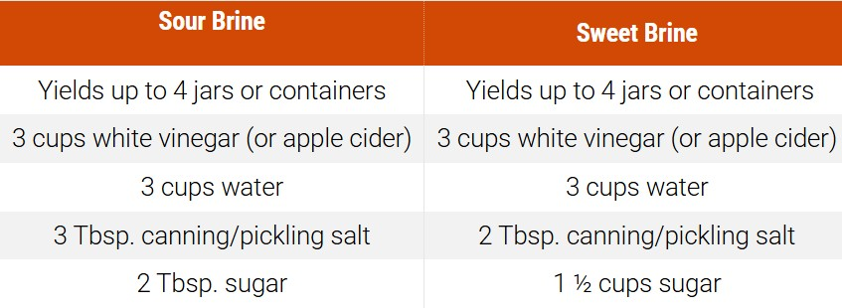

Step 5. Fill Jars with Brine
Carefully fill the jars with brine to within 1/2 inch of the top of the rim. Place the lids on the jars and refrigerate. Allow flavor to develop for 1 – 2 days before serving. Refrigerator pickles will last 2-6 weeks in the refrigerator. Do not eat if the brine becomes cloudy, mold develops or off-smells are emitted. Must be kept refrigerated to prevent bacterial growth. .

Source: adapted from North Carolina State University and Ball

Lemon Sage Wine Mustard Yield: about 7 pint jars

- 1 bunch of fresh sage
- 3/4 cup dry white wine
- 3/4 cup yellow mustard seeds
- 1 cup white wine vinegar
- Grated zest and juice from 2 large lemons
- 1/2 cup liquid honey
- 1/4 tsp salt

Finely chop enough sage leaves to measure 1/3 cup and set aside.

Coarsely chop remaining sage leaves and stems to measure 1/2 cup and place in a small stainless steel saucepan with the white wine. Bring to a boil over medium heat, stirring and pressing sage to release flavor. Remove from heat. Cover tightly and let steep for 5 minutes.

Transfer sage infusion to a sieve placed over a glass or stainless steel bowl and press leaves with the back of a spoon to extract all the liquid. Discard solids and return liquid to saucepan. dd mustard seeds. Cover and let stand at room temperature until the seeds have absorbed most of the moisture, about 2 hours.

In a blender or food processor fitted with a metal blade, combine marinated mustard seeds (with liquid) and vinegar. Process until blended and most seeds are well chopped (you want to retain a slightly grainy texture).

Transfer the mixture to a stainless-steel saucepan and add lemon zest, lemon juice, and honey, salt and reserved finely chopped sage. Bring to a boil over high heat, stirring constantly. Reduce heat to low and boil gently, stirring frequently, until volume is reduced by a third, about 20 minutes.

Ladle hot mustard into hot jars, leaving a generous 1/4 inch headspace. Remove air bubbles and adjust headspace, if necessary, by adding hot mustard. Wipe rim. Center lid on jar according to manufacturers instructions.

Process in a boiling water bath or atmospheric steam canner for:
0-1000 ft. = 10 minutes, 1001-6000 ft. = 15 minutes, above 6000 ft. = 20 minutes.

For boiling water canning, turn off the heat, remove canner lid and wait 5 minutes. For atmospheric steam canning, turn off the heat, leave canner lid on and wait 5 minutes. Cool jars for 12-24 hours, wash, label, and store in a cool dark place.

Source: Ball Complete Book of Home Food Preservation/2024

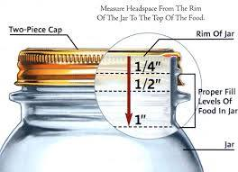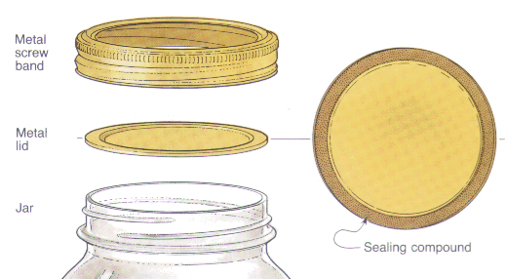

Lemon Peach Turmeric Chutney Yield: about 4 half-pint jars

- 3 large Meyer lemons (about 1 pound), quartered and thinly sliced
- 1 medium onion, small diced
- 8 to 10 peaches, roughly chopped (6 cups chopped)
- 2 red chilis, minced 1 teaspoon smoked paprika
- 2 cloves garlic, minced ¼ cup bottled lemon juice
- 2 tablespoons salt ½ cup apple cider vinegar
- 2 teaspoons grated fresh ginger 1 cup coconut sugar
- 1 ½ teaspoons turmeric powder ¼ cup honey
- 2 teaspoons mustard seeds

Combine all ingredients in a large stock pot and bring to a boil over high heat. Lower heat and simmer, stirring as needed, until chutney is thickened and reduced, about 30 minutes

Ladle hot chutney into jars, leaving 1/2 inch headspace. Remove air bubbles and adjust headspace by adding or removing sauce. Wipe rims clean, center lids on jars. Screw bands down according to Manufacturer’s instructions.

Process both pint and half-pint jars in a boiling water bath or atmospheric steam canner for:
0-1000ft. = 20 minutes, 1001-3000 ft. = 25 minutes, 3001-6000 ft. = 30 minutes, above 6000 ft. = 30 minutes.

For boiling water canning, turn off the heat, remove canner lid and wait 5 minutes.
For atmospheric steam canning, turn off the heat, leave canner lid on and wait 5 minutes.
Cool jars for 12-24 hours, wash, label, and store in a cool dark place.

Resources for tested recipes:
National Center for Home Food Preservation: https://nchfp.uga.edu/#gsc.tab=0

Complete Guide to Home Canning. 2015. https://nchfp.uga.edu/resources/category/usda-guide#gsc.tab=0
Also available in paper copy from Purdue Extension (online store is located at https://mdc.itap.purdue.edu/item.asp?item_number=AIG-539)

So Easy to Preserve, Sixth Edition. 2016. Bulletin 989. Cooperative Extension/University of Georgia, Athens

Ball Blue Book Guide to Preserving. 2024. Newell Corporation.
Ball Complete Book of Home Preserving, 2024. Bernardin, Newell Corporation.
Bernardin: https://www.bernardin.ca/
Ball: https://www.ballmasonjars.com

UCCE Master Food Preservers of El Dorado County
https://ucanr.edu/sites/mfp_of_cs/Recipes/Archived_Recipes/

UC Master Food Preserver Program
https://mfp.ucanr.edu/

No endorsement of any product/company is intended, nor is criticism implied of similar products or companies that are not included.
Photos courtesy of Pixabay.

