$5.00

“Preserve today, Relish tomorrow”

Pressure Canning
Soups & Stews

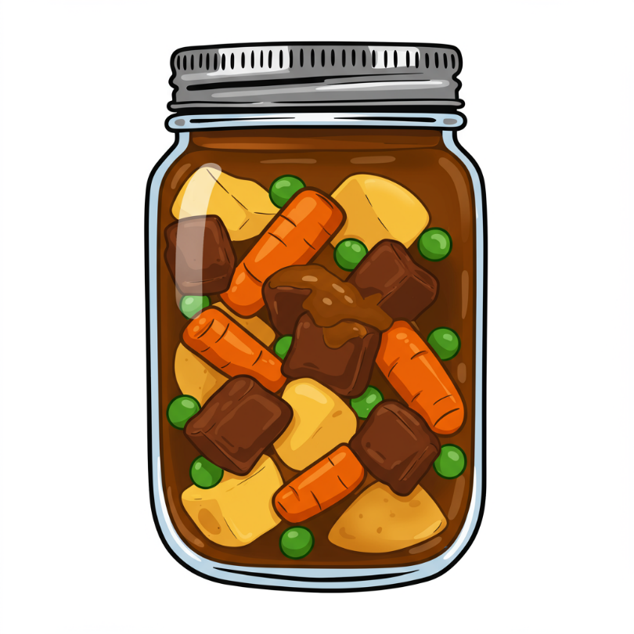



UCCE Master Food Preservers of El Dorado County
Website: https://link.ucanr.edu/mfp-cs
Ask a Master Food Preserver: https://link.ucanr.edu/mfp-cs-ask
Visit us on Facebook and Instagram!

It is the policy of the University of California (UC) and the UC Division of Agriculture & Natural Resources not to engage in discrimination against or harassment of any person in any of its programs or activities (Complete nondiscrimination policy statement can be found at http://ucanr.edu/sites/anrstaff/files/215244.pdf
Food Safety
Food preservation starts with food safety. Cleaning and sanitizing your work area, washing hands frequently, properly handling produce and meat, and avoiding cross-contamination are all part of the process in avoiding food-borne illness.

Following recipes from trusted resources is the next step in ensuring safety when preserving food. This is especially important when canning: It’s critical to follow a current, research-based recipe and to use the correct canning method for the food being processed.

For further details on food safety in general, as well as information on a variety of food preservation topics, visit our Food Safety website, where you’ll find free, downloadable publications and educational posters: https://ucanr.edu/sites/mfp_of_cs/Food_Safety/.

You can also access the site by scanning this QR code with your smartphone or tablet.



Pressure Canning Basics
To ensure safety when canning any type of food, it’s critical to follow a current, research-based recipe and to use the correct canning method. Meats, vegetables, and beans are low acid foods. Unless properly acidified (as in a pickle), these types of foods must be processed in a pressure canner in order to be shelf-stable.

With minor exceptions (such as adding or swapping dried herbs and spices), canning recipes should always be followed precisely to ensure a safe product. This means not canning old family recipes or using non-research based recipes found on the Internet.

There have been guidelines developed by the NCHFP, however, that allow for home canners to customize their own canned soups, within very strict parameters. In this process, certain liquids, meats or seafood, vegetables, and dried beans may be chosen to create a soup specific to your tastes. See the “Can Your Own Soup” information and recipes beginning on Pg. 6 for details.

Before canning any of the following recipes, please review our publication, Core Canning Techniques, which contains essential pressure canning information, step-by-step processing instructions, and helpful tips for canning success. It’s free to download from our website here: https://ucanr.edu/sites/default/files/2024-03/395607.pdf or use QR code above.

Meat or Poultry Broth
Yield: variable

Fresh trimmed meat bones, or large turkey or chicken carcass bones
Fresh water

- MEAT: To enhance extraction of flavor, saw or crack bones. Rinse bones, place in a large stockpot, and add enough water to cover bones. Cover the pot, and simmer for 3 to 4 hours.

- POULTRY: Place bones (with most of meat removed) in a large stockpot and add enough water to cover bones. Cover pot and simmer 30 to 45 minutes or until remaining attached meat can be easily stripped from the bones.

- Remove the meat or poultry bones, cool the broth, strip meat, skim off/discard excess fat, then return the meat trimmings to the broth. Reheat to boiling.

- Fill a hot jar with hot broth, leaving 1-inch headspace. Wipe jar rim with a clean paper towel or cloth dampened with white vinegar. Place lid and ring on jar, tightening ring only finger-tip tight (unless otherwise directed by the manufacturer). Place jar in canner. Repeat with remaining jar(s).

- Process in a pressure canner as follows:

Dial-Gauge Pressure Canner
Jar  Size | Process  Time | 0-  2,000 ft | 2,001-  4,000 ft | 4,001-  6,000 ft | 6,001-  8,000 ft
Pints | 20 minutes | 11 lb | 12 lb | 13 lb | 14 lb
Quarts | 25 minutes | 11 lb | 12 lb | 13 lb | 14 lb

Weighted-Gauge Pressure Canner
Jar Size | Process Time | 0-1,000 ft | + 1,000 ft
Pints | 20 minutes | 10 lb | 15 lb
Quarts | 25 minutes | 10 lb | 15 lb

Source: USDA Complete Guide to Home Canning

TIP: To make a heartier stock instead of a basic broth, add any or all of the following when cooking the bones:

For every 2 quarts of water: 1 medium carrot; 1 stalk celery; 1 medium onion; 5 peppercorns; 1 bay leaf; 1½ tsp salt. For beef stock, beef bouillon cubes or granules may be added as well for a more concentrated flavor.

Source: Ball Blue Book (2020)

Roasted Beef Stock
Yield: about 2 quart jars

- 4 lbs beef bones (with a little bit of meat on them)
- 2 quarts fresh water
- 2 tsp apple cider vinegar (5% acidity)
- 2 tsp salt
- 3 cloves garlic
- 2 bay leaves
- 1 large onion, quartered

- Roast the bones at 400°F for about 30 minutes.

- Remove the bones from the oven and place them, along with all the drippings, in a large nonreactive, oven-safe pot.

- Add the remaining ingredients, cover the pot, and roast in the oven for 8 hours.

- Reduce the oven temperature to 180°F and continue to roast for 8 more hours.

- Remove the pot from the oven and strain the stock through a fine mesh strainer. Discard the solids. Skim the fat from the strained stock. If necessary, add water to the stock so that the it measures 2 quarts. Reheat the strained stock to boiling.

- Fill a hot jar with hot broth, leaving 1-inch headspace. Wipe jar rim with a clean paper towel or cloth dampened with white vinegar. Place lid and ring on jar, tightening ring only finger-tip tight (unless otherwise directed by the manufacturer). Place jar in canner. Repeat with remaining jar(s).

- Process in a pressure canner as follows:

Dial-Gauge Pressure Canner
Jar  Size | Process  Time | 0-  2,000 ft | 2,001-  4,000 ft | 4,001-  6,000 ft | 6,001-  8,000 ft
Pints | 20 minutes | 11 lb | 12 lb | 13 lb | 14 lb
Quarts | 25 minutes | 11 lb | 12 lb | 13 lb | 14 lb

Weighted-Gauge Pressure Canner
Jar Size | Process Time | 0-1,000 ft | + 1,000 ft
Pints | 20 minutes | 10 lb | 15 lb
Quarts | 25 minutes | 10 lb | 15 lb

Source: Michigan State University Extension

TIP: Use a paper towel or cloth dampened with white vinegar (instead of water) to wipe jar rims before applying the lid. The vinegar helps to cut any greasy residue from food like stocks and soups and increases the likelihood of a successful seal.

Vegetable Stock
Yield: about 8 pint or 4 quart jars
WASTE NOT WANT NOT!
Save your veggie scraps in the freezer. When you have enough, make your own veggie stock and then can it by following the processing steps below.

TIP: Add an apple (or one apple’s worth of apple scraps) to your veggie stocks. It adds a touch of sweetness and counters bitterness.

- 5 to 6 medium carrots (about 1 lb)
- 6 stalks celery
- 3 medium onions (about 1 lb)
- 2 medium red bell peppers
- 2 medium tomatoes
- 2 medium turnips
- 3 cloves garlic, crushed
- 3 bay leaves
- 1 tsp crushed thyme
- 8 peppercorns
- 7 quarts water

- Wash carrots, celery, peppers, tomatoes, and turnips under cold running water; drain. Remove stem ends from carrots and cut into 1-inch pieces. Remove leafy tops and root ends from celery and cut into 1-inch pieces. Cut onions into quarters. Remove stems and seeds from peppers and cut into 1-inch strips. Remove cores and seeds from tomatoes and coarsely chop. Remove stem ends from turnips and coarsely chop.

- Combine all ingredients in a large saucepan. Bring mixture to a boil, then reduce heat to a simmer (180°F). Simmer, covered, for 2 hours. Uncover saucepan and continue to simmer for 2 hours. Strain stock through a fine sieve or several layers of cheesecloth. Discard solids.

- Ladle hot stock into a hot jar, leaving 1-inch headspace. Wipe jar rim with a clean paper towel or cloth dampened with white vinegar. Place lid and ring on jar, tightening ring only finger-tip tight (unless otherwise directed by the manufacturer). Place jar in canner. Repeat with remaining jar(s).

- Process in a pressure canner as follows:

Dial-Gauge Pressure Canner
Jar  Size | Process  Time | 0-  2,000 ft | 2,001-  4,000 ft | 4,001-  6,000 ft | 6,001-  8,000 ft
Pints | 30 minutes | 11 lb | 12 lb | 13 lb | 14 lb
Quarts | 35 minutes | 11 lb | 12 lb | 13 lb | 14 lb

Weighted-Gauge Pressure Canner
Jar Size | Process Time | 0-1,000 ft | + 1,000 ft
Pints | 30 minutes | 10 lb | 15 lb
Quarts | 35 minutes | 10 lb | 15 lb

Source: Adapted from Ball Blue Book (2020)

Can Your Own Soup:
Ingredients & Special Instructions

As noted on Pg. 2, guidelines were developed that allow for “custom” canned soups. There are two versions of the “Can Your Own Soup” recipe included in this publication, one for a “brothy” soup and one for a “hearty” soup, which conform to USDA safe canning guidelines. The difference between the two is primarily the ratio of solids to liquids, although the “hearty” soup has additional ingredient limitations. Be sure to follow the limitations noted below (sometimes referred to as “forbidden ingredients”) when using these recipes.

IMPORTANT! These processes apply only to the “Can Your Own Soups” recipes on Pgs. 7-8. Otherwise, follow the specific instructions listed in the other recipes.

“Can Your Own Soup” recipe limitations include the following:

- no noodles or pasta, rice, or other grains
- no thickening agents, such as flour, corn starch, tapioca, arrowroot, etc.
- no dairy, including butter, cream, milk, sour cream, yogurt, or cheese
- no vegetables that do not have current USDA pressure canning guidelines*
- dried beans or peas must be first fully rehydrated
- no puréeing all or a portion of the soup before canning

In addition to the above, “Hearty” soup recipe limitations include the following:

- no dried beans, greens, cream-style corn, winter squash, or sweet potatoes

*Note: While there are no individual pressure canning guidelines for celery, chopped onions, or zucchini/summer squash, these vegetables may be included in the “Can Your Own Soup” recipes. Summer squash should never be the primary ingredient.

Ingredients that are not allowed to be canned in these recipes may be added after the jar is opened at serving time. Purée your soup, if desired, after opening as well.

Prepare your chosen allowable ingredients as follows:

Vegetables: Wash, peel, and cut as specified for a hot pack for each type of vegetable.

Dried Beans or Peas: Rehydrate using one of the following methods:
- Place sorted and washed beans/peas in a large pot and cover with water. Soak 12 to 18 hours in a cool place. Drain water. Cover again with fresh water and boil for 30 minutes.
- Cover sorted and washed beans/peas with boiling water in a saucepan. Boil 2 minutes, then remove from heat. Soak for 1 hour, then drain. Cover again with fresh water and boil for 30 minutes.

Meat or Poultry: Remove bones, gristle and excess fat. Cut into bite-size pieces. Browning is optional.

Ground Meat: Cook bite-sized meatballs or crumbles until browned. Pour off excess fat.

Fish: Cut into bite-sized pieces (bones may remain as they will soften when canned).

Other Seafood: Prepare as for a hot pack as specified for each type of seafood.

Can Your Own Soup (continued)

Note! Refer to Pg. 6 for ingredient limitations and preparation instructions.

- Select and prepare ingredients as directed on Pg. 6.

- Combine all solid ingredients in a large pan. Cover with hot water, broth, or tomato juice. Wine may also be added. Boil for 5 minutes.

- Add salt, herbs and spices to taste. (Note: During canning, the flavor of many herbs and spices will strengthen, and the flavor of garlic may be reduced.)

- Fill a hot jar halfway with solid ingredients.

- Then fill the jar with hot liquid from the pot, leaving 1-inch headspace. Remove air bubbles and adjust headspace if needed, by adding more hot liquid. Wipe jar rim with a clean paper towel or cloth dampened with white vinegar. Place lid and ring on jar, tightening ring only finger-tip tight (unless otherwise directed by the manufacturer). Place jar in canner. Repeat with remaining jar(s).

- Process in a pressure canner as follows:

Dial-Gauge Pressure Canner
Recipe containing NO fish or seafood
Jar  Size | Process  Time | 0-  2,000 ft | 2,001-  4,000 ft | 4,001-  6,000 ft | 6,001-  8,000 ft
Pints | 60 minutes | 11 lb | 12 lb | 13 lb | 14 lb
Quarts | 75 minutes | 11 lb | 12 lb | 13 lb | 14 lb
Recipe containing fish or seafood
Pints | 100 minutes | 11 lb | 12 lb | 13 lb | 14 lb
Quarts | 100 minutes | 11 lb | 12 lb | 13 lb | 14 lb

Weighted-Gauge Pressure Canner
Recipe containing NO fish or seafood
Jar Size | Process Time | 0-1,000 ft | + 1,000 ft
Pints | 60 minutes | 10 lb | 15 lb
Quarts | 75 minutes | 10 lb | 15 lb
Recipe containing fish or seafood
Pints | 100 minutes | 10 lb | 15 lb
Quarts | 100 minutes | 10 lb | 15 lb

Source: University of Alaska Fairbanks Cooperative Extension

Salmon Selyanka
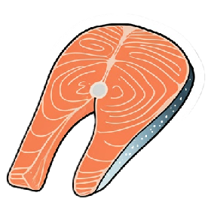
- 4 lbs salmon, skinned and cut to bite-size pieces
(fresh, frozen, previously cooked, or canned;
- boned or unboned)
- 1 tbsp oil
- 1 large onion, diced
- 2 qts chicken stock
- 2 qts water
- 6-8 medium potatoes, cubed
- 1 tsp dill weed
- 1 tsp salt
- additional hot chicken stock or water, if needed

- Cook onion in oil in a large pot until just tender. Add salmon, chicken stock, water, potatoes, dill weed, and salt. Bring to a boil and simmer 5 minutes.

- Fill a hot jar halfway with solid ingredients.

- Then fill the jar with hot stock from the pot, leaving 1-inch headspace. Remove air bubbles and adjust headspace if needed, by adding more hot liquid. Wipe jar rim with a clean paper towel or cloth dampened with white vinegar. Place lid and ring on jar, tightening ring only finger-tip tight (unless otherwise directed by the manufacturer). Place jar in canner. Repeat with remaining jar(s).

- Process in a pressure canner as follows:

Dial-Gauge Pressure Canner
Jar  Size | Process  Time | 0-  2,000 ft | 2,001-  4,000 ft | 4,001-  6,000 ft | 6,001-  8,000 ft
Pints | 100 minutes | 11 lb | 12 lb | 13 lb | 14 lb
Quarts | 100 minutes | 11 lb | 12 lb | 13 lb | 14 lb

Weighted-Gauge Pressure Canner
Jar Size | Process Time | 0-1,000 ft | + 1,000 ft
Pints | 100 minutes | 10 lb | 15 lb
Quarts | 100 minutes | 10 lb | 15 lb

VARIATION:
For a “Hearty” soup, double all ingredients except the stock. Cook as directed in Step 1. Fill hot pint or smaller jars with solid ingredients to 1-inch headspace. Add hot broth to jars leaving 1-inch headspace. Remove air bubbles and apply lids as directed in Step 3. Process in a pressure canner for 100 minutes. Do not process this variation in quart jars.

TO SERVE:
Add butter to taste when heating. When serving, top with fresh or dried dill and finely chopped red onion.

Source: Adapted from University of Alaska Fairbanks Extension
French Onion Soup
Yield: about 8 pint or 4 quart jars

- 4 lbs onions, thinly sliced
- 1 Tbsp salt
- 1 tsp ground black pepper
- 1 tsp dried thyme
- 3 cups dry white wine
- 3 qts beef bone broth (or beef, chicken or vegetable stock)

- Heat an 8-quart nonreactive Dutch oven over medium-low heat. Stir in onions, salt, and pepper. Cover and cook for 1 hour or until the onion is very tender, stirring occasionally.

- Uncover and cook, stirring constantly, until the onion is caramel colored. Add the thyme and wine, stirring to loosen browned bits from the bottom of the Dutch oven. Simmer for 10 minutes or until the wine has reduced to almost dry. Stir in the broth and bring to a boil, then reduce the heat and simmer, uncovered, for 15 minutes.

- Ladle hot soup into a hot jar, leaving 1-inch headspace. Remove air bubbles and adjust headspace if needed, by adding more hot soup. Wipe jar rim with a clean paper towel or cloth dampened with white vinegar. Place lid and ring on jar, tightening ring only finger-tip tight (unless otherwise directed by the manufacturer). Place jar in canner. Repeat with remaining jar(s).

- Process in a pressure canner as follows:

Dial-Gauge Pressure Canner
Jar  Size | Process  Time | 0-  2,000 ft | 2,001-  4,000 ft | 4,001-  6,000 ft | 6,001-  8,000 ft
Pints | 60 minutes | 11 lb | 12 lb | 13 lb | 14 lb
Quarts | 75 minutes | 11 lb | 12 lb | 13 lb | 14 lb

Weighted-Gauge Pressure Canner
Jar Size | Process Time | 0-1,000 ft | + 1,000 ft
Pints | 60 minutes | 10 lb | 15 lb
Quarts | 75 minutes | 10 lb | 15 lb

Source: All New Ball Book of Canning and Preserving (2023)



Southwestern Vegetable Soup
Yield: 4 quarts or 9 pints

- 1 ½ quarts whole kernel corn
- 1 quart chopped tomatoes
- 2 cups chopped tomatillos
- 1 cup sliced carrots
- 1 cup chopped onions
- 1 cup chopped red bell peppers
- 1 cup chopped green bell pepper
- ¾ cup chopped banana peppers
- ¼ cup chopped jalapeno peppers
- 3 tbsp minced fresh cilantro
- 2 tsp chili powder
- 1 tsp cayenne pepper (optional)
- 1 tsp black pepper
- 1 tsp salt
- 1 ½ quarts tomato juice
- 1 cup water
- 4 tsp hot pepper sauce

Note: When cutting or seeding hot peppers, wear rubber gloves to prevent hands from being burned.

- Wash corn, tomatoes, tomatillos, carrots, bell, banana, and jalapeno peppers, and cilantro under cold running water; drain. Cut corn off the cob. Measure 1 ½ quarts corn. To peel tomatoes, blanch 30-60 seconds in boiling water. Immediately transfer to cold water. Remove peel and core. Chop tomatoes: measure 1 quart chopped tomatoes. Remove husk from tomatillos. Chop tomatillos; measure 2 cups chopped tomatillos. Remove stem ends from carrots and peel. Slice carrots ¼ inch thick; measure 1 cups sliced carrots. Peel onions. Chop onion; measure 1 cup chopped onions. Remove stem and seeds from peppers and chop and measure 1 cup each red and green bell peppers, ¾ cup banana peppers, and ¼ cup jalapenos.

- Combine all ingredients in a large pot. Bring to a boil. Reduce heat to a simmer; simmer 15 minutes. While the soup simmers, prepare jars and pressure canner. Heat water and jars to 180F.

- Ladle hot soup into hot jar, leaving 1 inch headspace. Remove air bubbles. Clean jar rim. Place lid and ring on and tighten rings fingertip tight. Place jar in pressure canner. Repeat until jars are filled.

- Process in a pressure canner as follows:

Dial-Gauge Pressure Canner
Jar  Size | Process  Time | 0-  2,000 ft | 2,001-  4,000 ft | 4,001-  6,000 ft | 6,001-  8,000 ft
Pints | 55 minutes | 11 lb | 12 lb | 13 lb | 14 lb
Quarts | 85 minutes | 11 lb | 12 lb | 13 lb | 14 lb

Weighted-Gauge Pressure Canner
Jar Size | Process Time | 0-1,000 ft | + 1,000 ft
Pints | 55 minutes | 10 lb | 15 lb
Quarts | 85 minutes | 10 lb | 15 lb

Source: Ball Blue Book (2024)

Navy Bean Soup
Yield: about 5 pint or 2 quart jars

- 2 cups dried navy beans (about 1 lb)
- 1 ham hock or ¼ lb salt pork
- ½ cup peeled and chopped onion (about 1 medium)
- ½ red chili pepper, stem and blossom ends removed, and finely chopped

salt and pepper to taste

- Wash navy beans under cold running water, then drain. Discard shriveled or discolored beans.

- Place navy beans in a large saucepan. Add water to cover the beans by 2 inches. Bring to a boil over medium-high heat and boil for 2 minutes. Remove from the heat and let the beans soak for 1 hour, then drain.

- Return the beans to a large saucepan and cover with water by 2 inches. Add ham or salt pork, onion, and red chili pepper. Bring to a boil over medium-high heat. Reduce heat and simmer, covered, for 2 hours. Remove ham hock or salt pork, dice the meat (discarding the bone) and return the meat to the soup. Season with salt and pepper if desired.

- Ladle hot soup into a hot jar, leaving 1-inch headspace. Remove air bubbles and adjust headspace if needed, by adding more hot soup. Wipe jar rim with a clean paper towel or cloth dampened with white vinegar. Place lid and ring on jar, tightening ring only finger-tip tight (unless otherwise directed by the manufacturer). Place jar in canner. Repeat with remaining jar(s).

- Process in a pressure canner as follows:

Dial-Gauge Pressure Canner
Jar  Size | Process  Time | 0-  2,000 ft | 2,001-  4,000 ft | 4,001-  6,000 ft | 6,001-  8,000 ft
Pints | 75 minutes | 11 lb | 12 lb | 13 lb | 14 lb
Quarts | 90 minutes | 11 lb | 12 lb | 13 lb | 14 lb

Weighted-Gauge Pressure Canner
Jar Size | Process Time | 0-1,000 ft | + 1,000 ft
Pints | 75 minutes | 10 lb | 15 lb
Quarts | 90 minutes | 10 lb | 15 lb

Source: Ball Blue Book (2024)
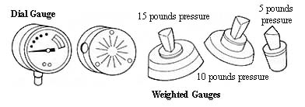

Hearty Chili (No Beans)
This chili features tender cubes of beef chuck, and no beans! Feel free to add canned pinto or kidney beans at serving time, if desired.

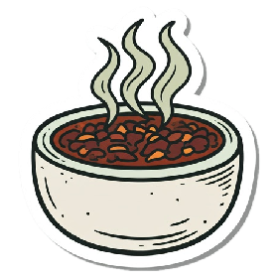
Yield: about 6 pint or 3 quart jars

- 4 lbs boneless beef chuck
- ¼ cup vegetable oil
- 3 cups diced onion
- 2 cloves garlic, minced
- 5 Tbsp chili powder
- 2 tsp cumin seed
- 2 tsp salt
- 1 tsp oregano
- ½ tsp pepper
- ½ tsp ground coriander
- ½ tsp crushed red pepper flakes (or to taste)
- 6 cups undrained and chopped canned tomatoes

- Cut meat into ½-inch cubes, removing excess fat. Lightly brown in hot oil. Add the onions and garlic and cook until soft but not brown. Add the spices and cook for 5 minutes.

- Stir in the tomatoes. Boil gently for 45 to 60 minutes, stirring occasionally.

- Fill a hot jar with chili, leaving 1-inch headspace. Remove air bubbles and adjust headspace if needed, by adding more hot chili. Wipe jar rim with a clean paper towel or cloth dampened with white vinegar. Place lid and ring on jar, tightening ring only finger-tip tight (unless otherwise directed by the manufacturer). Place jar in canner. Repeat with remaining jar(s).

- Process in a pressure canner as follows:

Dial-Gauge Pressure Canner
Jar  Size | Process  Time | 0-  2,000 ft | 2,001-  4,000 ft | 4,001-  6,000 ft | 6,001-  8,000 ft
Pints | 75 minutes | 11 lb | 12 lb | 13 lb | 14 lb
Quarts | 90 minutes | 11 lb | 12 lb | 13 lb | 14 lb

Weighted-Gauge Pressure Canner
Jar Size | Process Time | 0-1,000 ft | + 1,000 ft
Pints | 75 minutes | 10 lb | 15 lb
Quarts | 90 minutes | 10 lb | 15 lb


Source: bernardin.com

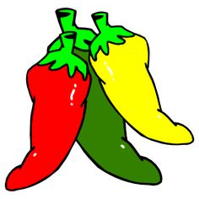
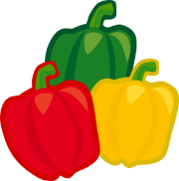

Louisiana Red Beans
Yield: about 6 pint or 3 quart jars

- 1 lb dried kidney beans, sorted and rinsed
- 1 smoked ham hock
- ¼ lb thick cut bacon, cut into 1-inch pieces
- 1 lb andouille sausage, cut into 1-inch pieces
- 2 medium onions, diced (about 2 cups)
- 2 tsp salt
- 2 tsp dried thyme
- 1 qt chicken stock
- 3 small bay leaves

- Place beans in a 6-quart stockpot and add water to cover by 2 inches. Add ham hock and bring to a boil over high heat. Boil for 15 minutes, turn off heat, and allow beans and ham hock to soak for 1 hour.

- Cook the bacon in a heavy saucepan until fat has rendered. Add sausage and cook until browned on all sides. Remove bacon and sausage with a slotted spoon and set aside.

- Add onions, salt and thyme to the fat in the same saucepan and sauté over medium-high heat until onions are golden.

- Drain beans and ham hock. Add beans, sausage and bacon to onions. Using a sharp knife, cut any remaining meat and skin off ham hock, chop into small pieces and add to the bean mixture. Reheat mixture until beans are very hot. Bring chicken broth to a simmer in a small saucepan.

- Fill a hot jar ¾ full with hot bean mixture. Place a small bay leaf (or half a leaf for pint jars) on top of beans. Ladle hot chicken broth into jar over the beans, leaving 1-inch headspace. Remove air bubbles and adjust headspace if needed, by adding more hot mixture. Wipe jar rim with a clean paper towel or cloth dampened with white vinegar. Place lid and ring on jar, tightening ring only finger-tip tight (unless otherwise directed by the manufacturer). Place jar in canner. Repeat with remaining jar(s).

- Process in a pressure canner as follows:

Dial-Gauge Pressure Canner
Jar  Size | Process  Time | 0-  2,000 ft | 2,001-  4,000 ft | 4,001-  6,000 ft | 6,001-  8,000 ft
Pints | 75 minutes | 11 lb | 12 lb | 13 lb | 14 lb
Quarts | 90 minutes | 11 lb | 12 lb | 13 lb | 14 lb

Weighted-Gauge Pressure Canner
Jar Size | Process Time | 0-1,000 ft | + 1,000 ft
Pints | 75 minutes | 10 lb | 15 lb
Quarts | 90 minutes | 10 lb | 15 lb

Source: Adapted from ballmasonjars.com

Beef Stew with Vegetables
Yield: about 14 pint or 7 quart jars

1 tbsp vegetable oil
4 to 5 lbs stewing beef, cut into 1½-inch cubes
12 cups peeled potatoes, cut into 1-inch cubes
8 cups peeled carrots, stem ends removed, sliced ½-inch thick
3 cups celery, sliced ½-inch thick
3 cups peeled, chopped onions
4½ tsp salt
1 tsp dried thyme
½ tsp freshly ground black pepper
boiling water

- Heat oil in a large nonstick skillet over medium-high heat. Working in batches, brown beef, adding oil if absolutely needed. Transfer beef to a large nonreactive saucepan and add the vegetables, salt, thyme, and pepper. Add boiling water to cover. Bring to a boil, stirring frequently.

- Ladle hot stew into a hot jar, leaving 1-inch headspace. Remove air bubbles and adjust headspace if needed, by adding more hot stew. Wipe jar rim with a clean paper towel or cloth dampened with white vinegar. Place lid and ring on jar, tightening ring only finger-tip tight (unless otherwise directed by the manufacturer). Place jar in canner. Repeat with remaining jar(s).

- Process in a pressure canner as follows:

Dial-Gauge Pressure Canner
Jar  Size | Process  Time | 0-  2,000 ft | 2,001-  4,000 ft | 4,001-  6,000 ft | 6,001-  8,000 ft
Pints | 75 minutes | 11 lb | 12 lb | 13 lb | 14 lb
Quarts | 90 minutes | 11 lb | 12 lb | 13 lb | 14 lb

Weighted-Gauge Pressure Canner
Jar Size | Process Time | 0-1,000 ft | + 1,000 ft
Pints | 75 minutes | 10 lb | 15 lb
Quarts | 90 minutes | 10 lb | 15 lb

Source: Adapted from Ball Complete Book of Home Preserving
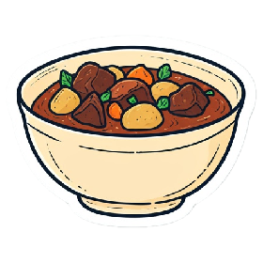

Beef Stroganoff
Yields 4 quarts or 8 pints
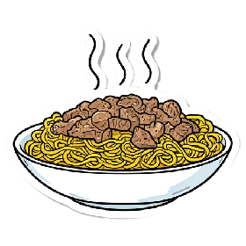
- 4 lbs boneless beef chuck, cut into 2 inch chunks
- 2 cups sliced mushrooms
- 2 cups chopped onions
- 8 tbsp tomato paste
- 4 tsp salt
- 2 tsp ground black pepper
- ½ cup worcestershire sauce
- 4 tsp dried thyme
- 4 tsp dried parsley
- 4 cloves garlic, minced

- Prepare pressure canner and jars. Heat the water and jars in the canner to 140 degrees, as this is a raw pack recipe.
- Combine ingredients in a bowl and mix well.
- Filling one jar at a time, pack beef mixture into prepared jars, leaving 1 inch headspace. Ladle HOT beef broth or water over ingredients, filling to 1 inch headspace.
- Debubble, adding more liquid if necessary to maintain 1 inch headspace. Wipe rims, put lids and rings on fingertip tight, and place jar in the pressure canner. Repeat with remaining jars.
- Process in a pressure canner as follows:

Dial-Gauge Pressure Canner
Jar  Size | Process  Time | 0-  2,000 ft | 2,001-  4,000 ft | 4,001-  6,000 ft | 6,001-  8,000 ft
Pints | 75 minutes | 11 lb | 12 lb | 13 lb | 14 lb
Quarts | 90 minutes | 11 lb | 12 lb | 13 lb | 14 lb

Weighted-Gauge Pressure Canner
Jar Size | Process Time | 0-1,000 ft | + 1,000 ft
Pints | 75 minutes | 10 lb | 15 lb
Quarts | 90 minutes | 10 lb | 15 lb

To serve: Whisk in 1-2 tablespoon flour, bring to a simmer, and let cook for 10 minutes. Remove from heat and stir in a large spoonful of sour cream.

Adapted from The All New Ball Book of Canning and Preserving, 2016

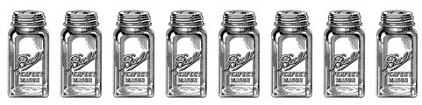

Pot Roast In A Jar
Yield 4 quarts or 8 pints

- 4 lbs boneless beef chuck, trimmed into 2 inch chunks
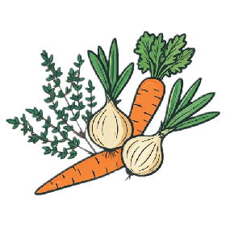
- 2 cups peeled and diced potatoes
- 2 cups diced onions
- 1 cup diced celery
- 1 cup sliced carrots
- 4 tsp canning salt
- 2 tsp ground black pepper
- 4 tsp dried thyme
- 2 cups dry red wine (optional)
- 4 bay leaves
- 4 garlic cloves, sliced
- Beef Broth or water

- Prepare pressure canner and jars. Heat the water in the canner to 140 degrees as this is a raw pack recipe.
- Place the first 8 ingredients in a bowl and mix well.
- Filling one jar at a time, place 1 bay leaf and 1 sliced garlic clove in each jar for quarts or half a leaf and half a garlic clove for pints. Fill jars with the beef mixture up to 1 inch headspace. If using red wine, add ½ cup to each quart jar or ¼ cup to each pint jar. Ladle HOT beef broth or water over ingredients, filling to 1 inch headspace.
- Debubble, adding more liquid if necessary to keep 1 inch headspace. Wipe rims, put lids and rings on fingertip tight, and place jar in the pressure canner. Repeat with remaining jars.
- Process in pressure canner as follows:

Dial-Gauge Pressure Canner
Jar  Size | Process  Time | 0-  2,000 ft | 2,001-  4,000 ft | 4,001-  6,000 ft | 6,001-  8,000 ft
Pints | 75 minutes | 11 lb | 12 lb | 13 lb | 14 lb
Quarts | 90 minutes | 11 lb | 12 lb | 13 lb | 14 lb

Weighted-Gauge Pressure Canner
Jar Size | Process Time | 0-1,000 ft | + 1,000 ft
Pints | 75 minutes | 10 lb | 15 lb
Quarts | 90 minutes | 10 lb | 15 lb

To serve: Whisk in 1-2 tablespoon flour, bring to a simmer, and let cook for 10 minutes.

Variation: Chicken Dinner in a Jar ~ Substitute boneless chicken for the beef, poultry seasoning for dried thyme and bay leaf, and dry white wine for the red wine to create a tasty chicken stew that is good on its own or as a base for chicken pot pie.

Adapted from The All New Ball Book of Canning and Preserving, 2016

References:
NCHFP, Soups https://nchfp.uga.edu/how/can_04/soups.html
NCHFP, Canning Vegetables and Vegetable Products https://nchfp.uga.edu/how/can4_vegetable.html#gsc.tab=0
NCHFP, Preparing and Canning Poultry, Red Meats and Seafood https://nchfp.uga.edu/how/can5_meat.html#gsc.tab=0

Safe preserving resources:
Websites:
National Center for Home Food Preservation: http://nchfp.uga.edu/index.html
Ball© freshpreserving: http://www.freshpreserving.com/
Bernardin: https://www.bernardin.ca/recipes/default.htm?Lang=EN-US

Books:
Complete Guide to Home Canning. 2015. http://nchfp.uga.edu//publications/publications_usda.html
Also available in paper copy from Purdue Extension (online store is located at https://mdc.itap.purdue.edu/item.asp?item_number=AIG-539)
So Easy To Preserve, Sixth Edition http://setp.uga.edu/
Ball© Blue Book Guide to Preserving, 2017
Ball© Complete Book of Home Preserving: 400 Recipes, 2020
The Spice Lover’s Guide to Herbs and Spices by Tony Hill

No endorsement of any product/company is intended, nor is criticism implied of similar products or companies that are not included.

