Preserving Citrus

Basic Food Safety & Sanitation

Food preservation starts with food safety. Cleaning and sanitizing your work area, washing hands frequently, properly handling produce and meat, and avoiding cross-contamination are all part of the process in avoiding food-borne illness.

Following recipes from trusted resources is the next step in ensuring safety when preserving food. This is especially important when canning: It’s critical to follow a current, research-based recipe and to use the correct canning method for the food being processed.

For further details on food safety in general, as well as information on a variety of food preservation topics, visit our Food Safety website, where you’ll find free, downloadable publications and educational posters: https://ucanr.edu/sites/mfp_of_cs/Food_Safety/.
You can also access the site by scanning this QR code with your smartphone or tablet.



When In Doubt, Throw It Out

Never taste food that looks or smells strange to see if it can still be eaten. Most bacteria that cause foodborne illness are odorless, colorless, and tasteless.

It is the policy of the University of California (UC) and the UC Division of Agriculture & Natural Resources not to engage in discrimination against or harassment of any person in any of its programs or activities (complete nondiscrimination policy statement can be found at https://policy.ucop.edu/doc/1001004/Anti-Discrimination).

Preserving Citrus

- Freezing
- Dehydrating and Candied
- Traditional Preserving
- Making salts and infused sugar cubes
- Using pectinase for canning citrus (see https://ucanr.edu/blogs/blogcore/postdetail.cfm?postnum=58880 and https://ucanr.edu/sites/mfp_of_cs/Classes_-_Events/Handouts_-_Presentations/ for more information.)

Freezing Citrus

Preparation – Select firm, tree-ripened fruit heavy for its size and free from soft spots. Wash and peel. Divide fruit into sections, removing all membranes and seeds. Slice oranges if desired. For grapefruit with many seeds, cut fruit in half and remove seeds; cut or scoop out sections.

Syrup Pack – Pack fruit into containers. Cover with cold 40 percent syrup made with excess fruit juice or water. Leave headspace. Seal and freeze.

Juice – Select fruit as directed for sections. Squeeze juice from fruit, using squeezer that does not press oil from rind.

Sweeten with 2 tablespoons sugar for each quart of juice or pack without sugar. Pour juice into containers immediately. To avoid development of off-flavors, pack juice in glass jars. Leave headspace. Seal and freeze.

PRO TIP: Our experience shows we can freeze whole lemons and limes. Always wash and dry the whole citrus fruit before freezing. We have no experience with oranges or mandarins.

Once thawed lemons and limes hold their shape quite well and can be sliced. The texture is softer than a fresh fruit. Fruit with thicker skins may be zested. Thinner skins do not zest as well. Try zesting the lemon while it is frozen.

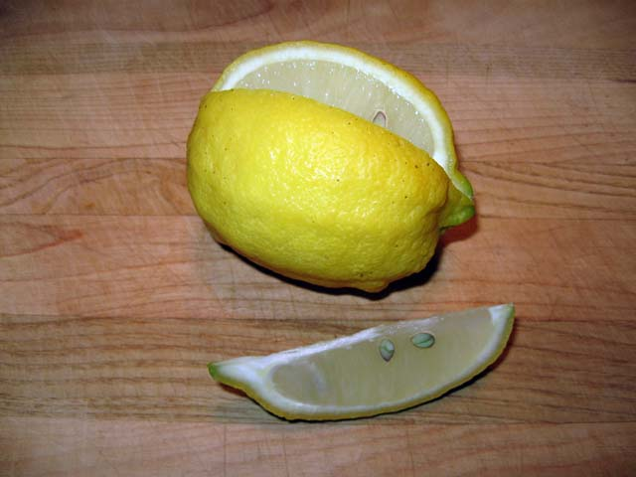

Previously frozen and thawed lemon with wedge.

Candied Citrus Peel Yield: about 2 cups
Refreshing, addictive, and absolutely satisfying at the end of a meal. Candied citrus peel keeps so well that it is a good idea to double the recipe.

- 2 grapefruit or 3 oranges or 6 lemons
- 2 cups sugar, divided
- 3 Tbsp light corn syrup
- water

Peel the fruit in ~3/8" thick strips, using only the zest and white peel. If the white is very thick, trim it down a little.
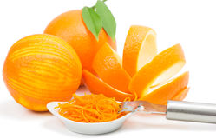
Put the peel in a pan, cover with cold water and simmer for 30 minutes. Drain, cover with cold water again, and simmer until tender. Drain.
Mix one cup of the sugar with the corn syrup and 3/4 cup water in a heavy saucepan; add fruit peel and stir over low heat until most of the syrup has been absorbed. Cover and let stand overnight. Reheat until syrup melts and citrus peel can be separated, then cool a little and drain. Pour remaining sugar (or more, if needed) into a baking dish and roll the peel in it, turning so that all the pieces are coated. Let them stand until they are dry; overnight or longer. Stored airtight, they will stay fresh for several months. If they become too dry put a lemon in the container for a day or two and the peel will soften.
The citrus peel may also be dried in an electric dehydrator. To dry on dehydrator trays, set temperature to 135°F, and dehydrate for 8-24 hrs. Check your candy every few hours. Rotate trays for even drying. Candy is done when dry but pliable, not brittle.
To test for dryness, condition your candy by filling a jar 2/3 full and close with a lid. If after 24 hours there is some condensation on the sides of the jar, return the candy to the dehydrator.
Source: Sunset Magazine

Traditional Preserved Lemons Yield: 1 quart jar

- 10 lemons, divided
- 1/2 cup pickling or canning salt, divided
- 4 bay leaves
- 4 cinnamon sticks (each about 4 inches)
- 1 tsp whole black peppercorns (optional)

- Prepare jar and lid. For this recipe, the jar needs to be sterilized prior to packing. Boil jar in water for 10 minutes at altitudes of 0-1000 feet above sea level, plus 1 additional minute for each additional 1000 of altitude, keep hot until ready to use.
- Wash 5 of the lemons in warm water, scrubbing well to remove any dirt and wax, and dry well using paper towels. Cut a thin (1/8 inch) slice off the stem end. From stem end, cut each lemon into quarters, without cutting through the bottom end and leaving it intact. Juice the remaining 5 lemons to measure 1-1/2 cups juice.
- Sprinkle 1 tablespoon pickling salt over the bottom of sterilized jar. Working over a bowl, pack 1 heaping tablespoon salt into each lemon before placing in the jar, stem end up. When 3 lemons have been salted and packed, slip bay leaves and cinnamon sticks against sides of the jar and add peppercorns, if using. Repeat with remaining lemons and salt. Cover with the remaining salt.
- Fill jar with lemon juice to within 1/2 inch of top of jar. Center lid on jar. Screw band down until resistance is met, then increase to fingertip tight.
- Place jar in a dark, cool cupboard for 2 weeks, shaking every day to distribute the salt. After 2 weeks, the lemons are ready to use. To use remove pulp and membrane, using only the peel. Rinse under water to remove excess salt and dry with a paper towel.
- Store preserved lemons in a container with an airtight lid. Cover and refrigerate for up to six months.

Source: Ball Complete Book of Home Preserving

Preserved Lemon Hummus Yield: about 2 cups

- 1 preserved lemon, rinsed under cold water, pulp and rind roughly chopped
- 1/2 cup sesame tahini
- 2 Tbsp miso paste
- 2 cloves garlic, peeled
- 1/4 tsp cayenne pepper
- 4 Tbsp olive oil
- 1 16-ounce can chickpeas (keep the liquid)

- Combine the lemon, tahini, miso, garlic, cayenne, olive oil, chickpeas, and 4 tablespoons of chickpea liquid in a blender or food processor.
- Blend until smooth.
- Add more chickpea liquid if necessary to get to a good, silky consistency.
- I predict you will taste this to see that it is the right consistency, and then you will eat most of it out of the blender. This is that kind of hummus.

Source: from the kitchen of MFP Chris Lewis

Citrus Flavored Salts Yield: 1 cup

- Zest from 1 lemon
- Zest from 1 lime
- 1 cup coarse sea salt
If using fresh lemon and lime zest:
- Use a zester to zest the lemon and lime. Save the fruit for a later use.
- Mix the lemon, lime, and salt in a mixing bowl before dehydrating.
- Spread the lemon-lime salt over a dehydrator sheet and dehydrate 125° F for about 6-8 hours, or until the zest is completely dried through. Alternatively, spread the lemon lime salt over a baking sheet and dry in the oven at 125° F about 6-8 hours, or until the zest is completely dried through. if your oven doesn't go to that low of a temperature, crack the oven a bit to let in some air flow.
- Next, grind down the zest into the salt with a spice grinder or mortar and pestle.
If using pre-dried lemon and lime zest. simply grind down the zest into the salt with a mortar and pestle.
A spice grinder works well, try not to over process.

Source: https://www.chilipeppermadness.com/recipes/citrus-lemon-lime-salt/

Homemade Lemon Pepper Seasoning Yield: about 1 cup

- 5 large lemons
- 1/3 cup crushed peppercorns, black and/or medley
- 1/4 cup kosher salt (optional)

- Zest all the lemons and mix with crushed peppercorns.
- Spread out on parchment-lined baking sheet and bake on lowest setting until the zest is completely dried.
- Add the lemon-pepper to a spice grinder and grind until desired texture.
- Mix with the kosher salt if desired and store in a airtight container for up to a few months.

Source: https://www.simplyscratch.com/homemade-lemon-pepper-seasoning/

Lemon Rosemary Seasoning Yield: about 1 cup

- 1/2 cup dried zested lemon (or any citrus) peel
- 1 tsp cracked black peppercorn
- 1 Tbsp canning salt
- 1 tsp garlic powder or 1 Tbsp garlic flakes
- 1 tsp onion powder or 1 Tbsp onion flakes
- 2 Tbsp coarsely ground dried rosemary
- 1 tsp red pepper flakes (optional)

1. Mix all ingredients together and place in an airtight container.
2. Label and date the container and store in a cool, dry place.

- Marinade: 1 Tbsp seasoning blend to 1 cup olive oil.
- Rice Seasoning: 1 tsp seasoning blend per cup of cooking water

Recipe from the kitchen of MFP Laurie Lewis



DIY Meyer Lemon Sugar Cubes

Ingredients
- 1/2 cup sugar: Any kind of sugar will work
- Meyer lemons: (use any kind of citrus fruit, mint leaves, or spices0

Tools

Zester or grater
Blender or food processor
Small molds i.e., the type used for candy.

- Zest the rind from one Meyer Lemon. Make sure not to get the pith (the white part).
- Add the zest into your blender/food processor and 1/2 cup of sugar, mix until well combined.
- Pour the contents into a bowl. Test the mixture to make sure it sticks to itself. Take a pinch and if it holds together and does not crumble then it is good to go. You can add a half a teaspoon of water to make the sugar a little wetter, or you can omit the water if your mixture sticks together easily.
- Scoop the sugar into the molds. Use the back of a plastic spoon to tamp it down tightly. Scrape any extra sugar off the tops to make them level. This amount of sugar should fill one mold if you have packed and scraped appropriately.
- Let your sugar cubes sit overnight and dry completely.
- Unmold and ENJOY!!

Orange Marmalade Yield: about 7 half pints

- 6 oranges **
- 2 lemons
- 2½ cups water
- 1/8 tsp baking soda
- 6½ cups sugar
- 1 package powdered pectin
- ¼ tsp butter

Using a serrated vegetable peeler, pare rind from fruit.
Remove white membrane and seeds from fruit. Chop fruit, saving the juice.
Thinly slice rinds.

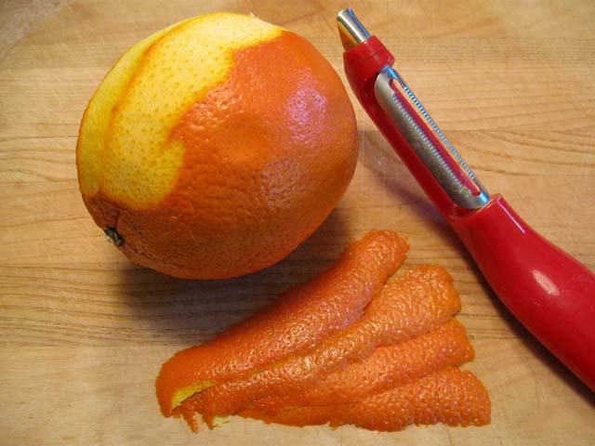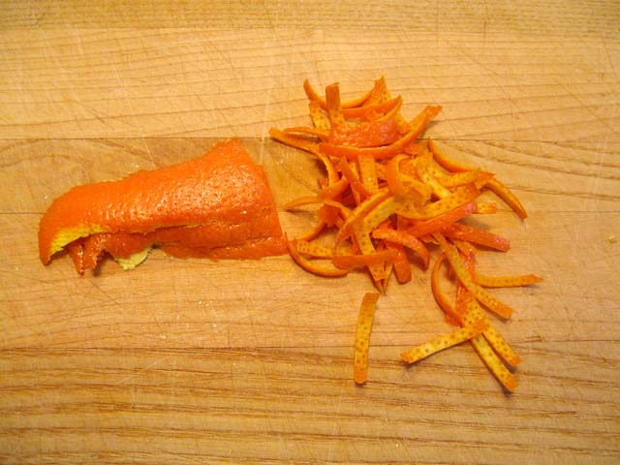

Simmer the sliced rinds in water and baking soda for 20 minutes, stirring occasionally. Add in fruit and juice. Simmer 10 minutes longer.

Drain rinds, reserve liquid.

Measure 4 cups fruit mixture - fruit, juice, and simmered rind. If more liquid is needed to get 4 cups then use the reserved water. Pour mixture into a non-reactive (such as stainless steel or enamel) pot.

Add pectin and ¼ tsp. butter (to prevent foaming).

Bring to a full rolling boil, stirring constantly.

Add sugar; bring back to a full boil for the time indicated on the pectin package.

Remove from heat and let stand 5 to 10 minutes, stirring often. Skim off foam.

Ladle into hot jars, leaving ¼" headspace. Wipe jar rims clean. Place lids and rings on jars, tightening rings per manufacturer’s instructions.

Process pint jars in a boiling water bath or atmospheric steam canner for:
0-1000ft. = 10 minutes, 1001-6000 ft. = 15 minutes, above 6000 ft. = 20 minutes.

For boiling water canning, turn off the heat, remove canner lid and wait 5 minutes.
For atmospheric steam canning, turn off the heat, leave canner lid on and wait 5 minutes.

** Cooks note: the juice and pulp from citrus can vary. Always have some extra fruit on hand to ensure you get the quantity needed for the recipe
This recipe can used with any citrus fruit.

References:
https://blog.modernistpantry.com/advice/appealingly-peeled/
https://www.discovermagazine.com/technology/the-science-of-perfect-citrus-supreme

Preserved Lemon Recipes from UCCE* Master Food Preservers of Humboldt County
https://ucanr.edu/sites/default/files/2022-01/362478.pdf

Resources for tested recipes:

Safe Canning Resources:
UC Master Food Preservers of Central Sierra https://ucanr.edu/sites/mfp_of_cs/
UC Master Food Preserver Program https://mfp.ucanr.edu/
National Center for Home Food Processing https://nchfp.uga.edu/
USDA Complete Guide to Home Canning https://nchfp.uga.edu/resources/category/usda-guide
So Easy to Preserve https://setp.uga.edu/
Ball Blue Book Guide to Preserving. ©2024. Newell Brands Inc.
Ball Complete Book of Home Preserving. ©2024. Newell Brands Inc.
All New Ball Book of Canning and Preserving. ©2023. Newell Brands Inc.
Ball website: https://www.ballmasonjars.com/
Bernardin website: https://www.bernardin.ca/

