CalFresh Healthy Living, UC Program Overview
- Key Integrated Work Plan activities
In FFY23, the Central Sierra CFHL, UC program (El Dorado, Amador, Calaveras, and Tuolumne Counties) made 3,111 direct education contacts (2,849 youth, 214 adult, 47 unknown), teaching 856 sessions (virtual, hybrid, and in-person) for a total of 760 instructional hours. An additional total of 91,769 indirect education contacts were made, with a focus on healthy eating and active living. Also, by working with 17 sites/organizations to implement 49 changes to their policies, systems, and physical environments, an estimated 4,397 people have been reached and provided greater opportunities to make healthier choices in their lives. These activities were delivered and supported by 15 dedicated professionals (10.9 FTE funded) and 43 volunteers who implemented many educational strategies and curricula to improve the health of the most vulnerable Central Sierra residents.
- Major achievements/outcomes
- Nutrition Education and Physical Activity Education in Schools:
CFHL UCCE’s presence providing nutrition and physical activity education in Central Sierra schools continues to comprise the majority of the program’s activities. In FFY23, 91% of the program’s direct education contacts (2,827 contacts) were made with youth in K-12 schools in the Central Sierra. In FFY23, 17 school sites received direct education, 20 school sites received indirect education, and 11 school sites received PSE support. The most commonly used direct education curriculum were:
- Teams with Intergeneration Support (TWIGS)
- Harvest of the Month
- Learn, Grow, Eat, Go
- Cooking Academy
- Coordinated Approach to Child Health (CATCH K-5, 6-8)

Nearly all of this programming was conducted in-person, as a majority of schools in the Central Sierra have reopened their doors to volunteers and outside visitors. Certain school sites have regulations such as wearing a mask indoors and maintaining social distancing whenever possible. By following these regulations, CFHL, UCCE educators were able to deliver a majority of the 646 sessions in-person.

The CFHL UCCE Central Sierra program was able to provide 586 food tastings to 4,078 students during in-person education while following strict food safety guidelines to ensure minimal food contamination of germs and viruses. These guidelines included always wearing gloves during the tasting, administering hand sanitizer to students, and only the educator handling the food to pass out to students.

- Gardens:
In the Central Sierra, much of CFHL UCCE’s education is enhanced by integration with gardens. School, community and ECE gardens continued to provide living laboratories for students to increase not just their nutrition knowledge, but also their food literacy. FFY23 featured an increasingly strong partnership between the CFHL UCCE program and the UCCE Master Gardner program. Major programmatic activities in gardens include teaching in and helping to maintain school gardens; hosting classes and educational events for youth and adults in Master Gardener demonstration gardens; and developing garden-focused extender programs with community partners. To further develop garden-enhanced programming throughout the Central Sierra, CFHL UCCE has created and filled a CES 3 Garden Coordinator position.
Other projects that highlight garden programming include:
- Implementation of garden-enhanced nutrition programming for adults with intellectual disabilities in El Dorado and Amador counties.
- Reinvigoration of school gardens at elementary, middle, and high school sites throughout El Dorado and Calaveras Counties.
- Development of garden-focused Youth Engagement programming in Calaveras County.

- Harvest of the Month (HOTM):
Delivered regularly by all educators across the Central Sierra, HOTM is one of the program’s main tools for promoting food literacy. Many of the school sites across the cluster were able to include various HOTM components such as a school-wide cafeteria promotion, an experiential complement to in-class education, short videos featuring the seasonal item, and educational handouts sent home to parents or handed out at community gatherings.

In El Dorado, Tuolumne, and Amador counties, HOTM messaging and produce tastings were offered in 13 schools to normalize eating fruits and vegetables and promote healthy eating on an institutional level. El Dorado not only provides the HOTM tastings in 10 classrooms at one school, paired with a short video and an activity, but they also provide cafeteria tastings and work with the Lake Tahoe Unified School District to distribute biweekly newsletters to partnering schools reaching teachers and SNAP-Ed eligible families in the community. HOTM has become an expected event in most of these schools and provides a good opportunity to reach a whole school population with the aim of changing norms and facilitating an event each month focused on healthy eating. Further, building on the success of the HOTM videos created in FFY22, work on additional videos is still a key activity for the team and has become an integral part of current outreach and ongoing nutrition education. In FFY23, CFHL, UCCE educators enhanced the farm to school connection in their HOTM videos by integrating interviews with local farmers and tours of their farms.
- Youth Engagement:
In partnership with the UCCE 4-H program, the CFHL UCCE program continued its efforts to move beyond serving youth and towards engaging youth in FFY23. In total, 100 youth were involved in Youth Engagement projects in the Central Sierra in FFY23.

El Dorado – South Lake Tahoe continued planning and implemented activities throughout the school year for FFY23; funded partly by a grant from the USDA NIFA’s Children, Youth and Families at Risk program in collaboration with the CFHL UCCE and 4-H programs, this project aims to create Student Nutrition Advisory Council (SNAC) Clubs at two Boys and Girls Club satellite locations. In these clubs, youth in grades 4th-6th are empowered to look for ways to improve their school or community’s food environments, and to serve as peer educators and role models to other students.

Two teens-as-teacher’s group projects continued in South Lake Tahoe. These projects train youth to deliver CFHL, UCCE curriculum in partnership with the 4-H program. During the school year, the South Lake Tahoe program partnered with the Boys and Girls Club and successfully trained 6th grade youth to teach in-person nutrition and cooking to 1st graders and provide outreach events to K-9th population at Boys and Girls Club.

In El Dorado County – West Slope, teens-as-teacher’s projects occurred in partnership with Foothill Indian Education Alliance—a Family Resource Center focused on providing educational resources to Native American youth. CFHL, UCCE educators trained high school and middle school aged youth to teach in-person nutrition and cooking to 3-5th graders and their families.

In Calaveras County, teens from Calaveras High School learned to teach the 4-H Cooking 101 (Cooking Academy) curriculum to students at Jenny Lind Elementary during “Ag Day” events. Additionally, youth from Toyon Middle School and Calaveras High School are trained via the 4-H Cooking 101 curriculum to prepare and distribute Harvest of the Month tastings to other students.

Also in Calaveras County, youth extenders from Toyon Middle School are trained to teach the Learn! Grow! Eat! Go! Curriculum to younger students during the after-school garden program.

- Community Activities Serving Adults:
In search of effective approaches to reach adults, the program focused on the following activities in FFY23.
- In El Dorado County – West Slope, the program continued nutrition education for a site serving adults with disabilities, including classes in the UCCE demonstration garden, providing hands-on garden experiences to enhance education, and Harvest of the Month tastings with this group. This program expanded work to include cooking lesson series and an Adult-PAR (adult participatory action research) group. Participants completed an Our Voice project using the Stanford Discovery Tool—an online application that helps capture data in photos and written testimonials about community health for the purpose of creating community and environmental change.
- In El Dorado County – South Lake Tahoe, CFHL, UCCE facilitated an Adult-PAR group in conjunction with nutrition lessons at the community’s Family Resource Center. Participants used the Stanford Discovery Tool to complete an Our Voice project focused on physical activity opportunities in the community.
- In Amador County, the program implemented nutrition education for a site serving adults with disabilities, including garden-enhanced education and cooking demonstrations. CFHL, UCCE partnered with UCCE Master Gardeners to coordinate the donation of composting and garden reinvigoration materials.
- In Amador County, 12 single sessions and 2 series of classes were held for a group of parents in Amador County Department of Social Services. 2 single session classes were also held at Tribal TANF—a temporary assistance for needy families site focus on working with Native families. Relevant curricula include Nutrition Spotlight; Fresh from the Garden; Making Every Dollar Count; My Plate for My Family; and Plan, Shop, Save, Cook.
- In three Central Sierra counties, the program collaborated with food banks to provide packets of recipes using all items in each month’s commodities distribution, including the printed EatFresh.org recipes for each bag that is distributed in the county. Collaborations and reach included El Dorado County – South Lake Tahoe’s Family Resource Center, serving 160 families; Calaveras County’s San Andreas Food Bank and the Resource Connection, serving 390 families cumulatively; and Tuolumne County’s ATCAA Food Bank, serving 400 families.
- In Tuolumne County, outreach for parents during Infant and Child Enrichment Services (ICES) community engagement event was successful in providing resources for healthy eating.

Summary FFY2023 Program Activities from PEARS
- FFY 2023 Direct Education Participants Reached by Age Group and Setting – tables to be provided by the State Office based on PEARS data
County | Total Youth | 0-4 | 5-17 | Total Adult | 18-59 | 60+ | Prefer not to Respond | Unknown | Total DE Partici-pants
Amador | 132 | - | 132 | 172 | 151 | 21 | - | 2 | 306
Calaveras | 690 | - | 690 | - | - | - | - | 25 | 715
El Dorado | 2,027 | 22 | 2,005 | 43 | 38 | 5 | - | 20 | 2,090
Tuolumne | - | - | - | - | - | - | - | - | -

Reach by IWP Setting | Schools K-12 |  |  |  |  |  | After School
County | 0-4 | 5-17 | Total Youth | 18-59 | 60+ | Total Adults | 0-4 | 5-17 | Total Youth | 18-59 | 60+ | Total Adults
Amador | - | 132 | 132 | - | - | - | - | - | - | - | - | -
Calaveras | - | 620 | 620 | - | - | - | - | 38 | 38 | - | - | -
El Dorado | 21 | 1,679 | 1,700 | - | - | - | 1 | 202 | 203 | 7 | - | 7
Tuolumne | - | - | - | - | - | - | - | - | - | - | - | -

 | Early Childhood |  |  |  |  |  | Community
County | 0-4 | 5-17 | Total Youth | 18-59 | 60+ | Total Adults | 0-4 | 5-17 | Total Youth | 18-59 | 60+ | Total Adults
Amador | - | - | - | - | - | - | - | - | - | 151 | 21 | 172
Calaveras | - | 32 | 32 | - | - | - | - | - | - | - | - | -
El Dorado | - | - | - | - | - | - | - | 124 | 124 | 31 | 5 | 36
Tuolumne | - | - | - | - | - | - | - | - | - | - | - | -

- Indirect Education channels and reach (total and new) – to be provided by State Office
Indirect Education | Amador | Calaveras | El Dorado | Tuolumne
Unique Reach | 31,433 | 2,316 | 56,012 | 2,008
New Reach | 8,308 | 2,016 | 8,358 | 1,481
Billboards, bus/van wraps, or other signage | - | - | 7 | -
Community events / fairs - participated | 6 | 1 | 8 | 3
Community events / fairs - sponsored | - | - | 1 | -
Electronic materials | 17 | 3 | 16 | -
Hard copy materials | 23 | 2 | 79 | 3
NERI | 7 | 2 | 42 | 2
Other | - | - | 10 | -
Site Level assets | - | - | - | -
Social Media | - | - | - | -
Videos | 5 | - | 18 | -
Websites | - | - | - | -

- PSE sites by stages, needs assessments conducted, reach by settings, changes adopted – information either provided by the State Office or available from PEARS Impact Dashboard SNAP-Ed Highlights.
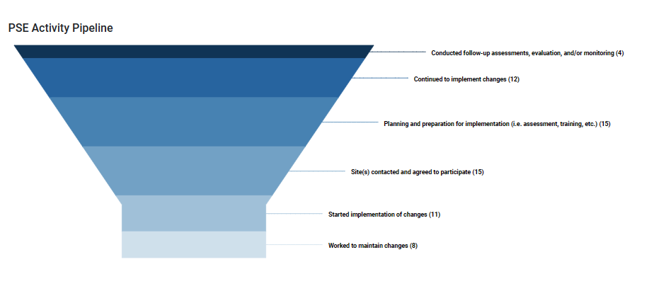
The PSE Activity Pipeline can be clipped from the PEARS Impact Dashboard SNAP-Ed Highlights. Filter for FFY2023 data and for your county or cluster.

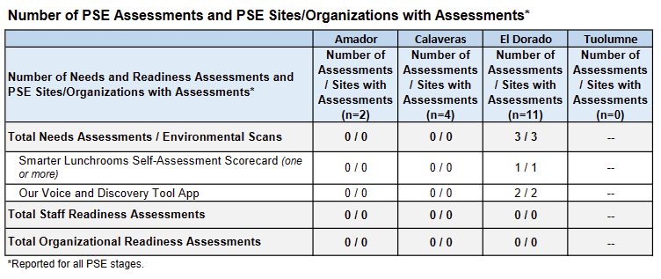

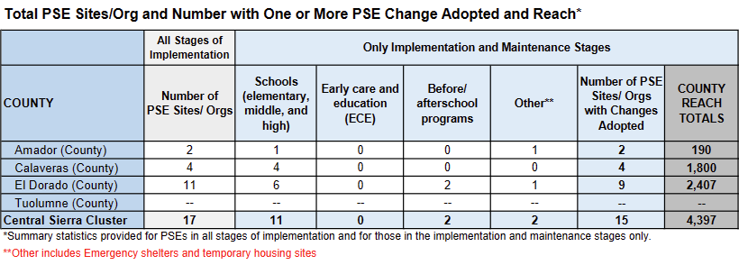
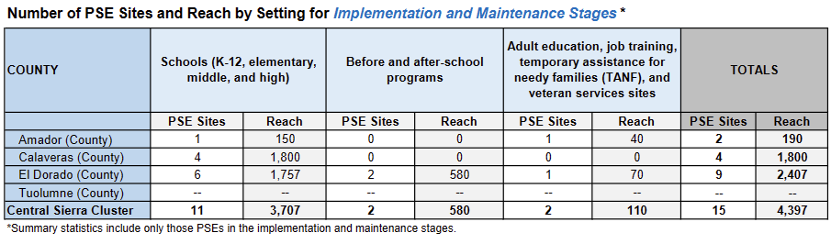
PSE Changes Adopted
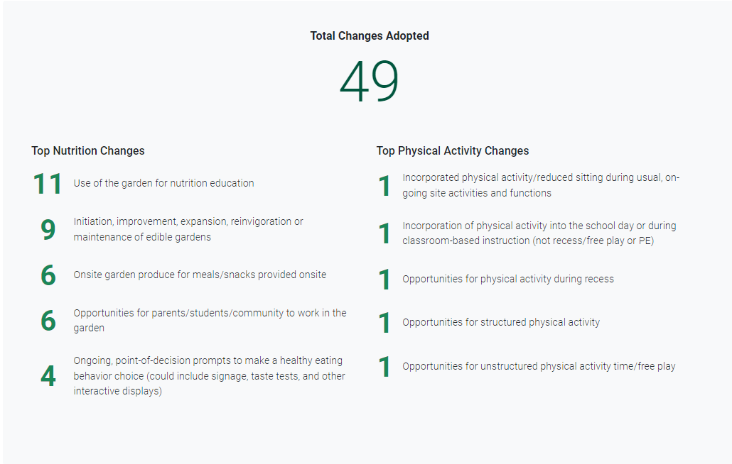
The PSE Changes Adopted (total and top 5 for Nutrition and Physical Activity) can be clipped from the Impact Dashboard SNAP-Ed Highlights. Filter for FFY2023 data and for your county or cluster.
- Total Partners and Partners by Type and Number of Coalitions and Members by Sectors of Influence) – Tables to be provided by the State Office
Partnerships by Type | Amador | Calaveras | El Dorado | Tuolumne
Total Partnerships | 3 | 3 | 13 | -
Agricultural organizations (includes farmers markets) | - | - | 2 | -
Community members/individuals | 1 | 2 | 1 | -
Early care and education facilities | - | - | - | -
Faith-based groups | - | - | - | -
Federal governments/agencies | - | - | - | -
s Food banks/food pantries | - | - | 1 | -
Foundations/philanthropy organizations/nonprofits | - | - | 1 | -
Government program/agency (Fed., St., local, etc.) | - | - | - | -
Hospitals/healthcare organizations | - | - | 1 | -
Human services organizations | - | - | - | -
Indian Tribal Organizations | 1 | - | 1 | -
Labor/workforce development groups | - | - | - | -
Libraries | - | - | - | -
Local governments/agencies | - | - | - | -
Organizations that work w/ people w/ disabilities (excludes housing) | - | - | 1 | -
Other: | - | - | - | -
Other Commercial Enterprises/Businesses | - | - | - | -
Parks and recreation centers | - | - | - | -
Public health organizations | - | - | 1 | -
Public/low-income housing groups | - | - | - | -
Schools (colleges and universities) | - | - | - | -
Shelter/temporary housing groups
Worksites

Coalition Members by Sector | El Dorado | Amador | Calaveras | Tuolumne
Total Coalitions | 1 | 1 | 2 | 0

Success Stories, Challenges and Planned Improvements for FFY 2023
- Success – See PEARS Success Story entry
PEARS ID | Title | County
32608 | CalFresh Healthy Living, UCCE Partners to Bloom School Gardens | Amador
32590 | Successful Youth Development Programming: The Boys & Girls Club of Lake Tahoe Partnership | El Dorado
33114 | MORE & CFHL, UCCE Central Sierra: Partnering to Engage Individuals with Disabilities | El Dorado

- Responding to Challenges
The program’s major challenge this year related to difficulties establishing MOUs with early childhood education providers in Calaveras County and schools in Amador County. Several SNAP-Ed approved sites required additional background checks and fingerprinting for CFHL, UCCE educators, as well as the disclosure of Protected Health Information related to immunization records. This obstacle is significant, as disclosure of this information violates UC ANR’s data privacy policies and educators were barred from entering campuses until these difficulties could be resolved. Local CFHL, UCCE leadership worked closely with CFHL, UCCE State Office representatives, the UC ANR Legal team, community partners, other Local Implementing Agencies, and the sites themselves to ensure that students were served without compromising UC ANR’s data privacy policy. Strategies used included developing extender programs to continue site outreach, establishing connections through indirect education channels, and making temporary edits to the Amador County Integrated Work Plan to ensure students are reached.
An additional challenge involved the program’s focus on working with adults with disabilities during FFY23. Successfully working with this population requires specialized program delivery techniques and curricula modifications, as CFHL, UCCE does not have approved curricula available to meet the needs of these participants. CFHL, UCCE Central Sierra addressed this challenge by working closely with CFHL, UCCE State Office representatives to modify the TWIGS curriculum to fit this population’s needs, and by providing professional development opportunities to educator staff related to skillfully working with individuals with disabilities. Central Sierra staff also heavily referenced the NCHPAD “Inclusive Nutrition Strategies for SNAP Settings” guide to glean best practices for working with this population. Further, there was a strong focus on ensuring the Americans with Disabilities Act (ADA) compliance of all educational materials and activities.
A final challenge in FFY23 involved staff transitions at SNAP-Ed eligible sites, within community partner organizations, and at CFHL, UCCE Central Sierra. Several projects were planned but never implemented due to key players leaving their organizations or transitioning roles. CFHL, UCCE education efforts in Tuolumne and Calaveras Counties were significantly limited by educator vacancies throughout FFY23. The program is addressing these challenges by extender training leadership staff at community organizations rather than more transitional educator roles. Additionally, educator positions in Tuolumne and Calaveras Counties are fully staffed at the close of FFY23.
- Planned Improvements
The program will continue to collaborate with statewide leadership, Local Implementing Agencies, and community partners to resolve MOU challenges with SNAP-Ed eligible sites. In Calaveras County, this takes the form of exploring extender programs with ECE Head Start sites in order to maintain a collaborative relationship with community partners. Additionally, CFHL, UCCE leadership will be reviewing the temporary modifications to the Amador County Integrated Work Plan with the goal of reestablishing CFHL, UCCE programming at Amador County schools.
In addition to exploring professional development opportunities, CFHL, UCCE Central Sierra staff will be collaborating with State Office representatives to develop a state-level workgroup relating to working with participants with disabilities. The goal of this workgroup is to further develop educator abilities and efficacy when serving this population by sharing resources and best practices.
Finally, CFHL, UCCE extender programming in the Central Sierra will focus on training leadership staff at eligible sites and community organizations in El Dorado and Amador counties using the TWIGS and CATCH curriculum. This strategy is meant to address the challenge of staff turnover in partner organizations. The program aims to ensure the longevity of extender relationships by partnering with long-term staff members.

Presentations, Publications and Awards
- Conference Presentations and Posters, Publications
Conference Presentations:
- Giron, M. (October 2022). Luncheon & Plenary Presentation: Lights, Camera, Action! Reaching Audiences through Online Videos. Oral presentation at the 2022 CalFresh Healthy Living Forum.
- Giron, M., McLaughlin, C. (October 2023). Reconnecting with Your Audience: Direct Education Strategies. Oral presentation at the 2023 CalFresh Healthy Living Forum.
- Luquin, C., McLaughlin, C., Tabarez, P., and Van Cleave-Hunt, V. (October 2023). Strategies and Best Practices for Engaging Participants with Disabilities in Nutrition. Oral presentation at the 2023 CalFresh Healthy Living Forum.
Posters:
- Garcia, M., McLaughlin, C., Campero, I. M., Brian, K. (October, 2023). Our Voice: MORE Empowering Individuals With Disabilities to Enhance Quality of Life. CalFresh Healthy Living Forum Poster at the 2023 CFHL Forum.
- Giron, A., Luquin, C. (October 2023). Cooking Up Healthy Partnerships. CalFresh Healthy Living Forum Poster Presented at the 2023 2023 CFHL Forum.
UC ANR Blogs (Food Blogs, Communities, etc.):
- Hsu, M. (January 10, 2023). CalFresh Healthy Living, UC helps connect Native youth with Native foods. https://ucanr.edu/blogs/Communities/index.cfm?start=16
- Hsu, M. (August 21, 2023). Adults with disabilities learn nutrition, grow gardening and cooking skills. https://ucanr.edu/blogs/Communities/
- Womack, M. (August 14, 2023). Award-Wining Excellence, Community and Empowerment in El Dorado County. https://ucanr.edu/blogs/blogcore/postdetail.cfm?postnum=57580
News coverage – Print and Electronic Media:
- Carter, K. (August 14th, 2023). Partnering Expands Opportunities in Amador County. Active News Beet. https://us7.campaign-archive.com/?u=a7bcc27755ff6e98f62827c28&id=e0560927d9
- Luquin, C., Giron, A. (May 16th, 2023). El Dorado County- South Lake Tahoe: CalFresh Healthy Living, UCCE & 4-H. Active News Beet. https://us7.campaign-archive.com/?u=a7bcc27755ff6e98f62827c28&id=b512749438
- Martella, D. (September 29th, 2023). Hometown Heroes, An Amazing Composting Crew. Ledger Dispatch. https://www.ledger.news/on_the_vine/hometown-heroes-an-amazing-composting-crew/article_b7a82128-5e1c-11ee-a672-9b24474f369a.html\
- McLaughlin, C. (November 21st, 2022). The Foothill Indian Education Alliance + CFHL, UCCE Central Sierra: Fostering Youth Cultural Knowledge in Food & Cooking. Active News Beet. https://us7.campaign-archive.com/?u=a7bcc27755ff6e98f62827c28&id=82a754a59d
- Nicoli, A. & McLaughlin, C. (July 18, 2023). MORE + CalFresh Healthy Living, UCCE Central Sierra Partner to Expand Opportunities for Adults with Disabilities. Active News Beet. https://us7.campaign-archive.com/?u=a7bcc27755ff6e98f62827c28&id=510ad34c14
- No Author (April 30th, 2023). Boys & Girls Club of Lake Tahoe hosts inaugural Bright Futures awards ceremony. Tahoe Daily Tribune. https://www.tahoedailytribune.com/news/boys-girls-club-of-lake-tahoe-hosts-inaugural-bright-futures-awards-ceremony/?fbclid=IwAR09mSq0qjIsq7nF5_TuZT9mKuna0Yt1hlru537gyV9wHKwHxpuE7wJuwlk
News coverage - Broadcast Media:
- Atwell, T., D’Onofrio, C. (Hosts), Luquin, C., McLaughlin, C. (Guests). (October 4th, 2023). Creating Inclusive Spaces for Participants with Disabilities (Episode 6). [Audio podcast episode]. Stocking the Pantry: A CalFresh Healthy Living Podcast. Leah’s Pantry. https://leahspantry.org/stocking-the-pantry-a-cfhl-podcast/
Newsletters- English
- Carter, K. Garcia, M. (January 2023). Wellness Prospector Newsletter– Grapefruit. Virtual newsletter sent to schools.
- Carter, K. (February 2023). Adult Wellness Prospector Newsletter – Dried Beans. Virtual newsletter sent to community sites.
- Carter, K. Garcia, M. (February 2023). Wellness Prospector – Dried Beans. Virtual newsletter sent to schools.
- Carter, K. Garcia, M. (March 2023). Wellness Prospector – Beets. Virtual newsletter sent to schools.
- Carter, K. Garcia, M. (March 2023). Adult Wellness Prospector Newsletter – Beets. Virtual newsletter sent to community sites.
- Carter, K. Garcia, M. (April 2023). Adult Wellness Prospector Newsletter– Strawberries. Virtual newsletter sent to community sites.
- Carter, K. Garcia, M. (April 2023). Wellness Prospector Newsletter – Strawberries. Virtual newsletter sent to schools.
- Carter K. (May 2023). Wellness Prospector Newsletter – Lettuce. Virtual newsletter sent to schools.
- Carter, K. Garcia, M. (May 2023). Adult Wellness Prospector Newsletter– Lettuce. Virtual newsletter sent to community sites.
- Carter K. (June 2023). Wellness Prospector – Peaches. Virtual newsletter sent to schools.
- Carter, K. (June 2023). Adult Wellness Prospector Newsletter– Peaches. Virtual newsletter sent to community sites.
- Carter, K. (July 2023). Adult Wellness Prospector Newsletter– Tomatoes. Virtual newsletter sent to community sites.
- Carter, K. (August 2023). Adult Wellness Prospector Newsletter– Peppers. Virtual newsletter sent to community sites.
- Carter, K. (September 2023). Adult Wellness Prospector Newsletter– Grapes. Virtual newsletter sent to community sites.
- Carter K. (September 2023). Wellness Prospector – Grapes. Virtual newsletter sent to schools.
- Garcia, M. (October, 2022) HOTM Apple Amador, Apple Spice Oatmeal, Apples. Virtual newsletter sent to schools.
- Garcia, M. (November, 2022) HOTM Persimmons Amador, Persimmons Spinach Salad, Persimmons. Virtual newsletter sent to schools.
- Garcia, M. (December, 2022) HOTM Cabbage Amador, Stir-Fry Noodles with Peanut Sauce, Cabbage. Virtual newsletter sent to schools.
- Garcia, M. (January 2023). Adult Wellness Prospector – Grapefruit. Virtual newsletter sent to community sites.
- Giron, M. (October 2022). Growing with Nutrition Newsletter – Apple Sandwiches. Virtual newsletter sent to schools.
- Giron, M. (October 2022). Growing with Nutrition Newsletter –Cranberry Applesauce. Virtual newsletter sent to schools.
- Giron, M. (November 2022). Growing with Nutrition Newsletter – Persimmon Pudding. Virtual newsletter sent to schools.
- Giron, M. (November 2022). Growing with Nutrition Newsletter –Persimmon Spinach Salad. Virtual newsletter sent to schools.
- Giron, M. (December 2022). Growing with Nutrition Newsletter –Sauteed Cabbage. Virtual newsletter sent to schools.
- Giron, M. (December 2022). Growing with Nutrition Newsletter –Kiwi Pineapple Slaw. Virtual newsletter sent to schools.
- Giron, M. (January 2023). Growing with Nutrition Newsletter –Glazed Squash. Virtual newsletter sent to schools.
- Giron, M. (Januray 2023). Growing with Nutrition Newsletter –Squash-Apple Casserole. Virtual newsletter sent to schools.
- Giron, M. (February 2023). Growing with Nutrition Newsletter –Chunky Black Bean Dip. Virtual newsletter sent to schools.
- Giron, M. (Feberuary 2023). Growing with Nutrition Newsletter –Salsa Pinto Beans. Virtual newsletter sent to schools.
- Giron, M. (March 2023). Growing with Nutrition Newsletter – Chard and Cranberry Stir-Fry. Virtual newsletter sent to schools.
- Giron, M. (March 2023). Growing with Nutrition Newsletter –Sauteed Swiss Chard. Virtual newsletter sent to schools.
- Giron, M. (May 2023). Growing with Nutrition Newsletter –Salmon Salad Mix. Virtual newsletter sent to schools.
- Giron, M. (May 2023). Growing with Nutrition Newsletter –Personal Salad in a Bag. Virtual newsletter sent to schools.
- Giron, M. (June 2023). Growing with Nutrition Newsletter – Plum Punch. Virtual newsletter sent to schools.
- Giron, M. (June 2023). Growing with Nutrition Newsletter –Plum Bread. Virtual newsletter sent to schools.
- Giron, M. (July 2023). Growing with Nutrition Newsletter – Tomato Pasta Salad. Virtual newsletter sent to schools.
- Giron, M. (July 2023). Growing with Nutrition Newsletter –Split Pea Salad. Virtual newsletter sent to schools.
- Giron, M. (August 2023). Growing with Nutrition Newsletter –Bell Pepper Salad. Virtual newsletter sent to schools.
- Giron, M. (August 2023). Growing with Nutrition Newsletter –Sautéed Peppers. Virtual newsletter sent to schools.
- Giron, M. (September 2023). Growing with Nutrition Newsletter – Grape Sorbet. Virtual newsletter sent to schools.
- Giron, M. (September 2023). Growing with Nutrition Newsletter –Grapes with Ginger Topping. Virtual newsletter sent to schools.
Newsletters – Spanish
- Garcia, M. (February 2023). Spanish version of the Wellness Prospector – Dried Beans. Virtual newsletter sent to schools.
- Garcia, M. (March 2023). Spanish version of the Wellness Prospector – Beets. Virtual newsletter sent to schools.
- Garcia, M. (April 2023). Spanish version of the Wellness Prospector – Strawberries. Virtual newsletter sent to schools.
- Garcia, M. (May 2023). Spanish version of the Wellness Prospector – Lettuce. Virtual newsletter sent to schools.
- Garcia, M. (June 2023). Spanish version of the Wellness Prospector – Peaches. Virtual newsletter sent to schools.
- Garcia, M. (July 2023). Spanish version of the Adult Wellness Prospector Newsletter– Tomatoes. Virtual newsletter sent to community sites.
- Garcia, M. (August 2023). Spanish version of the Adult Wellness Prospector Newsletter– Peppers. Virtual newsletter sent to community sites.
- Garcia, M. (September 2023). Spanish version of the Adult Wellness Prospector Newsletter– Grapes. Virtual newsletter sent to community sites.
- Garcia, M. (September 2023). Spanish version of the Wellness Prospector Newsletter – Grapes. Virtual newsletter sent to schools.
- Giron, M. (octubre, 2022). Creciendo con Nutrición –Sándwiches de Manzana. Boletín virtual enviado a las escuelas.
- Giron, M. (octubre, 2022). Creciendo con Nutrición –Puré de Manzana con Arándanos Rojos. Boletín virtual enviado a las escuelas.
- Giron, M. (noviembre, 2022). Creciendo con Nutrición –Pudín de Caqui. Boletín virtual enviado a las escuelas.
- Giron, M. (noviembre, 2022). Creciendo con Nutrición –Ensalada de Espinacas y Caqui. Boletín virtual enviado a las escuelas.
- Giron, M. (diciembre, 2022). Creciendo con Nutrición –Sofrito de Repollo. Boletín virtual enviado a las escuelas.
- Giron, M. (diciembre, 2022). Creciendo con Nutrición –Ensalada de Repollo con Kiwi y Piña. Boletín virtual enviado a las escuelas.
- Giron, M. (enero, 2023). Creciendo con Nutrición –Calabaza Glaseada al Horno. Boletín virtual enviado a las escuelas.
- Giron, M. (enero, 2023). Creciendo con Nutrición –Guisado de Calabaza con Manzana. Boletín virtual enviado a las escuelas.
- Giron, M. (febrero, 2023). Creciendo con Nutrición –Dip de Frijoles Negros. Boletín virtual enviado a las escuelas.
- Giron, M. (febrero, 2023). Creciendo con Nutrición –Salsa de Frijoles Pintos. Boletín virtual enviado a las escuelas.
- Giron, M. (marzo, 2023). Creciendo con Nutrición –Salteado de Acelgas y Arándanos. Boletín virtual enviado a las escuelas.
- Giron, M. (marzo, 2023). Creciendo con Nutrición –Acelgas Suizas Salteadas. Boletín virtual enviado a las escuelas.
- Giron, M. (abril, 2023). Creciendo con Nutrición –Salsa de Fresas. Boletín virtual enviado a las escuelas.
- Giron, M. (abril, 2023). Creciendo con Nutrición –Agua con Sabor a Fresa. Boletín virtual enviado a las escuelas.
- Giron, M. (mayo, 2023). Creciendo con Nutrición –Mezcla de ensalada de Salmón. Boletín virtual enviado a las escuelas.
- Giron, M. (mayo, 2023). Creciendo con Nutrición –Ensalada Individual en Bolsa. Boletín virtual enviado a las escuelas.
- Giron, M. (junio, 2023). Creciendo con Nutrición –Ponche de Ciruela. Boletín virtual enviado a las escuelas.
- Giron, M. (junio, 2023). Creciendo con Nutrición –Pan de Ciruela. Boletín virtual enviado a las escuelas.
- Giron, M. (julio, 2023). Creciendo con Nutrición –Ensalada fria de Pasta y Tomate. Boletín virtual enviado a las escuelas.
- Giron, M. (julio, 2023). Creciendo con Nutrición –Ensalada de Chicharos Partidos. Boletín virtual enviado a las escuelas.
- Giron, M. (agosto, 2023). Creciendo con Nutrición –Ensalada de Pimiento Dulce. Boletín virtual enviado a las escuelas.
- Giron, M. (agosto, 2023). Creciendo con Nutrición –Sofrito de Pimientos. Boletín virtual enviado a las escuelas.
- Giron, M. (septiembre, 2023). Creciendo con Nutrición –Sorbete de Uva. Boletín virtual enviado a las escuelas.
- Giron, M. (septiembre, 2023). Creciendo con Nutrición –Uvas con Jengibre. Boletín virtual enviado a las escuelas.
Newsletters – Spanish/English (double sided)
- Garcia, M. (October, 2022) HOTM October Calaveras Apple, Apple Spice Oatmeal, Apples. Virtual newsletter sent to community sites.
- Garcia, M. (November, 2022) HOTM November Calaveras Persimmons, Persimmons Spinach Salad, Persimmons. Virtual newsletter sent to community sites.
- Garcia, M. (December, 2022) HOTM December Calaveras Cabbage, Stir-Fry Noodles with Peanut Sauce, Cabbage. Virtual newsletter sent to community sites.
- Garcia, M. (January, 2023) HOTM January Winter Squash Calaveras, Three Sisters Soup, Winter Squash. Virtual newsletter sent to community sites.
- Garcia, M. (February, 2023) HOTM February Calaveras beans, Easy Cheesy Enchiladas, Beans. Virtual newsletter sent to community sites.
- Garcia, M. (March, 2023) HOTM March Swiss Chard, Swiss Chard Pinwheel Bread, Swiss Chard. Virtual newsletter sent to community sites.
- Garcia, M. (April, 2023) HOTM April Calaveras strawberries, Strawberry Salsa, Strawberries. Virtual newsletter sent to community sites.
- Garcia, M. (May, 2023) HOTM May Calaveras Lettuce, Ground Chicken Lettuce Wraps, Lettuce. Virtual newsletter sent to community sites.
- Garcia, M. (June, 2023) HOTM June Calaveras Plum, Peachy Peanut Butter Pita Pockets, Plum. Virtual newsletter sent to community sites.
- Garcia, M. (July, 2023) HOTM July Calaveras Tomatoes, Tomato Pasta Salad, Tomato. Virtual newsletter sent to community sites.
- Garcia, M. (August, 2023) HOTM August Calaveras Bell pepper, Mix and Match Skillet Meal, Bell Pepper. Virtual newsletter sent to community sites.
- Garcia, M. (September, 2023) HOTM September Calaveras Grapes, Magical Fruit Salad, Grapes. Virtual newsletter sent to community sites.
- Awards Received
- "Bright Futures Awards"- Presented to Cristina Luquin & Alejandra Giron by Boys and Girls Club South Lake Tahoe- 4/2023
- "2023 UC Master Gardener Search for Excellence 3rd Place" - Cross Pollination, Growing Abilities: Cultivating Independence and Community in the Garden - Presented to Tracy Celio, Diane Hernandez, Mike Davis, Alesha Nichole, Cailin McLaughlin 6/21/2023

