Reinvigorating In-Person Programming with Infant Child Enrichment Services

SUMMARY
Infant Child Enrichment Services (ICES) is a child-support organization in Tuolumne County that focuses on training childcare workers, assisting families finding childcare, providing financial assistance, and coaching parents to be nurturing caregivers to their children. CalFresh Healthy Living UCCE (CFHL UCCE) staff partnered with ICES in FFY24, offering virtual classes to parents using the Happy Healthy Family curricula. In FFY25, the partnership expanded to include in-person parent workshops, physical activity resources at play-day events, garden reinvigoration work, and training ICES staff to implement physical activity and gardening lessons.

BACKGROUND
In FFY24, ICES had yet to resume in-person programming that had paused in 2020 due to the COVID-19 pandemic. Site staff and participants had expressed interest in expanding virtual classes for parents to include in-person, intergenerational garden and physical activity lessons. At this time, the ICES location did not have gardening facilities and site staff expressed a need for technical assistance and training related to garden-based nutrition education. In FFY25, CalFresh Healthy Living UCCE (CFHL UCCE) and ICES partnered to expand in-person programming, install gardening beds and irrigation at the ICES office, hold workshops related to gardening and physical activity, and train ICES staff on gardening, physical activity, and nutrition education programming.

SOLUTION
In Fall 2024, ICES sponsored “Play Dates” with participants, where families with young children were invited to community facilities for structured play and socialization. CFHL UCCE led physical activity lessons using the CATCH curricula and offered tastings of healthy foods.

After completing the UC Garden Assessment in October 2024, CFHL UCCE pursued the opportunity to install 2 new garden beds at the ICES office with the goal of holding in-person garden workshops during Spring 2025. The programs shared costs associated with the garden installation, including the purchase of lumber, soil, irrigation supplies, seeds, and edible plant starts. In addition, CFHL staff were able to provide hands-on technical assistance during the installation in April 2025.

Following the installation of the garden beds, ICES and CFHL partnered to hold a "Family Day in the Garden" workshop in May 2025. Four families attended and planted a Salsa Garden in the new beds. Participants also planted herb seeds in take-home container gardens, transplanted pollinator-friendly flowers, and received take-home garden kits including gardening tools, story books, and seeds provided by ICES. ICES staff reported that this event was the first time they'd had children attend events at their office since the COVID-19 pandemic. The garden serves not only as a platform for education, but as a draw for families to participate in workshops and connect with services. Workshops continued through the summer with topics such as vermicomposting, harvesting, and cooking with garden produce.

In addition to leading garden workshops with participants, CFHL UCCE led trainings for ICES staff in September 2025 related to garden maintenance, physical activity lessons, and nutrition standards for students. ICES staff were equipped with growing guides, pest identification materials, maintenance plans for their site garden, physical activity curricula, CATCH pacing guides, and MyPlate resources.

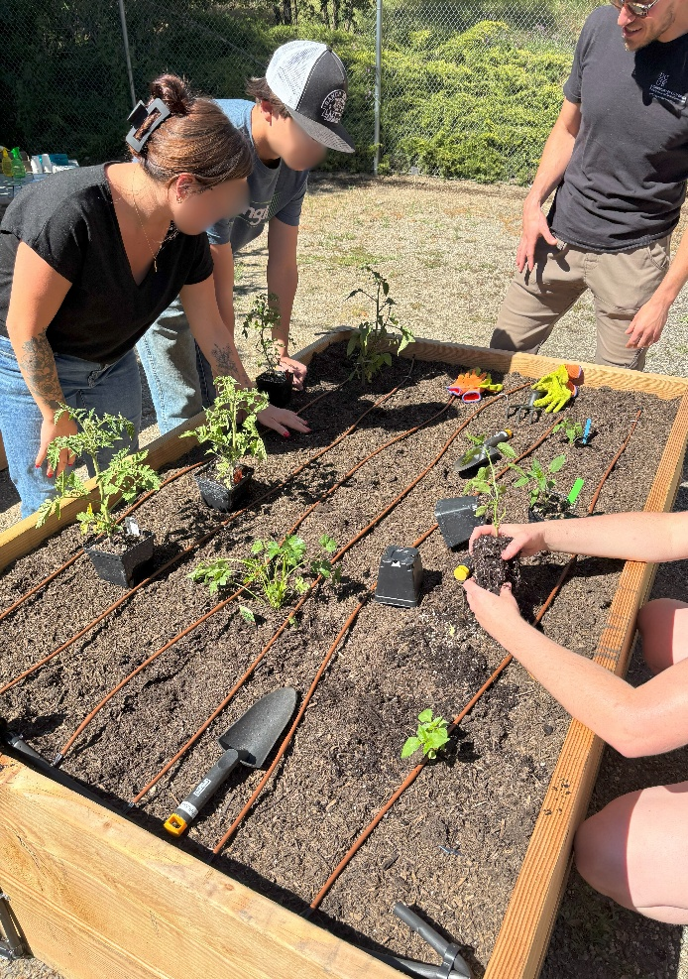
Infant Child Enrichment Services (ICES) participants plant tomatoes and peppers in their newly installed garden beds. May 2025. Photo credit Farrah Olson.
Our experience working with [CFHL UCCE educator] Farrah Olson, and the rest of her team has been nothing short of fantastic! From the planning stages, to building our garden beds, to the implementation of workshops and support with garden maintenance… we have been so impressed. The families that we serve have enjoyed watching the garden flourish, and our staff have begun to spend more time outside on their breaks to enjoy its beauty. We are so grateful for the support and guidance.”
-Jennifer Reggiardo, Raising Healthy Families Program Manager, Infant Child Enrichment Services

OUTCOME
This project is impactful in that it expands ICES's capacity to encourage healthy living behaviors, build community, and procure healthy food with approximately 325 participants per year. Beyond supporting environmental PSE changes at the ICES facility, staff are now equipped with the knowledge to maintain the garden, lead garden lessons with their participants, lead structured physical activity lessons, and provide on-going support for healthy living in Tuolumne County. This wealth of resources expands ICES’s ability to facilitate positive change in the community and sustains CalFresh Healthy Living efforts beyond FFY25.

